Answers to Questions

1. Financial accounting deals with regulated, historical, financial information that pertains to the whole company and is designed primarily to meet the information needs of outsiders. Managerial accounting is concerned with unregulated financial, economic as well as physical data, which pertains more to the sub-units of the organization, that is current and future oriented, and that is designed primarily to meet the information needs of insiders.

2. The value-added principle means that management accountants are free to engage in any information gathering and reporting activity so long as the activity adds value in excess of its cost. Estimates of future product costs are permissible in managerial accounting reports for budgeting and product costing but would not be allowed by financial regulations in financial accounting.

3. The two dimensions of the TQM program are: (1) management should follow a continuous, systematic problem solving philosophy that engages all employees to eliminate waste and errors and to simplify the design and delivery of products and services to customers, and (2) organizations need a strong commitment to customer satisfaction. TQM is being used in business to maintain profitability in an increasingly competitive global market. In this environment profit margins are tight, and therefore, inefficiencies can more easily erode business profits. To eliminate waste, errors, and dissatisfied customers, information must be timely and relevant in order to prevent or discover and correct mistakes immediately.

4. Both financial and managerial accountants need cost information about the company’s products and services. In managerial accounting cost information is useful in product pricing decisions and is an essential part of cost control (comparing actual product cost to budgeted product cost to assess needed improvement) and performance evaluation (assess managers’ success in controlling and eliminating unnecessary cost). In financial accounting cost information about the product is needed to determine ending inventory on the balance sheet and cost of goods sold on the income statement. Product costing in financial accounting can impact the decisions of not only managers but also outsiders such as investors, creditors, and taxing authorities. Product costing information in managerial accounting can affect the product’s price as well as management’s decisions as to whether cost correction changes are needed.

5. A cost that has the future economic potential to increase assets is recorded as an asset (e.g. cost of products purchased). A cost that is used in the process of earning revenue is recorded as an expense (e.g. administrative salaries, and product cost for products sold).

6. The cash paid to production workers has not been used to produce revenue but to produce inventory. The revenue is earned when the inventory is sold at which time the cost of salaries associated with those products sold should be expensed.

7. Product costs associated with goods that have not been sold are recorded in the account called inventory. Inventory cost is shown on the balance sheet as an asset. The amount of total assets and net income will be higher if a product cost is classified as an asset than if it is expensed. Product cost associated with goods that have been sold should be recorded in the account called cost of goods sold. Cost of goods sold is an expense shown on the income statement. The amount of total assets and net income will be lower if a product cost is classified as an expense as opposed to being classified as an asset.

8. An indirect product cost cannot be easily or economically traced to a specific product. Product costs that would be considered indirect include costs such as production supplies, salaries of production supervisors, and depreciation, rent, and utilities on factory facilities.

9. Product costs are all costs incurred to obtain a product or provide a service. These costs are treated as assets, recorded in inventory, and expensed when the associated products are sold. Period costs are all costs not associated with a product. They are associated with the general, selling, and administrative functions of the business and most are expensed in the period in which the associated economic sacrifice is made. A product cost would be the cost of direct materials used in the production of a product. A period cost would be rent on administrative facilities.

10. The effects of cost classification on the financial statements can have important implications with respect to the following:

(1) The availability of financing - Investors and creditors use financial statement data to predict businesses’ future earnings. Favorable financial statements provide evidence of favorable future performance whereas unfavorable financial statements are an indication of possible poor future financial performance. A company with favorable financial performance is more likely to generate sufficient cash flows to make interest payments, to repay the principal balance of its liabilities, and to pay dividends. Hence, investors and creditors believe they have a greater probability of receiving interest payments, the return of principal, and return on investment when companies show favorable financial statements. Since expenses reduce profit and financial performance, classifying a cost as an expense will inhibit the company’s ability to obtain financing. Classifying a cost as an asset, which will increase profit, total assets, and equity, enhances businesses’ ability to obtain financing.

10. (continued)

(2) Management motivation - Executive compensation may be affected by financial statement data. Many managers’ bonuses are based on a percentage of net income. If costs are classified as expenses, net income will be reduced which in turn affects managerial income. Managers may even be tempted to misclassify costs in order to manipulate financial statement data to their advantage.
(3) Income tax considerations - With respect to taxes, managers prefer to classify costs as expenses rather than assets. Classifying a cost as an expense reduces net income and in turn reduces income taxes, which are determined by computing a designated percentage of taxable income.

11. Cost allocation is the process of dividing a total cost into parts and assigning the parts to relevant objects. The determination of interest expense on a note payable is an allocation. If the note pays $1,200 of interest a year and has been outstanding for 3 months, then 3/12 or $300 of the $1,200 total interest expense should be allocated to interest expense for the three-month period. The remaining 9/12 of interest would be allocated to interest expense for the remaining 9 months of the year.

12. In recognition of its responsibility to uphold high ethical standards of conduct, the Institute of Management Accountants issued a statement entitled Standards of Ethical Conduct for Management Accountants. The statement sets forth professional ethical standards covering the areas of competence, confidentiality, integrity, and objectivity that management accountants are required to abide by in order to maintain their professional and personal integrity.

13. Some of the more common ethical conflicts encountered by accountants include the following:

(1) Pressure to perform duties for which they are not competently trained.
(2) Pressure to disclose confidential information.
(3) Pressure to engage in falsification, embezzlement, and bribery.
(4) Pressure to issue misleading or incomplete reports.

14. A pricing decision must include all costs associated with the product. The manufacturing product cost as well as all upstream costs (costs that occur before the manufacturing process begins, e.g., research and development costs) and downstream costs (costs that are incurred after the manufacturing process, e.g., sales commissions) must be covered by the product’s revenues in order for the company to be profitable.

15. JIT inventory system is a reengineering principle where inventory is made available for customer consumption at the time of customer demand. A JIT inventory system is designed to eliminate the storage of large amounts of inventory. By eliminating the storage of inventory, costs related to inventory such as financing, warehouse space, security and maintenance, theft, damage and obsolescence can be reduced or eliminated.

16. Reengineering is the term used to explain companies’ responses to world-wide competition by changing production and delivery systems so as to eliminate waste, reduce errors, and minimize costs. Some of the best practices used by world-class competitors include activity-based management, value-added activities, and just-in-time inventory acquisition.

17. In traditional costing systems, indirect costs are assigned to products, services, or customers using some allocation base measured in volume such as direct labor hours. In activity-based costing a different allocation system is used to improve the accuracy of allocations. With activity-based costing, indirect costs are first assigned to organizational activities and then to products, services, or customers based on their use of that activity. There is usually a two-level allocation process and more than one allocation base may be used.

18. A value chain is the sequence of activities through which an organization provides products to its customers.

19. A value-added activity is any unit of work that contributes to a product’s ability to satisfy customer needs. Value-added activities include the following:
(1) Input activities - research and development, product design, and hiring and training.
(2) Processing activities - assembly, inspection, and storing.
(3) Output activities - marketing, distribution, and customer relations.
(4) Administrative activities - accounting and legal services, personnel management, and public relations.

Nonvalue-added activities are tasks undertaken that do not contribute to a product’s ability to satisfy customer needs. Examples would include the following:

(1) Maintaining excess quantities of inventories.
(2) Transporting materials and products.
(3) Machine set-ups.

Exercise 1-1B

 | Managerial Accounting | Financial Accounting
a. |  | X
b. | X
c. |  | X
d. |  | X
e. | X
f. |  | X
g. |  | X
h. | X
i. | X
j. | X

Exercise 1-2B

 | Product Cost | General, Selling, and Administrative Cost
a. | X
b. |  | X
c. |  | X
d. | X
e. |  | X
f. | X
g. |  | X
h. |  | X
i. | X
j. | X

Exercise 1-3B

Cost Category | Product /  G,S,&A | Asset /  Expense
Cost of a delivery truck | G,S,&A | Asset
Cash dividend to stockholders | Neither | Neither
Cost of merchandise shipped to customers | Product | Expense
Depreciation on vehicles used by salespeople | G,S,&A | Expense
Wages of administrative building security guards | G,S,&A | Expense
Supplies used in the plant manager's office | Product | Asset
Computers for the accounting department | G,S,&A | Asset
Depreciation on computers used in factory | Product | Asset
Natural gas used in the factory | Product | Asset
Cost of television commercials | G,S,&A | Expense
Wages of factory workers | Product | Asset
Paper and ink cartridges used in the cashier's office | G,S,&A | Expense
Raw material used to make products | Product | Asset
Lubricant used to maintain factory equipment | Product | Asset

Exercise 1-4B

 |  | Assets | = | Liab. | + | Equity |  | Rev. | – | Exp. | = | Net Inc. |  | Cash Flow
1. |  |  |  | +$2,500 |  | –$2,500 |  |  |  | +$2,500 |  | –$2,500 |  | NA
2. |  | +$2,500 |  | +$2,500 |  |  |  |  |  |  |  |  |  | NA

Exercise 1-5B

 |  | Assets |  |  |  |  |  |  | = | Equity
Event |  |  |  | Prepaid |  |  |  |  |  | Com. |  | Ret.
No. |  | Cash | + | Insurance |  |  | + | Inventory | = | Stk. | + | Ear. |  | Rev. | – | Exp. | = | Net Inc. |  | Cash Flow
1. |  | NA |  |  | D |  |  | NA |  | NA |  | D |  | NA |  | I |  | D |  | NA
2. |  | NA |  |  | D |  |  | I |  | NA |  | NA |  | NA |  | NA |  | NA |  | NA

Exercise 1-6B

a. The three components of product cost incurred in producing cakes are direct materials such as flour, sugar, and eggs; direct labor such as Susan’s effort to mix ingredients together and bake them into cakes; and manufacturing overhead such as the cost of an oven, electric power cost, and the cost of detergent to wash pans.

b. Measuring product cost for a merchandising company, such as a retail store, is relatively easy. It includes the vendor’s invoice price, freight cost, and other costs necessary to get the inventory ready to sell. Measuring product cost for a manufacturing entity requires a more complex system. A manufacturing enterprise must classify its costs as product costs or period costs. It must accumulate product costs (direct materials, direct labor, and manufacturing overhead). It must then classify the cost of sold products as expense and unsold products as inventory, an asset.

c. If Susan produced only one type of cake, she could possibly use the number of cakes baked per month to allocate an equal portion of her utility cost increase to each cake. Since Susan’s cakes are custom-made for individual customers, however, they vary in size, shape, and ingredients. They bake for different lengths of time at different temperatures. Further, their refrigeration requirements differ. There is no cost-effective way to measure the amount of electricity used by individual cakes. Consequently, utility cost must be treated as a manufacturing overhead cost.

The cost of an oven is a component of product cost which is difficult to measure. The useful life is uncertain, as is the number of cakes Susan may bake over its lifetime. It is impossible to trace the amount of oven depreciation to the cost of an individual cake. Other difficult-to-measure costs include the costs of detergent, water, heating, and air conditioning to provide a pleasant kitchen in which Susan can work. These costs cannot easily be traced to individual cakes.
Exercise 1-7B

a. Depreciation costs that would be classified as general, selling, and administrative expense are the following:

Depreciation of a building for finished product display | $ 8,000
Depreciation of delivery trucks | 14,000
Depreciation of furniture used in the president's office | 9,000
Depreciation of elevators in administrative buildings | 6,000
Total | $37,000
b. Depreciation costs that would be classified as product costs are the following:

Depreciation of factory buildings | $ 25,000
Depreciation of computers used in manufacturing | 4,000
Depreciation of forklifts used in the factory | 22,000
Depreciation of factory machinery | 9,000
Total | $ 60,000
Since 2,000 units of 3,000 products finished were sold, 2/3 (2,000 ÷ 3,000) of the product cost would be included in cost of goods sold. Therefore, the total depreciation cost that would be included in cost of goods sold is:

$60,000 x 2/3 = $40,000

Exercise 1-8B

 |  | Assets |  |  |  |  |  |  | = | Equity
Event |  |  |  |  |  | Manuf. |  | Adm. |  | Cont. |  | Ret. |  |  |  |  |  |  |  | Cash
No. |  | Cash | + | Inventory | + | Equip. | + | Offices | = | Cap. | + | Ear. |  | Rev. | – | Exp. | = | Net Inc. |  | Flow
1 |  | I | + | NA | + | NA | + | NA | = | I | + | NA |  | NA | – | NA | = | NA |  | I FA
2 |  | D | + | I | + | NA | + | NA | = | NA | + | NA |  | NA | – | NA | = | NA |  | D OA
3 |  | D | + | NA | + | NA | + | NA | = | NA | + | D |  | NA | – | I | = | D |  | D OA
4 |  | D | + | I | + | NA | + | NA | = | NA | + | NA |  | NA | – | NA | = | NA |  | D OA
5 |  | NA | + | NA | + | NA | + | D | = | NA | + | D |  | NA | – | I | = | D |  | NA
6 |  | NA | + | I | + | D | + | NA | = | NA | + | NA |  | NA | – | NA | = | NA |  | NA
7 |  | I | + | NA | + | NA | + | NA | = | NA | + | I |  | I | – | NA | = | I |  | I OA
8 |  | NA | + | D | + | NA | + | NA | = | NA | + | D |  | NA | – | I | = | D |  | NA

Exercise 1-9B

a.
Raw materials purchased and used | $2,500
Wages of production workers | 2,000
Depreciation on manufacturing equipment | 1,500
Total product cost | $6,000
b.

Cost of inventory per unit = $6,000 ÷ 2,000 = $3

Ending inventory in units = 2,000 – 1,600 = 400

Cost of ending inventory = $3 x 400 = $1,200

c.

$3 x 1,600 = $4,800

Exercise 1-10B

a. Event No. 1 represents the expiration of insurance on a factory building because the recognition decreases prepaid insurance and increases inventory, both assets on the balance sheet. The expiration of insurance on a factory building does not affect the income statement until the products made in the factory are sold.

b. The cost of insuring a factory is among the costs necessary to produce inventory. The expiration of factory insurance, therefore, is an asset exchange: the asset prepaid insurance is exchanged for the asset inventory, affecting only the balance sheet. The expiration of insurance on an administrative building, however, is an asset use transaction which increases expense on the income statement. No asset that will benefit future periods is produced in the administrative building.

Exercise 1-11B

 | Net Income |  | Cash Flow
Event No. | Amount of Change |  | Amount of Change
1. Purchased franchise | NA |  | ($50,000) IA
1. Adjusting entry | ($5,000) |  | NA
2. Purchased a manufacturing patent | NA |  | ($50,000) IA
2. Adjusting entry | NA |  | NA
3. Purchased insurance—admin. bldg. | NA |  | ($3,600) OA
3. Adjusting entry | ($2,700) |  | NA
4. Purchased insurance—mfg. bldg. | NA |  | ($3,600) OA
4. Adjusting entry | NA |  | NA
5. Purchased office supplies—acct. dept. | NA |  | ($1,200) OA
5. Adjusting entry | ($900) |  | NA
6. Purchased factory supplies | NA |  | ($1,200) OA
6. Adjusting entry | NA |  | NA

Exercise 1-12B

a. The $10,000,000 of research and development costs is an upstream cost. Packaging, shipping, and sales commissions are downstream costs.

b. Cost of goods sold: $40 x 100,000 = $4,000,000
Ending inventory: $40 x 60,000 = $2,400,000

c.
Upstream cost per unit, $10,000,000 ÷ 1,000,000 | $ 10
Manufacturing cost per unit | 40
Downstream costs per unit | 5
Total cost | 55
Plus: 40% profit margin, $55 x 40% | 22
Price | $77

Exercise 1-12B (continued)

d.

Income Statement
Sales Revenue ($77 x 100,000) | $ 7,700,000
Cost of Goods Sold ($40 x 100,000) | (4,000,000)
Gross Margin | 3,700,000
Research and Development Expense | (10,000,000)
Selling Expenses ($5 x 100,000) | (500,000)
Net (Loss) | ($6,800,000)

e. GAAP requires expensing research and development costs in the period in which they are incurred. However, Moseley expects the R&D costs to result in overall Allergone sales of 1,000,000 units in 2007 and future years. The income statement for 2007 recognizes revenue from selling 100,000 units while recognizing the entire R&D cost as expense. No R&D cost will be recognized on future income statements. The 2007 net loss will be more than offset by positive net income from future Allergone sales.

Exercise 1-13B

Increases in inventory without corresponding increases in sales revenue often signal increasing working capital costs and a decreasing rate of cash inflows. More cash has been invested in inventory, but the inventory has not been sold and therefore converted back into cash. With a just-in-time inventory management system (JIT system), Crocker would only acquire inventory when it is needed for sale, eliminating its costly investment in idle inventory and speeding up its cash flow.

Exercise 1-14B

a.

Income Statement
Sales Revenue ($15 x 550) | $8,250
Cost of Goods Sold ($10 x 550) | (5,500)
Gross Margin | 2,750
Waste Due to Excess Inventory ($10 x 50) | (500)
Net Income | $ 2,250

b.

Income Statement
Sales Revenue ($15 x 600) | $9,000
Cost of Goods Sold ($10 x 600) | (6,000)
Net Income | $ 3,000

The opportunity cost of lost sales: ($15 – $10) x 150 = $750

c. If Daisy could arrange to order only the number of yearbooks actually needed, the school could eliminate potential losses from either the waste attributable to unsold yearbooks or the opportunity cost of lost sales from having too few yearbooks available. For example, the yearbook staff could request that students, faculty members, and staff members who want to purchase yearbooks complete order forms 10 days in advance of the school fair day. On that day, the yearbook staff could set up a yearbook stand to receive customer payments and deliver yearbooks at the same time.

Exercise 1-15B

a. The new inventory system is an approximate just-in-time system since it does not eliminate all inventory.

b. Reduced cost of inventory: $9,000 – $2,000 = $7,000

Finance cost: $7,000 x 12% = $840

The eliminated inventory holding cost: $1,000 + $840 = $1,840

Exercise 1-16B

a. While the entire $2,600,000 of upstream research and development cost should have been expensed immediately, the CFO put the $2,600,000 into an inventory account. Since some of the inventory was not sold, some of the R&D cost is still in the inventory account. The computations are shown below:

 |  | $2,600,000
Misclassified cost per unit | = | ––––––––– | = | $520 per unit
 |  | 5,000

Number of Units in Ending Inventory:

Inventory Completed |  | 5,000
Less Inventory Sold |  | (4,000)
Ending Inventory |  | 1,000
The portion of R&D cost still in ending inventory is $520,000 ($520 x 1,000 units).

Instead of being in the inventory account, the $520,000 should have been expensed. As a result, Assets, retained earnings, and net income are overstated by $520,000. Expenses are understated by the same amount.

b. The CFO’s motive was probably that he was under pressure to present an inflated amount of net income. Executive compensation is frequently tied to net income or stock price which is related by net income. Further, a strong balance sheet and income statement make borrowing money or selling stock easier, because the company appears more attractive to a potential lender or investor.

Exercise 1-17B

Had the Sarbanes-Oxley Act been in effect, HealthSouth would have been required to establish a hotline and other mechanisms for the anonymous reporting of fraudulent activities. The company also would have been prohibited from applying any form of punishment to whistleblowers such as Greg Madrid.

Exercise 1-18B

The process of shampooing a customer's hair before cutting is nonvalue-added if the customer’s hair isn’t dirty. The barber could change shop policy to offer a reduced price haircut to customers who have just washed their hair before coming to the barbershop.

Problem 1-19B

The following horizontal financial statements model is not required in the problem. It is provided to show the process of computation.

Event |  | Assets |  |  |  |  |  |  | = | Equity |  |  |  | Income Statement
 |  |  |  |  |  | Office |  | Manuf. |  | Cont. |  |  |  |  |  |  |  |  |  | Cash
No. |  | Cash | + | Invent. | + | Furn.* | + | Equip*. | = | Cap. | + | Ret. Ear. |  | Rev. | – | Exp. | = | Net Inc. |  | Flow
1 |  | 134,000 | + |  | + |  | + |  | = | 134,000 | + |  |  |  | – |  | = |  |  | 134,000 FA
2a |  | (20,000) | + |  | + | 20,000 | + |  | = |  | + |  |  |  | – |  | = |  |  | (20,000) IA
2b |  |  | + |  | + | (5,000) | + |  | = |  | + | (5,000) |  |  | – | 5,000 | = | (5,000)
3a |  | (38,000) | + |  | + |  | + | 38,000 | = |  | + |  |  |  | – |  | = |  |  | (38,000) IA
3b |  |  | + | 6,000 | + |  | + | (6,000) | = |  | + |  |  |  | – |  | =
4 |  | (14,000) | + |  | + |  | + |  | = |  | + | (14,000) |  |  | – | 14,000 | = | (14,000) |  | (14,000) OA
5 |  | (18,000) | + | 18,000 | + |  | + |  | = |  | + |  |  |  | – |  | = |  |  | (18,000) OA
6 |  | (24,000) | + | 24,000 | + |  | + |  | = |  | + |  |  |  | – |  | = |  |  | (24,000) OA
7a |  | 84,000 | + |  | + |  | + |  | = |  | + | 84,000 |  | 84,000 | – |  | = | 84,000 |  | 84,000 OA
7b |  |  | + | (36,000) | + |  | + |  | = |  | + | (36,000) |  |  | – | 36,000 | = | (36,000)
Total |  | 104,000 | + | 12,000 | + | 15,000 | + | 32,000 | = | 134,000 | + | 29,000 |  | 84,000 | – | 55,000 | = | 29,000 |  | 104,000

*Record accumulated depreciation as negative amounts under these columns.

Problem 1-19B (continued)

a.
Direct materials | $24,000
Direct labor | 18,000
Manufacturing overhead | 6,000*
Total product cost | 48,000
Divided by | ÷ 8,000
Average cost per unit | $6
* Depreciation of manufacturing equipment:
($38,000 − $2,000) ÷ 6 = $6,000

b. Cost of goods sold: $6 x 6,000 = $36,000

c. Ending inventory: $6 x (8,000 − 6,000) = $12,000

d. $29,000

e. $29,000

f. $104,000 + $12,000 + $15,000 + $32,000= $163,000

g. Net cash flow from operating activities:
($14,000) + ($18,000) + ($24,000) + $84,000 = $28,000

h. Net cash flow from investing activities:
($20,000) + ($38,000) = ($58,000)

Problem 1-20B

Event |  | Assets |  |  |  |  |  |  | = | Equity |  |  |  | Income Statement
 |  |  |  |  |  | Manuf. |  | Office |  | Com. |  |  |  |  |  |  |  |  |  | Cash
No. |  | Cash | + | Invent. | + | Equip*. | + | Furn.* | = | Stk. | + | Ret. Ear. |  | Rev. | – | Exp. | = | Net Inc. |  | Flow
1 |  | 99,000 | + |  | + |  | + |  | = | 99,000 | + |  |  |  | – |  | = |  |  | 99,000 FA
2 |  | (18,750) | + | 18,750 | + |  | + |  | = |  | + |  |  |  | – |  | = |  |  | (18,750) OA
3 |  | (7,500) | + |  | + |  | + |  | = |  | + | (7,500) |  |  | – | 7,500 | = | (7,500) |  | (7,500) OA
4 |  | (11,250) | + | 11,250 | + |  | + |  | = |  | + |  |  |  | – |  | = |  |  | (11,250) OA
5a |  | (15,000) | + |  | + |  | + | 15,000 | = |  | + |  |  |  | – |  | = |  |  | (15,000) IA
5b |  |  | + |  | + |  | + | (1,875) | = |  | + | (1,875) |  |  | – | 1,875 | = | (1,875)
6a |  | (27,500) | + |  | + | 27,500 | + |  | = |  | + |  |  |  | – |  | = |  |  | (27,500) IA
6b |  |  | + | 5,000 | + | (5,000) | + |  | = |  | + |  |  |  | – |  | =
7a |  | 53,750 | + |  | + |  | + |  | = |  | + | 53,750 |  | 53,750 | – |  | = | 53,750 |  | 53,750 OA
7b |  |  | + | (31,250) | + |  | + |  | = |  | + | (31,250) |  |  | – | 31,250 | = | (31,250)
Total |  | 72,750 | + | 3,750 | + | 22,500 | + | 13,125 | = | 99,000 | + | 13,125 |  | 53,750 | – | 40,625 | = | 13,125 |  | 72,750

*Record accumulated depreciation as negative amounts under these columns.

Problem 1-21B

Financial Statements
Pinion Company
 | Income Statement |  |  | Balance Sheet |  |  | Statement of Cash Flows
 | Sales Revenue | $26,100 |  | Assets |  |  | Operating Activities
 | Cost of Goods Sold¹ | (15,000) |  | Cash³ | $58,400 |  | Inflow from Revenue | $26,100
 | Gross Margin | 11,100 |  | Fin. Goods Inventory¹ | 4,000 |  | Outflow for Inventory¹ | (19,000)
 | Administrative Expense² | (4,700) |  | Total Assets | $62,400 |  | Outflow for Admin. Exp.² | (4,700)
 | Net Income | $6,400 |  |  |  |  | Net Inflow from Operat. Act. | 2,400
 |  |  |  | Equity |  |  | Investing Activities | 0
 |  |  |  | Common Stk. | $56,000 |  | Financing Activities | 56,000
 |  |  |  | Retained Earnings | 6,400 |  | Net Change in Cash | 58,400
 |  |  |  | Total Equity | $62,400 |  | Beginning Cash Balance | 0
 |  |  |  |  |  |  | Ending Cash Balance | $58,400

¹ The product costs are $9,600 for materials, $4,400 for labor, and $5,000 for overhead. Accordingly, $19,000 (i.e., $9,600+$4,400+$5,000) was used to make the 1,900 units of product. The cost per unit is $10 (i.e. $19,000 ÷ 1,900 units). Since 1,500 units were sold, ending inventory will be composed of 400 units (i.e. 1,900 units - 1,500 units). The amount of cost of goods sold is $15,000 (i.e., $10 x 1,500 units). The balance in ending inventory would be $4,000 (i.e., $10 x 400 units).
² Administrative expenses are composed of $1,500 administrative salaries + $3,200 administrative rent = $4,700.
³ Cash balance: $56,000 – $9,600 – $4,400 – $5,000 – $1,500 – $3,200 + $26,100 = $58,400.

Problem 1-22B

a.
Financial Statements
Voger Company
 | Income Statement |  |  | Balance Sheet |  |  | Statement of Cash Flows
 | Sales Revenue | $61,600 |  | Assets |  |  | Operating Activities
 | Operating Expenses¹ | (72,000) |  | Cash² | $64,800 |  | Inflow from Revenue |  | $61,600
 | Net Loss | $(10,400) |  | Total Assets | $64,800 |  | Outflow for Expenses¹ |  | (72,000)
 |  |  |  |  |  |  | Net Outflow from Operat. Act. |  | (10,400)
 |  |  |  | Equity |  |  | Investing Activities |  | 0
 |  |  |  | Common Stk. | $75,200 |  | Financing Activities |  | 75,200
 |  |  |  | Retained Earnings | (10,400) |  | Net Change in Cash |  | 64,800
 |  |  |  | Total Equity | $64,800 |  | Beginning Cash Balance |  | 0
 |  |  |  |  |  |  | Ending Cash Balance |  | $64,800

¹ The entire $72,000 expenditure is an administrative cost that is recognized as an expense.
² The cash balance will be the same for all three scenarios. The company always acquires $75,200 of capital, earns $61,600 and spends $72,000 thereby leaving a $64,800 ending balance. Do not be confused by the fact that the $72,000 is used to pay for different things under the alternative scenarios. The cash outflow is always $72,000 regardless of what is bought.

Problem 1-22B (continued)

b.
Financial Statements
Voger Company
 | Income Statement |  |  | Balance Sheet |  |  | Statement of Cash Flows
 | Sales Revenue | $61,600 |  | Assets |  |  | Operating Activities
 | Depreciation Exp.¹ | (14,400) |  | Cash | $ 64,800 |  | Inflow from Revenue | $61,600
 | Net Income | $47,200 |  | Trucks | 72,000 |  | Investing Activities
 |  |  |  | Accumulated Dep.¹ | (14,400) |  | Outflow to Purchase Trucks | (72,000)
 |  |  |  | Total Assets | $122,400 |  | Financing Activities
 |  |  |  |  |  |  | Issue Stock | 75,200
 |  |  |  | Equity |  |  | Net Change in Cash | 64,800
 |  |  |  | Common Stk. | $ 75,200 |  | Beginning Cash Balance | 0
 |  |  |  | Retained Earnings | 47,200 |  | Ending Cash Balance | $64,800
 |  |  |  | Total Equity | $122,400

¹ The $72,000 was used to purchase trucks that had a zero salvage value and 5-year useful lives. The depreciation charge is $14,400 [i.e., ($72,000 - 0) ÷ 5 years]. Since the solution applies to the first year of operation the amount in the accumulated depreciation account and the amount in depreciation expense are equal.

Problem 1-22B (continued)
c.
Financial Statements
Voger Company
 | Income Statement |  |  | Balance Sheet |  |  | Statement of Cash Flows
 | Sales Revenue | $61,600 |  | Assets |  |  | Operating Activities
 | Cost of Goods Sold¹ | (35,200) |  | Cash | $64,800 |  | Inflow from Revenue | $61,600
 | Gross Margin | 26,400 |  | Finished Goods Inv. ¹ | 6,400 |  | Outflow for Inventory | (36,800)
 | Administrative Expense² | (3,200) |  | Mfg. Equipment | 32,000 |  | Outflow for Admin. Exp. | (3,200)
 | Net Income | $23,200 |  | Accumulated Dep.¹ | (4,800) |  | Net Inflow from Operating Act. | 21,600
 |  |  |  | Total Assets | $98,400 |  | Investing Activities
 |  |  |  |  |  |  | Outflow to Purchase Equip. | (32,000)
 |  |  |  |  |  |  | Financing Activities
 |  |  |  | Equity |  |  | Issue Stock | 75,200
 |  |  |  | Common Stk. | $75,200 |  | Net Change in Cash | 64,800
 |  |  |  | Retained Earnings | 23,200 |  | Beginning Cash Balance | 0
 |  |  |  | Total Equity | $98,400 |  | Ending Cash Balance | $64,800
¹ The product costs are $14,400 for materials, $22,400 for labor, and $4,800 for overhead. The overhead cost results from depreciation on the manufacturing equipment [i.e., ($32,000 cost - $3,200 salvage) ÷ 6 year life]. Accordingly, $41,600 (i.e., $14,400+$22,400+$4,800) was used to make the 2,600 units of product. The cost per unit is $16 (i.e., $41,600 ÷ 2,600 units). Since 2,200 units were sold, ending inventory will be composed of 400 units (i.e., 2,600 units - 2,200 units). The amount of cost of goods sold is $35,200 (i.e., $16 x 2,200 units). The balance in ending inventory would be $6,400 (i.e., $16 x 400 units).
² Salaries of sales and administrative employees.

d. It is highly unlikely that Voger can determine the exact cost of any particular unit of product. Materials and labor usage will differ slightly between product units. Cost averaging smooths these differences across units of product.

Problem 1-23B

a. Option No. 1

Financial Statements
Russo Company
 | Income Statement |  |  | Balance Sheet |  |  | Statement of Cash Flows
 | Sales Revenue | $112,000 |  | Assets |  |  | Operating Activities
 | Cost of Goods Sold¹ | (32,000) |  | Cash | $122,000 |  | Inflow from Revenue | $112,000
 | Gross Margin | 80,000 |  | Finished Goods Inv. ² | 8,000 |  | Outflow for Inventory | (40,000)
 | Gen., Sell., & Adm. Exp. | (20,000) |  | Total Assets | $130,000 |  | Outflow for GS&A Expenses | (20,000)
 | Net Income | $60,000 |  |  |  |  | Net Inflow from Operating Act. | 52,000
 |  |  |  |  |  |  | Investing Activities | 0
 |  |  |  |  |  |  | Financing Activities
 |  |  |  | Equity |  |  | Issue Stock | 70,000
 |  |  |  | Common Stk. | $ 70,000 |  | Net Change in Cash | 122,000
 |  |  |  | Retained Earnings | 60,000 |  | Beginning Cash Balance | 0
 |  |  |  | Total Equity | $130,000 |  | Ending Cash Balance | $122,000
¹$40,000 (Total product cost) ÷ 10,000 = $4 per unit. $4 x 8,000 = $32,000.
²$4 x 2,000 = $8,000.

Problem 1-23B (continued)

a. Option 2

Financial Statements
Russo Company
 | Income Statement |  |  | Balance Sheet |  |  | Statement of Cash Flows
 | Sales Revenue | $112,000 |  | Assets |  |  | Operating Activities
 | Cost of Goods Sold¹ | (48,000) |  | Cash | $122,000 |  | Inflow from Revenue | $112,000
 | Gross Margin | 64,000 |  | Finished Goods Inv. ² | 12,000 |  | Outflow for Inventory | (60,000)
 | Gen., Sell., & Adm. Exp. | 0 |  | Total Assets | $134,000 |  | Net Inflow from Operating Act. | 52,000
 | Net Income | $64,000
 |  |  |  |  |  |  | Investing Activities | 0
 |  |  |  |  |  |  | Financing Activities
 |  |  |  | Equity |  |  | Issue Stock | 70,000
 |  |  |  | Common Stk. | $ 70,000 |  | Net Change in Cash | 122,000
 |  |  |  | Retained Earnings | 64,000 |  | Beginning Cash Balance | 0
 |  |  |  | Total Equity | $134,000 |  | Ending Cash Balance | $122,000
¹Total product cost: $40,000 + $20,000 = $60,000. Product cost per unit: $60,000 ÷ 10,000 = $6.
Cost of goods sold: $6 x 8,000 = $48,000.
²Inventory: $6 x 2,000 = $12,000.

Problem 1-23B (continued)

b. Option No. 2 results in financial statements that are more likely to leave a favorable impression on investors and creditors because the net income under option No. 2 is $4,000 greater than that under option No. 1.

c. President’s bonus under option No. 1:
$60,000 x 8% = $4,800

President’s bonus under option No. 2:
$64,000 x 8% = $5,120

Option No. 2 provides the president with a higher bonus.

d. Income tax expense under option No. 1:
$60,000 x 35% = $21,000

Income tax expense under option No. 2:
$64,000 x 35% = $22,400

Option No. 1 minimizes the amount of the company’s income tax expense.

e. Option No. 2 provides the president with a higher bonus. However, option No. 1 minimizes the amount of the company’s income tax expense. As a result, these two options reveal a conflict of interest between the company and its president. To avoid the conflict of interest, the company can offer a bonus plan that is tied to the company’s stock price instead of net income on financial statements. To the extent that the market is efficient, it will reward performance that adds value to a company by bidding up the company’s stock price. An efficient market is not deceived by accounting policies that are designed solely to manipulate financial statements.

Problem 1-24B

a. Annual inventory holding cost:
$320,000 x 15% + $80,000 = $128,000

b. Smartt uses a JIT system. Smartt acquires automobiles only when it has received customer orders. Therefore, Smartt does not hold inventory. Without the associated inventory holding cost, Smartt can afford to offer reduced prices to its customers.

Problem 1-25B

a. 100 hamburgers are sold:

Revenue (100 x $2.50) | $250
Cost of Hamburgers (160 x $.75) | (120)
Gross Margin | 130
General, Selling, & Administrative Expenses | (90)
Net Income | $40

Cost of wasted hamburgers: [(160 – 100) x $0.75] = $45.

b. 200 customers attempt to buy hamburgers but 40 of them must be turned away:

Revenue (160 x $2.50) | $400
Cost of Hamburgers (160 x $.75) | (120)
Gross Margin | 280
General, Selling, & Administrative Expenses | (90)
Net Income | $190

Had Laurie’s prepared 200 hamburgers in advance, it could have made more profit:

Revenue (200 x $2.50) | $500
Cost of Hamburgers (200 x $.75) | (150)
Gross Margin | 350
General, Selling, & Administrative Expenses | (90)
Net Income | $260
The lost profit resulting from insufficient supply is $70 per day ($260 − $190 = $70, or $1.75 x 40 = $70).

Problem 1-25B (continued)

c. 100 hamburgers are sold under the JIT system:

Revenue (100 x $2.50) | $250
Cost of Hamburgers (100 x $.75) | (75)
Gross Margin | 175
General, Selling, & Administrative Expenses | (110)
Net Income | $65

Under the JIT system, the cost of excessive hamburgers can be eliminated. The reduction of hamburger cost exceeds the increase of employee payroll cost. As a result, the net income increases by $25, as compared to the net income under the original inventory system.

d. 200 hamburgers are sold under the JIT system:

Revenue (200 x $2.50) | $500
Cost of Hamburgers (200 x $.75) | (150)
Gross Margin | 350
General, Selling, & Administrative Expenses | (110)
Net Income | $240

Under the JIT system, additional customer orders can be accepted. The additional revenue exceeds the additional employee payroll cost. Therefore, the net income increases by $50, as compared to that under the original inventory system.

e. The hamburgers prepared under the JIT system are fresher than those prepared hours in advance. Laurie’s can also prepare hamburgers according to individual customer preferences. Consequently, customer satisfaction will increase. Better customer satisfaction will lead to more customer purchases and higher revenues. As the cost per hamburger remains stable, the higher sales revenue will result in a higher profit. In addition, Laurie’s can avoid turning excess customers away, which could have a negative impact on its reputation.

Problem 1-26B

a. Separation of duties failed to prevent the company’s fraudulent reporting because collusion in the management team circumvented the control of separating duties.

b. The entire executive team was under pressure to report inflated earnings because their bonuses depended on it. They rationalized that the fraud could keep the company’s stock price high and, thus, was good for both company management and stockholders. Furthermore, they convinced themselves that the company would perform better in the future and the earnings growth would allow them to correct fraudulent revenues they were currently reporting. The opportunity was available because company management had the power to override any internal control design.

c. The Sarbanes-Oxley act charges the chief executive officer and the chief financial officer with the ultimate responsibility for the accuracy of the company’s financial statements and the accompanying footnotes. An intentional misrepresentation is punishable by a fine of up to $5 million and imprisonment of up to 20 years. The penalty clause would have served as a strong deterrence against this type of fraudulent reporting.

d. The CFO violated the Standards of Ethical Conduct for Management Accountants on two major items: integrity and objectivity. Regarding integrity, the officer’s interests conflicted with the company’s because the CFO, with other officers, reaped the bonus that he or she didn’t deserve. Moreover, their actions certainly discredited the accounting profession. Regarding objectivity, the CFO knowingly allowed unfair information to be communicated.

Problem 1-27B

a. The value-added activities include the doctor’s weighing Ms. Woodley, advising her to lose weight, taking her temperature, taking a throat culture and blood test, prescribing medicine, and advising Ms. Woodley to get bed rest. The nonvalue-added activities include Ms. Woodley’ completing the same forms repeatedly, waiting for a long time again and again, answering the accounting clerk's unnecessary questions, and handling the billing error.

b. Ms. Woodley’ personal information should have already been in her patient file when she walked in Dr. Bohn’s office. To eliminate the unnecessary repetition of completing personal information forms, the receptionist should ask the patient whether his or her personal information has changed since the last visit. If the answer is no, no additional forms should be given to the patient.

The office administrator should maintain a realistic schedule of patient appointments. Tight process control of a realistic schedule can reduce the time that patients must wait.

The patient file should accompany the patient to the accounting office. By consulting the personal information in the file, the accounting clerk would not have to ask the same personal questions that the patient has been asked repeatedly.

If the doctor hires qualified employees, trains them well, and establishes proper accounting controls, billing errors can be reduced or eliminated.

ATC 1-1

a. The information described in the narrative is managerial accounting information. It refers to nonfinancial measures. The disclosures are not restricted by GAAP or other regulation.

b. Other examples of managerial information include operating data such as store hours, employee time schedules, and types and quantities of inventory. Financial information would include financial statements, footnotes to financial statements, and the auditor’s opinion.

c. A store manager needs local information that enables the efficient operation of a particular store. Investors need global information that enables comparisons between companies rather than information about subunits of a particular company that allows comparisons between divisions within the same company. For example, a manager of a particular Costco store could use information regarding which employees are available and willing to work overtime. This information is of no use to an investor who tries to compare the financial condition of Costco to Wal-Mart.

ATC 1-2

a.

1. Cost of goods sold

Raw materials | $ 720,000
Utilities¹ | 96,000
Labor | 880,000
Depreciation on manufacturing equipment² | 1,000,000
Setup cost | 80,000
Total | $2,776,000

Cost of Goods Sold = $2,776,000 ÷ 69,400 units = $40 per unit
$40 x 60,000 units = $2,400,000

2. Upstream Costs

Note: The $10,000 of accrued engineer’s salaries is an upstream cost. However, it would not be used in the computation of net income because it applies to the previous accounting period.

Utilities¹ | $ 16,000
Salaries | 390,000
Redesign cost | 186,000
Insurance expense³ | 16,000
Total | $608,000

3. Downstream Costs

Advertising | $ 70,000
Utilities¹ | 48,000
Salaries ($658,000 + $16,000) | 674,000
Insurance expense³ | 32,000
Total | $824,000

ATC 1-2 (continued)

¹Allocation Rate for Utilities = $160,000 ÷ 100,000 = $1.60 per square foot.

Research and development | 10,000 | x | $1.60 | = | $ 16,000
Manufacturing | 60,000 | x | $1.60 | = | 96,000
Selling and administrative | 30,000 | x | $1.60 | = | 48,000
Total | 100,000 | x | $1.60 | = | $160,000
²Depreciation on manufacturing equipment = ($10,000,000 − $2,000,000) ÷ 8 = $1,000,000
³Amount of prepaid insurance to recognize as expense
= ($72,000 ÷ 12) x 8 = $48,000

Rate for insurance expense = $48,000 ÷ 12 = $4,000 per employee.

Research and development | 4 | x | $4,000 | = | $16,000
Selling and administrative | 8 | x | $4,000 | = | 32,000
Total | 12 | x | $4,000 | = | $48,000

b. Income Statement

Revenue (60,000 x $70) | $4,200,000
Cost of Goods Sold | (2,400,000)
Gross Margin | 1,800,000
Upstream Expense | (608,000)
Downstream Expenses | (824,000)
Net Income | $ 368,000

ATC 1-3

a. The skills that respondents identified as being most important for their success were:

- Communication
- Ability to work on a team
- Solid understanding of accounting
- Understanding of how a business functions

b. Thirty-nine percent of respondents described their work as finance and 33% as accounting.

c. The top five skills acquired or improved upon during the last five years were:

- Computer and technology (49.7% of respondents)
- Accounting software skills (20.4% of respondents)
- Communication skills (15.0% of respondents)
- Project management skills (13.6% of respondents)
- Knowledge about new laws and accounting rules (11.2% of respondents)

d. Fifty-six percent of respondents said they had worked on cross-functional teams in 1999.

ATC 1-4

Each letter prepared by the students will be unique. Accordingly, there is no single solution. However, student letters should include some discussion of at least a few of the following ideas: (1) global competition, (2) benchmarking, (3) value-added assessment, (4) reengineering, and (5) just-in-time inventory systems.

ATC 1-5

a. Ms. Emerson apparently believes that the number of units produced will be greater than the number of units sold. Under these circumstances, some of the start-up costs would be included in the inventory account on the balance sheet, rather than being recognized as an expense on the income statement. This would increase assets and net income; Ms. Emerson would receive a higher bonus.

b. As discussed in part a, misclassifying the start-up costs would present a more favorable representation of the company’s financial condition (i.e., assets and net income are overstated) than actually exists. Accordingly, investors or creditors may be lured into making an investment in or loan to the company that they otherwise would have avoided.

c. The overstatement of income would result in the overpayment of taxes. This would be detrimental to the owners of the business.

d. Ms. Emerson has a secret problem (i.e., financing her daughter’s education). She engaged in rationalization (i.e., her boss was being unfairly overpaid because of a family relationship with the owner). Finally, Ms. Emerson has the opportunity (i.e., no competent authority is available to disapprove her decision to misclassify the start-up costs).

ATC 1-5 (continued)

e. Ms. Emerson violated many of the ethical standards some of which included the failure to (1) perform professional duties in accordance with relevant laws, regulations, and technical standards, (2) prepare complete and clear reports and recommendations after appropriate analysis of relevant and reliable information, (3) avoid actual or apparent conflicts of interest and advise all appropriate parties of any potential conflict, (4) refrain from engaging in any activity that would prejudice their ability to carry out their duties ethically, (5) communicate information fairly and objectively, (6) disclose fully all relevant information that could reasonably be expected to influence an intended user’s understanding of the reports, comments, and recommendations presented. It is important to note that Ms. Emerson’s conduct is beyond the boundaries of mere ethics. Her actions constitute deliberate fraud that could lead to incarceration.

f. According to the Sarbanes-Oxley Act, the maximum penalty for an intentional misrepresentation of financial statements includes a fine of up to $5 million and imprisonment of up to 20 years.

ATC 1-6
Screen capture with cell values:

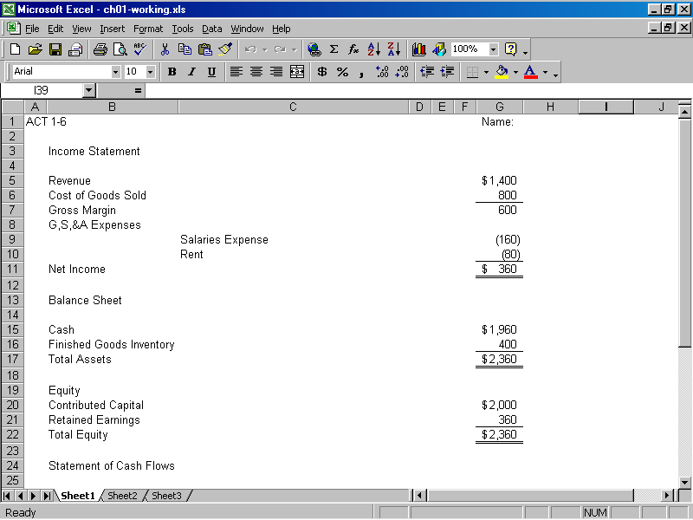

ATC 1-6
Screen capture with cell values (continued):

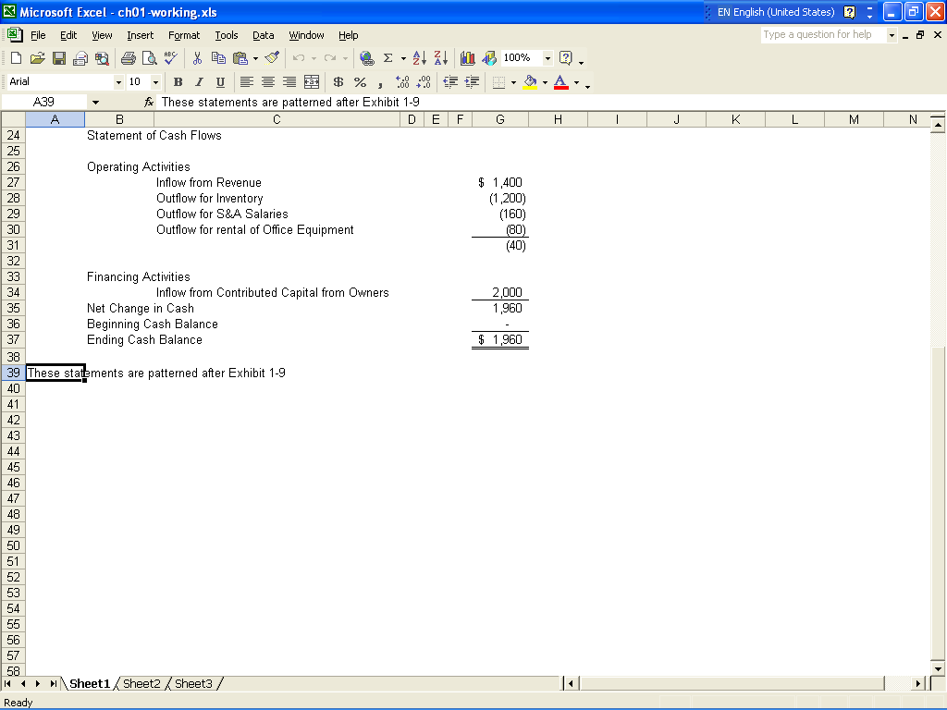

ATC 1-6
Screen capture of cell formulas:

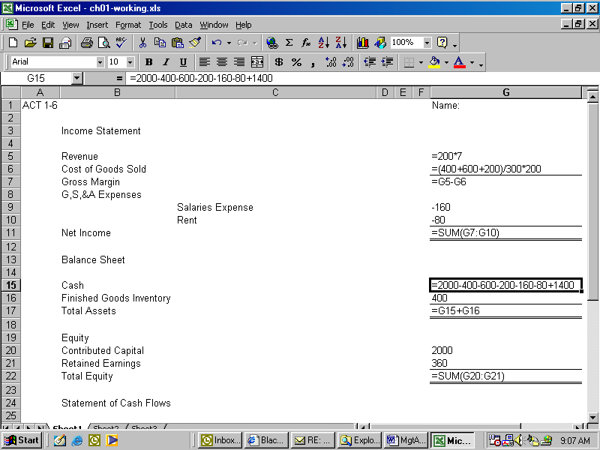

ATC 1-6
Screen capture of cell formulas (continued):

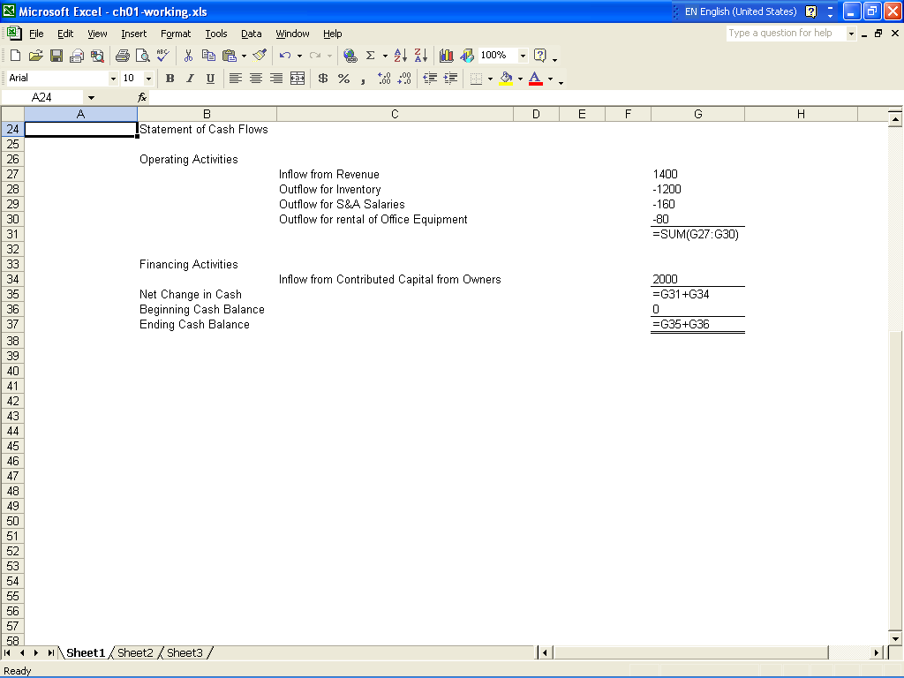
ATC 1-7
Screen capture of cell values:

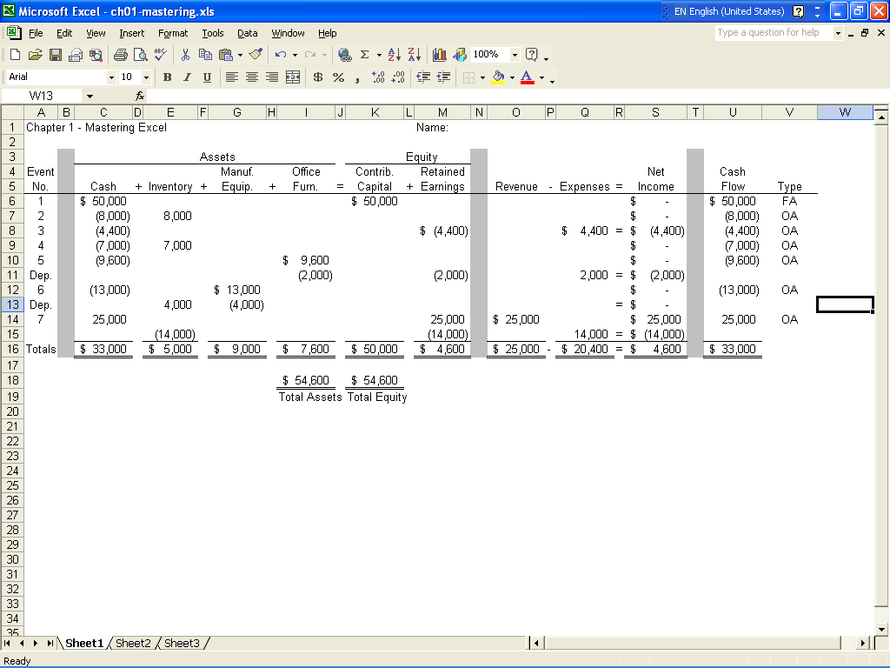

ATC 1-7
Screen capture of cell formulas:

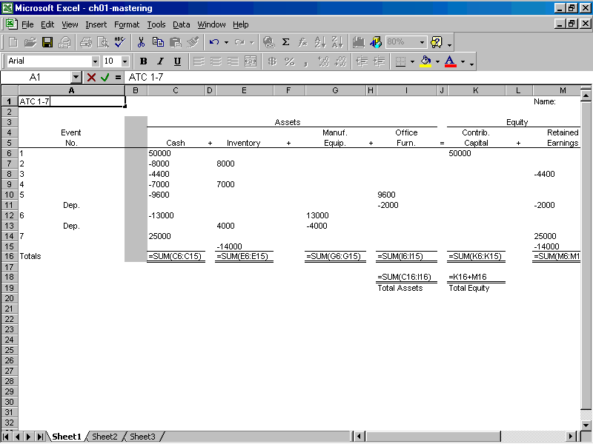

ATC 1-7 Screen capture of cell formulas (continued):

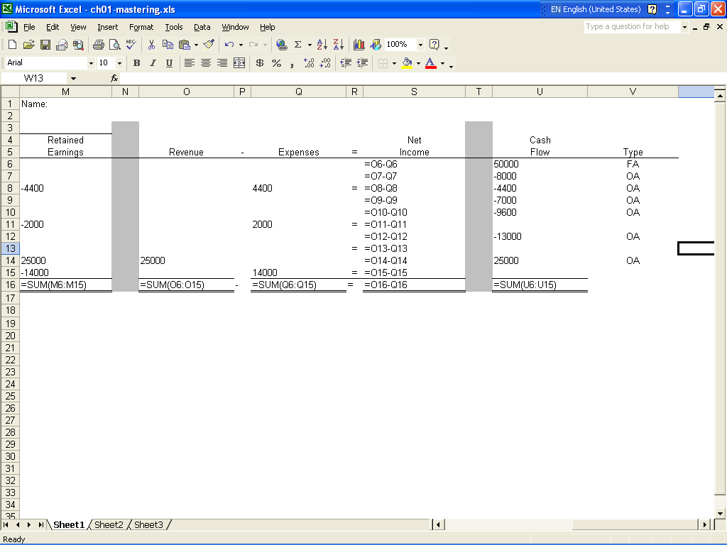
Chapter 1 Comprehensive Problem
Requirement a
 |  |  | Assets |  |  |  |  |  | = | Equity |  |  |  |  |  |  |  | Income Statement |  |  |  | Cash
 |  |  |  |  |  |  |  |  |  |  |  |  |  |  |  | Rev. | - | Exp | = | Net Inc. |  | Flow
Event |  |  |  |  |  | Manuf. |  | Office |  | Common |  | Retained
Number | Cash | + | Inventory | + |  | Equip. | + | Equip. | = | Stock | + | Earnings
1 | 750,000 | + |  | + |  |  | + |  | = | 750,000 | + |  |  |  |  |  | - |  | = |  |  | 750,000 | FA
2a | (270,000) | + |  | + |  | 270,000 | + |  | = |  | + |  |  |  |  |  | - |  | = |  |  | (270,000) | IA
2b |  | + | 60,000 | + |  | (60,000) | + |  | = |  | + |  |  |  |  |  | - |  | =
3 | (200,000) | + | 200,000 | + |  |  | + |  | = |  | + |  |  |  |  |  | - |  | = |  |  | (200,000) | OA
4 | (125,000) | + | 125,000 | + |  |  | + |  | = |  | + |  |  |  |  |  | - |  | = |  |  | (125,000) | OA
5 | (20,000) | + | 20,000 | + |  |  | + |  | = |  | + |  |  |  |  |  | - |  | = |  |  | (20,000) | OA
6 | (50,000) | + | 50,000 | + |  |  | + |  | = |  | + |  |  |  |  |  | - |  | = |  |  | (50,000) | OA
7a | 600,000 | + |  | + |  |  | + |  | = |  | + | 600,000 |  |  |  | 600,000 | - |  | = | 600,000 |  | 600,000 | OA
7b |  | + | (455,000) | + |  |  | + |  | = |  | + | (455,000) |  |  |  |  | - | 455,000 | = | (455,000)
8 | (30,000) | + |  | + |  |  | + |  | = |  | + | (30,000) |  |  |  |  | - | 30,000 | = | (30,000) |  | (30,000) | OA
9a | (39,000) | + |  | + |  |  | + | 39,000 | = |  | + |  |  |  |  |  | - |  | = |  |  | (39,000) | IA
9b |  | + |  | + |  |  | + | (12,000) | = |  | + | (12,000) |  |  |  |  | - | 12,000 | = | (12,000)
10 | (71,950) | + |  | + |  |  | + |  | = |  | + | (71,950) |  |  |  |  | - | 71,950 | = | (71,950) |  | (71,950) | OA
Total | 544,050 | + | 0 | + |  | 210,000 | + | 27,000 | = | 750,000 | + | 31,050 |  |  |  | 600,000 | - | 568,950 | = | 31,050 |  | 544,050
Requirement b
 | Income Statement |  |  |  |  |  |  |  |  | Balance Sheet
 | Sales |  |  |  | 600,000 |  |  |  |  | Assets:
 | Cost of Goods Sold |  |  |  | (455,000) |  |  |  |  | Cash |  |  |  |  |  |  |  |  |  | 544,050
 | Gross Margin |  |  |  | 145,000 |  |  |  |  | Manufacturing Equipment, Net of Acc. Depreciation |  |  |  |  |  |  |  |  |  | 27,000
 | Sales Commission |  |  |  | (30,000) |  |  |  |  | Office Equipment, Net of Acc. Depreciation |  |  |  |  |  |  |  |  |  | 210,000
 | Depreciation Expense |  |  |  | (12,000) |  |  |  |  | Total Assets |  |  |  |  |  |  |  |  |  | 781,050
 | Administrative Expense |  |  |  | (71,950)
 | Net Income |  |  |  | 31,050
 |  |  |  |  |  |  |  |  |  | Equity:
 |  |  |  |  |  |  |  |  |  | Common Stock |  |  |  |  |  |  |  |  |  | 750,000
 |  |  |  |  |  |  |  |  |  | Retained earnings |  |  |  |  |  |  |  |  |  | 31,050
 |  |  |  |  |  |  |  |  |  | Total Equity |  |  |  |  |  |  |  |  |  | 781,050

