Answer to Questions

1. A fixed cost is a cost that in total remains constant as volume of activity changes but on a per unit basis varies inversely with changes in volume of activity. A variable cost is a cost that in total changes directly proportionately with changes in volume of activity but on a per unit basis is constant as volume of activity changes. An example of a fixed cost is a supervisor’s salary in relation to units produced. An example of a variable cost is direct materials cost in relation to units produced.

2. Most business decisions are based on cost information. The behavior of cost in relation to volume affects total costs and cost per unit. For example, knowing that fixed cost stays constant in relation to volume and that variable cost increases proportionately with changes in volume affects a company’s cost structure decisions. Knowing that volume is expected to increase would favor a fixed cost structure because of the potential benefits of operating leverage.

3. Operating leverage is the condition whereby a small percentage increase in sales volume can produce a significantly higher percentage increase in profitability. It is the result of fixed cost behavior and measures the extent to which fixed costs are being used. The higher the proportion of fixed cost to total cost the greater the operating leverage. As sales increase, fixed cost does not increase proportionately but stays the same, allowing greater profits with the increased volume.

4. Operating leverage is calculated by dividing the contribution margin by net income. The result is the number of times greater the percentage increase in profit is to a percentage increase in sales. For example, if operating leverage is four, a 20% increase in sales will result in an 80% increase in profit.

5. The concept of operating leverage is limited in predicting profitability because in practice, changes in sales volume are usually related to changes in sales price, variable costs, and fixed costs, which all affect profitability.

6. With increasing volume a company would benefit more from a fixed cost structure because of operating leverage, where each sales dollar represents pure profit once fixed costs are covered. If volume is decreasing, the variable cost structure would be more advantageous because costs would decrease proportionately with decreases in volume. With a pure fixed cost structure, costs stay constant even when sales revenue is decreasing, eventually resulting in a loss.

7. Economies of scale are possible when the size of an operation is increased. Increases in size correspond to increases in volume, which reduces the unit cost of production because of fixed cost behavior. Economies of scale are found in businesses that are capital intensive (businesses that have a higher percentage of their assets in long-term operational assets that result in large amounts of fixed depreciation cost), e.g., steel and automotive industries.

8. Fixed costs can provide financial rewards with increases in volume, since increases in volume reduce fixed costs per unit, thereby increasing profits. The risk involved with fixed costs is that decreases in volume are not accompanied by decreases in costs, eventually resulting in losses.

9. Fixed costs can provide financial rewards with increases in volume, since increases in volume do not cause corresponding increases in fixed costs. This kind of cost behavior results in increasing profits (decreases in cost per unit). But this does not mean that companies with a fixed cost structure will be more profitable. Predominately fixed cost structures entail risks. Decreases in volume are not accompanied by decreases in costs, which can eventually result in losses (increases in cost per unit).

10. The definitions of both fixed and variable costs are based on volume being within the relevant range (normal range of activity). If volume is outside the relevant range, fixed cost may increase in total if volume increases require that additional fixed assets be acquired (whereby, depreciation charges would increase). Likewise, variable costs may decrease per unit if increases in volume allow quantity discounts on materials. Increases or decreases in volume that are outside the relevant range can invalidate the definitions of fixed and variable costs.

11. The average is more relevant for pricing purposes. Customers want standardized pricing in order to know the price of a service in advance. They don’t want to wait until after the service is performed to know how much it costs. Average cost is also more relevant for performance evaluation and for control purposes. Knowing the actual cost of each service is usually of little value in evaluating cost efficiency and knowing when to take corrective action.

12. The high-low method is the appropriate method when simplicity is more important than accuracy. Least squares regression is the more appropriate when accuracy is more important.

13. A fixed cost structure would have more risk because profits vary more with changes in volume. Small changes in volume can cause dramatic changes in profits. In addition, with a fixed cost structure losses occur until fixed costs are covered. Given high fixed costs, a company would need high volume to reap the rewards associated with this cost structure.

14. The president appears to be in error because fixed costs frequently can be changed. For example, fixed costs such as advertising expense, training, and product improvement result from short-term decisions and may be easily changed. While it is more difficult, even fixed costs such as depreciation expense can be reduced and changed by selling long-term assets.

15. The statement is false for two reasons. More importantly, the statement ignores the concept of relevant range. The terms fixed cost and variable cost apply over some level of activity within which the company normally operates. Accordingly, the definitions of fixed and variable costs only apply within the relevant range. Secondly, even if a business ceases operations and produces zero products, it incurs some fixed costs such as property taxes, maintenance, and insurance.

16. Norel could use the average heating cost by dividing total annual expected heating cost by total annual production. The result could then be multiplied by monthly production to determine the amount of monthly heating cost to assign to inventory. This procedure would have the effect of averaging the seasonal fluctuations and would, therefore, result in a more stable unit cost figure.

17. Verna is confused because the terms apply to total cost rather than to per unit cost. Total fixed cost remains constant regardless of the level of production. Total variable cost increases or decreases as production increases or decreases. Verna is correct in her description of unit cost behavior. She is incorrect about the use of the terms, for the reasons above.

Exercise 2-1B

Requirement | Fixed | Variable | Mixed
a. |  |  | x
b. |  | x
c. |  | x
d. | x
e. | x
f. | x

Exercise 2-2B

Requirement | Fixed | Variable | Mixed
a. |  | x
b. | x
c. |  |  | x
d. |  | x
e. | x
f. |  |  | x
g. |  | x
h. |  | x
i. | x
j. | x

Exercise 2-3B

Total Fixed Cost:
Item | Cost
Insurance cost | $ 75,000
Patent amortization cost | 1,000,000
Depreciation cost | 500,000
Property tax cost | 60,000
Total fixed cost | $1,635,000

Units Produced (a) | 10,000 | 20,000 | 50,000
Total fixed cost (b) | $1,635,000 | $1,635,000 | $1,635,000
Fixed cost per unit (b ÷ a) | $163.50 | $81.75 | $32.70

Exercise 2-4B

Units Produced (a) | 4,000 | 6,000 | 8,000
Variable cost per unit (b) | $6.00 | $6.00 | $6.00
Total variable cost (a x b) | $24,000 | $36,000 | $48,000

Exercise 2-5B

a.
 | January | February
Units Produced (a) | 500 | 1,000
Total Depreciation cost (b) | $4,000 | $4,000
Depreciation cost per unit (b ÷ a) | $8 | $4
Total factory supplies cost (c) | $2,000 | $4,000
Factory supplies cost per unit (c ÷ a) | $4 | $4

b.
Since the total depreciation cost remains unchanged when the number of units produced changes, it is a fixed cost. Since the total factory supplies cost changes in direct proportion to changes in the number of units, it is a variable cost.

Exercise 2-6B

a.
Number of Chairs | 5,000 | 6,000 | 7,000 | 8,000
Total costs incurred
Fixed | $ 84,000 | $ 84,000 | $ 84,000 | $ 84,000
Variable | 60,000 | 72,000 | 84,000 | 96,000
Total costs | $144,000 | $156,000 | $168,000 | $180,000
Per unit chair cost
Fixed | $16.80 | $14.00 | $12.00 | $10.50
Variable | 12.00 | 12.00 | 12.00 | 12.00
Total cost per chair | $28.80 | $26.00 | $24.00 | $22.50

b. The total cost per chair decreases as the number of chairs produced increases because the same amount of fixed cost is spread over an increasingly larger number of chairs.
Exercise 2-7B

a.

Number of Customers (a) | 5 | 10 | 15 | 20 | 25
Total rental cost (b) | $50 | $50 | $50 | $50 | $50
Cost per customer (b) ÷ (a) | $10.00 | $5.00 | $3.33 | $2.50 | $2.00

b. Since the cost of renting the booth is $50 regardless of the number of customers, it is a fixed cost.

c.

Total cost

$50

0
5
10
15
20
25

Number of customers

Exercise 2-7B (continued)
Cost per customer

$10.00

$8.00

$6.00

$4.00

$2.00

0
5
10
15
20
25

Number of customers

d. Lou Jordan’s major business risk is whether he can generate enough revenue telling fortunes to pay for renting the booth and also earn a desired profit. The booth rental cost is fixed while revenue will vary with the price Lou decides to charge and the number of customers he attracts. Lou must set a price low enough to attract as many customers as possible that is also high enough to maximize total revenue.

Other business risks include competition, economic downturns, theft of cash receipts, and potential litigation. Lou will also likely need to advertise his booth to inform prospective customers about the opportunity to have fortunes told in the evening.

Since Lou's primary business risk results from the expected relationship between revenue and cost he could try to minimize that risk by changing that relationship. Perhaps he could negotiate a flexible cost scheme, offering to pay Jack some percentage of revenue instead of a fixed booth rental amount. Such an arrangement would virtually eliminate Lou's risk of suffering a loss. It would not, however, ensure Lou his desired profit. Minimizing risk does not generally totally eliminate risk.
Exercise 2-8B
a.
Number of Customers (a) | 5 | 10 | 15 | 20 | 25
Total soft drink cost $0.50 x (a) | $2.50 | $5.00 | $7.50 | $10.00 | $12.50

b. Since the total soft drink cost increases proportionately as the number of customers increases, it is variable.

c.

Total soft drink cost
.

$12.50
.

$10.00

$7.50
.

$5.00
.

$2.50

0
5
10
15
20
25

Number of customers

Soft drink cost per customer

$

$0.50

0
5
10
15
20
25
Number of customers

Exercise 2-8B (continued)

d. Lou’s major business risk is whether his business can generate a desired profit. The soft drink cost and the revenue are both variable. As long as the price he charges each customer is greater than the soft drink cost, Lou will make a profit. However, the number of customers he will serve is uncertain. Lou should set a competitive price for soft drinks. He may need to advertise to attract customers. His ultimate goal is to generate the maximum profit.

Lou’s other business risks include competition and unfavorable economic conditions.

Exercise 2-9B

a. | Total Monthly Rental Cost

b. | Rental Cost per Computer

$
$
$3,000
$3,000

Number of Computers
Number of Computers

Exercise 2-10B

a. | Total Product Cost

$

Number of Computers Sold

b. | Product Cost per Computer

$

$500

Number of Computers Sold

Exercise 2-11B

The fixed portion of the mixed cost is therefore $50 for any level of activity within the relevant range of production. This cost is the daily base wage and it will be the same each day.

Day | Monday | Tuesday | Wednesday | Thursday
Number of hats | 100 | 120 | 160 | 80
Total variable cost | $10 | $12 | $16 | $ 8
Total fixed cost | 50 | 50 | 50 | 50
Total wages cost | $60 | $62 | $66 | $58

Exercise 2-12B
a. & b.
Income Statements
 |  | a. |  | b.
Company |  | Oak |  | Riggs
Number of customers (n) |  | 160 |  | 160
Sales Revenue (n x $75) |  | $12,000 |  | $ 12,000
Variable Cost (n x $80) |  |  |  | 12,800
Variable Cost (n x $0) |  | 0
Contribution Margin |  | 12,000 |  | (800)
Fixed Cost |  | (6,400) |  | 0
Net Income (Loss) |  | $ 5,600 |  | $ (800)

c. The price-cutting strategy increases each company’s revenue by $2,000 ($12,000 – $10,000) because selling to 160 customers at $75 each ($12,000) produces more revenue than selling to 80 customers at $125 each ($10,000). Since Oak’s costs are fixed, the entire $2,000 increase in sales revenue increases net income. In contrast, Riggs’s costs vary with the number of customers it serves. Increasing the number of customers by 80 increases Riggs’s costs by $6,400 (80 units x $80). The price-cutting strategy increases Riggs’s revenue by $2,000 and increases its costs by $6,400, resulting in a net decline in profitability of $4,400 ($2,000 of additional revenue less $6,400 in additional costs). Riggs’s projected results change from $3,600 of net income to $800 of net loss.
Exercise 2-13B

Income Statement
a.
Sales Revenue (8,000 units x $100) |  | $800,000
Less: Variable Costs
Cost of Goods Sold (8,000 units x$60) |  | (480,000)
Sales Commissions (10% of Sales Revenue) |  | (80,000)
Shipping and Handling Expense (8,000 units x $1) |  | (8,000)
Contribution Margin |  | 232,000
Less: Fixed Costs
Administrative Salaries Expense |  | (60,000)
Advertising Expense |  | (75,000)
Depreciation Expense |  | (68,000)
Net Income |  | $ 29,000

b. |  |  | Contribution margin
 | Operating leverage | = | —––——————––—
 |  |  | Net income

 |  |  | $232,000
 | Operating leverage | = | ——————— | = | 8 times
 |  |  | $29,000

c. A 10 percent increase in sales revenue will produce an 80 percent increase in net income (10 percent x 8 = 80 percent). Peak’s net income would increase to $52,200 [$29,000 + ($29,000 x .8)].

Exercise 2-14B

a. |  |  | Contribution margin
 | Operating leverage | = | —–––———————
 |  |  | Net income

 |  |  | $24,000
 | Operating leverage | = | ——————— | = | 3 times
 |  |  | $8,000

b. (10% Change in revenue x 3 Operating leverage) =
30% Change in net income

30% x $8,000 = $2,400 Change
Revised net income = $8,000 + $2,400 = $10,400

c.
Annual Income Statements
Sales volume in units (a) |  | 600 | % Change | 660
Sales Revenue (a x $90) |  | $54,000 | ⇒+10%⇒ | $59,400
Variable Costs (a x $50) |  | (30,000) |  | (33,000)
Contribution Margin |  | 24,000 |  | 26,400
Fixed Cost |  | (16,000) |  | (16,000)
Net Income |  | $ 8,000 | ⇒+30%⇒ | $ 10,400

($10,400 – $8,000) ÷ $8,000 = 30%

Exercise 2-15B

Cooper should charge the same amount per ticket throughout the year regardless of the number of patrons expected in a given month. Using a cost plus pricing strategy, Cooper would set the ticket price as follows: Price = Average Fixed Cost Per Patron + Variable Cost Per Patron + Desired Profit Per Patron. The fixed cost must be averaged over the annual total number of patrons. The computations are shown below:

Computation of average fixed cost per patron:

 |  | $5,000 x 12
Fixed cost per patron | = | ————————— | = | $1.50
 |  | 40,000 patrons

Price = Fixed cost per patron + Variable cost per patron + $3
Price = $1.50 + $2 + $3
Price = $6.50

Exercise 2-16B

 |  | Change in total cost |  | $36,000 – $30,000
Variable cost per Gallon | = | —––———————— | = | –––––————————— | = | $0.25
 |  | Change in volume |  | 45,000 – 21,000

The fixed cost can be determined by the following formula. The computations shown below are based on the high point. Computations at the low point would produce the same result.

Fixed cost = Total cost – Variable cost
Fixed cost = $36,000 – (45,000 gallons x $0.25)
Fixed cost = $36,000 – $11,250
Fixed cost = $24,750

Problem 2-17B

Requirement | Fixed | Variable
a. |  | x
b. | x
c. | x
d. |  | x
e. | x
f. | x
g. |  | x
h. |  | x
i. | x
j. | x
k. | x
l. |  | x
m. | x
n. |  | x
o. | x
p. |  | x
q. | x
r. |  | x
s. |  | x
t. | x

Problem 2-18B

a. | No. of Lawn Services (a) | 20 | 25 | 30
 | Total expected monthly depreciation cost (b) | $750 | $750 | $750
 | Average per unit depreciation cost (b ÷ a) | $37.50 | $30 | $25

Depreciation per month = $27,000 x 1/3 x 1/12 = $750

Type of cost: Since the total depreciation cost remains constant at $750 regardless of the number of lawn services, it is a fixed cost.

Problem 2-18B (continued)

b. | No. of Lawn Services (a) | 20 | 25 | 30
 | Average per unit labor cost (b) | $30 | $30 | $30
 | Total labor cost (a x b) | $600 | $750 | $900
Type of cost: Since the total labor cost increases proportionately with the number of lawn services, it is a variable cost.

c. | No. of Lawn Services (a) | 20 | 25 | 30
 | Average per unit supplies cost (b) | $6 | $6 | $6
 | Total cost of materials (a x b) | $120 | $150 | $180
Type of cost: Since the total cost of materials increases proportionately with the number of lawn services, materials cost is a variable cost.

d. | No. of Lawn Services (a) | 20 | 25 | 30
 | Total expected depreciation cost | $ 750 | $ 750 | $ 750
 | Total labor cost | 600 | 750 | 900
 | Total cost of materials | 120 | 150 | 180
 | Total cost | $1,470 | $1,650 | $1,830

e. The amount of total cost shown below was determined in part d.

No. of Lawn Services (a) | 20 | 25 | 30
Total cost (b) | $1,470.00 | $1,650.00 | $1,830
Cost per unit (b ÷ a) | $73.50 | $66.00 | $61

The decline in the cost per lawn service is caused by the fixed cost behavior that is applicable to the equipment depreciation.

f. Mr. Ditto means average cost per unit. It would be virtually impossible to determine actual cost per unit. Consider these questions. Exactly how much pesticide was used in one lawn versus another? Did the service person work on one lawn a few minutes longer than another? Obviously, it would not be practical to determine the exact cost of servicing any specific lawn. The average cost is much easier to determine and more practical for pricing purposes.

Problem 2-19B

a. If a branch fails to process at least 1,500 tax returns, the branch is closed. Branches that process more than 2,500 tax returns are transferred out of the Development Department. Accordingly, the relevant range is 1,500 to 2,500 tax returns.

b. | No. of Tax Returns (a) | 1,500 | 2,000 | 2,500
 | Total payroll cost (b) | $80,000 | $80,000 | $80,000
 | Average per unit payroll cost (b ÷ a) | $53.33 | $40.00 | $32.00
Type of Cost: Since the total payroll cost remains constant at $80,000 regardless of the number of tax returns filed, it is a fixed cost.

c. | No. of Branches (a) | 20 | 30 | 40
 | Payroll Cost Per Branch (b) | $ 80,000 | $ 80,000 | $ 80,000
 | Total Payroll Cost (a x b) | $1,600,000 | $2,400,000 | $3,200,000
Type of Cost: Since the total payroll cost increases proportionately with the number of branches in operation, the cost is a variable cost.

Problem 2-20B

a.
Sales Volume in Units (a) | 100 | 200 | 300 | 400 | 500
Total cost of cameras (a x $150) | $15,000 | $30,000 | $45,000 | $60,000 | $75,000
Total cost of store rental | 5,000 | 5,000 | 5,000 | 5,000 | 5,000
Total cost of sales (b) | $20,000 | $35,000 | $50,000 | $65,000 | $80,000
Average cost per unit (b ÷ a) | $200 | $175 | $166.67 | $162.50 | $160

b.
Sales Volume in Units | 100 | 200 | 300 | 400 | 500
Average cost per unit (a) | $200 | $175 | $166.67 | $162.50 | $160
Price per package (a + $20) | $220 | $195 | $186.67 | $182.50 | $180

Problem 2-20B (continued)

c.
Shopping Malls (a) | 1 | 2 | 3 | 4 | 5
Total cost of store rental  (a x $5,000) | $5,000 | $10,000 | $15,000 | $20,000 | $25,000

Type of cost: Since the total rental cost increases proportionately with the number of stores in operation, the cost is a variable cost.

d. The additional cost is $150 ÷100 units = $1.50 per unit.
The cost would be treated as a variable cost for decision making purposes. While it is not purely proportional, its behavior pattern closely approximates a variable cost pattern.

Problem 2-21B

Part 1

a. Since the total cost remains constant at $7,500 regardless of how many CMA candidates attend the course, the cost of instruction is a fixed cost.

b. c. and d.
Number of Candidates | 45 | % Change | 50 | % Change | 55
Revenue ($400 per candidate) | $18,000 | ⇐(10%)⇐ | $20,000 | ⇒+10%⇒ | $22,000
Cost of instruction (Fixed) | 7,500 |  | 7,500 |  | 7,500
Gross profit | $10,500 | ⇐(16%)⇐ | $12,500 | ⇒+16%⇒ | $14,500
Percentage change in revenue: ±$2,000 ÷ $20,000 = ±10%
Percentage change in profit: ±$2,000 ÷ $12,500 = ±16%

e. Operating leverage caused the percentage change in profitability to be higher than the percentage change in revenue. Since the fixed costs have been covered and no variable costs exist, each additional dollar of revenue contributes directly to additional profitability and vice versa.

Problem 2-21B (continued)
Part 2

f. Since the total cost changes proportionately with changes in the number of candidates, the cost of instruction is a variable cost.

g. h. and i.
Number of Candidates | 45 | % Change | 50 | % Change | 55
Revenue ($400 per candidate) | $18,000 | ⇐(10%)⇐ | $20,000 | ⇒+10%⇒ | $22,000
Cost of instruction (Variable) | 6,750 |  | 7,500 |  | 8,250
Gross profit | $11,250 | ⇐(10%)⇐ | $12,500 | ⇒+10%⇒ | $13,750
Percentage Change in Revenue: ±$2,000 ÷ $20,000 = ±10%
Percentage Change in Profit: ±$1,250 ÷ $12,500 = ±10%

j. Since costs as well as revenue change in direct proportion to changes in the number of CMA candidates attending the course, the change in profit is proportional to the change in revenue.

Part 3

k.
Number of Candidates Attempting to Attend | 45 | 50 | 55
Number of candidates accepted (a) | 45 | 50 | 50
Total cost of workbooks [b= (50 x $40)] | $2,000 | $2,000 | $2,000
Cost per candidate (b ÷ a) | 44.44 | 40 | 40

l. Since the workbooks must be produced in advance, the total cost is incurred before any workbook is sold. Subsequently, the number of workbooks sold does not affect the total cost. This is, therefore, a fixed cost.

m. CMA R Us faces the risk of producing too many or too few workbooks. When too many are produced, the company will incur expenses due to waste. When too few are produced, the company will miss the opportunity to earn additional profits. Also, CMA R Us faces risk associated with the incursion of costs such as storage, maintenance, and interest.

Problem 2-21B (continued)

n. A just-in-time inventory system would produce goods as needed to meet sales demand. Accordingly, there would be no risk of over or under production. Further, there would be no stockpiling of inventory; therefore inventory holding costs such as storage, maintenance, and interest would be avoided.

Problem 2-22B

a. | Club |  | Green |  | Wood
 | Tuition revenue | (30 x $300) | $9,000 |  | $9,000
 | Total cost of instruction | (Fixed) | (6,000) | (30 x $200) | (6,000)
 | Net income |  | $3,000 |  | $3,000

b. | Club | Green
 | Tuition revenue (60 x $180) | $10,800
 | Total cost of instruction (fixed) | 6,000
 | Net income | $ 4,800

c. | Club |  | Wood
 | Tuition revenue | (60 x $180) | $10,800
 | Total cost of instruction (variable) | (60 x $200) | (12,000)
 | Net loss |  | $ (1,200)

d. The strategy in Part b produced a profit because Green’s cost of coaching was fixed. Accordingly, the increase in the number of students did not increase the total cost of coaching. In contrast, the cost of coaching for Wood was variable. As a result, when the number of students increased, the total cost of coaching increased as well. Since the increase in revenue was not sufficient to cover the increase in the cost of coaching, the strategy in Part c produced a loss.
Problem 2-22B (continued)
e. | Club |  | Green |  | Wood
 | Tuition revenue | (18 x $300) | $5,400 |  | $5,400
 | Total cost of instruction | (Fixed) | (6,000) | (18 x $200) | (3,600)
 | Net income (loss) |  | $ (600) |  | $1,800

f. When volume is insufficient to produce revenue that is above the level of fixed cost, the enterprise will produce a loss. This condition is demonstrated in Part e above. The loss could be avoided if the cost of instruction were variable. Accordingly, fixed costs are not always better than variable costs.

g. When the revenue per unit is below the variable cost per unit, the enterprise will incur additional losses for each unit produced and sold. This condition is depicted in Part c above. As demonstrated in Part b lower per unit revenue can be offset by increases in sales volume when costs are fixed. Accordingly, variable costs are not always better than fixed costs.

Problem 2-23B
a.
Company Name |  | Hardy |  | Lavoy
Contribution margin |  | $200,000 |  | $500,000
Divided by NI |  | ÷ 100,000 |  | ÷ 100,000
Operating leverage |  | 2 |  | 5
b.
Company Name |  | Hardy |  | Lavoy
Variable Cost Per Unit (a) |  | $24 |  | $12
Sales Revenue (25,000 units x $32 x 110%) |  | $880,000 |  | $880,000
Variable Cost (25,000 units x a x 110%) |  | (660,000) |  | (330,000)
Contribution Margin |  | $220,000 |  | $550,000
Fixed Cost |  | (100,000) |  | (400,000)
Net Income |  | $120,000 |  | $150,000
Percentage Change * |  | 20% |  | 50%
*Hardy:$120,000 − $100,000= $20,000; $20,000 ÷ $100,000=20%
Lavoy: $150,000 − $100,000= $50,000; $50,000÷$100,000=50%

Problem 2-23B (continued)
c.
Company Name |  | Hardy |  | Lavoy
Variable Cost Per Unit (a) |  | $24 |  | $12
Sales Revenue (25,000 units x $32 x 90%) |  | $720,000 |  | $720,000
Variable Cost (25,000 units x a x 90%) |  | (540,000) |  | (270,000)
Contribution Margin |  | $180,000 |  | $450,000
Fixed Cost |  | (100,000) |  | (400,000)
Net Income |  | $80,000 |  | $50,000
Percentage Change ** |  | (20%) |  | (50%)

** Hardy: $80,000 − $100,000 = ($20,000); ($20,000)÷ $100,000 = (20%)
Lavoy: $50,000 − $100,000 = ($50,000); ($50,000)÷ $100,000 = (50%)

d. The following memo is just an example. Students can form different opinions from their analyses. However, the main focus of the analyses should be the risk and reward relationship as demonstrated by the data of the two investments.

Memorandum

TO: Ms. Michelle Welch
FROM: John Doe
SUBJECT: Analysis and Recommendation Regarding Investments
DATE: September 29, 2007

I have evaluated the income statements of Hardy and Lavoy. Even though both companies had the same amounts of sales and net income last year, the risk and reward structures of the two companies are quite different. From my analysis, Hardy’s operating leverage is 2 while Lavoy’s is 5. The analytical data suggests that Lavoy’s future income may be much more volatile than Hardy’s.

If the economy prospers in the long run, Lavoy will be the better choice for investment. Otherwise, Hardy will be better. If we can’t forecast future economic conditions with a reasonable degree of confidence, a conservative investor should choose Hardy whereas an aggressive investor should invest in Lavoy.

Problem 2-24B

a. | Day | M | Tu | W | Th | F | Sat | Sun
 | Total cost (a) | $2,700 | $2,700 | $2,700 | $2,700 | $2,700 | $2,700 | $2,700
 | No. people (b) | 600 | 500 | 450 | 700 | 960 | 1,450 | 1,340
 | Per unit (a ÷ b) | $4.50 | $5.40 | $6.00 | $3.86 | $2.81 | $1.86 | $2.01

b. | Day | M | Tu | W | Th | F | Sat | Sun
 | Per unit cost | $4.50 | $5.40 | $6.00 | $3.86 | $2.81 | $1.86 | $2.01
 | Mark-up | 1.80 | 1.80 | 1.80 | 1.80 | 1.80 | 1.80 | 1.80
 | Ticket price | $6.30 | $7.20 | $7.80 | $5.66 | $4.61 | $3.66 | $3.81

c. A more rational pricing policy would base the computation of average cost on weekly totals. Total contract cost is $18,900 (i.e., $2,700 x 7 days). Total expected attendance for the week is 6,000. Average cost per ticket sold is $3.15 (i.e., $18,900 ÷ 6,000 tickets). Given a desired profit of $1.80 per ticket, the price would be set at $4.95 (i.e., $3.15 + $1.80).

d. As indicated in Part b, prices based on daily attendance would vary from a low of $3.66 per ticket to a high of $7.80 per ticket. This pricing structure is unrealistic. It suggests that higher prices should be charged when demand is low. If implemented, the pricing policy would likely drive the small number of Wednesday customers away. Very few people would be interested in $7.80 circus tickets if the same tickets were available for much less the day before or after.
Problem 2-25B

Using information from a single recent tour can distort the predictive value of the data because certain variables may not represent normal averages. For example, the most recent tour served 32 tourists. The average number of tourists that normally makes a trip could be larger or smaller than the number that made the most recent trip. While recent data is more relevant, it can be distorted if the time frame is too short to provide representative results. Similarly, data that is too old may not be representative. For example, the cost of equipment, salaries, and food is likely different today as compared to ten years ago. Accordingly, the data drawn from the one-year average is likely to provide the best indication of future conditions. Additional factors to be considered for pricing strategies include market demand, competition, and general economy.

Memorandum

TO: Nick Boles, President
FROM: John Doe, Accountant
SUBJECT: Analysis and Recommendation Regarding the Use of Per Unit Cost for Pricing Decisions
DATE: October 1, 2007

I have evaluated the Company's data about cost per tour over three different time periods: recent, one year, and ten years. It is my recommendation that the cost per tour data over the one-year period be used for pricing decisions.

The recent tour data includes only 32 tourists, a small number that may not represent normal operations. The ten-year tour data extends too far to past periods that may not reflect the current costs of operations. The one-year tour data represents an appropriate base for our cost estimation for the coming year.

I suggest that you consider other factors such as future market demand, competition, and general economy to adjust the cost estimate and devise a successful pricing strategy.

Problem 2-26B

a.

b.

÷
Fixed cost = $9,680 − $24 x 195 = $5,000 or,

= $6,200 − $24 x 50 = $5,000

c. Contribution margin per hour = $80 − $24 = $56

Problem 2-26B (continued)
d.
Operating costs
.

.
$9,000
.
.
.
.
8,000
.

7,000
.

6,000

5,000

4,000

100
150
200
0
50

Service hours

e. The results of the two methods are very similar. In b, the high-low method relies on the relationship between the highest point and the lowest point to define the variable cost and the fixed cost. In d, the scattergraph method relies on human observation to fit a straight line among the six given points. As it turns out, the variable cost per unit (the slope of the straight line) determined in the scattergraph method is less than that determined in the high-low method. The fixed cost determined in the scattergraph is $5,400, which is greater than $5,000 as determined in the high-low method.

Problem 2-27B

a.
Month | # of Frames  Produced | Total Costs  $
December | 800 | $33,000
April | 1,200 | 37,200
January | 1,600 | 42,000
July | 2,200 | 51,200
June | 2,600 | 54,000
May | 3,200 | 58,000
August | 3,600 | 62,000
March | 3,920 | 59,000
September | 4,560 | 64,000
October | 5,880 | 63,000
November | 6,560 | 64,000
February | 7,200 | 65,000

Total cost
$
.
.
.
.
.
.
.
.
.
.
.
.
$24,000
$36,000
$48,000
0
1,600
3,200
4,800
6,400
8,000
# of Frames Produced
$60,000

Problem 2-27B (continued)

b. The total cost of producing 4,000 units should be about $56,000.

c.

Fixed cost = $65,000 – $5.00 x 7,200 = $29,000
 | Total Cost |  | # of Frames  Produced
High | $65,000 |  | 7,200
Low | 33,000 |  | 800
 | $32,000 | ÷ | 6,400 | = | $5.00 per frame (variable cost)

Total cost
$
$24,000
$36,000
$48,000
$60,000
0
1,600
3,200
4,800
6,400
8,000
.
.
.
.
.
.
.
.
.
.
.
.
# of Frames Produced

Problem 2-27B (continued)

d. $5.00 x 4,000 + $29,000 = $49,000

e. Neither method is accurate. However, judging from the data distribution as displayed on the sketch, the high-low method greatly distorts the underlying data because the observations for high and low points are both outliers to down side. In other words, the estimates determined by the high-low method would significantly understate the reality. Consequently, the scattergraph method is a better one.

Problem 2-28B

a.

Assume the following :

X = the number of machine hours
Y = the dollar amount supplies cost

The algebraic equation should be as follows :

Y = a + bX

Where a represents the fixed cost and b represents the variable cost per professional hour.

b. The result of regression analysis follows :

Regression Statistics
Multiple R | 0.95883
R Square | 0.91936
Adjusted R Square | 0.91667
Standard Error | 339.596
Observations | 32
ANOVA
 | df | SS | MS | F | Significance F
Regression | 1 | 3.9E+07 | 3.9E+07 | 342.002 | 6E-18
Residual | 30 | 3459755 | 115325
Total | 31 | 4.3E+07
Problem 2-28B (continued)

 | Coefficients | Standard Error | t Stat | P-value | Lower 95% | Upper 95% | Lower 95.0%
Intercept | 1001.66 | 153.295 | 6.53425 | 3.2E-07 | 688.596 | 1314.73 | 688.596
X Variable 1 | 36.8204 | 1.99101 | 18.4933 | 6E-18 | 32.7542 | 40.8865 | 32.7542
RESIDUAL OUTPUT
Observation | Predicted Y | Residuals
1 | 4168.21 | -349.21
2 | 3652.73 | -42.73
3 | 3910.47 | 5.52774
4 | 3284.53 | -369.53
5 | 4352.32 | -25.317
6 | 2548.12 | -334.12
7 | 2364.02 | -258.02
8 | 2216.74 | 173.264
9 | 1848.53 | 258.468
10 | 4536.42 | 331.582
11 | 4462.78 | 558.222
12 | 4352.32 | 458.683
13 | 3652.73 | -72.73
14 | 3210.89 | -410.89
15 | 2769.04 | -500.04
16 | 2953.14 | -205.14
17 | 3358.17 | 497.833
18 | 4241.86 | 37.1446
19 | 5751.49 | -118.49
20 | 6046.05 | -748.05
21 | 6303.8 | 417.205
22 | 2364.02 | 83.9826
23 | 3063.6 | 464.396
24 | 2805.86 | 31.1383
25 | 1443.51 | -84.509
26 | 3100.42 | 195.576
27 | 2989.96 | 482.037
28 | 3394.99 | -130.99
29 | 3836.83 | 88.1684
30 | 4131.39 | -129.39
31 | 4389.14 | 193.863
32 | 4020.93 | -497.93

Problem 2-28B (continued)

Fixed cost = $1,002 (rounded)
Variable cost per machine hour = $37 (rounded)

c.

Estimated total cost for 100 machine hours :

Y = $37 x 100 + $1,002 = $4,702

Total fixed cost = $1,002

Total variable cost = $3,700

ATC 2-1 Business Applications

a. CSX Corporation experienced a 6.0% [i.e., ($8,020 − $7,566) ÷ $7,566] increase in revenue. This increase in revenue produced a 205.1% (i.e., [$418 − $137] ÷ $137) change in operating income. In contrast Starbucks Corporation experienced a 29.9% (i.e., [$5,294 − $4,076] ÷ $4,076) change in revenue that produced a 46.3% (i.e., [$392 − $268] ÷ $268) change in operating income. Given that the change in income relative to the change in revenue is much more dramatic for CSX than for Starbucks, CSX’s operating leverage is higher than Starbucks’.

b. Many rational explanations are possible. However, the student’s answer should in some fashion make note of the fact that CSX must have a higher portion of fixed assets than Starbucks. A logical explanation is that CSX is a rail and marine transportation company with a significant investment in fixed assets such as rail tracks and equipment. For this reason, depreciation (i.e., a fixed cost) is a significant expense. In contrast, Starbucks is a retail restaurant establishment and its most significant expense is cost of goods sold (i.e., a variable cost).

Dramatic changes in earnings versus revenue can also be the result of “special charges” that a company has in one year but not in the next.

c. In the case of declining revenues, CSX can be expected to have the greatest decline in operating income. The effects of operating leverage are present on the downside (i.e., declining revenues) as well as the upside.

ATC 2-2 Group Assignment

a. | Revenue ($28 x 500) | $14,000
 | Cost of Speaker* | 10,000
 | Net Income | $ 4,000
*With an audience of 500, the cost of the speaker is the same whether a fixed fee (i.e., $10,000) is paid or a fee of $20 per ticket sold is paid (i.e., $20 x 500 = $10,000).

b. Group Task 1: Assuming growth of 10% in revenue and speaker’s fee is fixed at $10,000.

 | Revenue | $14,000 | x 1.10 = | $15,400
 | Cost of Speaker | 10,000 |  | 10,000
 | Net Income | $ 4,000 |  | $ 5,400
Growth in net income is 35% [i.e., ($5,400 − $4,000) / $4,000]

Group Task 2: Assuming a decline of 10% in revenue and speaker’s fee is fixed at $10,000.

 | Revenue | $14,000 | x 0.90 = | $12,600
 | Cost of Speaker | 10,000 |  | 10,000
 | Net Income | $ 4,000 |  | $ 2,600
Decline in net income is 35% [i.e., ($2,600 − $4,000) / $4,000]

ATC 2-2 Group Assignment (continued)

Group Task 3 Assuming growth of 10% in revenue and speaker’s fee is variable at $20 per unit (500 x 1.10 x $20 = $11,000):

 | Revenue | $14,000 | x 1.10 = | $15,400
 | Cost of Speaker | 10,000 |  | 11,000
 | Net Income | $ 4,000 |  | $ 4,400
Growth in net income is 10% [i.e. ($4,400 − $4,000) / $4,000]

Group Task 4: Assuming a decline of 10% in revenue, speaker’s fee is variable at $20 per unit (500 x 0.90 x $20 = $9,000):

 | Revenue | $14,000 | x 0.90 = | $12,600
 | Cost of Speaker | 10,000 |  | 9,000
 | Net Income | $ 4,000 |  | $ 3,600
Decline in net income is 10% [i.e. ($3,600 − $4,000) / $4,000]

c. In-class assignment requiring no written solution.

d. 1. A fixed cost structure provides greater growth potential in profitability due to operating leverage.
2. A fixed cost structure faces the greater risk of declining in profitability due to operating leverage.
3. A fixed cost structure should be used if volume of sales is expected to increase.
4. A variable cost structure should be used if volume of sales is expected to decline.

ATC 2-3 Research Assignment

a. Schwab invested an additional $19,000 on marketing. This cost is fixed relative to the number of new customers that Schwab attracts.

b. Many correct answers are possible. Examples include cost of facilities, executive salaries, and furniture.

c. Many correct answers are possible. Examples include cost of supplies and customer correspondence.

d. If new accounts are processed in-house and employees are paid a fixed salary, the account information is processed in an existing company-owned electronic data base with excess capacity, and phone or other communication channels are set up on an unlimited usage basis, the majority of the costs associate with establishing a new account could be fixed.

If Schwab pays a third party company a per-account fee to establish new accounts, the establishment cost would be variable.

ATC 2-4 Writing Assignment

The memo should give recognition to the use of an average cost that is based on annual expectations rather than monthly expectations. The average annual fixed cost per visit is $12.80 per visit [i.e., ($300 rent + $180 other) x 12 ÷ 450 visits=$12.80). Total cost per visit amounts to $22.80 (i.e., $12.80 fixed + $10 variable). A price of $22.80 would spread all costs evenly throughout the year. While Dr. Sterling may lose money in the months of low volume she will earn enough in the months of high volume to break even. As a result, service for the year will be provided at cost.

ATC 2-5 Ethical Dilemma

a. | Accounting Period | 2004 | 2005
 | Amount of scientific seed sold (a) | 2,400,000 Pounds | 1,300,000 Pounds
 | Royalty per pound (b) | $0.50 | $0.50
 | Total royalty paid (a x b) | $1,200,000 | $650,000
 | Total cost savings:
 | 2004 royalty payment | $1,200,000
 | Less: 2005 royalty payment | 650,000
 | Royalty cost savings | 550,000
 | Less: cost of Ad Campaign | 100,000
 | Total savings for World Agra | $ 450,000
World Agra’s sales revenue remained the same in the second year after Mr. Borrough’s new policy. However, World Agra paid $550,000 less royalty to Scientific Associates after spending $100,000 on the ad campaign. These events increased World Agra’s net income by $450,000.

b. World Agra’s customers and society in general suffered from the move to promote the Bio Labs seed. The Scientific Associates seed would have produced greater yields and better flavor.

c. While it could be argued that Mr. Borrough’s actions violated some of the ethical standards such as engaging in activities that would discredit the profession, it is highly unlikely that such argument would prevail if he were charged with an ethics violation. Mr. Borrough acted in the financial interest of his company and his conduct did not blatantly violate any of the standards of ethical conduct. While he may have pushed the envelope, Mr. Borrough’s behavior would most likely be viewed as in compliance with contemporary ethical standards.

d. (This requirement asks for the opinion of the respondent. There is no right or wrong response.)

e. The Sarbanes-Oxley Act requires public companies to set up a code of ethics. Ray’s action may have violated the company’s code of ethics and, in turn, may have infringed the law. However, the unethical behavior is not a criminal offense under the law.
ATC 2-6
Screen capture of cell values:

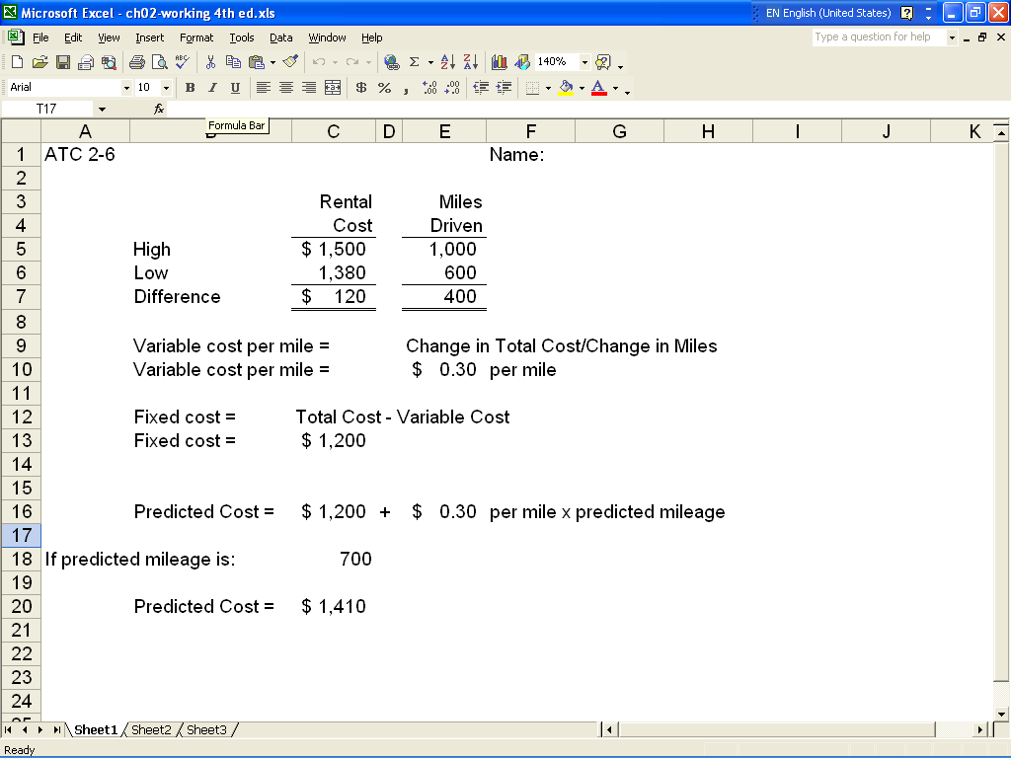

ATC 2-6
Screen capture of cell formulas

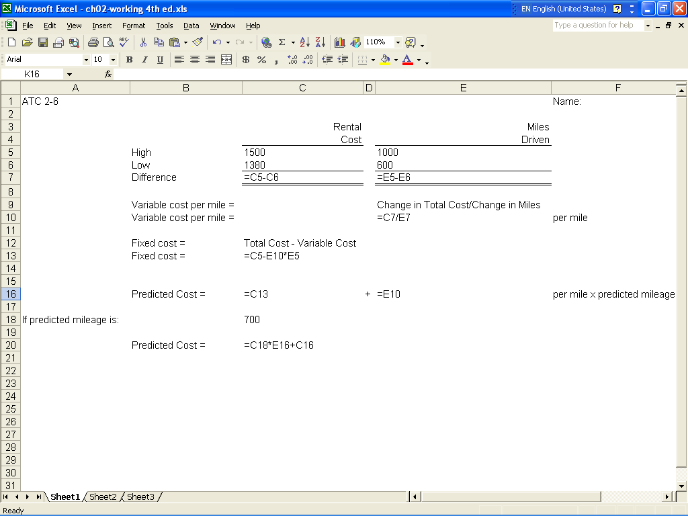

ATC 2-7
Screen capture of cell values:

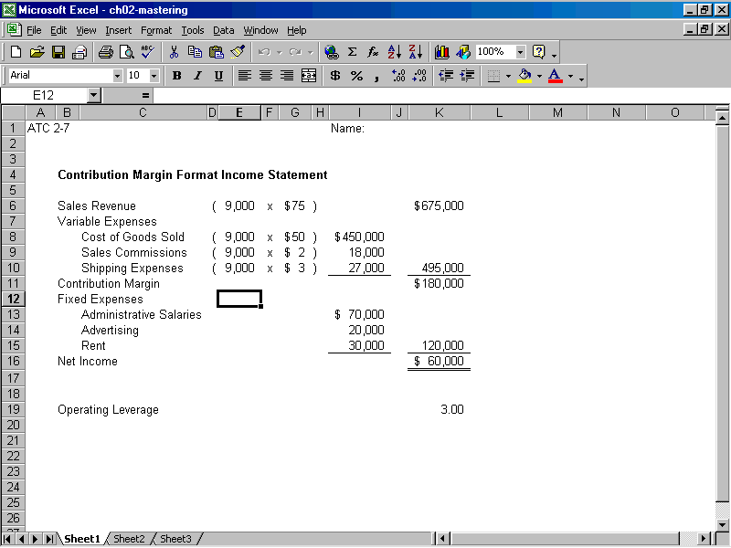

ATC 2-7
Screen capture of cell formulas:
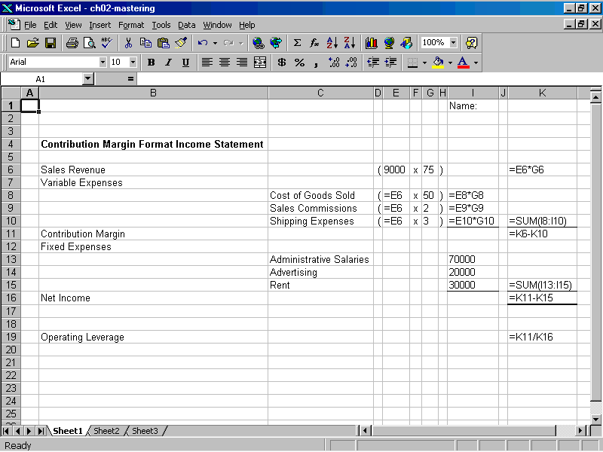

Chapter 2 Comprehensive Problem
Requirement a
Review the accounting events experienced by Magnificant Modems, Inc. during its 2006 accounting period.
Identify each cost incurred by the company as (1) fixed versus variable relative to the number of units produced and sold; and (2) product versus general, selling and administrative (G, S, and A).
The solution for the first item is shown as an example.
 | Cost Item |  |  |  | Fixed | Variable | Product | G,S,& A
 | Depreciation on Manufacturing Equipment |  |  |  | X |  | X
 | Direct Materials |  |  |  |  | X | X
 | Direct labor |  |  |  |  | X | X
 | Production supplies |  |  |  |  | X | X
 | Rent on Manufacturing Facility |  |  |  | X |  | X
 | Sales Commissions |  |  |  |  | X |  | X
 | Depreciation on Administrative Equipment |  |  |  | X |  |  | X
 | Administrative costs (rent and Salaries) |  |  |  | X |  |  | X
Requirement b
Replace the question marks in the following table to indicate the product cost per unit assuming levels of
production of 5,000, 6,000, 7,000 and 8,000. Use the power of Excel to perform the division necessary to
determine the cost per unit amounts shown in the bottom row of the table.
 | Cost of Goods Sold* |  |  | 455,000 | 524,000 | 593,000 | 662,000
 | Divided by Number of units |  |  | 5,000 | 6,000 | 7,000 | 8,000
 | Cost per unit |  |  | 91 | 87 | 85 | 83
*Fixed cost of goods sold = $60,000 (Depreciation on manuf. equip.) + $50,000 (Rent on manuf. facility)
= $110,000

Variable cost / unit = ($455,000 – $110,000) ÷ 5,000 = $69 / unit

Cost of goods sold at 6,000 units = $69 x 6,000 + $110,000 = $524,000
Cost of goods sold at 7,000 units = $69 x 7,000 + $110,000 = $593,000
Cost of goods sold at 8,000 units = $69 x 8,000 + $110,000 = $662,000

