Answers to Questions

1. A cost object is something for which one is trying to determine the cost. Cost objects that accountants would need to know the cost of would include products, activities, services, and departments.

2. Managers need timely cost information. They may have to sacrifice accuracy in order to get the information in time for decision making. For instance, managers need cost information for planning (budgeting) before the activities that cause the costs have occurred. Consequently, they rely on estimates and judgment that are not as precise as actual cost data.

3. For product costing one needs to accumulate the costs necessary to produce the product, which are direct materials, direct labor, and overhead.

4. A direct cost is a cost that is easily traceable to a cost object. A cost-benefit analysis is necessary to determine if a cost is easily traceable to a cost object. If the costs or sacrifices to trace a cost are small in relation to the informational benefits, the cost is easily traceable.

5. A direct cost can be either a fixed or variable cost and an indirect cost can be either a fixed or variable cost. For example, supervisor salaries are usually fixed costs but they are direct or indirect depending on the cost object. If the cost object is the product, supervisor salaries are indirect costs; whereas, if the cost object is the department, supervisor salaries are direct costs.

6. The depreciation on machinery used in only one department is a direct cost to that department but the depreciation is not avoidable if the activities of the department are eliminated.

7. The cost driver chosen to use in allocating a cost should be some activity that drives the cost. In other words, the cost driver should be the activity responsible for changes in the cost. The best cost driver is not only the one that drives the cost to be allocated but the activity that accomplishes the intended goals in allocating the cost. In other words, the cost driver should provide an assignment of costs such that the allocation motivates behavior toward intended objectives.

8. To determine an allocation rate divide the total cost to be allocated by the total cost driver for that cost. To make an allocation to a cost object multiply the allocation rate by the weight (the actual amount) of the cost driver for that object.

9. Direct material and direct labor costs are direct costs of the product. Overhead costs are indirect costs of the product. Overhead is composed of a myriad of costs that have the common property of being indirect costs of the product.

10. It is not possible to trace some costs, such as the utility cost of heating a factory, to individual products. It is not cost effective to trace other manufacturing costs to products. In other words, the costs to trace these costs would outweigh the benefits. In addition, the amounts of some costs are unknown at the time products are made. An example would be manufacturing supplies under the periodic inventory system. Finally some fixed costs do not change with changes in production volume; therefore, these costs cannot be traced to any specific product or level of production.

11. Overhead costs are allocated to the product in order to estimate the total cost of manufacturing the product and to evenly spread overhead costs over the units produced in a period. This smoothing will assign an equal amount of indirect cost to each unit of product. Smoothing is necessary for the following reasons: (1) overhead may not be easily traceable to products, (2) some overhead may be unknown when the products are produced and (3) some overhead costs are not related to the number of units produced.

12. The volume of production may vary from month to month. If an equal amount of overhead is allocated to each month, the per unit cost of the product each month varies depending on production volume. The per unit cost will be lower in months of high volume and higher in months of low volume.

13. The statement is incorrect. Choosing an inappropriate allocation base can result in inaccurate product costs which can cause poor decisions. An allocation base that does not rationally link the costs to be allocated to the cost object will assign costs arbitrarily without reasonable justification for the assignment. The allocation base chosen should be the factor that drives the allocated costs. An appropriate allocation base will result in a more accurate assignment of costs and more reasonable and productive decisions.

14. Both students are correct. Costs should be estimated beforehand to determine the project's merits and to plan expenditures. Projected costs have to be estimated costs and will not be completely accurate but these costs are relevant because of their timeliness. They are known in time to make decisions that can affect the success or failure of the project. Actual costs cannot be timely and relevant for decisions that need to be made before the project begins. Actual costs are useful for evaluating the results of the project and for the planning of future projects.

15. The three methods used for allocating service center costs are as follows:

Direct Method – The simplest method of allocating service center costs. The technique allocates accumulated service center cost pools directly to operating departments using the most appropriate allocation base. The method does not consider that service center departments render services to other service center departments.

Step Method – A two-step allocation method that considers the effect of interdepartmental services but does not consider reciprocal allocations between service departments. In the first-stage allocation process, pooled service center costs are distributed to other service departments and to operating departments in a sequence of step-down allocations. The service center cost pool that represents resources used by the largest number of departments is first allocated to the other service centers and to operating departments. Next, allocations are made from the service center cost pool that represents resources used by the second largest number of departments. This first-stage allocation process continues until all service center costs have been distributed to the operating departments. Finally in a second stage, costs are allocated from the operating departments to the company’s products. The method eliminates many of the distortions that result when interdepartmental services are ignored as in the direct method and provides a more accurate product cost.

Reciprocal Method – This allocation method gives recognition to reciprocal relationships between service centers. It requires complex mathematical computations involving the use of simultaneous linear equations. Because the results of the allocation process do not differ significantly from the step method and are difficult to interpret, the method is not widely used.

Exercise 4-1B

Step 1. Determine the allocation rate:

 |  | Monthly rent |  | $7,500
Allocation rate | = | –––––––––––––––––––– | = | –––––––––– | = | $1.50
 |  | Total office space |  | 5,000* |  | per square foot
 |  | (Cost driver)

*Total Office Space = 2,500 + 1,500 +1,000 = 5,000

Step 2. Assign the rent cost by multiplying the allocation rate by the weight of the base (cost driver) for each division:

Division | Allocation Rate | x | Weight of Base | = | Allocated Cost
Auditing | $1.50 | x | 2,500 ft² | = | $3,750
Tax | $1.50 | x | 1,500 ft² | = | 2,250
IS | $1.50 | x | 1,000 ft² | = | 1,500
Total allocated cost |  |  |  |  | $7,500

Exercise 4-2B

a.
Items | Direct  Cost | Indirect  Cost
Salary of the partner in charge of the audit department |  | x
Salary of the managing partner of the firm |  | x
Cost of office supplies such as paper, pencils, erasers, etc. |  | x
Depreciation of computers used in the tax department |  | x
License fees of the firm |  | x
Professional labor for a tax engagement | x
Secretarial labor supporting both departments |  | x
Professional labor for an audit engagement | x
Depreciation of computers used in the audit department |  | x
Salary of the partner in charge of the tax department |  | x
Travel expenditures of an audit engagement | x

Exercise 4-2B (continued)

b.
Items | Direct  Cost | Indirect  Cost
Salary of the partner in charge of the audit department | x
Salary of the managing partner of the firm |  | x
Cost of office supplies such as paper, pencils, erasers, etc. |  | x
Depreciation of computers used in the tax department | x
License fees of the firm |  | x
Professional labor for a tax engagement | x
Secretarial labor supporting both departments |  | x
Professional labor for an audit engagement | x
Depreciation of computers used in the audit department | x
Salary of the partner in charge of the tax department | x
Travel expenditures of an audit engagement | x

c.
Items | Direct  Cost | Indirect  Cost
Salary of the partner in charge of the audit department | x
Salary of the managing partner of the firm | x
Cost of office supplies such as paper, pencils, erasers, etc. | x
Depreciation of computers used in the tax department | x
License fees of the firm | x
Professional labor for a tax engagement | x
Secretarial labor supporting both departments | x
Professional labor for an audit engagement | x
Depreciation of computers used in the audit department | x
Salary of the partner in charge of the tax department | x
Travel expenditures of an audit engagement | x

Exercise 4-3B

a. Step 1. Determine the allocation rate:

Allocation rate |  | Overhead cost |  | $900,000
for | = | –––––––––––––––––– | = | ––––––––––– | = | $75 per DL hour
overhead cost |  | Direct labor hours |  | 12,000

Step 2. Assign the cost by multiplying the allocation rate by the weight of the base (cost driver):

Product | Allocation Rate | x | Weight of Base | = | Allocated Cost
Large | $75/DLH | x | 2,500 | = | $187,500
Medium | $75/DLH | x | 5,000 | = | 375,000
Small | $75/DLH | x | 4,500 | = | 337,500
Total |  |  |  |  | $900,000

b. Step 1. Determine the allocation rate:

Allocation rate |  | Overhead cost |  | $900,000
for | = | ––––––––––––––– | = | –––––––––– | = | $300 per machine hour
overhead cost |  | Machine hours |  | 3,000

Step 2. Assign the cost by multiplying the allocation rate by the weight of the base (cost driver):

Product | Allocation Rate | x | Weight of Base | = | Allocated Cost
Large | $300/MH | x | 700 | = | $210,000
Medium | $300/MH | x | 1,300 | = | 390,000
Small | $300/MH | x | 1,000 | = | 300,000
Total |  |  |  |  | $900,000

Exercise 4-3B (continued)

c. If the manufacturing process is labor-intensive, the amount of labor used for a cost object would be a good indication of a corresponding use of indirect costs for the same object. Even if the manufacturing process is not labor-intensive, labor hours can still be a good indicator of the use of indirect costs as long as a consistent relationship between the use of direct labor and that of indirect costs can be demonstrated.

d. If the manufacturing process is machine-intensive, the amount of machine hours used for a cost object would be a good indication of a corresponding use of indirect costs for the same object. Even if the manufacturing process is not machine-intensive, machine hours can still be a good indicator of the use of indirect costs as long as a consistent relationship between the use of direct machine hours and that of indirect costs can be demonstrated.

Exercise 4-4B

a. Step 1. Determine the allocation rate:

Allocation rate |  | Overhead cost |  | $420,000
for | = | –––––––––––––––– | = | –––––––––––– | = | $100 per hour
overhead cost |  | Labor hours |  | 4,200

Step 2. Assign the cost by multiplying the allocation rate by the weight of the base (cost driver):

Product | Allocation Rate | x | Weight of Base | = | Allocated Cost
Zip100 | $100/DLH | x | 2,000 | = | $ 200,000
Zip250 | $100/DLH | x | 1,300 | = | 130,000
Zip40 | $100/DLH | x | 900 | = | 90,000
Total |  |  |  |  | $420,000

b. It was probable that Doddy’s manufacturing process is labor intensive and the level of labor activity reflects the pattern of overhead cost better than that of machine hours.

Exercise 4-5B

The amount of direct materials used is a rational cost driver for the wages (indirect labor) paid to workers who move materials and products to different stations in the factory. The more direct materials used, the more indirect labor cost Duong likely incurs. Similarly, there is a plausible cause-and-effect relationship between employee pension cost and direct labor cost. The more labor cost Duong incurs, the more pension cost it incurs. In other words, labor is driving the pension cost. These relationships suggest bases that will yield reasonable allocations. Computations are shown below:

Step 1. Determine the allocation rates:

Allocation rate |  | Indirect labor cost |  | $36,000
for | = | –––––––––––––––– | = | ––––––––––– | = | $0.048
Indirect labor |  | Direct mater. cost |  | $750,000 |  | per material $

Allocation rate |  | Pension cost |  | $27,500
for | = | –––––––––––––––––– | = | –––––––––– | = | $0.055 per labor $
Pension cost |  | Direct labor cost |  | $500,000

Step 2. Assign the costs by multiplying the allocation rates by the weights of the bases (cost drivers) for each indirect cost:

Indirect labor cost

Product | Allocation Rate | x | Weight of Base | = | Allocated Cost
Snack | $0.048 | x | $140,000 | = | $ 6,720
Sandwich | $0.048 | x | $235,000 | = | 11,280
Storage | $0.048 | x | $375,000 | = | 18,000
Total |  |  |  |  | $36,000

Exercise 4-5B (continued)

Pension Cost
Product | Allocation Rate | x | Weight of Base | = | Allocated Cost
Snack | $0.055 | x | $ 75,000 | = | $ 4,125
Sandwich | $0.055 | x | $145,000 | = | 7,975
Storage | $0.055 | x | $280,000 | = | 15,400
Total |  |  |  |  | $27,500

Step 3. Add the direct and indirect cost components to determine the total cost of each product line:

Expected Costs |  | Snack |  | Sandwich |  | Storage |  | Total
Direct materials |  | $140,000 |  | $235,000 |  | $375,000 |  | $ 750,000
Direct labor |  | 75,000 |  | 145,000 |  | 280,000 |  | 500,000
Indirect labor |  | 6,720 |  | 11,280 |  | 18,000 |  | 36,000
Pension cost |  | 4,125 |  | 7,975 |  | 15,400 |  | 27,500
Total cost |  | $225,845 |  | $399,255 |  | $688,400 |  | $1,313,500

Exercise 4-6B

There is a plausible relationship between the amount of time the factory operates and production levels. The more the factory operates, the more products it produces. In order to assign indirect costs (such as depreciation) usefully over the total number of products made, more depreciation cost should be assigned to the months when the factory operates more. This objective can be met by allocating total annual depreciation costs based on factory hours.

Step 1. Determine the allocation rate:

 |  | Annual depreciation |  | $18,000
Allocation rate | = | –––––––––––––––––– | = | ––––––––––– | = | $7.50
 |  | Annual factory hours |  | 2,400 |  | per factory hour
 |  | (Cost driver)

Step 2. Assign the depreciation cost by multiplying the allocation rate by the weight of the base (cost driver) for each month:

Month | Allocation Rate | x | Weight of Base | = | Allocated Cost
Nov. | $7.50/hour | x | 200 hours | = | $1,500
Dec. | $7.50/hour | x | 150 hours | = | $1,125

Exercise 4-7B

A problem exists because Litton makes the patent royalty payment only once each year, in January. If Litton assigns all of the cost to January production, the cost of batteries made in January would be high relative to the cost of batteries made in other months. Allocating the royalty cost based on machine hours will assign meaningful portions of the cost to the products manufactured in each month.

Step 1. Determine the allocation rate:

 |  | Annual patent cost |  | $576,000
Allocation rate | = | –––––––––––––––––––– | = | ––––––––––– | = | $12 per hour
 |  | Total machine hours |  | 48,000
 |  | (Cost driver)

Step 2. Assign the cost by multiplying the allocation rate by the weight of the base (cost driver) for each month:

Month | Allocation Rate | x | Weight of Base | = | Allocated Cost
June | $12/hour | x | 3,000 hours | = | $36,000
July | $12/hour | x | 3,600 hours | = | $43,200

Exercise 4-8B

a. Mr. Lloyd could allocate the automobile depreciation cost using an allocation rate based on the total mileage he expected to drive the vehicle during its life. He could determine a weekly charge by multiplying the allocation rate by the weight of the base. The computations for such an allocation are shown below:

Step 1. Determine the allocation rate:

 |  | Automobile cost |  | $27,000*
Allocation rate | = | ––––––––––––––––––– | = | –––––––––– | = | $0.18 per mile
 |  | Total mileage |  | 150,000
*$29,000 – $2,000 = $27,000

Step 2. Assign the cost by multiplying the allocation rate by the weight of the base (cost driver) for each week:

Period | Allocation Rate | x | Weight of Base | = | Allocated Cost
This week | $0.18/mile | x | 3,200 miles | = | $576
Last week | $0.18/mile | x | 2,800 miles | = | $504

b. An important question is why Mr. Lloyd would allocate the vehicle cost to particular weeks. Miles driven affects wear and tear on the vehicle and when Mr. Lloyd will have to replace it. Since Mr. Lloyd can control the number of miles he drives, the cost per mile would be more relevant than the cost per week. Understanding the reasons for allocation is as important as learning allocation methods.

Exercise 4-9B

a. | Quarter |  | 1st |  | 2nd |  | 3rd |  | 4th |  | Total
 | No. of units |  | 3,300 |  | 2,700 |  | 4,500 |  | 2,000 |  | 12,500

Allocation rate |  | Overhead cost |  | $135,000
for | = | ––––––––––––––– | = | ––––––––––– | = | $10.80 per unit
overhead |  | Number of units |  | 12,500

b. Assign the cost by multiplying the allocation rate by the weight of the base (cost driver) for each quarter:

Quarter | Allocation Rate | x | Weight of Base | = | Allocated Cost
1st | $10.80 | x | 3,300 | = | $ 35,640
2nd | $10.80 | x | 2,700 | = | 29,160
3rd | $10.80 | x | 4,500 | = | 48,600
4th | $10.80 | x | 2,000 | = | 21,600
Total |  |  |  |  | $135,000

c. Computation of total cost per unit:

Quarter |  | 1st |  | 2nd |  | 3rd |  | 4th
Number of units (a) |  | 3,300 |  | 2,700 |  | 4,500 |  | 2,000
Cost
Overhead (b) |  | $ 35,640 |  | 29,160 |  | $ 48,600 |  | $ 21,600
Direct costs (c=a x $20) |  | 66,000 |  | 54,000 |  | 90,000 |  | 40,000
Total cost (d) |  | $101,640 |  | $83,160 |  | $138,600 |  | $61,600
Cost per unit (d÷a) |  | $30.80 |  | $30.80 |  | $30.80 |  | $30.80

Exercise 4-10B

Cost  a. | ÷ | Base | Computation | Allocation Rate
Total overhead | ÷ | No. units | $528,000÷6,400 = | $82.50 per unit

 | Allocation  Rate | x | Weight  of Base | = | January
Number of units (a) |  |  |  |  | 500
Overhead costs | $82.50 | x | 500 | = | $ 41,250
Direct materials (a x $74) |  |  |  |  | 37,000
Direct labor (a x $84) |  |  |  |  | 42,000
Total (b) |  |  |  |  | $120,250

b. The cost computed in part a is an estimated amount. Abbott could improve accuracy by waiting until December to determine product cost. However, managers need to know the cost of products on a timely basis for various reasons, such as performance evaluation and pricing. If Abbott waits until December to tell a manager that he or she needs to improve, it is too late.

Exercise 4-11B

First, allocate the insurance cost. The allocation rate is:
Cost | ÷ | Base | Computation | Allocation Rate
Insurance cost | ÷ | No. Kits | $42,000÷30,000= | $1.40 per Kit

 | Allocation  Rate | x | Weight  of Base | = | January |  | February
Number of kits (a) |  |  |  |  | 1,800 |  | 2,200
Insurance cost | $1.40 | x | 1,800 | = | $2,520
Insurance cost | $1.40 | x | 2,200 | = |  |  | $ 3,080
Direct materials |  |  |  |  | 7,200 |  | 8,800
Direct labor |  |  |  |  | 9,000 |  | 11,000
Total (b) |  |  |  |  | $18,720 |  | $22,880
Cost per kit [c=(b÷a)] |  |  |  |  | $10.40 |  | $10.40
Price (c x 1.25) |  |  |  |  | $13.00 |  | $13.00

Exercise 4-12B

a. Step 1. Determine the allocation rate.

Allocation rate |  | Joint product cost |  | $10,000
Allocation rate | = | –––––––––––––––––– | = | –––––––––– | = | $0.10 per pound
Allocation rate |  | Total weight |  | 100,000

Step 2. Assign the cost by multiplying the allocation rate by the weight of the base for each product.

Product | Allocation Rate | x | Weight of Base | = | Allocated Cost
Cooking oil | $0.10 | x | 20,000 pounds | = | $ 2,000
Cattle feed | $0.10 | x | 80,000 pounds | = | 8,000
Total allocated cost |  |  |  |  | $10,000

b. The total market value of the two products:

Product | Sales Price | x | Weight | = | Market Value
Cooking oil | $1.00/pound | x | 20,000 pounds | = | $ 20,000
Cattle feed | $0.75/pound | x | 80,000 pounds | = | 60,000
Total market value |  |  |  |  | $80,000

Step 1. Determine the allocation rate.

Allocation rate |  | Joint product cost |  | $10,000
Allocation rate | = | ––––––––––––––––––– | = | –––––––––– | = | $0.125 per sales $
Allocation rate |  | Total market value |  | $80,000

Step 2. Assign the joint cost by multiplying the allocation rate by the weight of the base for each product.

Product | Allocation Rate | x | Weight of Base | = | Allocated Cost
Cooking Oil | $0.125 | x | $ 20,000 | = | $ 2,500
Cattle feed | $0.125 | x | 60,000 | = | 7,500
Total allocated cost |  |  |  |  | $10,000

Exercise 4-13B

a. Four allocation bases that could be used to allocate the overhead cost to each boat include No. of units, direct material dollars, direct labor dollars, or total direct material and labor dollars of each boat.

b. The production manager of Boat 2 would most likely recommend the direct labor as the allocation base because Boat 2’s direct labor cost represents only 36% of total direct labor ($20,000 / $56,000) while its cost of direct materials represents 46% ($32,000 / $69,000) of total direct materials. In other words, by choosing direct labor as the allocation base, the production manager would share a smaller portion of the overall overhead cost. The production manager of Boat 2 would likely argue that workers, rather than materials, make boats. Consequently, labor reflects the pattern of overhead cost.

c. Without further information of the manufacturing process as given in this problem, the president should probably use direct materials as the allocation base because the amount of total materials is greater than that of direct labor for a fairer allocation of overhead cost.

d. Classifying overhead costs into separate pools based on the characteristics of the underlying manufacturing procedures would allow management to analyze each individual pool according to the common characteristics, which can be used as the cost driver. The approach would reduce the level of human manipulation over the allocation of overhead cost.

Exercise 4-14B

Step 1. Determine the allocation rate:

Allocation rate |  | Administrative costs |  | $450,000
Allocation rate | = | ––––––––––––––––––––––– | = | –––––––––– | = | $7.50 per hour
Allocation rate |  | No. of chargeable hours |  | 60,000*
 |  | (Allocation base)

*24,000 + 36,000 = 60,000

Step 2. Assign the cost by multiplying the allocation rate by the weight of the base for each operating department:

Department | Allocation Rate | x | Weight of Base | = | Allocated Cost
Information services | $7.50 | x | 24,000 | = | $180,000
Financial planning | $7.50 | x | 36,000 | = | 270,000
Total allocated cost |  |  |  |  | $450,000

Exercise 4-15B

a. Step 1. Determine the allocation rate:

Allocation rate |  | Maintenance cost |  | $450,000
Allocation rate | = | ––––––––––––––––––– | = | –––––––––– | = | $30 per square foot
Allocation rate |  | Total square footage |  | 15,000*
 |  | (Allocation base)

*8,000 + 2,000 + 4,000 +1,000 =15,000

Step 2. Assign the cost by multiplying the allocation rate by the weight of the base for the other departments:

Department | Allocation Rate | x | Weight  of Base | = | Allocated Cost
Tax | $30 | x | 8,000 | = | $ 240,000
Estate planning | $30 | x | 2,000 | = | 60,000
Small business | $30 | x | 4,000 | = | 120,000
Internal accounting | $30 | x | 1,000 | = | 30,000
Total allocated cost |  |  |  |  | $450,000

Exercise 4-15B (continued)

b. Step 1. Determine the allocation rate:

Allocation rate |  | Internal accounting cost |  | $720,000*
Allocation rate | = | ––––––––––––––––––––––– | = | –––––––––––– | = | $0.04 per $
Allocation rate |  | Total Operating revenues |  | $18,000,000
 |  | (Allocation base)

*$690,000 + $30,000 = $720,000

Step 2. Assign the cost by multiplying the allocation rate by the weight of the base for each operating department:

Department | Allocation Rate | x | Weight  of Base | = | Allocated Cost
Tax | $0.04 | x | $8,500,000 | = | $340,000
Estate planning | $0.04 | x | 3,500,000 | = | 140,000
Small business | $0.04 | x | 6,000,000 | = | 240,000
Total allocated cost |  |  |  |  | $720,000

c.
Department | Maintenance Cost | + | Internal  Accounting Cost | = | Allocated Cost
Tax | $240,000 | + | $340,000 | = | $ 580,000
Estate Planning | 60,000 | + | 140,000 | = | 200,000
Small Business | 120,000 | + | 240,000 | = | 360,000
Total allocated cost |  |  |  |  | $1,140,000

Exercise 4-16B

 | No. of Pages | No. of Hours
Children | 15,000 | 5,000
Youth | 10,000 | 8,000
Adult | 5,000 | 7,000
Total | 30,000 | 20,000

Exercise 4-16B (continued)

a. Step 1. Determine the allocation rates.

The allocation rate for the editing cost:

Allocation rate |  | Editing cost |  | $240,000
Allocation rate | = | –––––––––––––––– | = | –––––––––– | = | $8 per page
Allocation rate |  | Total No. of pages |  | 30,000
 |  | (Allocation Base)

The allocation rate for the typesetting cost:

Allocation rate |  | Typesetting cost |  | $420,000
Allocation rate | = | –––––––––––––––– | = | –––––––––– | = | $14 per page
Allocation rate |  | Total No. of pages |  | 30,000
 |  | (Allocation Base)

Step 2. Assign the cost by multiplying the allocation rate by the weight of the base for each operating department.

Allocation of editing cost:

Department | Allocation Rate |  | x | Weight of Base | = | Allocated Cost
Children | $8 |  | x | 15,000 | = | $ 120,000
Youth | $8 |  | x | 10,000 | = | 80,000
Adult | $8 |  | x | 5,000 | = | 40,000
Total allocated cost |  |  |  |  |  | $240,000

Allocation of typesetting cost:

Department | Allocation Rate |  | x | Weight of Base | = | Allocated Cost
Children | $14 |  | x | 15,000 | = | $ 210,000
Youth | $14 |  | x | 10,000 | = | 140,000
Adult | $14 |  | x | 5,000 | = | 70,000
Total allocated cost |  |  |  |  |  | $420,000

Exercise 4-16B (continued)

b. Step 1. Determine the allocation rates.

The allocation rate for the editing cost:

Allocation rate |  | Editing cost |  | $240,000
Allocation rate | = | –––––––––––––– | = | –––––––––– | = | $12 per page
Allocation rate |  | No. of hours |  | 20,000
 |  | (Allocation base)

The allocation rate for the typesetting cost:

Allocation rate |  | Typesetting cost |  | $420,000
Allocation rate | = | –––––––––––––––– | = | ––––––––– | = | $21 per page
Allocation rate |  | No. of hours |  | 20,000
 |  | (Allocation base)

Step 2. Assign the cost by multiplying the allocation rate by the weight of the base for each operating department.

Allocation of editing cost:

Department | Allocation Rate | x | Weight of Base | = | Allocated Cost
Children | $12 | x | 5,000 | = | $ 60,000
Youth | $12 | x | 8,000 | = | 96,000
Adult | $12 | x | 7,000 | = | 84,000
Total allocated cost |  |  |  |  | $240,000

Allocation of typesetting cost:

Department | Allocation Rate | x | Weight of Base | = | Allocated Cost
Children | $21 | x | 5,000 | = | $105,000
Youth | $21 | x | 8,000 | = | 168,000
Adult | $21 | x | 7,000 | = | 147,000
Total allocated cost |  |  |  |  | $420,000

Problem 4-17B
a.

Cost Assignment Categories | Home Tools | Prof.  Tools | Indirect
Salary of V. P. of production |  |  | $180,000
Salary of manager, home tools | $ 54,000
Salary of manager, professional tools |  | $ 43,500
Direct materials cost, home tools | 300,000
Direct materials cost, professional tools |  | 375,000
Direct labor cost, home tools | 336,000
Direct labor cost, professional tools |  | 414,000
Direct utilities cost, home tools | 75,000
Direct utilities cost, professional tools |  | 30,000
General factorywide utilities |  |  | 31,500
Production supplies |  |  | 40,500
Fringe benefits |  |  | 112,500
Depreciation |  |  | 360,000
Total costs | $765,000 | $862,500 | $724,500

Problem 4-17B (continued)

b. The following bases were used to allocate the various indirect costs. Logical arguments for other bases may be possible. You may want to discuss alternatives with your instructor. The bases and computations used herein are as follows:

Cost | Base | Computation | Allocation Rate
Salary of VP | No. Depts. | $180,000÷2= | $90,000 per dept.
General utilities | Direct utility $ | $31,500÷$105,000= | $0.30 per D. utility $
Prod. supplies | Direct mater. $ | $40,500÷$675,000= | $0.06 per mater. $
Fringe benefits | Direct labor $ | $112,500÷$750,000= | $0.15 per labor $
Depreciation | Machine hours | $360,000÷6,000hrs= | $60 per machine hr.

Indirect  Costs | Allocation  Rate | x | Weight  of Base | = | Allocated  To Dept. of Home Tools |  | Allocated To Dept. of Prof. Tools
Salary of VP | $90,000 | x | 1 dept. | = | $ 90,000
Salary of VP | $90,000 | x | 1 dept. | = |  |  | $ 90,000
General utilities | $.30 | x | $75,000 | = | 22,500
General utilities | $.30 | x | $30,000 | = |  |  | 9,000
Prod. supplies | $.06 | x | $300,000 | = | 18,000
Prod. supplies | $.06 | x | $375,000 | = |  |  | 22,500
Fringe benefits | $.15 | x | $336,000 | = | 50,400
Fringe benefits | $.15 | x | $414,000 | = |  |  | 62,100
Depreciation | $60 | x | 4,000 hrs. | = | 240,000
Depreciation | $60 | x | 2,000 hrs. | = |  |  | 120,000
Total indirect cost |  |  |  |  | $420,900 |  | $303,600

Department  c. |  | Home Tools |  | Professional Tools
Total direct cost |  | $ 765,000 |  | $ 862,500
Total Indirect cost |  | 420,900 |  | 303,600
Total Production costs (a) |  | $1,185,900 |  | $1,166,100
Number of units (b) |  | 30,000 |  | 20,000
Cost per unit (c = a÷b) |  | $39.53 |  | $58.31*
Price (c x 1.3) |  | $51.39* |  | $75.80*
*The figure has been rounded.

Problem 4-18B

a. The objective is to determine the cost of operating each department. Accordingly, the cost objects are the Departments of Biology, Chemistry, and Physics.

b. The costs, cost drivers, and allocation rates used to assign the costs to the departments are shown below:

Cost | Base | Computation | Allocation Rate
Telephone exp. | No. telephones | $11,200÷40= | $280 per phone
Supplies exp. | No. of researchers | $2,400÷30= | $80 per researcher
Office rent | Square footage | $1,120,000÷28,000 | $40 per sq. foot
Janitorial | Square footage | $140,000÷28,000 | $5 per sq. foot
Director’s salary | No. of departments | $150,000÷3 | $50,000 per dept.

There are other logical cost drivers. For example, students may have chosen to allocate supplies cost on the basis of the number of secretaries. It is also logical to use a combination of cost drivers. For example, combine the number of researchers and the number of secretaries to develop an allocation base for supplies cost.

c. | Dept. | Cost to be  Allocated | Allocation  Rate | x | Weight  of Base | = | Amount  Allocated
 | Biology | Telephone exp. | $280 | x | 10 | = | $ 2,800
 | Chemistry | Telephone exp. | $280 | x | 14 | = | 3,920
 | Physics | Telephone exp. | $280 | x | 16 | = | 4,480
 | Total |  |  |  |  |  | $11,200

d. | Dept. | Cost to be  Allocated | Allocation  Rate | x | Weight  of Base | = | Amount  Allocated
 | Physics | Supplies expense | $80 | x | 12 | = | $960

e. | Dept. | Cost to be  Allocated | Allocation  Rate | x | Weight  of Base | = | Amount  Allocated
 | Chemistry | Office rent | $40 | x | 8,000 | = | $320,000

Problem 4-18B (continued)

f. | Dept. | Cost to be  Allocated | Allocation  Rate | x | Weight  of Base | = | Amount  Allocated
 | Biology | Janitorial cost | $5 | x | 8,000 | = | $40,000

g. The director’s salary could be allocated on the basis of the number of research projects, or dollar amount of research grants.

Problem 4-19B

a. The costs incurred for the part-time attorneys and private investigator were direct costs. Secretaries’ salary was an indirect cost.

b. The allocation rate for secretaries’ salary is determined as follows:

Cost | Base | Computation | Allocation Rate
Secretaries’ salary | No. hours | $48,000÷3,200= | $15 per hour

Costs | Allocation  Rate | x | Weight  of Base | = | Landon’s  Case |  | Mosley’s Case
Secretaries’ salary | $15 | x | 30 | = | $ 450
Secretaries’ salary | $15 | x | 40 | = |  |  | $ 600
Landon’s salary |  |  |  |  | 3,600
Mosley’s salary |  |  |  |  |  |  | 1,000
Investigation fee |  |  |  |  | 1,000
Investigation fee |  |  |  |  |  |  | 750
Total cost |  |  |  |  | $5,050 |  | $2,350

c. Other costs that may need to be allocated include managing partner’s salary, office rent, telephone expense, and utility expense.

Problem 4-20B

a. Changes in the number of doors made will not affect the total factory rental cost so long as the number remains within the relevant range. Indeed, the number of doors does not actually drive the cost of rent, but does constitute a rational allocation base that promotes smoothing. Smoothing or averaging the total cost over the total number of units can facilitate management’s ability to make certain decisions such as pricing the product.

b. There is an inverse relationship between the number of doors made and the rental cost per door. Since the total rental cost is fixed, the cost per unit will increase as the number of doors made decreases. Similarly, the cost per unit will decrease as the number of doors made increases.

c. The factory rent is an indirect cost. Since it is not related to the number of doors made, it cannot be traced to any particular unit.

d. First determine the allocation rate.
The annual rental cost is $720,000 (i.e., $60,000 x 12)

Cost | Base | Computation | Allocation Rate
Factory rent | No. of doors | $720,000 ÷ 24,000 | $30 per door

Month | Allocation  Rate | x | Weight  of Base | = | Amount  Allocated
March | $30 | x | 2,000 | = | $60,000
April | $30 | x | 3,000 | = | 90,000

Problem 4-21B

Computation of Allocation rates for total overhead cost
The total cost to be allocated is $888,000 (i.e., $600,000 + $288,000)

Cost |  | Base | Computation | Allocation Rate
Overhead | ÷ | Machine hours | $888,000÷60,000 | $14.80 per mach. hr.
Overhead | ÷ | Labor hours | $888,000÷24,000 | $37.00 per labor hr.

a. Since the Parts Department uses fewer labor hours, that base will minimize the amount of overhead cost allocated to the department.

Department | Allocation  Rate | x | Weight  of Base | = | Allocated  Cost
Parts | $37.00 | x | 3,500 | = | $129,500
Assembly | $37.00 | x | 20,500 | = | 758,500
Total |  |  |  |  | $888,000

b. Since the Assembly Department uses fewer machine hours, that base will minimize the amount of overhead costs allocated to the department.

Department | Allocation  Rate | x | Weight  of Base | = | Allocated  Cost
Parts | $14.80 | x | 52,000 | = | $769,600
Assembly | $14.80 | x | 8,000 | = | 118,400
Total |  |  |  |  | $888,000

c. Since fringe benefit costs are driven by labor hours and utility costs are driven by machine hours, it would be fair to allocate the individual costs using separate allocation bases. Allocation rates using separate bases are shown below:
Problem 4-21B (continued)

Cost |  | Base | Computation | Allocation Rate
Utility | ÷ | Machine hours | $288,000÷60,000 | $4.80 per mach. hr.
Fringe benefits | ÷ | Labor hours | $600,000÷24,000 | $25.00 per labor hr.

Allocations for the Respective departments

Costs | Allocation  Rate | x | Weight  of Base | = | Parts |  | Assembly
Utility | $4.80 | x | 52,000 | = | $249,600
Utility | $4.80 | x | 8,000 | = |  |  | $ 38,400
Fringe benefits | $25.00 | x | 3,500 | = | 87,500
Fringe benefits | $25.00 | x | 20,500 |  |  |  | 512,500
Total |  |  |  |  | $337,100 |  | $550,900

Problem 4-22B

a. The items used to compute the predetermined overhead rate are:

Total expected overhead costs = ($24,000 x 12) + $54,000 = $342,000
Total expected labor hours = [(5,000 x 9) + (9,000 x 3)] = 72,000 hours

The rate is computed as follows:

Total expected overhead costs
–––––––––––––––––––––––––––––––– | = | Predetermined overhead rate
Total expected labor hours

 | $342,000
Predetermined overhead rate = | –––––––––––– | = | $4.75 per labor hour
 | 72,000

Problem 4-22B (continued)

b. c. & d.
 |  | March |  | August |  | December
Direct labor hours (a) |  | 5,000 |  | 9,000 |  | 5,000
Units produced (b) |  | 5,000 |  | 9,000 |  | 5,000
Allocated overhead cost (a x $4.75) |  | $23,750 |  | $ 42,750 |  | $23,750
Direct labor (b x $8) |  | 40,000 |  | 72,000 |  | 40,000
Direct materials (b x $7) |  | 35,000 |  | 63,000 |  | 35,000
Total estimated product cost (c) |  | $98,750 |  | $177,750 |  | $98,750
Cost per unit (d) = c ÷ b |  | $19.75 |  | $19.75 |  | $19.75
Price (d + $7) |  | $26.75 |  | $26.75 |  | $26.75

Problem 4-23B

a. Determine the Predetermined overhead Allocation rate:

Total Estimated Overhead Cost | ÷ | Allocation Base | = | Allocation Rate
$8,000 | ÷ | 160 hours | = | $50 per hour

Product | Marvelous |  | Wonderful
Total cost of product
(100 units x $90) | $9,000
(70 units x $144) |  |  | $10,080
Allocated fixed cost
(48 hours x $50) | 2,400
(112 hours x $50) |  |  | 5,600
Total cost of sales | $11,400 |  | $15,680
Average cost per unit
Total cost ÷ No. of units
($11,400 ÷ 100 units) | $114
($15,680 ÷ 70 units) |  |  | $224

Problem 4-23B (continued)

b.
Product | Marvelous |  | Wonderful
Total cost of product
(250 units x $90) | $22,500
(140 units x $144) |  |  | $20,160

Allocated Fixed cost
(48 hours x $50) | 2,400
(112 hours x $50) |  |  | 5,600
Total cost of sales | $24,900 |  | $25,760
Average cost per unit
Total cost ÷ No. of units
($24,900 ÷ 250 units) | $99.60
($25,760 ÷ 140 units) |  |  | $184

c. The allocated fixed cost is spread over a larger number of units. Increasing sales volume enables price reductions.

Problem 4-24B

a. Step 1 is to determine the allocation rate.

 |  | Joint product cost |  | $900*
Allocation rate | = | ––––––––––––––––––– | = | –––––––––– | = | $3 per kilogram (kg)
 |  | Total weight |  | 300**
 |  | (Allocation Base)

*$600 + $300 = $900
**100 + 200 = 300 kg

Step 2 is to assign the cost by multiplying the allocation rate times the weight of the base for each operating department.

Product | Allocation Rate | x | Weight of Base | = | Allocated Cost
Wulong | $3 | x | 100 | = | $300
San Tea | $3 | x | 200 | = | 600
Total allocated cost |  |  |  |  | $900

 |  | Wulong |  | San Tea
Revenue | (100x $20) | $2,000 | (200x $2) | $400
COGS |  | (300) |  | (600)
G. margin |  | $1,700 |  | $(200)

Even though the sale of San Tea results in a net loss, the product should not be eliminated. If San Tea were to be abandoned, the joint cost of $600 could not be eliminated or reduced while the total revenue would decrease by $400. Consequently, the net profit would decrease by $400.

b. Using relative market value at the split-off point:

Product | Price per Kg | x | Weight by Kg | = | Market Value
Wulong | $20.00 | x | 100 | = | $2,000
San Tea | $2.00 | x | 200 | = | 400
Total net market value |  |  |  |  | $2,400

Problem 4-24B (continued)

Step 1 is to determine the allocation rate.

 |  | Joint product cost |  | $900
Allocation rate | = | ––––––––––––––––––––– | = | ––––––––– | = | $0.375 per sales $
 |  | Total market value |  | 2,400
 |  | (Allocation base)

Total cost of Wulong = .375 x 2,000 = $750
Total cost of San Tea = .375 x 400 = $150

 |  | Wulong |  | San Tea
Revenue | (100 x $20) | $2,000 | (200 x $2) | $400
COGS |  | (750) |  | (150)
G. margin |  | $1,250 |  | $250

The total net incomes in requirements a and b are the same because the same amount of expense has been allocated in a different way. The allocation base of market value is less misleading to non-accountants. However, number of kilograms highlights the fact that San Tea is not covering its fair share of the cost. This may indicate that the price set for it is too low and corrective action is necessary. Corrective action may not be possible due to market conditions. However, other measures may be possible. In summary, the allocation base of weight provides information that may be useful in improving the company’s profitability. However, it may be confusing to non-accountants thereby motivating bad decisions.

c. Without further processing, the revenue of Wulong is $2,000 (100 x $20). After incurring an additional cost of $250, Wulong is processed into Donding. Donding will generate a revenue of $3,000 (30 x $100), which is $1,000 greater than the revenue generated by Wulong. After subtracting the $250 processing cost, the company’s profit will increase by $750. Hence, the company should further process Wulong into Donding.

Problem 4-25B

a. The Step Method

The first step: Allocate the cost of computer services

The sum of the allocation base: 14 + 20 + 11 + 15 = 60 (computers)

Predetermined overhead rate | $90,000
for the cost of computer services = | ––––––––––– | = | $1,500 per computer
 | 60

 | Forming | Assembly | Packaging | Maintenance
Number of computers | 14 | 20 | 11 | 15
Overhead rate | $1,500 | $1,500 | $1,500 | $1,500
Allocated overhead cost | $21,000 | $30,000 | $16,500 | $22,500

The second step: Allocate the cost of maintenance:

The sum of the allocation base: 12,000 + 5,000 + 3,000 = 20,000

Predetermined overhead rate | $100,000 + $22,500
for the cost of maintenance = | –––––––––––––––––––––– | = | $6.125 per machine hr.
 | 20,000

 | Forming | Assembly | Packaging
Machine hours | 12,000 | 5,000 | 3,000
Overhead rate | $6.125 | $6.125 | $6.125
Allocated overhead cost | $73,500 | $30,625 | $18,375

b. The Direct Method

The allocation of computer services cost:

The sum of the allocation base: 14 + 20 + 11 = 45

Predetermined overhead rate | $90,000
for the cost of computer services = | ––––––––––– | = | $2,000 per computer
 | 45

Problem 4-25B (continued)

 | Forming | Assembly | Packaging
Number of computers | 14 | 20 | 11
Overhead rate | $2,000 | $2,000 | $2,000
Allocated overhead cost | $28,000 | $40,000 | $22,000

The allocation of the cost of maintenance:

The sum of the allocation base: 12,000 + 5,000 + 3,000 = 20,000

Predetermined overhead rate | $100,000
for the cost of maintenance = | ––––––––––– | = | $5 per machine hr.
 | 20,000

 | Forming | Assembly | Packaging
Machine hours | 12,000 | 5,000 | 3,000
Overhead rate | $5 | $5 | $5
Allocated overhead cost | $60,000 | $25,000 | $15,000

c. Total allocated cost under the step method:

Department | Computer Services | + | Maintenance | = | Total  Allocated Cost
Forming | $21,000 | + | $73,500 | = | $94,500
Assembly | 30,000 | + | 30,625 | = | 60,625
Packaging | 16,500 | + | 18,375 | = | 34,875
Total |  |  |  |  | $190,000

Total allocated cost under the direct method:

Department | Computer Services | + | Maintenance | = | Total  Allocated Cost
Forming | $28,000 | + | $60,000 | = | $88,000
Assembly | 40,000 | + | 25,000 | = | 65,000
Packaging | 22,000 | + | 15,000 | = | 37,000
Total |  |  |  |  | $190,000

ATC 4-1

a. | 1. Product
 | 2. Not relevant
 | 3. Fixed
 | 4. Indirect

b. Based on actual costs and actual production levels for each month independently, the cost per unit for February and March would be:
 |  |  | February | March
 | Total Cost | (a) | €21,900,000 | €21,900,000
 | Units Produced | (b) | 6,000 | 9,000
 | Cost Per Unit | (a ÷ b) | €3,650 | €2,434

c. If Porsche expected its annual depreciation cost to be €264,000,000 and its annual production to be 95,000 units, its predetermined cost for depreciation would have been €2,779 (€264,000,000 ÷ 95,000). If Porsche used a predetermined rate, the depreciation cost included in each car’s total production costs would be consistent from month to month regardless of how many vehicles were actually produced. If it included actual depreciation costs in production costs, as shown in Requirement b, its production costs per vehicle would fluctuate from month to month based on changes in the number of units produced.

d. Based on actual depreciation costs and actual production for the entire year, the depreciation per unit would be:

€264,432,000 ÷ 90,954 units = €2,907 per unit.

Since the actual depreciation cost per vehicle of €2,907, was greater than the predetermined amount, €2,779, Porsche’s profits would be lower than expected.

ATC 4-2

a. Since the accounting and marketing departments are larger than the management department, they will benefit from an allocation base that divides the cost equally among the departments. The management department will receive a share of the cost that is disproportionately higher relative to the size of the department. Accordingly, the dean’s plan is unfair.

b. It is in the self-interest of each department to minimize the amount of the overhead cost allocation. By minimizing total cost, net income will be maximized, and the department will thereby receive the largest amount of discretionary funding. The cost driver (allocation base) for each department that will minimize the allocation to that department can be determined by computing each department’s proportionate share of the total cost driver for the entire school. Consider the number of students as an example. There is a total of 2,600 students in the school of business (i.e., 1,400 + 800 + 400). The accounting department’s share of the total is approximately 53.8% (i.e., 1,400 / 2,600). The marketing and management departments’ shares are 30.8% (i.e., 800 / 2,600) and 15.4% (i.e., 400 / 2,600), respectively. Computations for all cost drivers under this approach appear as follows:

Cost Driver |  | Accounting |  | Marketing |  | Management
Number of students |  | 53.8% |  | 30.8% |  | 15.4%
Number of classes per semester |  | 50.0% |  | 28.1% |  | 21.9%
Number of professors |  | 37.0% |  | 44.4% |  | 18.5%

A analysis of each column reveals that the accounting department will receive the smallest percentage of the overhead costs if the number of professors is used as the cost driver. Marketing will receive its smallest allocation if number of classes is used. Finally, the management department will receive its smallest allocation if number of students is used.

ATC 4-2 (continued)

c. The groups in the section representing the accounting department should base their allocation on number of professors. The following allocation results:

Allocation rate : Cost to be allocated / Cost driver = Allocation rate
$4,492,800 / 54 = $83,200 per professor

Department |  | Rate | x | No. Professors | = | Allocated Cost
Accounting |  | $83,200 | x | 20 | = | $1,664,000
Marketing |  | $83,200 | x | 24 | = | 1,996,800
Management |  | $83,200 | x | 10 | = | 832,000
Total |  | $83,200 | x | 54 | = | $4,492,800

Income Statements
 |  | Accounting |  | Marketing |  | Management
Revenue |  | $29,600,000 |  | $16,600,000 |  | $8,300,000
Direct costs |  | (24,600,000) |  | (13,800,000) |  | (6,600,000)
Indirect costs |  | (1,664,000) |  | (1,996,800) |  | (832,000)
Net income |  | $ 3,336,000 |  | $ 803,200 |  | $ 868,000

The groups in the section representing the marketing department should base their allocation on number of classes per semester. The following allocation results:

Allocation rate : Cost to be allocated / Cost driver = Allocation rate
$4,492,800 / 128 = $35,100 per class

Department |  | Rate | x | No. Classes | = | Allocated Cost
Accounting |  | $35,100 | x | 64 | = | $2,246,400
Marketing |  | $35,100 | x | 36 | = | 1,263,600
Management |  | $35,100 | x | 28 | = | 982,800
Total |  | $35,100 | x | 128 | = | $4,492,800

ATC 4-2 (continued)

Income Statements
 |  | Accounting |  | Marketing |  | Management
Revenue |  | $29,600,000 |  | $16,600,000 |  | $8,300,000
Direct costs |  | (24,600,000) |  | (13,800,000) |  | (6,600,000)
Indirect costs |  | (2,246,400) |  | (1,263,600) |  | (982,800)
Net income |  | $ 2,753,600 |  | $ 1,536,400 |  | $ 717,200

The groups in the section representing the management department should base their allocation on number of students. The following allocation should result:

Allocation rate : Cost to be allocated / Cost driver = Allocation rate
$4,492,800 / 2,600 = $1,728 per student

Department |  | Rate | x | No. Students | = | Allocated Cost
Accounting |  | $1,728 | x | 1,400 | = | $2,419,200
Marketing |  | $1,728 | x | 800 | = | 1,382,400
Management |  | $1,728 | x | 400 | = | 691,200
Total |  | $1,728 | x | 2,600 | = | $4,492,800

Income Statements
 |  | Accounting |  | Marketing |  | Management
Revenue |  | $29,600,000 |  | $16,600,000 |  | $8,300,000
Direct costs |  | (24,600,000) |  | (13,800,000) |  | (6,600,000)
Indirect costs |  | (2,419,200) |  | (1,382,400) |  | (691,200)
Net income |  | $2,580,800 |  | $1,417,600 |  | $1,008,800

d. Many rational arguments are possible for each scenario. However, each argument should establish a logical link between the allocation base and some identifiable component of overhead cost. For example students use supplies. Classes cause the incursion of utility costs (i.e., lights, heat, etc.). Faculty causes the incursion of overhead cost (i.e., supplies, travel, secretarial support, etc.). Indeed, it is probably necessary to divide the overhead costs into several cost pools and to use different cost drivers for each cost pool.

ATC 4-3

a. The respondents believe that cost management is an important element for strategic decision making because:

- The economic slowdown that was occurring around the time the survey was taken had increased the demand for cost management information, as companies were seeking ways to improve profits by lowering costs.
- The role of management accountants has changed such that they are seen as “… business partners who focus on key strategic issues…”

b. Although not formally defined, the article the discussion of “actionable” cost notes that it is important “… to generate key, timely, and accurate costing information.” That cost information, it is noted, should help the entity “… accomplish at least one of the following: improve the corporation, change employee behavior, or manage costs more efficiently.”

c. Three factors were identified that are responsible for the distortion of cost information:

- overhead allocations
- shared services
- greater product diversity

d. According to the article, 72% of companies develop software systems “in-house.” If companies are going to develop accounting software in-house, then managerial accountants should be involved in that development. This means that these accountants need to understand software development as well as accounting.

ATC 4-4

Each memo will be unique. Even so, the student should take the position that the current cost driver (i.e., number of units) is an appropriate allocation base. The most appropriate cost driver is the one that reflects the factors that cause overhead to be incurred. In the case of BEI, material dollars is not related to the consumption of overhead. Indeed, there is no indication that type of material has any effect on the production process, shipping, or any other factors. The implication is that all products consume overhead equally. Under these circumstances, number of units is an appropriate allocation base.

ATC 4-5

a. The answer to the question as to “Who should pay?” is a matter of opinion.

b. Allocation could be used to spread the cost of disability services evenly over all courses. For example, this cost could be treated as any other overhead cost. It would add $240 to the total overhead cost pool or $9.60 (i.e., $240  25 classes) to the overhead charge allocated to each class. In this case, all instructors would pay a portion of the total cost. Alternatively, the cost could be passed on proportionately to all students by increasing the price charged for courses.

ATC 4-6

Screen capture of cell values:

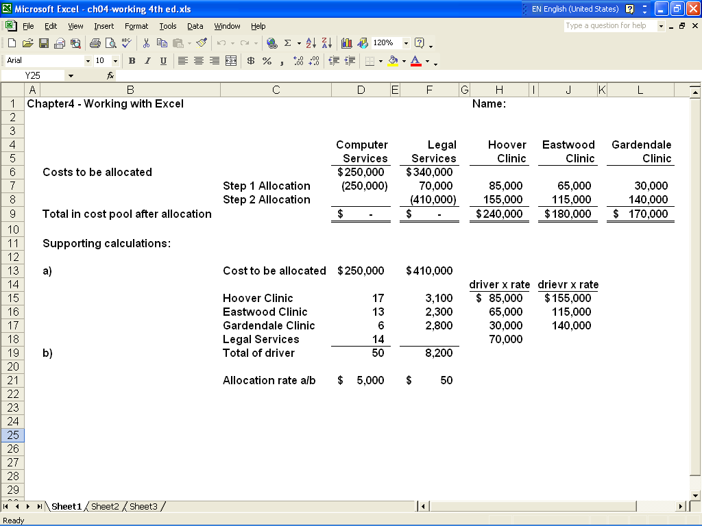

ATC 4-6 (continued)

Screen capture of cell formulas:

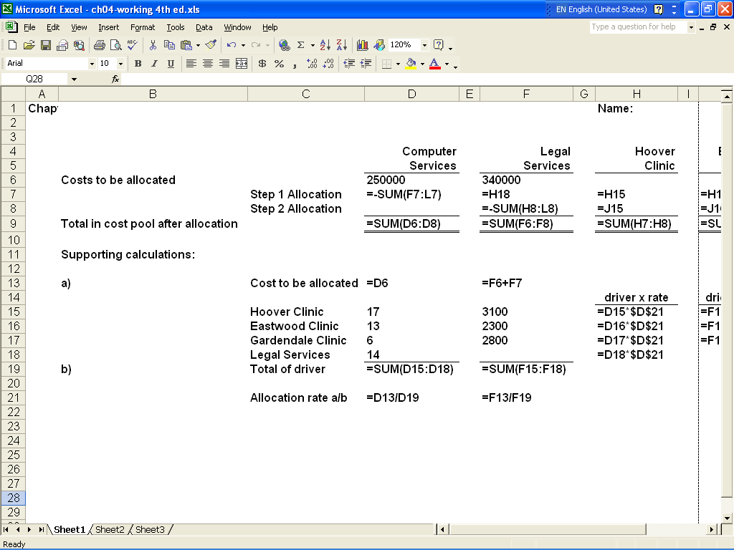

ATC 4-6 (continued)

Screen capture of cell formulas (continued):

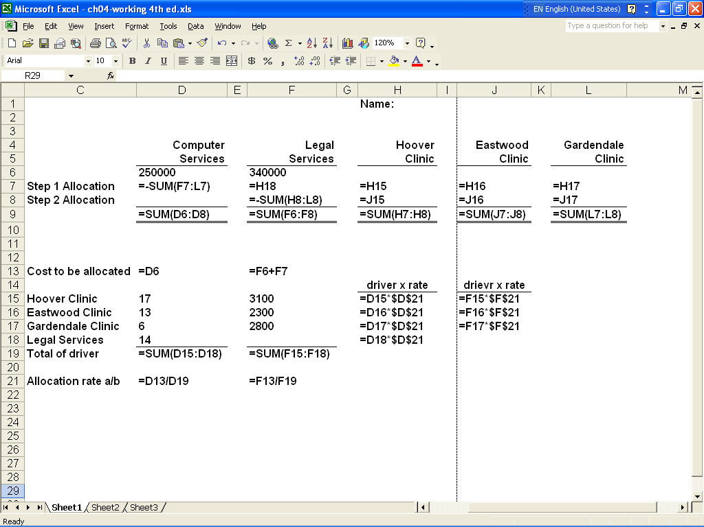

ATC 4-7

Screen capture of cell values:

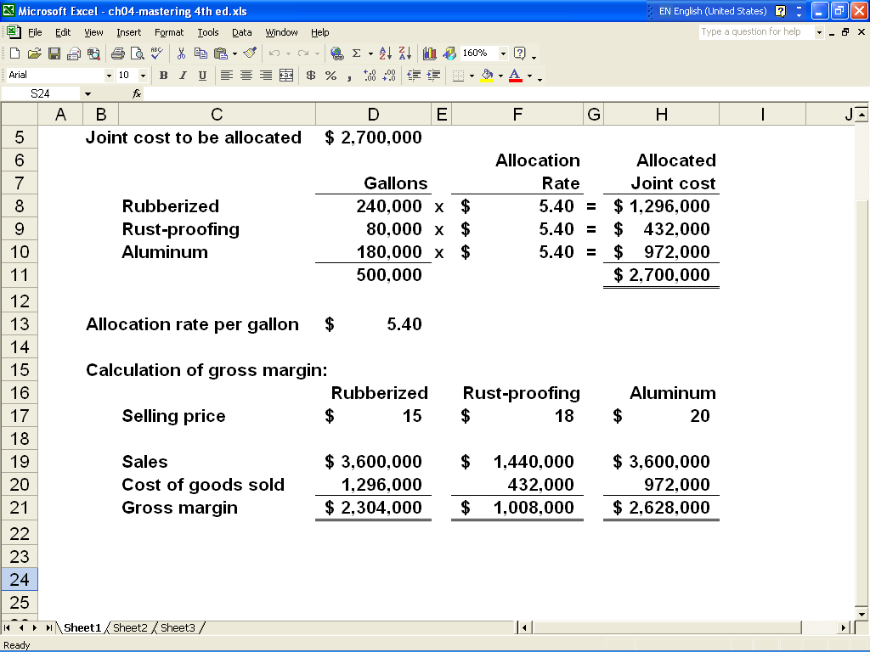

ATC 4-7 (continued)

Screen capture of cell formulas:

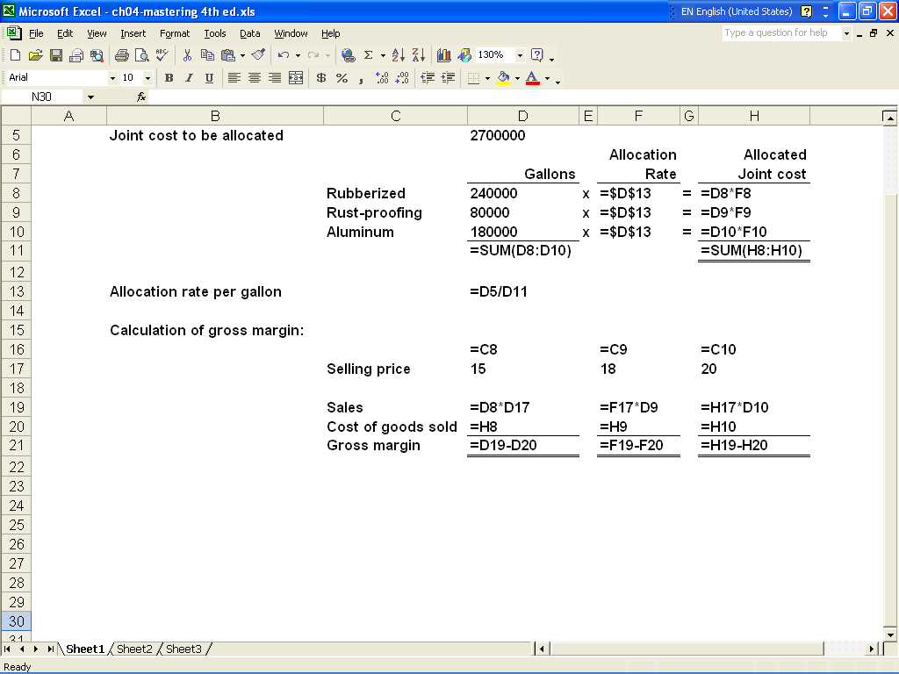

Chapter 4 -- Comprehensive Problem
Requirement a
Determine the per unit cost of making and selling 1,000 pagers.

 | Allocated Facility-Level Costs:
 | $60,000 + $50,000 + $12,000 + $71,950 = $193,950 Total Facility-level Cost
 | $193,950 / 6,000 Units = $32.325 per unit x 1,000 Units = |  |  |  |  |  | $32,325
 | Unit-level Costs
 | $20 x 1,000 Units |  |  |  |  |  | 20,000
 | $1 x 1,000 Units |  |  |  |  |  | 1,000
 | Total Cost of Production and Sales |  |  |  |  |  | $53,325
 | Cost per Unit ($53,325 / 1,000) |  |  |  |  |  | $53.325

Requirement b
Yes, they should make the pagers. The allocated facility-level costs are not relevant to the decision. The relevant cost of making and selling the pagers is the unit-level cost of
$21 each ($20 unit-level manufacturing costs + $1 selling commission). Since the sales
price is $34, each unit will return a contribution margin of $13 (i.e., $34 - $21).

Requirement c

Number of units appears to be an inappropriate allocation base because the units are not
homogenous. Since modems are more expensive, they should carry a proportionately
higher amount of the overhead cost. Material dollars, labor dollars, labor hours or some
other cost driver would probably constitute a more appropriate allocation base.

