Answers to Questions

1. Traditional cost systems evolved when the manufacturing process was labor intensive. Labor constituted the major manufacturing cost and was correlated to overhead use. This situation made it rational to allocate overhead cost on a companywide basis using one rate based on labor usage.

2. In an automated business environment more highly skilled workers, that are not easily replaced, are required. When production falls, they are not as easily laid off and when production rises, increased labor may not be useful since most production processes are machine driven and labor is merely used to keep machinery functional. With these changes, labor is less related to volume of production and no longer provides an effective companywide allocation base.

3. Volume-based cost drivers are based on some measure of production volume such as units, direct labor hours, or material quantities. They are highly correlated with production volume, i.e. increase and decrease in direct relation to production volume. They are useful allocation bases when allocating costs related to volume. Activity-based cost drivers are based on some measure of business activity such as number of setups, utilization of research activities, or number of pounds of material moved. They are designed to measure the cost of a particular production activity. They are useful allocation bases when allocating costs resulting from designated business activities.

4. Automated business environments are based on more technically complex equipment and machinery. Machinery replaces labor as the major production vehicle. These automated processes based on a new kind of manufacturing generate costs that have no cause and effect relationship with volume-based cost drivers. Activities, rather than volume, drive overhead costs. Volume-based cost drivers assign more overhead to high-volume products and assign less overhead to low-volume products. Since the new kinds of overhead cost are not driven by volume, inaccuracies in allocations and poor decisions can occur. Activity-based cost drivers are not based on volume and therefore avoid overcosting high volume products and undercosting low-volume products. They assign overhead based on incursion of activities. The activity-based cost driver produces a better allocation because it distributes the relevant costs to the appropriate products.

5. Volume-based cost drivers should be used to assign costs that exhibit variable cost behavior in relation to volume. They assure that the greater the volume the greater the costs assigned. This choice results in assigning an equal amount of cost to each unit. Activity-based cost drivers can be used to assign costs that exhibit either variable or fixed behavior in relation to volume depending on the level of cost that is being assigned. Most unit-level overhead costs do exhibit variable behavior in relation to volume and are best assigned using a volume-based cost driver. Most batch-level costs exhibit fixed cost behavior in relation to volume and are best assigned by a measure of activity. The cost assigned by measures of activity would exhibit variable cost behavior in relation to the activity but fixed cost behavior in relation to volume.

6. Because of the product's low volume, less of the company’s engineering overhead cost would have been assigned than the product's complexity warrants. An activity-based cost driver would provide a more accurate assignment of engineering overhead cost. Erroneous cost assignment can affect the quality of the company’s short-term decisions. For instance, in an outsourcing decision, it may have been decided to continue performing the engineering design internally instead of outsourcing because the cost assigned to the product for engineering appears lower than the cost of outsourcing this service activity. If a more accurate allocation based on the engineering department’s time and effort on each product had been used, the decision may have been different. Cost allocation has an effect on the relevant cost that is considered in business decisions.

7. Activity-based costing consists of two allocation stages and employs a variety of cost drivers. In the first stage, ABC assigns costs to pools. These pools represent the activities that cause the costs to be incurred. In the second stage the costs in the activity cost pools are allocated to products or other cost objects through the use of cost drivers that measure the object's use of that activity.

8. Facility-level costs are relevant for pricing decisions. Even though the costs are unavoidable, the company’s revenues must cover all costs incurred by the company for the company to remain profitable. The company’s products must be sold at prices that exceed total cost of administration, research and development, production, and marketing. To do so all costs, not just product costs, must be allocated to the product even if the allocation is arbitrary.

9. To facilitate cost tracing a company's activities can be divided into the following categories:

Unit-level activities: Activities that increase or decrease each time a unit of product is made. Examples are inspection costs, production supplies, indirect labor, and machine-related utilities.
9. (continued)

Batch-level activities: Activities associated with the production of a group of products. Examples include material handling cost, setup cost, quality control cost, and inspection cost.

Product-level activities - Activities related to a specific product line. Examples include design and engineering cost, and product-specific advertising cost.

Facility-level activities – Activities that are performed for the benefit of the production process as a whole and not related to any specific product, batch, or unit of production. Examples include the cost of depreciation for the manufacturing facility, the cost of security, landscaping cost, and the cost of maintenance and taxes.

10. In order to stay in business, a company’s product revenues must cover the company’s total costs. The total overhead costs include overhead cost directly associated with producing products and overhead cost incurred in other companywide operations. All these costs must be allocated to products for appropriate pricing. The price of ping pong balls must include not only production cost but a proportionate share of the following costs: facility-level utilities and rent, administrative salaries, supplies, companywide marketing, research and development, depreciation on the manufacturing facility, maintenance, security, and landscaping.

11. Unit-level costs associated with a hospital patient would include supplies, medications, laundry, and food. Batch-level costs could include food service, rehabilitation, and quality control. Product-level costs could include depreciation on specialized equipment used for specific illnesses, salaries of doctors, nurses, and orderlies, and emergency room costs. Facility-level costs could include maintenance, security, hospitalwide utilities, and administrative costs.

12. Facility-level costs are not directly associated with a particular product but incurred to support the facility as a whole. Therefore, the allocation is arbitrary and difficult to defend.
13. Using a volume-driven allocation base (machine hours) will allocate more batch-level costs to products that consume the most machine hours. There may be little or no correlation between batch-level costs such as setups, material handling, and inspection and the number of machine hours. In fact, most batch-level costs are fixed regardless of the number of units in a batch. Units and machine hours are normally strongly correlated. Machine hours and batches are not necessarily correlated at all. A product could require few machine hours but many different setups in the manufacturing process. Batch-level costs are related to the production of groups of products and could best be allocated using an activity measure that is correlated to the number of batches.

14. In order to stay in business, products must be priced above all costs, not just production cost. The costs of product-related activities that occur before (upstream) and after (downstream) the manufacturing process must be considered in product costing. These kinds of costs include research and development, marketing, packaging and labeling, and sales commissions. The price must exceed the total cost of making and selling products. Pricing the product only above production costs will lead to operating losses.

15. If the company is using a traditional cost system based on volume to assign overhead costs to the company’s two product lines, it may be over-assigning overhead costs to the simple and high-volume product line and under-assigning overhead cost to the more complex and low-volume product line. More technologically complex products usually require more overhead cost because they consume more production activities. A volume-driven cost driver assigns costs based on volume, not based on activities consumed in production. If prices are linked to cost, then the Starscore line may be overpriced and losing market share while the Arrowsmith line may be underpriced and losing money. Using an activity-based cost system would probably give more accurate production costs for the company’s two product lines. More accurate costs would facilitate a more profitable pricing scheme.

16. Activity-based management seeks to eliminate or reduce non-value added activities. A nonvalue-added activity is any unit of work that does not contribute to a product’s satisfaction of customer needs. The maintenance of excessive inventory is an example of a nonvalue-added activity. Excessive inventories contribute to high inventory holding costs such as the costs of financing, warehouse space, supervision, theft, and obsolescence. Just-in-time inventory seeks to eliminate this nonvalue-added activity by reducing inventory holdings and eliminating the activities associated with their maintenance. Under just-in-time systems, inventory is made available just-in-time for customer consumption.

Exercise 6-1B

Cost Activity | Cost Pool
a. Factory depreciation | Facility
b. Advertising costs for a particular product | Product
c. Wages of assembly line workers | Unit
d. Product design costs | Product
e. Materials requisition costs for a particular work order | Batch
f. Security guard wages | Facility
g. Lubricant for machines | Facility
h. Parts used to make a particular product | Unit
i. Machine setup cost | Batch
j. Salary of the plant manager’s secretary | Facility

Other classifications may be appropriate based on different assumptions about the context in which the given activity occurs.

Exercise 6-2B

a. Number of hours, number of moves, pounds of material
b. Number of machine hours
c. Number of units, number of hours
d. Number of hours
e. Amount of square feet, number of labor hours
f. Number of machine hours, number of maintenance jobs
g. Number of hours
h. Number of setups, number of machine configurations, labor hours
i. Number of work orders
j. Number of materials requisition forms

Other cost drivers may be appropriate based on different assumptions about the context in which the given activity occurs.

Exercise 6-3B

 | a. | b.
1. | Facility | Square feet or arbitrary
2. | Unit | Number of units
3. | Batch | Number of batches
4. | Batch | Number of batches
5. | Unit | Number of units
6. | Batch or unit | Number of batches or units
7. | Product | Number of minutes of commercial time

Other classifications and cost drivers may be appropriate based on different assumptions about the context in which the given activity occurs.

Exercise 6-4B

Numerous valid answers exist; examples follow. Labor cost incurred to produce individual units of product would be unit-level. Labor cost incurred to set up machines to make a batch of products would be batch-level. Labor cost incurred to test a newly designed product would be product-level. Labor cost incurred to maintain the manufacturing facility would be facility-level.

Exercise 6-5B

a. Unit-level activities assumption

Cost to be allocated ÷ Cost driver = Allocation rate
$150,000 ÷ 50,000 hours = $3 per direct labor hour

Handy: 26,000 labor hours x $3 =$78,000 allocated cost
Action: 24,000 labor hours x $3 =$72,000 allocated cost

b. Batch-Level Activities Assumption

Cost to be allocated ÷ Cost driver = Allocation rate
$150,000 ÷ 60 Batches = $2,500 per Batch

Handy: 38 batches x $2,500 = $95,000 allocated cost
Action: 22 batches x $2,500 = $55,000 allocated cost

c. Product-Level Activities Assumption

Cost to be allocated ÷ Cost driver = Allocation rate
$150,000 ÷ 15 engineers = $10,000 per engineer

Handy: 10 inspectors x $10,000 = $100,000 allocated cost
Action: 5 inspectors x $10,000 = $50,000 allocated cost

d. Facility-Level Activities Assumption

Cost to be allocated ÷ Cost driver = Allocation rate
$150,000 ÷ 120,000 square feet = $1.25 per square foot

Handy: 37,000 square feet x $1.25 = $46,250 allocated cost
Action: 83,000 square feet x $1.25 = $103,750 allocated cost

Exercise 6-6B

a.

Activity Pool | Cost | ÷ | Cost Driver | = | Allocation Rate
Machine setup | $120,000 | ÷ | 120 | = | $1,000.00
Machine operation | 300,000 | ÷ | 4,000 | = | 75.00
Quality control | 48,000 | ÷ | 250 | = | 192.00
Packaging | 32,000 | ÷ | 40,000 | = | 0.80

b.

Overhead Cost Allocated to VC620:

Activity Pool | Allocation Rate | x | Cost Driver | = | Allocated Cost
Machine setup | $1,000.00 | x | 48 | = | $ 48,000
Machine operation | 75.00 | x | 1,400 | = | 105,000
Quality control | 192.00 | x | 78 | = | 14,976
Packaging | 0.80 | x | 25,000 | = | 20,000
Total |  |  |  |  | $187,976

Overhead Cost Allocated to PH630:

Activity Pool | Allocation Rate | x | Cost Driver | = | Allocated Cost
Machine setup | $1,000.00 | x | 72 | = | $ 72,000
Machine operation | 75.00 | x | 2,600 | = | 195,000
Quality control | 192.00 | x | 172 | = | 33,024
Packaging | 0.80 | x | 15,000 | = | 12,000
Total |  |  |  |  | $312,024

Total Cost: | $187,976 | + | $312,024 | =$500,000

Exercise 6-7B

a.

Cost | ÷ | Cost Driver | = | Rate
$500,000 | ÷ | 25,000 | = | $20

Product |  | Rate | x | Weight of Base | = | Allocated Cost
VC620 |  | $20 | x | 16,000 | = | $320,000
PH630 |  | 20 | x | 9,000 | = | 180,000
 |  |  |  | Total Cost |  | $500,000

b.
VC620 | Higher Volume
Cost System | Allocated Cost | ÷ | ÷ Units | = | Cost per Unit
ABC | $187,976 | ÷ | 25,000 | = | $ 7.52
Labor hours | 320,000 | ÷ | 25,000 | = | 12.80
PH630 | Lower Volume
Cost System | Allocated Cost | ÷ | Units | = | Cost per Unit
ABC | $312,024 | ÷ | 15,000 | = | $20.80
Labor hours | 180,000 | ÷ | 15,000 | = | 12.00

c. ABC assigns cost based on the activities undertaken to produce a product. Since the higher-volume product used fewer setups, machine hours, and inspections, that product was assigned a lower amount of the overhead costs.

Exercise 6-8B

a.

Total Overhead cost = $1,000,000 + $500,000 + $300,000 +$900,000 = $2,700,000

Total Overhead Cost | ÷ | Cost Driver |  |  | = | Overhead Rate
$2,700,000 | ÷ | 12,500 |  |  | = | $216 / hour

Overhead Rate | x | Weight | = | Allocated Cost
$216 | x | 4,000 | = | $864,000

b.
Level | Unit | Batch | Product | Facility | Total
Cost (a) | $1,000,000 | $500,000 | $300,000 | $900,000
Driver (b) | 12,500 | 50 | % of Use | 15,000
Rate (a ÷ b = c) | $80/hr | $10,000/setup | % of Use | $60/unit
Weight (d) | 4,000 hrs | 25 setups | 30% | 5,000 units
Allocation (c x d) | $320,000 | $250,000 | $90,000 | $300,000 | $960,000

- OH cost per unit using DL hrs= $864,000 ÷ 5,000 units = $172.80

OH cost per unit under ABC = $960,000 ÷ 5,000 units = $192

 | ABC | Labor Hrs
Allocated overhead | $192.00 | $172.80
Direct product costs | 337.00 | 337.00
Total cost per unit (a) | 529.00 | 509.80
x 30% | x 20% | x 20%
Desired profit (b) | 105.80 | 101.96
Sales price (a) + (b) | $634.80 | $611.76

Exercise 6-8B (continued)

d. If Cray priced PFT200 using direct labor hours to allocate overhead costs, PFT200 would be underpriced. Underpricing can result in management’s committing too much of scarce resources to a product that is earning a less than desirable profit. Management would not be able to use the committed resources for other products that produce better profits. Consequently, the company’s profitability would be lower than its potential.

e. For long-term pricing decisions all costs should be considered in cost-plus pricing, including facility-level costs. Upstream and downstream costs should also be considered. When making a short-term special order decision, however, only relevant (differential) costs should be considered. In those circumstances, facility-level costs should be ignored.

Exercise 6-9B

a. Overhead Application rate:

Overhead Costs

Fringe Benefits | $360,000
Setups | 200,000
Packing | 40,000
QC | 300,000 | Labor Hrs | OH Rate
Total | $900,000 | ÷ 50,000 | = $18 | per labor hour

 | Brisk | Pro | Runner | Total
Labor Hours (a) | 10,000 | 20,000 | 20,000
Rate (b) | $18 | $18 | $18
Allocation (a x b = c) | $180,000 | + $360,000 | + $360,000 | = $900,000
Pair of Shoes (d) | ÷ 10,000 | ÷ 15,000 | ÷ 20,000
Cost/Pair (c ÷ d) | $18.00 | $24.00 | $18.00

Exercise 6-9B (continued)

b.
ABC System
Driver | Brisk | Pro | Runner | Total
Labor Hours | 10,000 | 20,000 | 20,000 | 50,000
Number of Setups | 15 | 25 | 10 | 50
Number of Cartons | 200 | 300 | 300 | 800
Number of Tests | 120 | 200 | 80 | 400

Driver | Cost | ÷ | Base | = | Rates
Labor Hours | $360,000 | ÷ | 50,000 | = | $7.20/Hour
Number of Setups | $200,000 | ÷ | 50 | = | $4,000/Setup
Number of Cartons | $40,000 | ÷ | 800 | = | $50/Carton
Number of Tests | $300,000 | ÷ | 400 | = | $750/Test

Cost Allocation for Brisk:

Activity Pool | Allocation Rate | x | Cost Driver | = | Allocated Cost
Fringe Benefits | $7.20/Hr | x | 10,000 | = | $ 72,000
Setups | $4,000/Setup | x | 15 | = | 60,000
Packing Costs | $50/Carton | x | 200 | = | 10,000
Quality Control | $750/Test | x | 120 | = | 90,000
Total |  |  |  |  | $232,000

Cost Allocation for Pro:

Activity Pool | Allocation Rate | x | Cost Driver | = | Allocated Cost
Fringe Benefits | $7.20/Hr | x | 20,000 | = | $144,000
Setups | $4,000/Setup | x | 25 | = | 100,000
Packing Costs | $50/Carton | x | 300 | = | 15,000
Quality Control | $750/Test | x | 200 | = | 150,000
Total |  |  |  |  | $409,000

Exercise 6-9B (continued)

Cost Allocation for Runner:
Activity Pool | Allocation Rate | x | Cost Driver | = | Allocated Cost
Fringe Benefits | $7.20/Hr | x | 20,000 | = | $144,000
Setups | $4,000/Setup | x | 10 | = | 40,000
Packing Costs | $50/Carton | x | 300 | = | 15,000
Quality Control | $750/Test | x | 80 | = | 60,000
Total |  |  |  |  | $259,000

Computation of Overhead Cost per Pair of Shoes:

 | Brisk | Pro | Runner | Total
Allocated Cost (a) | $232,000 | + $409,000 | + $259,000 | = $900,000
Units (b) | ÷ 10,000 | ÷ 15,000 | ÷ 20,000
Cost/Unit (a÷ b) | $23.20 | $27.27 | $12.95

c. Because Runner required relatively few setups and tests but more labor hours, Julian would allocate more overhead cost to it using labor hours as the base than with activity-based costing. The reverse is true for Brisk and Pro. Burns’ current method fails to account for the higher costs caused by more setups and quality control tests. It is too general and therefore, inaccurate.

Exercise 6-10B

a.
Cost allocation for N100:
Activity Pool | Allocation Rate | x | Cost Driver | = | Allocated Cost
Material R & H | 3% | x | $250,000 | = | $ 7,500
Setup | $800/setup | x | 10 | = | 8,000
Assembly | $10/part | x | 10,000 | = | 100,000
Quality insp. | $25/minute | x | 800 | = | 20,000
Packing/shipping | $80/order | x | 25 |  | 2,000
Total |  |  |  |  | $137,500

Cost allocation for D200:
Activity Pool | Allocation Rate | x | Cost Driver | = | Allocated Cost
Material R & H | 3% | x | $300,000 | = | $ 9,000
Setup | $800/setup | x | 25 | = | 20,000
Assembly | $10/Part | x | 10,000 | = | 100,000
Quality insp. | $25/Minute | x | 4,800 | = | 120,000
Packing/shipping | $80/order | x | 50 |  | 4,000
Total |  |  |  |  | $253,000

Computation of product cost per Camcorder:
 | N100 | D200
Allocated overhead cost | $137,500 | $253,000
Labor cost | 450,000 | 300,000
Material cost | 250,000 | 300,000
Total cost (a) | $837,500 | $853,000
Units (b) | ÷ 1,000 | ÷ 1,000
Total cost/unit (a ÷ b) | $837.50 | $853.00

b. The D200s are made in smaller batches (more setups), are sold in smaller quantities (more orders), and require more inspection time. These activities drive up the overhead cost. ABC allocates overhead costs in a manner that reflects a product's consumption of those costs. Consequently, Raspino assigned a greater amount of overhead cost to D200s to reflect the higher cost per unit to produce it.

Exercise 6-11B
a.
 | Unit Cost x Units | Orange Juice | Unit Cost x Units | Tomato Juice
Sales |  | $280,000 |  | $170,000
Materials cost | $3 x 25,000 | (75,000) | $2 x 15,000 | (30,000)
Labor cost | $2 x 25,000 | (50,000) | $3 x 15,000 | (45,000)
Overhead cost | $3 x 25,000 | (75,000) | $4 x 15,000 | (60,000)
Packaging expense |  | (40,000) |  | (40,000)
Net income (loss) |  | $40,000 |  | $ (5,000)

- The allocation of the packaging expense is flawed. This expense is likely to correlate highly with the number of cases produced, which would be a more rational allocation base. If Kincaid used the number of cases as the allocation base for packaging expenses it would allocate $30,000 ($80,000/40,000 cases = $2 per case; $2 per case x 15,000 cases = $30,000) of packaging expense to tomato juice. Since the packaging cost is avoidable, the company should allocate it appropriately for the product elimination decision. Given that the $30,000 of facility-level cost is probably not avoidable, Kincaid should ignore it in the product elimination decision. As shown below, the amount of revenue generated by tomato juice exceeds the avoidable cost of producing it. Therefore, the company should continue to produce and sell tomato juice.

 |  | Tomato Juice
Sales |  | $170,000

Avoidable cost*:
Materials cost | $2 x 15,000 | (30,000)
Labor cost | $3 x 15,000 | (45,000)
Overhead cost | $4 x 15,000 – $30,000 | (30,000)
Packaging expense |  | (30,000)
Contribution to profit |  | $ 35,000

*The $30,000 facility-level cost is not avoidable, hence it is ignored.

Exercise 6-12B

Memorandum

TO: Mr. Rodney Nance, President
FROM: Christy Tucker, Production Manager
SUBJECT: The Zero-Defect Policy
DATE: September 1, 2007

Your quest for high-quality products is admirable. Quality is a very important component in a competitive market. I appreciate your superb wisdom and leadership in this endeavor. Accordingly, my staff and I have worked very hard to bring the defect rate of our products down to 3% from 20%.

Quality control, like other managerial tasks, requires strategic planning and prudent implementation. As quality improves, marginal costs of quality control increase and marginal benefits decrease. Beyond a certain level of quality, the costs of quality control will exceed its benefit. As the defect rate approaches zero, the costs of control will skyrocket to an unreasonable level. Not only will our profits erode, our customers may not accept the increasing prices resulting from the rising costs. After all, the company needs a healthy profit to prosper continuously. For this reason, I recommend that we shift the policy of zero defects to a policy of reasonably low defects. Under your leadership, I believe the company will fare even better with this recommended policy.

Problem 6-13B

a. Total Overhead Cost:

Total labor hours:

Product S109 |  | Product N227
2 x 10,000 | + | 2.8 x 10,000 | = | 48,000 hours
Allocation rate = $1,008,000 ÷ 48,000 hours = $21 per labor hour.

b. Allocated Overhead Costs:

Type of Product | Allocation Rate | x | No. of Hours | = | Allocated Cost
Product S109 | $21 | x | 20,000 | = | $ 420,000
Product N227 | $21 | x | 28,000 | = | 588,000
Total |  |  | 48,000 |  | $1,008,000

c. Total Cost of Each Product Line and Combined Cost.

Type of Product | Direct  Materials¹ | + | Direct  Labor ² | + | Allocated Overhead | = | Total
Product S109 | $240,000 | + | $300,000 | + | $ 420,000 | = | $ 960,000
Product N227 | 240,000 | + | 420,000 | + | 588,000 | = | 1,248,000
Combined totals | $480,000 | + | $720,000 | + | $1,008,000 | = | $2,208,000

¹Direct materials
Product S109 | $24 | x | 10,000 units | = | $240,000
Product N227 | $24 | x | 10,000 units | = | $240,000
²Direct labor
Product S109 | $15 | x | 20,000 hours | = | $300,000
Product N227 | $15 | x | 28,000 hours | = | $420,000

Problem 6-13B (continued)

Cost per unit computations under traditional cost system

Type of Product | Total Cost | ÷ | Units | = | Cost per Unit
Product S109 | $ 960,000 | ÷ | 10,000 | = | $ 96.00
Product N227 | 1,248,000 | ÷ | 10,000 | = | $124.80
Combined total | $2,208,000

d. Price of each product under traditional cost system

Type of Product | Cost /Unit | + | Markup | = | Price
Product S109 | $96.00 | + | $ 96.00 x 20% | = | $115.20
Product N227 | $124.80 | + | $124.80 x 20% | = | $149.76

e. Overhead cost allocation under ABC
 | Unit | Batch | Product | Facility | Total
Cost pool | $540,000 | $228,000 | $180,000 | $60,000 | $1,008,000
Cost drivers | # M Hours | # Setups | # Inspections | Equally
 | 80,000 | 5,000 | 800 | %
Rate | $6.75 | $45.60 | $225 | $60,000

f.

Allocation for Product S109
 | Unit | Batch | Product | Facility | Total
Weight | 20,000 | 1,500 | 200 | 50%
x Rate | $6.75 | $45.60 | $225 | $60,000
Allocation | $135,000 | $68,400 | $45,000 | $30,000 | $278,400

Allocation for Product N227
 | Unit | Batch | Product |  | Facility |  | Total
Weight | 60,000 | 3,500 | 600 |  | 50%
x Rate | $6.75 | $45.60 | $225 |  | $60,000
Allocation | $405,000 | $159,600 | $135,000 |  | $30,000 |  | $729,600

Problem 6-13B (continued)

Total Cost of Each Product Line and Combined Cost.

Type of Product | Direct  Materials¹ | + | Direct  Labor ² | + | Allocated Overhead | = | Total
Product S109 | $240,000 | + | $300,000 | + | $ 278,400 | = | $ 818,400
Product N227 | 240,000 | + | 420,000 | + | 729,600 | = | 1,389,600
Combined Totals | $480,000 | + | $720,000 | + | $1,008,000 | = | $2,208,000

¹Direct materials
Product S109 | $24 | x | 10,000 units | = | $240,000
Product N227 | $24 | x | 10,000 units | = | $240,000
²Direct labor
Product S109 | $15 | x | 20,000 hours | = | $300,000
Product N227 | $15 | x | 28,000 hours | = | $420,000

Cost per Unit Computations Under ABC System

Type of Product | Total Cost | ÷ | Units | = | Cost per Unit
Product S109 | $ 818,400 | ÷ | 10,000 | = | $ 81.84
Product N227 | 1,389,600 | ÷ | 10,000 | = | $138.96
Combined total | $2,208,000

g. Price of Each Product

Type of Product | Cost /Unit | + | Markup | = | Price
Product S109 | $ 81.84 | + | $81.84 x 20% | = | $ 98.21
Product N227 | $138.96 | + | $138.96 x 20% | = | $166.75

h. Product N227 is more costly to make because its production process requires more machine hours, machine setups, and inspections than Product S109. Moreover, the ABC system, reflecting the cause-effect relationship of production activities to overhead cost, reveals that the real cost of Product N227 is greater than the traditional cost system indicated. Kenneth Laboratory needs to adjust its prices to reflect this reality in order to remain viable in the market for the long run.

Problem 6-14B

a. Allocation rate =$240,000÷30,000 hours = $8.00 per labor hour.

Type of Product | Allocation Rate | x | No. of Hours | = | Allocated Cost
Diana plates | $8.00 | x | 25,000 | = | $200,000
Monroe plates | $8.00 | x | 5,000 | = | $ 40,000

b. The measurement of labor hours is an inappropriate allocation base because it is not correlated with machine-related activities. While it is an appropriate allocation base for labor-related cost, it distorts the allocation of machine-related overhead cost.

c. An ABC system would reflect the underlying fact that the company has two activity pools related to overhead cost. A cost driver that causes the cost of each pool would be used to allocate the cost to each product. As a result, the ABC system will better reflect the true cost of each product than the original system that uses only one allocation base for all overhead cost.

Problem 6-15B

a. | Machine-Related | Labor-Related
Cost pool | $140,000 | $100,000
Cost driver | Machine hours | Labor hours
 | 3,500 | 30,000
Rate | $40 | $3.33333

b. Allocating Machine-Related Cost
 | Diana Plates | Monroe Plates
Weight | 1,000 | 2,500
x Rate | $40 | $40 |  |  | Total
Allocation | $40,000 | $100,000 |  |  | $140,000

Problem 6-15B (continued)

c. Allocating Labor-Related Cost
 | Diana Plates | Monroe Plates
Weight | 25,000 | 5,000
x Rate | $3.33333 | $3.33333 |  |  | Total
Allocation | $83,333 | $16,667 |  |  | $100,000

Problem 6-16B

a.
 | Bookkeeping | Tax | Total
Revenue | $60,000 | $60,000 | $120,000
Direct Expense | (22,500) | (22,500) | (45,000)
Indirect Supervisory Expense | (8,000)* | (24,000)* | (32,000)
Net income | $29,500 | $13,500 | $43,000

*The new allocation of indirect cost is determined as follows:
Bookkeeping ($32,000 x .25 = $8,000)
Tax ($32,000 x .75 = $24,000)

b. Bookkeeping is a more profitable segment, requiring only 1/4 of the supervisory time. More emphasis should be put on expanding this line of business. Alternatively, Weik may decide to alter its pricing policy. Perhaps the fee for tax services should be increased to reflect the higher cost of providing that service.

Problem 6-17B

a. Wellington Boot and Shoe Company uses only one overhead cost pool with direct labor hours as the allocation base. When Wellington bought additional manufacturing equipment and restructured the plant layout, the total overhead cost increased but Wellington did not change its allocation base. Consequently, the overhead allocation rate per labor hour increased. Since the production of boots used the same number of labor hours with an increased overhead rate, the cost of boots increased.
b. Because some of the overhead cost that was related to the production of shoes was allocated to boots, the cost of shoes would be understated. If Wellington used the cost-markup pricing strategy, it would underprice its shoes accordingly.
c. Wellington could use an ABC system to improve the accuracy of assigning overhead costs to the products that caused them to be incurred. ABC would use a variety of allocation bases that more accurately reflect the cause and effect relationships.

Problem 6-18B

a. Overhead cost allocation under ABC
 | Inspections | Setups | Advert. | Depreciation | Total
Cost pool | $120,000 | $75,000 | $210,000 | $405,000 | $810,000
Cost driver | # of units | # setups | # comm. | Mach. hrs.
 | 10,000 | 50 | 14 | 10,000
Rate | $12 | $1,500 | $15,000 | $40.50

Allocation for Elegance
 | Inspections | Setups | Advert. |  | Depreciation |  | Total
Weight | 2,500 | 23 | 5 |  | 5,000
x Rate | $12 | $1,500 | $15,000 |  | $40.50
Allocation | $30,000 | $34,500 | $75,000 |  | $202,500 |  | $342,000

Allocation for Comfort
 | Inspections | Setups | Advert. |  | Depreciation |  | Total
Weight | 7,500 | 27 | 9 |  | 5,000
x Rate | $12 | $1,500 | $15,000 |  | $40.50
Allocation | $90,000 | $40,500 | $135,000 |  | $202,500 |  | $468,000

Overhead cost per unit:

Type of Product | Total OH Cost | ÷ | # of Units | = | OH Cost  per Unit
Elegance | $342,000 | ÷ | 2,500 | = | $136.80
Comfort | 468,000 | ÷ | 7,500 | = | 62.40
Combined totals | $810,000

Cost per unit computation:

Type of Product | Direct  Materials | + | Direct  Labor | + | Allocated Overhead | = | Total
Elegance | $70.00 | + | $54.00 | + | $136.80 | = | $260.80
Comfort | 43.00 | + | 36.00 | + | 62.40 | = | 141.40

Problem 6-18B (continued)

b. The price of Elegance should be determined as follows:

 | Cost per Unit |  | Profit Margin
 | $260.80 | + | $260.80 x 30% | = | $339.04

c. For a short-term decision, only direct materials, direct labor, and product inspection, and product setup costs are avoidable. Unavoidable costs should not be considered.

Product inspection cost per unit for the Comfort table:
$90,000 ÷ 7,500 = $12.00

Product setup cost per unit for the Comfort table:
$40,500 ÷ 7,500 = $5.40

The minimum price for which the company can continue producing Comfort is the total avoidable cost per unit:

Direct Materials |  | Direct Labor |  | Overhead
$43.00 | + | $36.00 | + | $17.40 | = | $96.40

Problem 6-19B

a. Overhead Cost Allocation Under ABC
 | M. Handling | Setups | Testing | Depreciation | Total
Cost pool | $366,000 | $180,000 | $28,000 | $360,000 | $934,000
Cost drivers | # of parts | # setups | # units | mach. hrs.
 | 1,220,000 | 90 | 1,400 | 7,200
Rate | $0.30 | $2,000 | $20 | $50

Allocation for Model Wonder
 | M. Handling | Setups | Testing |  | Depreciation |  | Total
Weight | 700,000 | 50 | 1,000 |  | 3,200
x Rate | $0.30 | $2,000 | $20 |  | $50
Allocation | $210,000 | $100,000 | $20,000 |  | $160,000 |  | $490,000
÷ # of units | 20,000 | 20,000 | 20,000 |  | 20,000 |  | 20,000
Cost/Unit | $10.50 | $5.00 | $1.00 |  | $8.00 |  | $24.50

Problem 6-19B (continued)

Allocation for Model Marvel
 | M. Handling | Setups | Testing |  | Depreciation |  | Total
Weight | 520,000 | 40 | 400 |  | 4,000
x Rate | $0.30 | $2,000 | $20 |  | $50
Allocation | $156,000 | $80,000 | $8,000 |  | $200,000 |  | $444,000
÷ # of units | 8,000 | 8,000 | 8,000 |  | 8,000 |  | 8,000
Cost/Unit | $19.50 | $10.00 | $1.00 |  | $25.00 |  | $55.50

Cost per Unit Computations:

Type of Product | Direct  Materials | + | Direct  Labor | + | Allocated Overhead | = | Total
Wonder | $ 8.00 | + | $ 8.00 | + | $24.50 | = | $40.50
Marvel | 20.00 | + | 24.00 | + | 55.50 | = | 99.50

b.
 | Wonder | Marvel | Total
Price per unit | $36.00 | $110.00
Cost per unit | (40.50) | (99.50)
Profit (loss) / Unit | (4.50) | 10.50
x # of units | x 20,000 | x 8,000
Total profit (loss) | $(90,000) | $84,000 | $(6,000)

c.
Target Cost | Wonder | Marvel
Target price | $36.00 | $110.00
Profit margin (25%) | 9.00 | 27.50
Target cost / Unit | $27.00 | $82.50

Target Profit | Wonder | Marvel | Total
Profit margin | $ 9.00 | $ 27.50
x # of units | 20,000 | 8,000
Target cost / Unit | $180,000 | $220,000 | $400,000

Problem 6-19B (continued)

d. Overhead Cost Allocation Under the New Design
 | M. Handling | Setups | Testing | Depreciation | Total
Cost pool | $183,000 | $16,000* | $28,000 | $440,000** | $667,000
Cost drivers | # of parts | # Setups | # units | Mach. Hrs.
 | 1,220,000 | 8 | 1,400 | 11,000
Rate | $0.15 | $2,000 | $20 | $40

* The cost per setup is not affected. Total setup cost = $2,000 x 8 = $16,000
** $360,000 + $400,000 ÷ 5 = $440,000

Allocation for Model Wonder
 | M. Handling | Setups | Testing |  | Depreciation |  | Total
Weight | 700,000 | 4 | 1,000 |  | 4,500
x Rate | $0.15 | $2,000 | $20 |  | $40
Allocation | $105,000 | $8,000 | $20,000 |  | $180,000 |  | $313,000
÷ # of units | 20,000 | 20,000 | 20,000 |  | 20,000 |  | 20,000
Cost/Unit | $5.25 | $0.40 | $1.00 |  | $9.00 |  | $15.65
Allocation for Model Marvel
 | M. Handling | Setups | Testing |  | Depreciation |  | Total
Weight | 520,000 | 4 | 400 |  | 6,500
x Rate | $0.15 | $2,000 | $20 |  | $40
Allocation | $78,000 | $8,000 | $8,000 |  | $260,000 |  | $354,000
÷ # of units | 8,000 | 8,000 | 8,000 |  | 8,000 |  | 8,000
Cost/Unit | $9.75 | $1.00 | $1.00 |  | $32.50 |  | $44.25

Cost per Unit Computations:

Type of Product | Direct  Materials | + | Direct  Labor | + | Allocated Overhead | = | Total
Wonder | $ 8.00 | + | $ 8.00 | + | $15.65 | = | $31.65
Marvel | 20.00 | + | 24.00 | + | 44.25 | = | 88.25

Ingram will not be able to achieve its target cost with the new production design.

Problem 6-20B

a. Overhead cost allocation under ABC
 | Inspection | Setups | Promotion | Depreciation | Total
Cost pool | $60,000 | $15,000 | $200,000 | $295,000 | $570,000
Cost driver | # of units | # Setups | # Comm. | Mach. Hrs.
 | 60,000 | 75 | 20 | 11,800
Rate | $1 | $200 | $10,000 | $25

Allocation for Professional
 | Inspection | Setups | Promotion |  | Depreciation |  | Total
Weight | 15,000 | 30 | 10 |  | 7,160
x Rate | $1 | $200 | $10,000 |  | $25
Allocation | $15,000 | $6,000 | $100,000 |  | $179,000 |  | $300,000
÷ # of units | 15,000 | 15,000 | 15,000 |  | 15,000 |  | 15,000
Cost/unit | $1.00 | $0.40 | $6.67 |  | $11.93 |  | $20.00

Allocation for Home
 | Inspection | Setups | Promotion |  | Depreciation |  | Total
Weight | 45,000 | 45 | 10 |  | 4,640
x Rate | $1 | $200 | $10,000 |  | $25
Allocation | $45,000 | $9,000 | $100,000 |  | $116,000 |  | $270,000
÷ # of units | 45,000 | 45,000 | 45,000 |  | 45,000 |  | 45,000
Cost/unit | $1.00 | $0.20 | $2.22 |  | $2.58 |  | $6

Cost per unit computations
Type of Product | Direct  Materials | + | Direct  Labor | + | Allocated Overhead | = | Total
Professional | $21.00 | + | $14.40 | + | $20.00 | = | $55.40
Home | 7.00 | + | 5.40 | + | 6.00 | = | 18.40

Problem 6-20B (continued)

b.
 | Professional | Home | Total
Price per unit | $65.00 | $22.00
Cost per unit | (55.40) | (18.40)
Profit / unit | 9.60 | 3.60
x # of units | x 15,000 | x 45,000
Gross profit | $144,000 | $162,000 | $306,000
Administrative expenses |  |  | (195,000)
Net profit (loss) |  |  | $111,000

c. Sun's proposal affects only the cost of product promotion. The cost of promotion for Professional will be $21,000 and for Home will be $72,000.

Type of Product | Cost of  Promotion | ÷ | # of  Units | = | Cost of Promotion  per Unit
Professional | $ 21,000 | ÷ | 15,000 | = | $1.40
Home | 72,000 | ÷ | 45,000 | = | 1.60

Total Overhead per Unit
 | Inspection | Setups | Promotion |  | Depreciation |  | Total
Professional | $1.00 | $0.40 | $1.40 |  | $11.93 |  | $14.73
Home | $1.00 | $0.20 | $1.60 |  | $2.58 |  | 5.38

Cost per Unit computations
Type of Product | Direct  Materials | + | Direct  Labor | + | Allocated Overhead | = | Total
Professional | $21.00 | + | $14.40 | + | $14.73 | = | $50.13
Home | 7.00 | + | 5.40 | + | 5.38 | = | 17.78

Problem 6-20B (continued)

d.
 | Professional | Home | Total
Price per unit | $65.00 | $22.00
Cost per unit | (50.13) | (17.78)
Profit / unit | 14.87 | 4.22
x # of units | x 15,000 | x 45,000
Gross profit | $223,050 | $189,900 | $412,950
Administrative expenses |  |  | (195,000)
Net profit (loss) |  |  | $217,950

Problem 6-21B

a. Mr. Eason undertook aggressive measures to cut the cost of quality control activities. Mainly, he cut the costs of training and education, inspection, and reliability testing. These were all factors under his administrative control. This conclusion is supported by the fact that the cost of training and education decreased by $50,000. Furthermore, the cost of product and materials inspection decreased by $40,000 and the cost of reliability testing decreased by another $40,000.

b. Mr. Eason's strategy was unsuccessful. While he had control over the activities of prevention and appraisal, he did not enjoy the same control of the company's failure costs. In fact, when training and education activities were scaled back, errors in the production process increased. In the meantime, the decrease in appraisal activities allowed more defective products to slip through and reach customer's hands. The conclusion is supported by the fact that the cost of internal failure decreased from $334,000 to $170,000 and the cost of external failure escalated from $226,000 to $586,000. Overall, the total failure cost increased from $560,000 ($334,000 + $226,000) to $756,000 ($170,000 + $586,000). The overall quality cost increased from $934,000 to $990,000.

c. The long-term effect of Mr. Eason’s cost-cutting measures could be daunting. As defects reach more customers, the increasing number of dissatisfied customers may switch to competitor's products, causing the company serious long-term damage in the market.

ATC 6-1

a.
Product | Selling Price  per Foot |  | ABC Cost  per Foot |  | Per Unit  Margin |  | Feet  Produced |  | ABC Margin
Door Frames | $3.32 | − | $1.85 | = | $1.47 | x | 275,000 | = | $404,250
Window Frames | 3.68 | − | 2.06 | = | 1.62 | x | 160,000 | = | 259,200
Metal Signs | 4.29 | − | 3.46 | = | 0.83 | x | 20,000 | = | 16,600

b.
Product | Selling Price  per Foot |  | Traditional Cost  per Foot |  | per Unit  Margin |  | Feet  Produced |  | Traditional Margin
Door Frames | $3.32 | − | $1.90 | = | $1.42 | x | 275,000 | = | $390,500
Window Frames | 3.68 | − | 2.10 | = | 1.58 | x | 160,000 | = | 252,800
Metal Signs | 4.29 | − | 2.45 | = | 1.84 | x | 20,000 | = | 36,800

c. Under traditional costing, costs that were incurred to produce Metal Signs were being allocated to Door Frames and Window Frames. The more accurate allocations of the ABC system show that Metal Signs actually cost more than previously determined. The higher costs result in lower profits.

d. If management wishes to maintain a profit margin of 40% based on the ABC costs, they would need to raise the selling price of Metal Signs to at least $5.77. This would yield a gross profit of $2.31 ($5.77 – $3.46 = $2.31), and a gross profit margin of 40% ($2.31 ÷ $5.77 = 40%). [Note: the target selling price is obtained by dividing the unit cost, $3.46 by 1.0 – the desired profit margin. ($3.46 ÷ .60 = $5.77)
ATC 6-2

a. Task 1

Allocation rate $239,120 ÷ 7 RNs = $34,160 per RN

Type of Service | RNs | x | Allocation Rate | = | Allocated Cost
HD | 5 | x | $34,160 | = | $170,800
PD | 2 | x | $34,160 | = | 68,320
Total | 7 | x | $34,160 | = | $239,120
Task 2

Allocation rate $404,064 ÷ 19 LPNs = $21,266.526 per LPN

Type of Service | LPNs | x | Allocation Rate | = | Allocated Cost*
HD | 15 | x | $21,266.526 | = | $318,998
PD | 4 | x | $21,266.526 | = | 85,066
Total | 19 | x | $21,266.526 | = | $404,064
*Rounded to the nearest whole dollar.

Task 3

Allocation rate $115,168 ÷ 34,967 = $3.2936197 per Treatment

Type of Service | Treatments | x | Allocation Rate | = | Allocated Cost*
HD | 14,343 | x | $3.2936197 | = | $47,240
PD | 20,624 | x | $3.2936197 | = | 67,928
Total | 34,967 | x | $3.2936197 | = | $115,168
*Rounded to the nearest whole dollar.

ATC 6-2 (continued)

Task 4

Allocation rate: Since the PD service does not involve dialyzer treatments, the total cost is assigned to the HD service.

Type of Service | Allocated Cost
HD | $124,928
PD | 0
Total | $124,928
b.
Allocated Cost | HD | PD
RNs | $170,800 | $68,320
LPNs | 318,998 | 85,066
Nursing admin. & support | 47,240 | 67,928
Dialysis mach. operations | 124,928 | 0
Total | $661,966 | $221,314
c. (1) PD services are overcosted by the traditional allocation system and HD services are undercosted.

(2) With respect to the HMO patients, pricing is not affected because the clinic is paid a flat fee regardless of the service provided. Profitability will depend on the company’s success in controlling costs.

(3) Since prices cannot be increased, management must be able to find legitimate ways to cut the costs of providing HD services. Another alternative to consider is to abandon the HD services and focus on the more cost-effective PD patients. When considering an elimination decision, management must focus on the relevant cost (i.e., the costs that can be avoided if the HD service is eliminated).

ATC 6-3

a. Six Sigma is defined as “… the data-driven technique for eliminating defects in any business process.”

b. In 1999 Xerox had consolidated 36 administrative centers into three, and it was simultaneously reorganizing its sales operations. These combined actions caused a breakdown of its ordering and billing systems. Six Sigma was adopted to address these issues.

c. The company estimated it earned a $6 million return in 2003 alone on a $14 million investment.

d. According to Xerox’s CEO, “… the hardest task is getting employees to accept that how they have always done things may not be the best way.”

ATC 6-4

Student responses will certainly be varied. However, consideration should be given to the fact that the company appears to be focused on identifying and correcting problems rather than preventing them. Additional expenditures that support this philosophy are not likely to be justified. Indeed, a $610,000 [i.e., ($430,000 + $560,000) − ($240,000 + $140,000)] increase in appraisal and internal failure costs produced only a $110,000 (i.e., $320,000 − $210,000) decrease in external failure costs. A more fruitful strategy appears to be increasing expenditures for prevention costs. The $40,000 decrease in prevention costs could explain why more inspections discovered more defects that required more rework (i.e., internal failure costs). If Sawyer makes fewer mistakes in the first place, there is less need for inspection and correction.

ATC 6-5

a. (1) The answer to this question is a matter of opinion. Some students may feel that the clinic has a moral obligation to provide HD service; others may feel that the clinic has no such moral obligation. However, it should be noted that HMOs created the problem by paying an amount for treatments that is below the cost of providing treatments. Perhaps a more appropriate question is, do HMOs have a moral obligation to pay in full for the services their clients need?

(2) The accountant’s recommendation does not violate any of the standards of ethical conduct described in the CMA code of ethics. Indeed, an accountant has a professional responsibility to act in the legitimate interest of his/her employer.

b. Differential pricing is a debatable issue. Like it or not, it happens. Through higher prices, patients who are able to pay their bills have subsidized patients who do not pay. The practice existed long before HMOs entered the picture. Even so, the business practices employed by HMOs are under hot debate throughout the United States. The issues are not likely to be resolved in the near future. Students are likely to have different opinions. The instructor should evaluate logic rather than conclusions.

c. In this case the clinic administrators must be held accountable. ABC is useful when it leads to discoveries that enable a company to provide the same or better standard of quality at lower costs. In other words, ABC is useful when it leads to the elimination of non-value-added activities. ABC is not an excuse for indiscriminate cost cutting.

ATC 6-6
Screen capture of cell values:

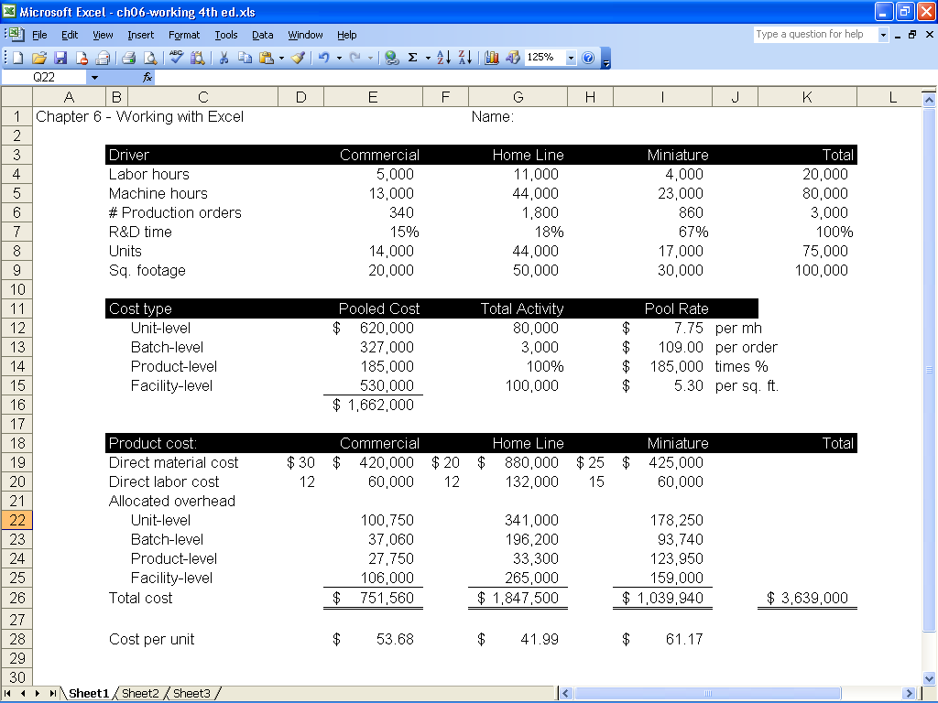

ATC 6-6 (continued)

Screen capture of cell formulas:

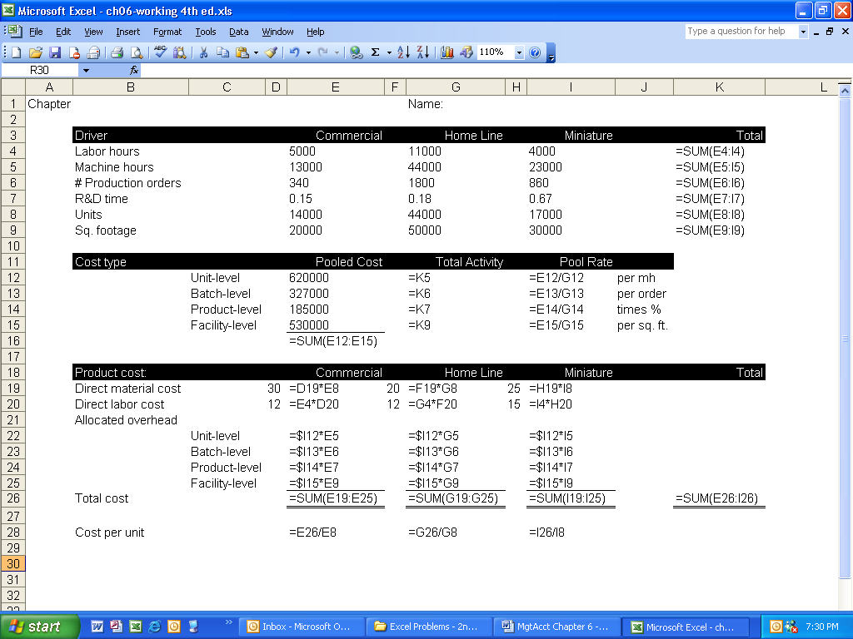

ATC 6-7

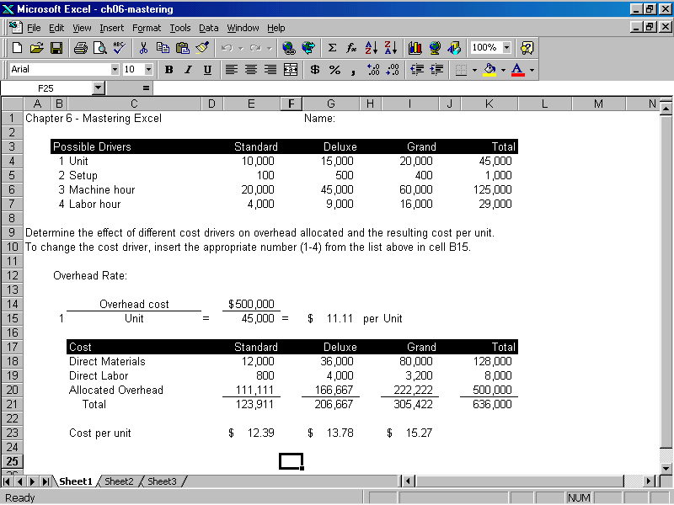
Screen capture of cell values:

ATC 6-7 (continued)

Screen capture of cell formulas:

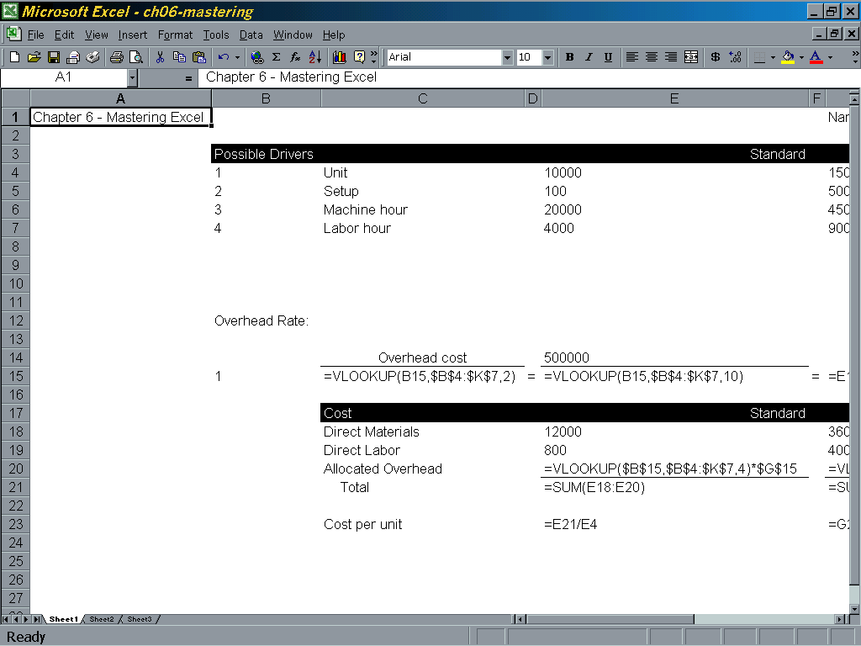
ATC 6-7 (continued)

Screen capture of cell formulas (continued):

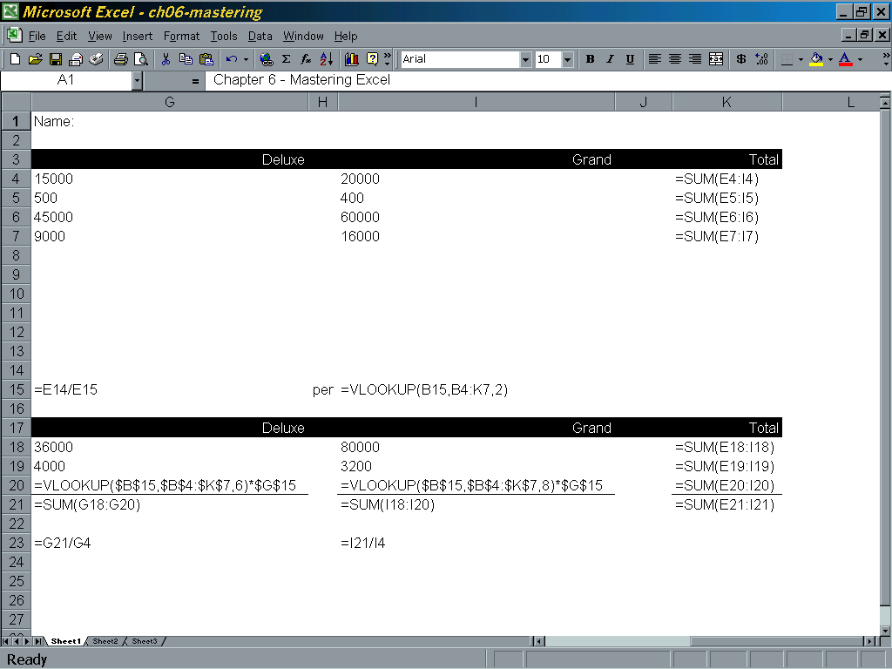

Chapter 6 -- Comprehensive Problem

Using number of units as the sole allocation base assigns the same amount of overhead cost to all units. In this case it is clear that some types of modems required different production activities than other modem types. Since production activities drive costs, assigning the same amount of cost to all modem types misallocates costs. Misallocating major costs destroys the usefulness of accounting information and leads to poor decisions.

One way to solve the misallocation problem is to find a more suitable volume-based cost driver. For example, setup costs could be allocated using number of batches rather than number of units. Indeed, Magnificent could use a number of activity-based cost drivers to improve the accuracy of indirect cost allocations. Based on the information provided in this case, it appears that Magnificent could benefit from the implementation of an activity based cost system.

