Answers to Questions

- Budgets are useful for large companies with complex activities as well as small companies. Budgets act as a vehicle for communication by formalizing management’s plans in a document that communicates company objectives. The benefits associated with this kind of planning apply to all sizes of companies operating at all levels of complexity.

- The budget represents the companywide plans stated in financial terms as to how to coordinate operating activities to accomplish goals and objectives. Accordingly, its success depends upon the combined effort of all of the parties involved. A committee that includes representatives from all pertinent departments is necessary to formulate the master budget.

- The three levels of planning are as follows:
- Strategic planning – the long-run planning activities that address issues such as overall company goals and objectives.
- Capital budgeting – the intermediate financial planning activities of the entire company that concern investments, product selection, and desired profitability.
- Operations budgeting – the short-run financial planning for the company’s different departments that culminates in the formation of a master budget.

- The span of time is the primary factor that distinguishes the three levels of planning from each other. Strategic planning involves long-range decisions; capital budgeting is associated with intermediate-range plans; and operational budgeting is concerned with short-range plans.

- The perpetual budget has the advantage of keeping management involved in the budget process. Too often budgets are prepared and forgotten. The perpetual budget forces management to maintain a constant focus on the company’s goals and objectives.

- The primary advantages associated with budgeting are as follows:
Planning – formalizes management’s plans in a document that communicates company objectives.
Coordination – forces departments to coordinate their activities in a manner that ensures the attainment of the objectives of the whole company.
Performance measurement – represents specific, quantitative standards that can be used to evaluate performance.
Corrective action – acts as an early warning system that promotes corrective action.

- Budgeted amounts represent management’s expectations regarding how the firm as a whole and individual departments within the firm should perform. By comparing actual performance with the expected performance (i.e., the budgeted amounts), managers can be effectively evaluated.

- Mr. Shilov’s failure with budgets seems to stem from his misunderstanding of the human element. He states that “he made budgets.” Experience shows that, in general, employees are more willing to accept budget standards if they participate in the budgeting process. Further, Mr. Shilov appears to have used the budget as a tool for punishment – a basis for reprimanding employees. As a result, employees would resent the budget and would be unmotivated to accomplish budget standards.

- A master budget consists of a series of detailed schedules and budgets that describe the overall financial plans for the forthcoming accounting period.

- The sales forecast normally functions as the starting point for the development of the master budget. Clearly, production and other related activities depend upon the level of sales.

- The desired level of ending inventory must be added to projected sales in order to determine the amount of goods that are needed during the period. The beginning inventory is subtracted from the amount of goods needed in order to determine the amount of goods to be produced. Managing inventory is important because an inventory shortage can result in customer dissatisfaction and loss of sales. Conversely, excess inventory ties up capital investment, creates unnecessary storage cost, and is subject to obsolescence or spoilage. Finding the balance between too much and too little inventory is essential to the profitability of a company.

- The cash budget is composed of three major components:

- Cash receipts – expected cash inflows from sales, sale of investments, and borrowing activities, etc.

- Cash payments – expected cash outflows for inventory purchases, selling and administrative costs, and purchases of investments, etc.

- Financing activities – expected borrowing and repayment activities.

- Determining the amount of the cash balance to include on the budgeted balance sheet is an insignificant reason for preparing a cash budget. The real purpose of preparing a cash budget is to enable a company to effectively manage its financing and investing activities. If the company can foresee a cash surplus then investment opportunities can be investigated to earn interest or debt can be repaid to reduce interest. If the company anticipates a cash shortage, appropriate sources of financing can be investigated to avoid possible bankruptcy. When dealing with large amounts of money, investing, borrowing, and repayment activities that involve interest can be critical to profitability.

- The pro forma income statement provides information about the expected profitability of the company. The completion of this statement is dependent on the departmental operating budgets. For example, the sales budget provides information about projected sales revenues, the purchases budget provides information as to projected cost of goods sold, the selling and administrative budget provides information about projected operating expenses, and the cash budget provides information as to expected interest revenue and expense.

- The cash budget, like the pro forma statement of cash flows, provides information as to expected cash receipts and cash payments, but in addition it shows how a firm plans to effectively manage its cash through financing and investing activities.

Exercise 7-1B

The primary deficiencies in Howard’s budgeting process are the absence of leadership and top management participation and the failure of the controller and department managers to coordinate their efforts. As a result of these flaws, department managers proposed budgets that would satisfy their individual needs at the expense of the company’s best interests.

Ms. Pruett should have established general corporate goals early in the budgeting process. She needn’t dictate company goals based on her personal ambitions; rather, she could have created a high-level committee to evaluate the company’s long-term competitive position in the market and to advise her regarding possible alternative future company goals. Once top management establishes company goals, individual departments should propose department-level goals and budgets to support the company’s general goals.

Mr. Snowden should have coordinated the budgeting process among the different departments to ensure that they would propose individual budgets in support of the company’s overall goals.

Exercise 7-2B

a.
Revenues Budget | Jul | Aug | Sep
Food sales | $20,000 | $21,000 | $22,050
Beverage and liquor sales | 12,000 | 12,600 | 13,230
Total budgeted revenues | $32,000 | $33,600 | $35,280

- The total revenue Addison’s will report on the 3rd quarter pro forma income statement is the sum of the monthly amounts, $32,000 + $33,600 + $35,280 = $100,880.

Exercise 7-3B

a.
Schedule of Cash Receipts | April | May | June
Current cash sales | $120,000 | $132,000 | $124,000
Plus collections from accounts receivable | 430,000 | 480,000 | 568,000
Total budgeted collections | $550,000 | $612,000 | $692,000

b. Since the current month’s sales on account will be collected in the following month, the amount of accounts receivable at the end of June is equal to June’s credit sales of $500,000.

Exercise 7-4B

a.

 | This Quarter | 1st Quarter | 2nd Quarter | 3rd Quarter | 4th Quarter
Falcon | $ 250,000 | $ 260,000 | $ 270,400 | $ 281,216 | $ 292,465
Ammons | 350,000 | 353,500 | 357,035 | 360,605 | 364,211
Ocean | 450,000 | 463,500 | 477,405 | 491,727 | 506,479
Total | $1,050,000 | $1,077,000 | $1,104,840 | $1,133,548 | $1,163,155

b. Corporate Budget

Budgeted | 1st Quarter | 2nd Quarter | 3rd Quarter | 4th Quarter | Annual
Income | $1,077,000 | $1,104,840 | $1,133,548 | $1,163,155 | $4,478,543

Exercise 7-5B

a. The expected cash collections in July are 50% of that month’s expected sales revenues. The computation follows:

$100,000 x 50% = $50,000

b. The expected cash collections in August are the sum of 50% of July’s expected revenues and 50% of August’s expected revenues. The computation follows:

$100,000 x 50% + $120,000 x 50% = $110,000

Exercise 7-6B

Sales would likely be high in February because of Valentine’s Day sales, in May because of Mother’s Day sales, in June because of Father’s Day sales, and in December because of Christmas sales. Sales should be relatively stable in other months since birthdays and other personal events occur in a normal distribution pattern.

Exercise 7-7B

a.
Inventory Purchases Budget
 | January | February | March
Budgeted cost of goods sold | $40,000 | $35,000 | $48,000
Plus desired ending inventory | 7,000 | 9,600 | 10,000
Inventory needed | 47,000 | 44,600 | 58,000
Less beginning inventory | 8,000 | 7,000 | 9,600
Required purchases (on account) | $39,000 | $37,600 | $48,400

- The amount of cost of goods sold reported on the first quarter income statement is the sum of the monthly amounts, $40,000 + $35,000 + $48,000 = $123,000.

c. Since the quarter ends on March 31, the ending inventory for March is also the ending inventory for the quarter, $10,000.

Exercise 7-8B

a.
Schedule of Cash Payments for Inventory Purchases
 | Oct. | Nov. | Dec.
Payment for current accounts payable | $17,500 | $16,800 | $21,700
Payment for previous accounts payable | 6,000 | 7,500 | 7,200
Total budgeted payments for inventory | $23,500 | $24,300 | $28,900

- Since 70% of current accounts payable are paid in cash in the month of purchase, 30% will remain payable at the end of any month ($31,000 x .30 = $9,300 at the end of December).

Exercise 7-9B

a. Budgeted cost goods sold for February is $410,000 ($400,000 x 1.025).

Desired February ending inventory balance | $ 25,000
Budgeted cost of goods sold | 410,000
Inventory needed in February | 435,000
Less: beginning inventory balance (January) | (22,000)
Budgeted February purchases | $413,000

b.

January’s payables balance paid in February | $ 30,000
Cash paid for February purchases ($413,000 x .6) | 247,800
Projected cash payments for February | $277,800

Exercise 7-10B

a.

Schedule of Cash Payments for Selling and Administrative Expenses
 | January | February | March
Equipment depreciation* | $ 0 | $ 0 | $ 0
100% of prior month's salary expense | 0 | 2,900 | 2,700
Cleaning supplies | 1,000 | 940 | 1,100
Insurance premium | 7,200 | 0 | 0
Equipment maintenance expense | 500 | 500 | 500
Leases expense | 1,600 | 1,600 | 1,600
Miscellaneous expenses | 400 | 400 | 400
Total payments for S&A expenses | $10,700 | $6,340 | $6,300
*Depreciation is a noncash charge.

b. Since salary expense is paid in the month following the month it is incurred, the amount payable at the end of March will be the amount of salary expense incurred in March ($3,050).

c. Since the annual insurance premium is prepaid on January 1, the amount of prepaid insurance at the end of March will be $5,400 [$7,200 – ($600 x 3)].

Exercise 7-11B

a. An inventory purchases budget prepared with Jenny’s estimate:

 | 1st Quarter | 2nd Quarter | 3rd Quarter | 4th Quarter
Sales | $320,000 | $400,000 | $280,000 | $360,000
Cost of goods sold | $192,000 | $240,000 | $168,000 | $216,000
Plus: ending inventory | 36,000 | 25,200 | 32,400 | 35,000
Inventory needed | 228,000 | 265,200 | 200,400 | 251,000
Less: beginning inventory | 25,000 | 36,000 | 25,200 | 32,400
Required purchases | $203,000 | $229,200 | $175,200 | $218,600

b. An inventory purchases budget prepared with Haley's estimate:
 | 1st Quarter | 2nd Quarter | 3rd Quarter | 4th Quarter
Sales | $280,000 | $300,000 | $320,000 | $400,000
Cost of goods sold | $168,000 | $180,000 | $192,000 | $240,000
Plus: ending inventory | 27,000 | 28,800 | 36,000 | 35,000
Inventory needed | 195,000 | 208,800 | 228,000 | 275,000
Less: beginning inventory | 25,000 | 27,000 | 28,800 | 36,000
Required purchases | $170,000 | $181,800 | $199,200 | $239,000

Exercise 7-12B
a. Budgeted payments for January 2008:
Office lease | $ 5,000
Utilities | 1,600
Office supplies | 2,400
Miscellaneous | 1,000
Total* | $10,000

*The referral fees are not included because cash payment for them will be made in February. The depreciation is not included because depreciation does not require a cash payment. Cash for depreciable assets is paid when the assets are purchased rather than when depreciation is recognized.

- The full $5,000 balance for the referral fees will remain payable at the end of January.
- Since the office lease is $5,000 each month, the annual lease expense will be $60,000 ($5,000 x 12).

Exercise 7-13B

a.

Cash Budget | July | August | September
Beginning cash balance | $ 16,000 | $ 4,000 | $ 4,000
Add cash receipts | 180,000 | 192,000 | 208,000
Cash available (a) | 196,000 | 196,000 | 212,000
Less disbursements
For inventory purchases | 158,000 | 153,000 | 171,000
For S&A expenses | 37,000 | 36,000 | 39,000
Interest exp. at 1% per month | 0 | 30¹ | 0
Total budgeted disbursements (b) | 195,000 | 189,030 | 210,000
Cash surplus (shortage) (a–b) | 1,000 | 6,970 | 2,000
Financing activity
Borrowing (repayment) (c) | 3,000 | (2,970) | 2,000
Ending cash balance (a – b + c) | $ 4,000 | $ 4,000 | $ 4,000

¹$3,000 x 1 % = $30
²($3,000 – $2,970) x 1% = 0 (rounded)

b. Net cash flows from operating activities equals total (sum of the monthly amounts) cash receipts from customers minus total (sum of the monthly amounts) cash payments for inventory, S&A expenses, and interest. The computation follows:

($180,000 + $192,000 + $208,000) – ($195,000 + $189,030 + $210,000)
= $580,000 – $594,030
= $(14,030) Net cash Outflow

c. Cash flow from financing activities is the amount borrowed less repayments. The computation follows:

$3,000 – $2,970 + $2,000 = $2,030 Net cash Inflow

Exercise 7-14B

a.
Cash Collections
Collections from June 30 receivables balance | $ 40,000
Collections from July’s credit sales ($320,000 x .75) | 240,000
July cash sales | 74,000
Total cash receipts in July |  | $354,000
Desired cash balance | 15,000
Cash disbursements in July | 400,000
Total July cash needs |  | 415,000
Cash shortage (amount to borrow) |  | $ 61,000

b. There will be no interest reported on July pro forma income statement because money was borrowed on the last date of the month.

c. Estimated Interest expense for August is $610 [$61,000 x (12%  12)].

Exercise 7-15B

a. Pro forma income statement prepared with Mr. Stull’s estimate:

 | 1st Quarter | 2nd Quarter | 3rd Quarter | 4th Quarter | Total
Sales Revenue | $252,000 | $210,000 | $226,800 | $329,700 | $1,018,500
Cost of Goods Sold | 126,000 | 105,000 | 113,400 | 164,850 | 509,250
Gross Margin | 126,000 | 105,000 | 113,400 | 164,850 | 509,250
S&A Expenses | 31,500 | 26,250 | 28,350 | 41,213* | 127,313
Net Income | $ 94,500 | $ 78,750 | $ 85,050 | $123,637 | $ 381,937
*rounded

b. Pro forma income statement prepared with Ms. Simpson’s estimate:

 | 1st Quarter | 2nd Quarter | 3rd Quarter | 4th Quarter | Total
Sales Revenue | $259,200 | $216,000 | $233,280 | $339,120 | $1,047,600
Cost of Goods Sold | 129,600 | 108,000 | 116,640 | 169,560 | 523,800
Gross Margin | 129,600 | 108,000 | 116,640 | 169,560 | 523,800
S&A Expenses | 32,400 | 27,000 | 29,160 | 42,390 | 130,950
Net Income | $ 97,200 | $ 81,000 | $ 87,480 | $127,170 | $ 392,850

Exercise 7-15B (continued)

c. Forecasting is not likely to be 100% accurate. It is based on inexact factors such as judgment and economic predictions. Different executive officers in the same company will probably have different future expectations. In addition to legitimate differences of opinion, self-interest may also contribute to disagreement. For example, Brian Stull, who deals with customers’ credit problems and uncollectible accounts, may want stricter criteria for granting customer credit, which would naturally result in lower sales growth. On the other hand, May Simpson, who deals with market potential and sales commissions, may want looser criteria for customer credit, which would result in greater sales growth.

Problem 7-16B

a.
Sales Budget | January | February | Total
Sales on Account | $840,000 | $924,000 | $1,764,000

b. Sales revenue for January and February is equal to the sum of the monthly amounts (i.e., $840,000 + $924,000 = $1,764,000).

c.

Schedule of Cash Receipts | January | February
Receipts from December Sales | $140,000
Receipts from January Sales | 672,000
Receipts from January Sales |  | $168,000
Receipts from February Sales |  | 739,200
Receipts from February Sales
Total | $812,000 | $907,200

d. The accounts receivable as of February 28, 2007 is equal to the amount due to be collected in March, $184,800 (i.e., $924,000 x 20%).

Problem 7-17B

a.

Inventory Purchases Budget | Oct. | Nov. | Dec.
Budgeted cost of goods sold | $480,000 | $576,000 | $720,000
Plus desired ending inventory | 115,200 | 144,000 | 120,000*
Inventory needed | 595,200 | 720,000 | 840,000
Less beginning inventory | 90,000 | 115,200 | 144,000
Required purchases (on account) | $505,200 | $604,800 | $696,000
*$800,000 x .75 x .20 = 120,000

b. Since the quarter ends on December 31, the ending inventory for December is also the ending inventory for the quarter (i.e., $120,000).

c.

Schedule of Cash Payments | Oct. | Nov. | Dec.
Payment of current accounts payable | $353,640 | $423,360 | $487,200
Payment of previous accounts payable | 90,000 | 151,560 | 181,440
Total budgeted payments for inventory | $443,640 | $574,920 | $668,640

d. Since the quarter ends on December 31, the ending accounts payable balance for December is the balance in accounts payable that will appear on the end of quarter pro forma balance sheet. 70% of the current purchases on account are paid in cash during the month of purchase; therefore, 30% will remain payable at the end of the month (i.e., $696,000 x .30 = $208,800).

Problem 7-18B

This is a typical problem for what-if analysis. Students can use a computerized spreadsheet to try different possible scenarios.

Budgeted net income for the next year: $60,000 x 120%= $72,000
Budgeted cost of goods sold for the next year:
$350,000 ÷ $500,000 = 70% of sales
Budgeted selling and administrative expenses for the next year:
$68,000 +10% of sales.

a. The budgeted sales that meet the goal:
If sales = X
Sales – Cost of goods sold – S&A expenses = NI
1X – .70X – ($68,000 + .10X) = $72,000
.20X – $68,000 = $72,000
.20X = $140,000
X = $700,000
($700,000 – $500,000) ÷ $500,000 = 40% increase in sales

Pro Forma Income Statement
Sales Revenue | $700,000
Cost of Goods Sold | 490,000
Gross Profit | 210,000
Selling & Admin. Expenses | 138,000*
Net Income | $ 72,000
*($700,000 x 10% + $68,000) = $138,000

b.
Budgeted cost of goods sold with a 3% cut:
$350,000 x 97% = $339,500
Budgeted gross profit: $500,000 – $339,500= $160,500
The budgeted level of selling and administrative expenses:
If X = S&A expenses
Gross Profit – X = $72,000
$160,500 – X = $72,000
X = $88,500

Problem 7-18B (continued)

Pro Forma Income Statement
Sales Revenue | $500,000
Cost of Goods Sold | 339,500
Gross Profit | 160,500
Selling & Admin. Expenses | 88,500*
Net Income | $ 72,000

*The figure means that management has to cut the selling and administrative expenses by $1,500 in order to reach Mr. Lowery’s goal.

c.

Projected sales revenue to increase by 25%:
$500,000 x 125%= $625,000
Projected cost of goods sold: $625,000 x 70% = $437,500

Pro Forma Income Statement
Sales Revenue | $625,000
Cost of Goods Sold | 437,500
Gross Profit | 187,500
Selling & Admin. Expenses | 150,000
Net Income | $ 37,500

Since the projected net income under the given scenario will be only $37,500, which is far short of the original $60,000 and the desired $72,000, the company cannot reach its goal.

Problem 7-19B
a.

Schedule of Cash Payments for S&A Expenses
 | Jan. | Feb. | Mar.
Salary expense | $ 8,000 | $ 8,000 | $ 8,000
Prior month's sales commissions | 0 | 600 | 640
Prior month's advertising expense | 0 | 500 | 500
Prior month's telephone expense | 0 | 1,000 | 1,080
Rent | 10,000 | 10,000 | 10,000
Miscellaneous | 800 | 800 | 800
Total payments for S&A expenses | $18,800 | $20,900 | $21,020
Depreciation is a noncash charge.

b. Since telephone expense is paid in the month following the month it is incurred, the amount payable at the end of March will be the amount of telephone expense incurred in March (i.e., $1,100).

c. Since sales commissions are paid in the month following the month they are incurred, the amount payable at the end of February will be the amount of sales commissions expense incurred in February (i.e., $640).

Problem 7-20B

Cash Budget | April | May |  | June
Beginning cash balance | $ 36,000 | $ 60,000 | $ 60,090
Add cash receipts | 320,000 | 470,000 | 624,000
Cash available (a) | 356,000 | 530,000 | 684,090
Less cash payments
For inventory purchases | 410,000 | 420,000 | 464,000
For S&A expenses | 80,000 | 106,000 | 132,000
Interest exp at 1% per month | 0¹ | 2,910² | 3,795³
Total budgeted payments (b) | 490,000 | 528,910 | 599,795
Payments minus receipts
Surplus (shortage) (a–b) | (134,000) | 1,090 | 84,295
Financing Activity
Borrowing (repayment) (c) | 194,000 | 59,000 | (24,295)
Ending cash balance (a – b + c) | $ 60,000 | $ 60,090 | $ 60,000

¹$0 x 1.5% = $0
²194,000 x 1.5% = $2,910
³($194,000 + $59,000) x 1.5% = $3,795

Problem 7-21B

When necessary, all computations are rounded to the nearest dollar.
a.
 | 1st Quarter | 2nd Quarter | 3rd Quarter | 4th Quarter | Total
Computer | $550,000 | $605,000 | $682,000 | $ 803,000 | $2,640,000
Calculator | 260,000 | 286,000 | 301,600 | 338,000 | 1,185,600
Total | $810,000 | $891,000 | $983,600 | $1,141,000 | $3,825,600

Problem 7-21B (continued)

b. Budgeted cost of goods sold: $3,825,600 x 75% = $2,869,200

Budgeted Annual Income Statement
Sales Revenue | $3,825,600
Cost of Goods Sold | 2,869,200
Gross Profit | 956,400
Selling & Admin. expenses | 500,000
Net Income | $ 456,400

c. Inventory purchases budget for palm-size computers:

 | 1st Quarter | 2nd Quarter | 3rd Quarter | 4th Quarter
Sales | $550,000 | $605,000 | $682,000 | $803,000
Cost of goods sold | $412,500 | $453,750 | $511,500 | $602,250
Plus: desired ending inventory | 45,375 | 51,150 | 60,225 | 88,000
Inventory needed | 457,875 | 504,900 | 571,725 | 690,250
Less: beginning inventory | 78,000 | 45,375 | 51,150 | 60,225
Required purchases | $379,875 | $459,525 | $520,575 | $630,025

Inventory purchases budget for programmable calculators:

 | 1st Quarter | 2nd Quarter | 3rd Quarter | 4th Quarter
Sales | $260,000 | $286,000 | $301,600 | $338,000
Cost of goods sold | $195,000 | $214,500 | $226,200 | $253,500
Plus: desired ending inventory | 21,450 | 22,620 | 25,350 | 42,000
Inventory needed | 216,450 | 237,120 | 251,550 | 295,500
Less: beginning inventory | 32,000 | 21,450 | 22,620 | 25,350
Required purchases | $184,450 | $215,670 | $228,930 | $270,150

Problem 7-22B (Note: All computations are rounded to the nearest whole dollar.)

a. & b.
Sales Budget
 |  |  |  |  |  |  | Pro Forma
Sales | Jan. |  | Feb. |  | Mar. |  | Data
Cash sales | $ 75,000 |  | $ 82,500 |  | $ 90,750
Sales on account | 175,000 |  | 192,500 |  | 211,750 |  | $211,750(a)
Total budgeted sales | $250,000 |  | $275,000 |  | $302,500 |  | 827,500(b)
Schedule of Cash Receipts
Current cash sales | $ 75,000 |  | $ 82,500 |  | $ 90,750
Plus collections from accts. rec. | 0 |  | 175,000 |  | 192,500
Total collections | $75,000 |  | $257,500 |  | $283,250 |  | $615,750 (c)
(a) Ending accounts receivable balance appearing on balance sheet.
(b) Sales Rev. appearing on income statement (i.e., sum of monthly amounts).
(c) Cash receipts from customers on statement of cash flows (i.e., sum of monthly amounts).

c. and d.
Inventory Purchases Budget
 |  |  |  | Pro Forma
 | Jan. | Feb. | Mar. | Data
Budgeted cost of goods sold | $125,000 | $137,500 | $151,250 | $413,750(a)
Plus desired ending inventory | 27,500 | 30,250 | 33,000 | 33,000(b)
Inventory needed | 152,500 | 167,750 | 184,250
Less beginning inventory | 0 | 27,500 | 30,250
Required purchases (on Acct.) | $152,500 | $140,250 | $154,000 | 61,600(c)
Schedule of Cash Payments Budget for Inventory Purchases
Pmt of current month's A/P | $91,500 | $ 84,150 | $ 92,400
Pmt for prior month's A/P | 0 | 61,000 | 56,100
Total budgeted Pmts for Invent. | $91,500 | $145,150 | $148,500 | $385,150(d)
(a) Cost of goods sold appearing on pro forma income statement (i.e., sum of monthly amounts).
(b) Ending inventory balance appearing on pro forma balance sheet.
(c) Ending accounts payable balance appearing on pro forma balance sheet (i.e., $154,000 x .4).
(d) Cash payments for inventory purchases on statement of cash flows (i.e., sum of monthly amounts).

Problem 7-22B (continued)

e. and f.
Selling and Administrative Expense Budget
 |  |  |  | Pro Forma
 | Jan. | Feb. | Mar. | Data
Salary expense | $25,000 | $25,000 | $25,000
Sales commissions 8% sales | 20,000 | 22,000 | 24,200 | $24,200(a)
Supplies expense 4% sales | 10,000 | 11,000 | 12,100
Utilities | 1,800 | 1,800 | 1,800 | 1,800(b)
Depreciation on store equipment | 5,000 | 5,000 | 5,000 | 15,000(c)
Rent | 7,200 | 7,200 | 7,200
Miscellaneous | 2,000 | 2,000 | 2,000
Total S&A expenses before interest | $71,000 | $74,000 | $77,300 | 222,300(d)
The determination of interest expense is shown in the cash budget.

Schedule of Cash Payments for S&A Expenses
Salary expense | $25,000 | $25,000 | $25,000
100% prior month's sales comm. | 0 | 20,000 | 22,000
Supplies expense | 10,000 | 11,000 | 12,100
100% prior month's utilities | 0 | 1,800 | 1,800
Depreciation on store equipment | 0 | 0 | 0
Rent | 7,200 | 7,200 | 7,200
Miscellaneous | 2,000 | 2,000 | 2,000
Total payments for S&A exp. | $44,200 | $67,000 | $70,100 | $181,300(e)
Depreciation is a noncash charge.
(a) Ending sales commissions payable account balance shown on pro forma balance sheet.
(b) Ending utilities payable account balance shown on pro forma balance sheet.
(c) Accumulated depreciation appears on the pro forma balance sheet (i.e., sum of monthly amounts).
(d) S&A expense appearing on pro forma income statement (i.e., sum of monthly amounts).
(e) Cash payments for S&A expenses on statement of cash flows (i.e., sum of monthly amounts).

Problem 7-22B (continued)

g.
Cash Budget
 |  |  |  | Pro Forma
 | Jan. | Feb. | Mar. | Data
Beginning cash balance | $ 0 | $ 50,300 | $ 50,000
Add cash receipts | 75,000 | 257,500 | 283,250 | $615,750(a)
Cash available (w) | 75,000 | 307,800 | 333,250
Less payments
For inventory purchases | 91,500 | 145,150 | 148,500 | 385,150(b)
For S&A expenses | 44,200 | 67,000 | 70,100 | 181,300(c)
Purchase of store fixtures | 350,000 | 0 | 0 | 350,000(d)
Interest expense* | 0 | 6,915 | 6,334 | 13,249(f)
Total budgeted payments (x) | 485,700 | 219,065 | 224,934
Payments minus receipts
Surplus (shortage) (w–x) | (410,700) | 88,735 | 108,316
Financing activity
Borrowing (repayment) (y) | 461,000 | (38,735) | (58,316) | 363,949(e)
Ending cash balance (w– x+ y) | $ 50,300 | $ 50,000 | $50,000 | 50,000(g)
*Jan. ($0 x .015); Feb. ($461,000 x .015); Mar. [($461,000 – $38,735) x .015]
(a) Operating activities section of pro forma statement of cash flows (i.e., sum of monthly amounts).
(b) Operating activities section of pro forma statement of cash flows (i.e., sum of monthly amounts).
(c) Operating activities section of pro forma statement of cash flows (i.e., sum of monthly amounts).
(d) Investing activities section of pro forma statement of cash flows. The investment in store fixtures also appears on the pro forma balance sheet.
(e) Financing activities section of pro forma statement of cash flows (i.e., sum of monthly amounts).
(f) Operating activities section of pro forma statement of cash flows (i.e., sum of monthly amounts).
(g) The ending cash balance appears on the pro forma balance sheet and as the last item in the statement of cash flows.

Problem 7-22B (continued)

h.
World Gifts Corporation
Pro Forma Income Statement
For the Quarter Ended March 31, 2008
Sales Revenue | $827,500
Cost of Goods Sold | (413,750)
Gross Margin | 413,750
S&A Expenses | (222,300)
Operating Income | 191,450
Interest Expense | (13,249)
Net Income | $178,201

i.
World Gifts Corporation
Pro Forma Balance Sheet
March 31, 2008
Assets
Cash |  | $ 50,000
Accounts Receivable |  | 211,750
Inventory |  | 33,000
Store Equipment | $350,000
Accumulated Depreciation | (15,000)
Book Value of Equipment |  | 335,000
Total Assets |  | $629,750
Liabilities
Accounts Payable |  | $ 61,600
Sales Commissions Payable |  | 24,200
Utilities Payable |  | 1,800
Line of Credit |  | 363,949
Equity
Retained Earnings |  | 178,201
Total Liabilities and Equity |  | $629,750
Problem 7-22B (continued)

j.
World Gifts Corporation
Pro Forma Statement of Cash Flows
For the Quarter Ended March 31, 2008
Cash Flow From Operating Activities
Cash Receipts from Customers | $615,750
Cash Payments for Inventory | (385,150)
Cash Payments for S&A Expenses | (181,300)
Cash Payments for Interest Expense | (13,249)
Net Cash Flow from Operating Activities |  | $ 36,051
Cash Flow From Investing Activities
Cash Outflow to purchase Fixtures |  | (350,000)
Cash Flow From Financing Activities
Net Inflow from Line-of-Credit |  | 363,949
Net Change in Cash |  | 50,000
Plus Beginning Cash Balance |  | 0
Ending Cash Balance |  | $ 50,000

Problem 7-23B

a. Pro forma income statement assuming a 4% annual growth rate:

 | Budget
Sales Revenue | $9,984,000
Cost of Goods Sold | 5,491,200
Gross Profit | 4,492,800
Selling & Admin. Expenses | 1,996,800
Net Income | $2,496,000

Problem 7-23B (continued)

b. Pro forma income statement assuming a 8% annual growth rate:

 | Budget
Sales Revenue | $10,368,000
Cost of Goods Sold | 5,702,400
Gross Profit | 4,665,600
Selling & Admin. Expenses | 2,073,600
Net Income | $2,592,000

c. Excess of actual net income over budget:

2,592,000 – $2,496,000 = $96,000

Bonus: $96,000 x 10% = $9,600

d. The process of participative budgeting is recommended. This process requires two-way communication between the president and divisional directors. Any disagreement on budget assumptions should be fully discussed and pros and cons well considered. If the president believes that the divisional budget is unrealistic, he/she should tell the vice president directly and explain the reasons. Participative budgeting is more than just a submission of a budget proposal from a subordinate and a review and final decision by the superior. The process described in the problem is nothing but gamesmanship.

It would be unethical if Ms. Pender proposes only a 4% growth rate because it not only reflects a dishonest estimate but also results in Ms. Pender’s personal gain at the expense of her employer. On the other hand, the company's plan to use the excess of actual income over budget as the basis for bonuses is an invitation for unethical behavior.

ATC 7-1

a.
Budgeted
Financial Statements
Income Statement | Amounts | Computations
Sales Revenue | $76,800 | 12 x $6,400
Cost of Goods Sold | (46,800) | 12 x $3,900
Depreciation Expense | (1,667) | ($4,000 – $500) ÷ 3
Other Expense | (1,200) | $5,200 – $4,000
Operating Income | 27,133
Interest Expense | (270) | $4,500 x .06
Net Income | $26,863
Statement of Cash Flows
Operating Activities:
Inflows from sales | $76,800 | 12 x $6,400
Outflows for:
Purchase of food, etc. | (46,800) | 12 x $3,900
Other initial expenses | (1,200) | $5,200 – $4,000
Interest Expense | (270) | $4,500 x .06
NCF Operating Activities | 28,530
Investing Activities:
Outflow for purchase of  cart | (4,000) | given
Financing Activities:
Inflows from:
Contribution by owners | 700 | given
Loan from parents | 4,500 | given
Financing Act. | 5,200
Net Change in Cash | 29,730
Plus beginning cash | 0
Ending cash balance | $29,730
ATC 7-1 (continued)

Budgeted
Financial Statements
continued
Balance Sheet | Amounts | Computations
Cash | $29,730 | from SCF
Food cart | 4,000 | given
Acc. Depreciation | (1,667) | ($4,000 – $500) ÷ 3
Total Assets | $32,063
Note Payable | $ 4,500 | given
Contributed Capital | 700 | given
Retained Earn. | 26,863 | from Inc. Statement
Total Liab. & Equity | $32,063

b. The budget financial statements above assume sales for each month of the year will be approximately equal to sales for September and October. Most likely, sales will be lower during periods between semesters, during the colder months, and during the summer session.

Also, the presentation above assumes the owners do not take any money out of the business. Obviously, they would need to use some of the earnings from the business to pay their living expenses.

ATC 7-2

a. Group Tasks

Task 1
 |  |  |  | Pro Forma
Sales | Oct | Nov | Dec | Data
Cash sales | $ 40,000 | $ 44,000 | $ 48,400
Sales on account | 140,000 | 154,000 | 169,400 | $169,400 | Accounts Rec.
Total budgeted sales | $180,000 | $198,000 | $217,800 | $595,800 | Sales Rev.

Schedule of Cash Receipts
 | October | November | December
Cash sales | $ 40,000 | $ 44,000 | $ 48,400
Collections from accounts receivable | 60,000 | 140,000 | 154,000
Total cash collections | $100,000 | $184,000 | $202,400

Task 2

 |  |  |  | Pro Forma
 | Oct | Nov | Dec | Data
Budgeted cost of goods sold | $72,000 | $79,200 | $87,120 | $238,320 | Cost of Goods Sold
Plus desired ending inventory | 14,400 | 15,840 | 17,424 | 17,424 | Ending Inventory
Inventory needed | 86,400 | 95,040 | 104,544
Less beginning inventory | 40,000 | 14,400 | 15,840
Required purchases (on account) | $46,400 | $80,640 | $88,704 | 22,176 | Accounts Payable

Schedule of Cash Payments Budget for Inventory Purchases
 | October | November | December
Pmt of current month's accts. pay. | $34,800 | $60,480 | $66,528
Pmt for prior month's accts. pay. | 72,000 | 11,600 | 20,160
Total budgeted pmts for inventory | $106,800 | $72,080 | $86,688

ATC 7-2 (continued)

Task 3

 |  |  |  | Pro Forma
 | Oct | Nov | Dec | Data
Sales commissions | $ 7,200 | $ 7,920 | $ 8,712 | $ 8,712 | Commissions pay
Supplies expense | 1,800 | 1,980 | 2,178
Utilities | 2,200 | 2,200 | 2,200 | 2,200 | Utility pay
Depreciation on store equipment | 1,600 | 1,600 | 1,600 | 4,800 | Accum. dep.
Salary expense | 34,000 | 34,000 | 34,000
Rent | 6,000 | 6,000 | 6,000
Miscellaneous | 1,000 | 1,000 | 1,000
Total S&A expenses before interest | $53,800 | $54,700 | $55,690 | $164,190 |  | S&A Exp.

b. Financial Statements

Income Statement
Sales Revenue | $595,800
Cost of Goods Sold | (238,320)
Gross Margin | 357,480
Operating Expenses | (164,190)
Operating Income | 193,290
Interest Expense | (2,530)
Net Income | $190,760

ATC 7-2 (continued)

Balance Sheet
Assets
Cash |  |  |  | $ 9,760
Accounts Receivable |  |  |  | 169,400
Inventory |  |  |  | 17,424
Store Equipment |  |  | $200,000
Accumulated Depreciation Store Equipment |  |  | (81,600)
Book Value of Equipment |  |  |  | 118,400
Total Assets |  |  |  | $314,984
Liabilities
Accounts Payable |  |  |  | $ 22,176
Utilities Payable |  |  |  | 2,200
Sales Commissions Payable |  |  |  | 8,712
Line of Credit |  |  |  | 23,936
Equity
Common Stock |  |  |  | 50,000
Retained Earnings |  |  |  | 207,960
Total Liabilities and Equity |  |  |  | $314,984

c. Havel will need to borrow money in October.

Cash Budget for October
Beginning cash balance | $ 16,000
Add cash receipts | 100,000 (1)
Cash available | 116,000
Less disbursements
For inventory purchases | 106,800 (2)
For S&A expenses | 42,800 (3)
Total budgeted disbursements | 149,600
Payments minus receipts = Shortage | $33,600

ATC 7-2 (continued)

(1) $40,000 cash sales + $60,000 collection on September accounts receivable.
(2) $34,800 payment for Oct. Inventory + $72,000 payment on September accounts payable.
(3) $53,800 October S&A expenses – $7,200 sales commissions – $2,200 Utilities expense – $1,600 depreciation = $42,800

ATC 7-3

a. The five steps of budgeting identified by the author are:
- planning
- controlling
- coordinating
- motivation
- evaluation

b. The article defines “the Three C’s” of motivation for those preparing a budget as:

- Choice of employees who make decisions relevant to the budget.
- Collaboration of employees from different areas, i.e., “multi-functional teams.”
- Content of what is to be accomplished. That is, employees involved in the budgeting process should be given meaningful tasks to accomplish, not just small parts of a bigger budgeting objective.

c. “Activity budgeting” is an outgrowth of activity based costing. Under activity budgeting a budget is organized by “… expected costs of activities rather than products, services, or resources…”

d. “Global budgeting” has nothing to do with international issues. Rather, it relates to preparing a budget that is easier to read and use. To accomplish this, the author recommends preparing a budget with a few, relevant spending lines rather than one with a lot of detail.

e. The author suggests that more budget categories be devoted to variable-cost categories.

ATC 7-4

HON could use a technique known as perpetual or continuous budgeting. This technique utilizes a twelve-month budgeting period. However, at the completion of the current month, a new month is added to the end of the budget period. The result is a continuous twelve-month budget. The advantage of the perpetual budget is that it keeps management involved in the budget process. The traditional approach too often leads to a frenzied stop-and-go mentality. The annual budget is prepared in a year-end rush, and the assumptions underlying its formation are forgotten shortly thereafter. Changing conditions are not likely to be discussed until the next year-end review cycle. The perpetual budget overcomes these shortcomings by keeping management involved with the budget. Each month a new monthly budget is prepared to replace the budget of the ending month. Management is thereby forced into a constant twelve-month think-ahead process.

ATC 7-5

a. Mr. Cleaver’s behavior could be construed to be in violation of the objectivity standards. The failure to disclose the lack of need for computers to the Board of Education would violate (1) the standard to communicate information fairly and objectively and (2) the standard to disclose fully all relevant information that could reasonably be expected to influence an intended user’s understanding of the reports, comments, and recommendations presented. However, Mr. Cleaver could have disclosed all information fairly to the board. He is correct in his assessment that neither he nor Ms. Simmons has the right to establish policy. Also, it should be noted that Mr. Cleaver may not be a member of the Institute of Management Accountants and is therefore not bound by the organization’s code of ethics.

b. Sarbanes-Oxley Act requires management of public companies to report accurately the financial statements to external users such as investors and creditors. This case does not involve external reporting, and, consequently, the law is not applicable.

c. As its name implies, participative budgeting encourages participation by subordinates as well as upper level managers in the budget process. Information flows from the bottom up as well as from the top down during the preparation of the budget. Accordingly, the Board of Education members would be in a position to gain insight as to the true needs of the schools and would thereby be more likely to allocate funds where they would produce the greatest benefit.

ATC 7-6

Screen capture of cell values:

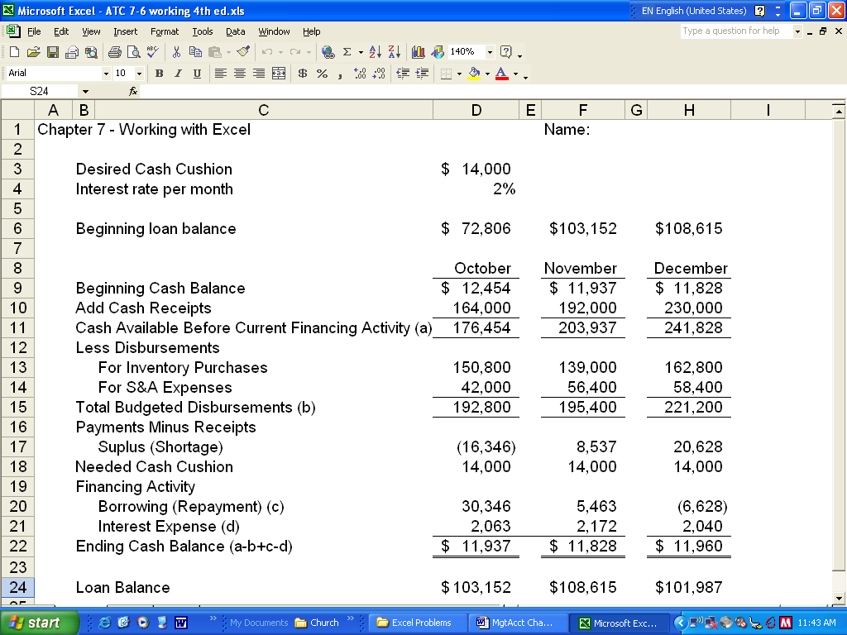

ATC 7-6 (continued)

Screen capture of cell formulas:

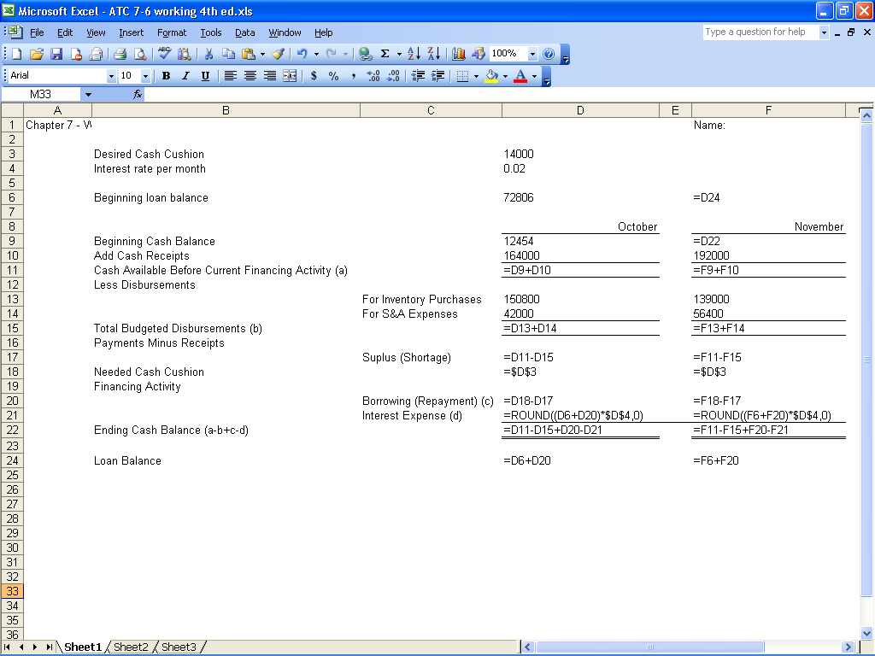

ATC 7-6

Screen capture of cell formulas (continued):

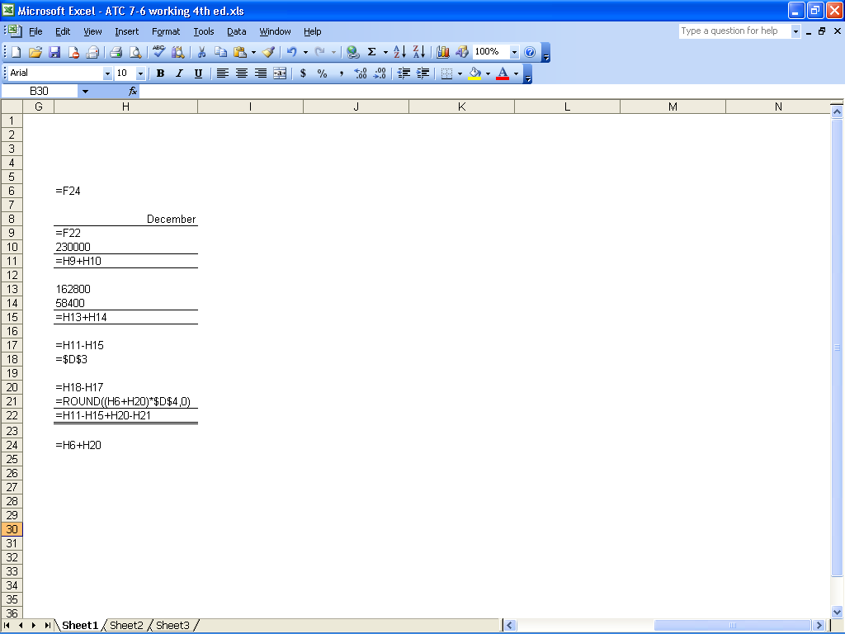

ATC 7-7

Screen capture of cell values:
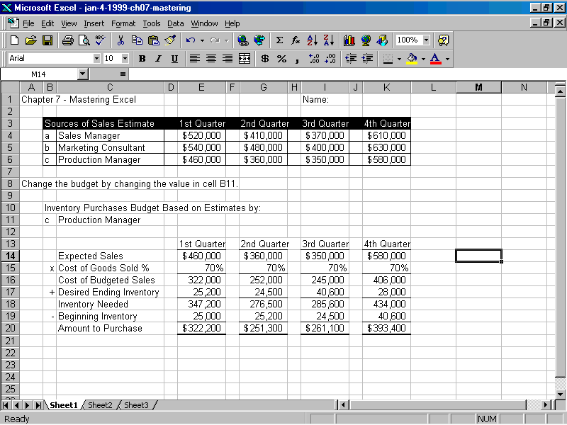

ATC 7-7

Screen capture of cell formulas:
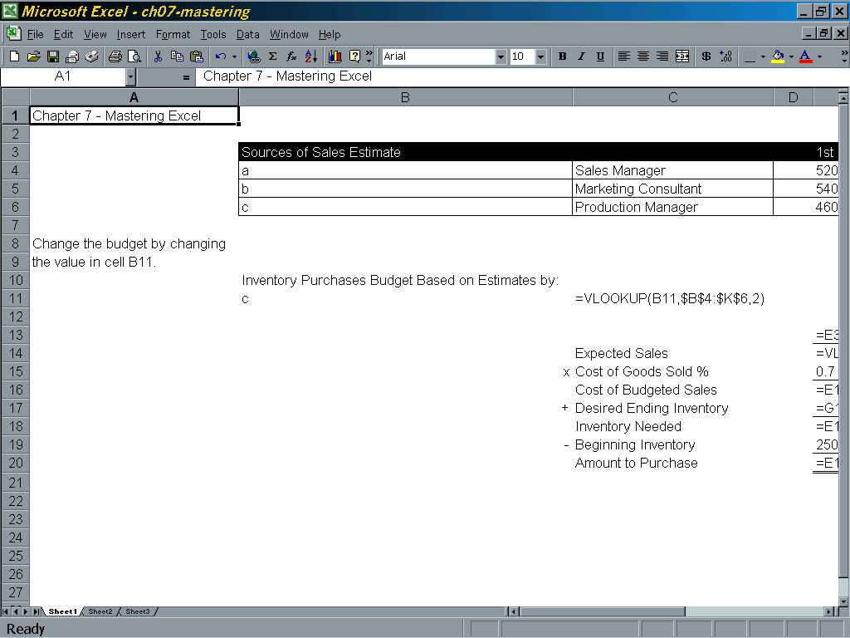

ATC 7-7

Screen capture of cell formulas (continued):

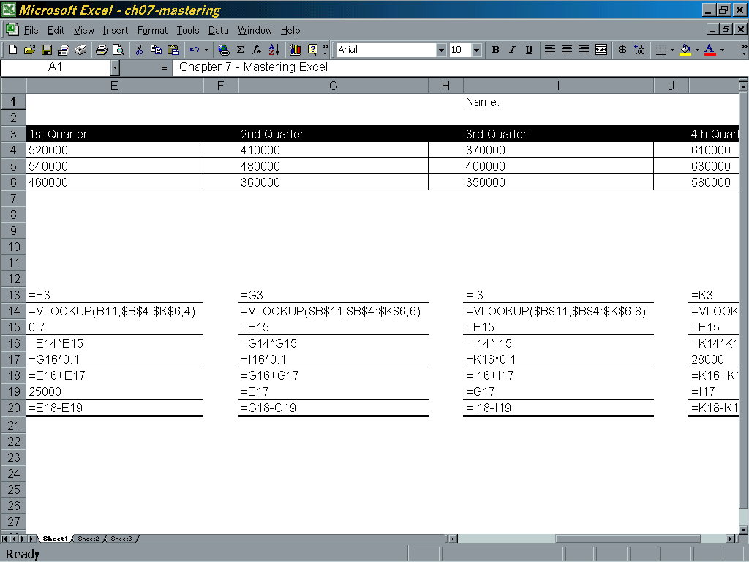

ATC 7-7

Screen capture of cell formulas (continued):

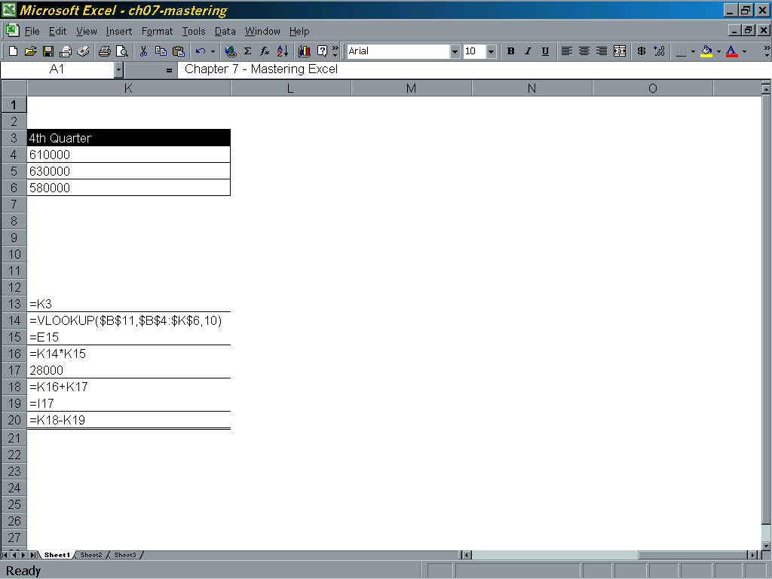

Chapter 7 Comprehensive Problem
 | Growth Rate of Sales |  | 0.01
 | Sales Budget
 | Sales | Jan | Feb | Mar
 | Cash sales | $10,000 | $10,100 | $10,201
 | Sales on account | 50,000 | 50,500 | 51,005
 | Total budgeted sales | $60,000 | $60,600 | $61,206
 | Schedule of Cash Receipts
 | Current cash sales | $10,000 | 10,100 | 10,201
 | Plus collections from accts. rec. | 48,000 | 50,000 | 50,500
 | Total budgeted collections | $58,000 | 60,100 | 60,701
 | Growth Rate of Sales |  | 0.02
 | Sales Budget
 | Sales | Jan | Feb | Mar
 | Cash sales | $10,000 | $10,200 | $10,404
 | Sales on account | 50,000 | 51,000 | 52,020
 | Total budgeted sales | $60,000 | $61,200 | $62,424
 | Schedule of Cash Receipts
 | Current cash sales | $10,000 | $10,200 | $10,404
 | Plus collections from accts. rec. | 48,000 | 50,000 | 51,000
 | Total budgeted collections | $58,000 | $60,200 | $61,404

 | Growth Rate of Sales |  | 0.04
 | Sales Budget
 | Sales | Jan | Feb | Mar
 | Cash sales | $10,000 | $10,400 | $10,816
 | Sales on account | 50,000 | 52,000 | 54,080
 | Total budgeted sales | $60,000 | $62,400 | $64,896
 | Schedule of Cash Receipts
 | Current cash sales | $10,000 | $10,400 | $10,816
 | Plus collections from accts. rec. | 48,000 | 50,000 | 52,000
 | Total budgeted collections | $58,000 | $60,400 | $62,816

