Answers to Questions

1. A static budget is based on the expected or planned volume of activity. An example of a static budget would be the master budget prepared for planning purposes. Flexible budgets differ from static budgets in that they show the estimated amount of revenues and costs that are planned at a variety of different levels of activity. Static budgets are used for planning purposes in determining labor, material, cash, and equipment needs for a variety of different potential activity levels. Flexible budgets are used also for performance evaluation. Since flexible budgets can be prepared for the actual level of activity, volume influences on budget variances can be isolated allowing departments, managers, or employees to be evaluated on the price and usage of materials, labor, and overhead. These are factors over which they have control and would be reasonable measures of performance.

2. Mr. Smith is assessing his performance based on a comparison between a static budget and actual results. Since a static budget is based on the planned level of activity, Mr. Smith’s numbers could be the result of a decrease in production. The volume of sales determines the level of production. Costs would be less if fewer units were produced than planned. To judge Mr. Smith’s performance fairly, his results should be compared with a flexible budget in order to eliminate the effects of sales volume over which Mr. Smith has no control.

3. Sales variances are favorable when actual sales are greater than planned sales and are unfavorable when actual sales are less than planned sales. Cost variances are favorable when actual costs are less than planned costs and are unfavorable when actual costs are greater than planned costs.

4. Many circumstances at the production level could affect Joan’s sales. Low quality control in the production process could lead to lower quality goods that are difficult to sell. Delays in the production process could affect the availability of products and inhibit sales volume. Failures in the production department to satisfy customer specifications could also limit sales. Careful investigation of significant sales volume variances can substantiate who is responsible for poor sales performance.

5. To determine volume variances a static budget based on planned volume is compared to a flexible budget based on actual volume. When actual volume is greater, variable costs are planned to be greater under the flexible budget. Variable costs increase proportionately with volume increases. Since sales revenues also increase proportionately with increases in volume, the increase in costs is off set by an increase in volume, thereby resulting in a higher contribution margin. Unfavorable variable cost volume variances should not be interpreted as poor performance until there is a significant decrease in contribution margin. If the increase in volume affects costs per unit, there may be some justification for concern.

6. Sales revenues could increase because of either an increase in sales volume or an increase in the sales price. The increase in sales volume could have resulted from the actions of the marketing manager or could have resulted from circumstances or decisions that were outside the manager's control. For instance, the increase in sales volume may have been the result of a market-wide increase in consumer demand, not the result of decisions made by the marketing manager to lure customers away from competitors. The increase in sales could also have been the result of the marketing manager lowering prices, which may or may not have been profitable. Only if the increased demand was of greater magnitude than the decrease in price, accompanied by an increase in contribution margin, would the lowering of sales prices be reason to congratulate the marketing manager.

7. The amount of fixed costs will remain the same under planned or actual volume. Based on this cost behavior when actual volume is greater than planned, there will be a decrease in the fixed cost per unit. This decrease in fixed unit costs represents the principle of operating leverage. Operating leverage means that with the existence of fixed costs, percentage increases in sales volume result in significantly greater percentage increases in profitability. Therefore, when actual volume is greater than planned, more dramatic increases in profitability can be planned because of operating leverage.

8. Flexible budget variances are determined by taking the difference between flexible budget amounts (based on standard per unit costs and actual volume) and actual amounts (based on actual per unit costs and actual volume). The resultant variances are caused by differences between the standard and actual per unit costs since the volume of activity is the same for both amounts.

9. To determine if the marketing department’s variances are favorable or unfavorable overall, the combination of variances requires analysis. The magnitude of the price variance versus the magnitude of the volume variance would have to be compared. If the magnitude of the unfavorable volume variance is less than the magnitude of the favorable price variance, then raising prices greater than was planned would have been a good strategy even though actual consumer demand was lower than planned. The results of any one variance cannot be interpreted in isolation. The combination of all significant variances needs consideration in determining good or bad performance.

10. Standards represent “what should be” price, cost, and quantity per unit amounts based on a certain set of anticipated circumstances. Effective standard setting requires experience, judgment, and predictive capacity for price, cost, and quantity decisions. Historical data provides a good starting point for their establishment. The historical data is then revised based on relevant information and other considerations. Information to be considered would include: changes in technology, plant layout, methods of production, and worker productivity; engineering reports based on research to establish efficient performance of work tasks, or efficient utilization of materials; labor, purchase, and transportation contracts; production demands to determine volume and the need for overtime. Behavioral considerations with regard to the extent of employee participation in standard setting and the desired level of difficulty must also be taken into account.

11. The three ranges of difficulty in standard setting are as follows:

Ideal standards – These standards represent perfection with no allowances for normal materials waste and spoilage, and labor inefficiencies. These standards are unattainable and are not useful for motivating most employees.

Practical standards – Standards that can be achieved with a reasonable degree of effort. They allow for normal levels of inefficiency in materials and labor usage. Since they represent attainable goals, they have the most motivational appeal to employees.

Lax standards – Standards that represent easily attainable goals that can be accomplished with minimal effort. They lack motivational appeal for most employees because they require minimal effort and result in continual success.

12. Carl is right. Not all variances can be investigated and to try to do so would be inefficient use of management talent. Several factors are important to consider in determining which variances merit investigation. The first of these factors is materiality. Only the material favorable and unfavorable variances should be investigated. Materiality guidelines in terms of set dollar or percentage limits can indicate which variances to investigate. The frequency of occurrence of the variance is another important consideration. A small variance that is repeated throughout the year can amount to a large significant variance when the total annual amount is considered. The capacity to control variances by corrective action must be considered. Variances that are not controllable should not monopolize a manager’s time. Finally, there are certain items that permit management abuse and variances associated with these items need close investigation. Expenditures on maintenance, research and development, and advertising can be shortchanged to produce favorable variances but the reductions may have long-term adverse impacts on profitability.

13. The primary benefit of using a standard cost system is the promotion of the efficient use of management talent to control costs. Management can identify areas requiring special analyses, which facilitates the practice of management by exception.

14. The plant manager seems to be overreacting. Many factors that are not under the control of the supervisor may have caused the unfavorable usage variance. For example, the standard may be unrealistically high or the materials may have been inferior because the purchasing department compromised quality for a lower price. More importantly, a standard cost system should be used to help personnel improve performance. If it is used in a threatening or abusive manner, it will have a negative effect on motivation that will outweigh its potential benefits.

15. Favorable as well as unfavorable variances should be investigated. For example, a favorable materials variance may indicate that employees are sacrificing quality in an effort to save materials. Favorable variances do not always imply positive results.
16. The two factors that affect the total materials and labor variances are price and quantity.

17. The company’s purchasing agent is normally held responsible for price variances. Some factors that are beyond his control that could cause unfavorable price variances include: suppliers charging higher prices, strikes that force the use of alternative materials or transportation modes, rush orders, and changes in planned quantities to be produced.

18. The use of semiskilled employees to perform highly skilled tasks or vice versa could result in labor price variances even when the established rate per hour is paid to employees.

19. Production department supervisors are normally held responsible for labor usage variances.

20. When actual volume is lower than planned volume, fixed overhead costs must be spread over fewer units than anticipated. This results in a higher cost per unit of product. The higher cost per unit is caused by a failure to take advantage of the economies of scale with higher volumes, thus resulting in an unfavorable overhead volume variance. An unfavorable volume variance signifies the underutilization of facilities rather than over- or under-spending.

21. When actual fixed overhead costs are less than budgeted fixed overhead costs, a favorable overhead spending variance will result.

Exercise 8-1B

Item to Classify | Standard | Actual | Type of  Variance
Sale volume | 38,000 units | 36,750 units | Unfavorable
Sales price | $6.90 per unit | $6.78 per unit | Unfavorable
Materials cost | $2.10 per pound | $2.30 per pound | Unfavorable
Materials usage | 102,400 pounds | 103,700 pounds | Unfavorable
Labor cost | $8.25 per hour | $8.80 per hour | Unfavorable
Labor usage | 56,980 hours | 55,790 hours | Favorable
Fixed cost spending | $249,000 | $244,000 | Favorable
Fixed cost per unit (volume) | $2.51 per unit | $3.22 per unit | Unfavorable

Exercise 8-2B

Item | Budget | Actual | Variance | F or U
Sales revenue | $620,000 | $650,000 | $30,000 | F
Cost of goods sold | $450,000 | $400,000 | $50,000 | F
Material purchases at 10,000 pounds | $260,000 | $290,000 | $30,000 | U
Materials usage | $270,000 | $260,000 | $10,000 | F
Sales price | $550 | $560 | $10 | F
Production volume | 890 units | 900 units | 10 units | F
Wages at 7,600 hours | $91,200 | $90,800 | $400 | F
Labor usage | 7,600 | 8,000 | 400 hours | U
Research and development expense | $81,000 | $90,000 | $9,000 | U
Selling and administrative expenses | $75,000 | $71,000 | $4,000 | F

Exercise 8-3B
 | Price / Cost  per Unit | a.  Master  Budget  18,000 Units |  | b.  Flexible  Budget  19,000 Units
Sales | $12 | $216,000 |  | $228,000
Variable manufacturing | $ 8 | (144,000) |  | (152,000)
Contribution margin |  | 72,000 |  | 76,000
Fixed manufacturing |  | (20,000) |  | (20,000)
Fixed selling and admin. |  | (18,000) |  | (18,000)
Net income |  | $ 34,000 |  | $ 38,000

Exercise 8-4B
 | Master  Budget  18,000 Units |  | Flexible  Budget  19,000 Units |  | a. & b.  Activity  Variances
Sales | $216,000 |  | $228,000 |  | $12,000 F
Variable manufacturing | (144,000) |  | (152,000) |  | 8,000 U
Contribution margin | 72,000 |  | 76,000 |  | 4,000 F
Fixed manufacturing | (20,000) |  | (20,000) |  | 0
Fixed selling and admin. | (18,000) |  | (18,000) |  | 0
Net income | $ 34,000 |  | $ 38,000 |  | $ 4,000 F

Exercise 8-4B (continued)

c. Since the per unit sales price and per unit variable manufacturing costs are the same for both the master and flexible budgets, the activity variances are solely attributable to the fact that sales volume was 1,000 units more than planned. The favorable $12,000 sales variance suggests that increased sales are beneficial. However, Irvin needs more information before drawing this conclusion. The increase in sales may have resulted from reducing the actual sales price which could produce negative consequences. The unfavorable $8,000 variable manufacturing cost variance is misleading. The total amount of variable cost is expected to increase when volume increases. This variance is expected and not a bad thing. Upper-level marketing managers are normally responsible for the sales volume variances.

d. The fixed costs in both the master and flexible budgets are estimates. Total fixed costs are assumed to be constant regardless of the volume of production and sales. Therefore, no variance between the master and flexible budgets is expected for fixed costs.

e.
 | Master  Budget |  | Flexible  Budget
Fixed manufacturing | $20,000 |  | $20,000
Fixed selling and admin. | 18,000 |  | 18,000
Total fixed cost (a) | $38,000 |  | $38,000
Units (b) | 18,000 |  | 19,000
Cost per unit (a ÷ b) | $2.11 |  | $2.00

The increase in sales volume reduces the fixed cost per unit, thereby increasing profitability. If the company uses a cost-plus pricing strategy, overstating cost per unit (underestimating volume) could result in overpricing the company’s product. The company could lose market share to competitors who offer lower prices.

Exercise 8-5B

 | Flexible  Budget  19,000 Units |  | Actual  Price / Cost at  19,000 Units |  | a. & b.  Flexible  Budget  Variances
Sales | $228,000 |  | $226,100¹ |  | $1,900 U
Variable manufacturing | (152,000) |  | (151,050)² |  | 950 F
Contribution margin | 76,000 |  | 75,050 |  | 950 U
Fixed manufacturing | (20,000) |  | (21,000) |  | 1,000 U
Fixed selling and admin. | (18,000) |  | (17,300) |  | 700 F
Net income | $ 38,000 |  | $ 36,750 |  | $1,250 U

¹Actual sales: $11.90 x 19,000 units = $226,100
²Actual variable cost: $7.95 x 19,000 units = $151,050

c. The unfavorable flexible budget sales variance results from actually selling products below the planned price. To properly interpret this result, Irvin must also consider the sales volume variance. As shown in Exercise 8-4B, the sales volume variance was $12,000 favorable. A rational explanation for the two variances is that management sought to increase sales volume by reducing the sales price. The strategy succeeded because the reduction in sales dollars caused by selling products at a lower price ($1,900 unfavorable flexible budget variance) was more than offset by the increase in sales volume ($12,000 favorable sales volume variance) and total contribution margin increased.

The variable manufacturing cost variance ($950 favorable) is normally the responsibility of the purchasing agent or production supervisor. The variance suggests that either the purchasing agent paid less than planned or that employees used less than the planned amount of resources. The fixed manufacturing cost variance indicates that the company spent more than planned for those resources. The favorable fixed selling and administrative cost variance indicates that the company spent less than planned for those fixed costs. A variety of managers may be responsible for fixed cost variances.

Exercise 8-6B
a.
 | Flexible  Budget  30,000 Hours |  | Flexible  Budget  35,000 Hours |  | Flexible  Budget  40,000 Hours
Sales ($40/hr) | $1,200,000 |  | $1,400,000 |  | $1,600,000
Variable cost ($25/hr) | (750,000) |  | (875,000) |  | (1,000,000)
Contribution margin | 450,000 |  | 525,000 |  | 600,000
Fixed cost | 550,000 |  | 550,000 |  | 550,000
Net income | $ (100,000) |  | $ (25,000) |  | $ 50,000

b. The flexible budgets indicate that Escott will have to operate at the upper end of the estimated sales volume range in order to produce a profit. Therefore, the venture appears to be risky. However, the large amount of fixed cost (high operating leverage) indicates that significant profit potential exists for future years if Escott can increase the sales volume as the new office becomes well established.

Exercise 8-7B

a.
 | Master  Budget  400 Roofs |  | Flexible  Budget  450 Roofs |  | Sales  Volume  Variance
Sales ($420 per roof) | $168,000 |  | $189,000 |  | $21,000 F

b.
 | Flexible  Budget  450 Roofs |  | Actual  Revenue for  450 Roofs |  | Flexible  Budget  Variance
Sales | $189,000 |  | $175,500¹ |  | $13,500 U
¹Actual sales: $390 x 450 roofs = $175,500

c. Reducing the sales price increased revenues. The favorable sales volume variance is greater than the unfavorable flexible budget variance. The result is greater total sales than was planned.

Exercise 8-8B

Mr. Piedra’s arguments are flawed. Since fixed costs are not affected by changes in the volume of activity, the unfavorable spending variance is unrelated to the favorable volume variance. Further, the scenario described in the problem suggests that the marketing director is responsible for the favorable volume variance. Mr. Piedra appears to be attempting to cover for his poor performance by claiming credit for the hard work and successful performance of the new marketing director.

Exercise 8-9B

The data in the problem suggest that employees can produce three units of software for each hour of labor (180,000 units / 60,000 hours = 3 units per hour). Employees should therefore have taken 70,000 labor hours (210,000 units / 3 units per hour) to complete the actual volume of software units. At the standard labor price, the production department should have incurred $1,330,000 (70,000 hours x $19 per hour) of labor cost. Since the actual labor cost was $1,323,000, the flexible budget labor variance is $7,000 favorable ($1,330,000 – $1,323,000). The Vice President of Manufacturing should praise the production supervisor.

Exercise 8-10B

a. Materials usage variance =
|Actual quantity – Standard quantity| x Standard price
|22,100 oz. – (3,800 servings x 6 oz.)| x .20 = $140 F

b. Possible explanations for the favorable usage variance include: (1) clerks used less than an average of 6 ounces of candy in each serving; (2) the sales clerks overcharged some customers (e.g., charged a customer for two servings and provided only one serving).

Exercise 8-11B

a. |Actual cost per unit – Standard cost per unit | x Actual units
|$0.80 – $0.72| x 198,000 = $15,840 U

b. |Actual price – Standard price | x Actual quantity
|$0.32 – $0.30| x (2.5 x198,000) = $9,900 U

c. |Actual quantity – Standard quantity | x Standard price
| (2.5 x 198,000) – (2.4 x 198,000) | x $0.30 = $5,940 U

d. Price variance $ 9,900 Unfavorable
Usage variance 5,940 Unfavorable
Total variance $15,840 Unfavorable

Exercise 8-12B

a. |Actual price – Standard price | x Actual quantity
|$0.40 – $0.39| x (2.1 x 97,000) = $2,037 U

b. |Actual quantity – Standard quantity | x Standard price
| (2.1 x 97,000) – (2.0 x 97,000) | x $0.39 = $3,783 U

c. Poor production scheduling could have forced the purchasing department to make hasty buying decisions without adequate time to shop for good prices, resulting in paying more than the standard cost for materials.

Exercise 8-13B

a. The personnel manager may have failed to do a thorough search for qualified employees who were willing to work for the standard labor price.

b. The production manager may have scheduled work poorly thereby incurring overtime cost. Alternatively, poor scheduling could contribute to labor shortages, forcing the personnel manager to hire whatever labor was available on short notice.

Exercise 8-14B

a. | Labor Variance Information Table | Amounts
 | Standard cost per lawn ($12 x 2 hours) | $24.00
 | Actual cost per lawn ($14 x 1.75 hours) | $24.50
 | Actual number of lawns serviced | 500

|Actual cost – Standard cost| x Actual units
|$24.50 – $24.00| x 500 = $250 Unfavorable

b. |Actual price – Standard price| x Actual hours
|$14 – $12| x (1.75 x 500) = $1,750 Unfavorable

c. |Actual hours – Standard hours| x Standard price
|(1.75 x 500) – (2 x 500)| x $12 = $1,500 Favorable

d. The unfavorable price variance could have been due to a failure to conduct a proper search for employees. It could also have been due to poor planning that resulted in overtime pay. Other explanations are possible.

The favorable usage variance could be due to hiring better employees who worked harder than planned. The fact that employees were paid more than the standard labor price supports this explanation. Alternatively, the production supervisor could have motivated the employees to work harder than expected.

Exercise 8-15B

a. |Actual price – Standard price| x Actual quantity = Price variance
|$14.80 – $15.00| x (125 x Act. labor hrs. used per treatment) = $15
125 x Actual labor hrs. used per treatment = 15 / .2
125 x Actual labor hrs. used per treatment = 75
Actual labor hrs. used per treatment = 75 / 125
Actual labor hrs. used per treatment = .6

b. Since the actual hours per treatment (.6) is greater than the standard hours (.5) the labor usage variance would be unfavorable.

Exercise 8-16B

a. |Actual cost – Standard cost| x Actual hours
|$9.50 – $10.00| x 152,000 = $76,000 Favorable

b. If particular variable overhead costs are significant companies may choose to isolate the variances associated with these particular costs. Analyzing specific variable overhead cost variances would require that a company establish multiple predetermined overhead rates, each relating to specific overhead costs, to overcome the interpretation problem inherent in using a single companywide rate.

Exercise 8-17B

a. Actual fixed overhead costs $2,750,000
Budgeted overhead cost (19,000 x $135) 2,565,000
Spending variance $ 185,000 U

The spending variance measures whether the actual amount spent on fixed cost was more or less than the planned amount. Many different managers could be responsible for the fixed cost spending variance. For example, upper management may be responsible for paying more than planned for rent on the manufacturing facility while the production manager may be responsible for paying more than planned for a supervisor’s salary.

b. Budgeted fixed overhead cost (19,000 x $135) $2,565,000
Applied overhead (20,000 x $135) 2,700,000
Volume variance $ 135,000 F

The favorable fixed overhead volume variance means that the company produced more products than planned, resulting in a lower than planned cost per unit. If the variance had been unfavorable, it would mean that the company produced fewer units of product than planned, resulting in a higher than planned cost per unit.

Problem 8-18B

a. & b.
 |  |  | Master Budget |  | Flexible Budgets
Number of units |  |  | 200,000 |  | 180,000 | 220,000
 |  | Per Unit
 |  | Standards
Sales revenue |  | $25.96 | $5,192,000 |  | $4,672,800 | $5,711,200

Variable manufacturing costs
Materials |  | $9.00 | (1,800,000) |  | (1,620,000) | (1,980,000)
Labor |  | $2.60 | (520,000) |  | (468,000) | (572,000)
Overhead |  | $0.56 | (112,000) |  | (100,800) | (123,200)
Variable G,S,&A |  | $4.20 | (840,000) |  | (756,000) | (924,000)
Contribution margin |  |  | 1,920,000 |  | 1,728,000 | 2,112,000

Fixed costs
Manufacturing |  |  | (500,000) |  | (500,000) | (500,000)
G,S,&A |  |  | (360,000) |  | (360,000) | (360,000)
Net income |  |  | $1,060,000 |  | $ 868,000 | $1,252,000
c. & d.
Number of units |  |  | 200,000 | 190,000
 |  | Per Unit | Master | Flexible
 |  | Standards | Budget | Budget | Variances
Sales revenue |  | $25.96 | $5,192,000 | $4,932,400 | $259,600 U

Variable manufacturing costs
Materials |  | $9.00 | (1,800,000) | (1,710,000) | 90,000 F
Labor |  | $2.60 | (520,000) | (494,000) | 26,000 F
Overhead |  | $0.56 | (112,000) | (106,400) | 5,600 F
Variable G,S,&A |  | $4.20 | (840,000) | (798,000) | 42,000 F
Contribution margin |  |  | 1,920,000 | 1,824,000 | 96,000 U

Fixed costs
Manufacturing |  |  | (500,000) | (500,000) | 0
G,S,&A |  |  | (360,000) | (360,000) | 0
Net income |  |  | $1,060,000 | $ 964,000 | $96,000 U

e. The sales volume variances are useful in determining how changes in sales volume affect revenues and costs. Since the flexible budget is computed at standard prices and costs, the variances do not provide insight into differences between standard prices and costs and actual prices and costs.

Problem 8-19B

a. & b.

Number of units |  | 216,000 | 216,000
 |  | Flexible | Actual
 |  | Budget | Results | Variances
Sales revenue |  | $5,607,360 | $5,572,800 | $34,560 U
Variable manufacturing costs
Materials |  | (1,944,000) | (1,900,800) | 43,200 F
Labor |  | (561,600) | (578,880) | 17,280 U
Overhead |  | (120,960) | (120,960) | 0
Variable G,S,&A |  | (907,200) | (950,400) | 43,200 U
Contribution margin |  | 2,073,600 | 2,021,760 | 51,840 U

Fixed costs
Manufacturing |  | (500,000) | (512,000) | 12,000 U
G,S,&A |  | (360,000) | (356,000) | 4,000 F
Net income |  | $1,213,600 | $1,153,760 | $59,840 U

c. Upper-level marketing managers are responsible for the sales variance. These managers are normally responsible for establishing the sale price. In this case the actual sales price is less than the planned sales price, thereby causing an unfavorable flexible budget variance ($34,560).

Mid-level production supervisors are normally responsible for the variable manufacturing cost variances. The favorable materials variance could have been caused by better usage efficiency or by paying less than the standard materials price. The unfavorable labor variance could have been caused by lower worker efficiency or by paying higher than the standard labor price.

Problem 8-19B (continued)

Many different managers may be responsible for fixed manufacturing cost variances. For example, a plant manager may be responsible for setting supervisory salaries while the chief executive officer may be responsible for determining the salary of the plant manager. In this case, the unfavorable variance could have been caused by higher than planned salary costs. Many different managers may be responsible for fixed selling and administrative costs. For example, a marketing manager may be responsible for advertising costs while the manager of the electronic data processing center may be responsible for purchases of computer equipment. The favorable variance could have been generated when a marketing manager paid less than the budgeted amount for advertising.

Problem 8-20B

 |  | a. |  | b. |  | c.
 | Standard  Costs per Can | Master Budget  $3.00 Price @ 600,000 Cans |  | Flexible Budget  $2.70 Price @810,000 Cans |  | Flexible Budget  $3.25 Price @400,000 Cans
Sales revenue |  | $1,800,000 |  | $2,187,000 |  | $1,300,000
Variable costs:
Materials cost | $1.05 | (630,000) |  | (850,500) |  | (420,000)
Labor cost | $0.64 | (384,000) |  | (518,400) |  | (256,000)
Overhead cost | $0.10 | (60,000) |  | (81,000) |  | (40,000)
G, S, & A cost | $0.25 | (150,000) |  | (202,500) |  | (100,000)
Contribution margin |  | 576,000 |  | 534,600 |  | 484,000
Fixed costs:
Production |  | (215,000) |  | (215,000) |  | (215,000)
G, S, & A cost |  | (180,000) |  | (180,000) |  | (180,000)
Net income |  | $ 181,000 |  | $ 139,600 |  | $ 89,000

d. Since the price of $3.00 per can generates the highest net income, this pricing strategy should be implemented.

Problem 8-21B

a. The flexible budget materials variances are computed on the basis of the actual quantity (i.e., 102,000 swimsuits).

b. Actual price per yard = $1,653,600 ÷ 636,000 = $2.60 Per yard

c. Standard quantity = 6 yards x 102,000 Swimsuits = 612,000 yards

d. Price variance =⎥Actual price – Standard price⎥ x Actual quantity
Price variance ⎥$2.60 – $2.50⎥ x 636,000 = $63,600 Unfavorable

e. ⎪Standard quantity – Actual quantity⎪ x Standard price
⎪612,000 – 636,000 ⎪ x $2.50 = $60,000 Unfavorable

Problem 8-22B

a. Employees should be evaluated on the basis of the work they actually did rather than the work that was planned in the static budget. Accordingly, the labor variances should be based on the actual units made (i.e., 102,000 swimsuits).

b. | Labor Variance Information Table | Amounts
 | Standard price per hour | $15.00
 | Actual price per hour  ($1,647,800 / 107,000 hours) | $15.40
 | Standard hours for flexible budget  (1.0 Hrs. per swimsuit x 102,000 swimsuits) | 102,000 Hrs.
 | Actual hours used | 107,000 Hrs.

c. Labor price variance = ⎪Standard price – Actual price⎪ x Actual hours
Labor price variance = ⎪$15 – $15.40⎪x 107,000 = $42,800 Unfavorable

d. Labor usage var. =⎪Standard Hrs. – Actual Hrs. ⎪ x Standard price
Labor usage var. = ⎪102,000 Hrs. – 107,000 Hrs. ⎪ x $15.00
=$75,000 Unfavorable
Problem 8-23B

a. |  | Total expected overhead costs
 | Predetermined overhead rate = | –––––––––––––––––––––––––––––––
 |  | Total expected units

 |  | $600,000
 | Predetermined overhead rate = | ––––––––––––––––– | = $3 per unit
 |  | 200,000

b. Spending variance = ⎟Actual overhead – Budgeted overhead⎟
Spending variance = ⎟$592,000 – $600,000⎟ = $8,000 Favorable

The variance is favorable because the actual fixed overhead costs were less than the standard overhead.

c. Overhead volume variance =⎥Budgeted overhead – Applied overhead⎥
Overhead volume variance =⎥$600,000 – ($3 x 187,000)⎥
=$39,000 Unfavorable

The variance is unfavorable because the company produced fewer units than planned, thereby increasing the fixed cost per unit.

Problem 8-24B

a. | Materials Variance Information Table | Amounts
 | Standard price per pound | $1.50
 | Actual price per pound | $1.60
 | Standard quantity for flexible budget  (2 pounds per unit x 10,800 units) | 21,600 pounds
 | Actual quantity used  (1.9 pounds per unit x 10,800 units) | 20,520 pounds

b. Materials price variance:

⎥ Actual price – Standard price⎥ x Actual quantity = price variance
⎥ $1.60 – $1.50⎥ x 20,520 pounds = $2,052 Unfavorable

The variance is unfavorable because the actual price was higher than the standard price.

Materials usage variance:

⎟Actual quantity – Standard quantity⎟ x Standard price = Usage variance
⎟ 20,520 – 21,600⎟ x $1.50 = $1,620 Favorable

The variance is favorable because the actual quantity used was less than the standard quantity.

c. | Labor Variance Information Table | Amounts
 | Standard price per hour | $10.00
 | Actual price per hour | $8.00
 | Standard hours for flexible budget  (0.5 hours per unit x 10,800 units) | 5,400 hours
 | Actual hours used  (0.6 hours per unit x 10,800 units) | 6,480 hours

d. Labor price variance:

⎟Actual price – Standard price⎟ x Actual hours = Price variance
⎟ $8.00 – $10.00⎟ x 6,480 hours = $12,960

The variance is favorable because the actual price paid for labor was less than the standard price.
Problem 8-24B (continued)

Labor usage variance:

⎟Actual hours – Standard hours⎟ x Standard price= Usage variance
⎟ 6,480 – 5,400⎟ x $10.00 = $10,800 Unfavorable

The variance is unfavorable because the actual hours used was more than the standard hours.

e. |  | Total planned overhead costs
 | Predetermined overhead rate = | ————————————––––———
 |  | Total expected units

 |  | $12,000
 | Predetermined overhead rate = | ————————– | = $1.20 per unit
 |  | 10,000

f. Overhead spending variance =⎥Actual overhead – Budgeted overhead⎥
Overhead spending variance =⎥$12,400 – $12,000⎥
Overhead spending variance = $400 Unfavorable
The variance is unfavorable because the company spent more than it expected to spend.

g. Overhead volume variance = ⎥Budgeted overhead – Applied overhead⎥
Overhead volume variance = ⎥$12,000 – ($1.20 x 10,800)⎥
Overhead volume variance = $960 Favorable
The variance is favorable because the company produced more units than planned, thereby reducing the fixed cost per unit.

Problem 8-25B

a. | Materials Variance Information Table | Amounts
 | Standard price per Square Foot | $0.25
 | Actual price per Square Foot | $0.24
 | Standard quantity for flexible budget  (1 Square Foot per unit x 208,000 units) | 208,000 Square Feet
 | Actual quantity used | 230,000 Square Feet

b. Materials price variance:

⎟Actual price – Standard price⎟ x Actual quantity = Price variance
⎟$0.24 – $0.25⎟ x 208,000 Square Feet = $2,080 Favorable

The variance is favorable because the actual price was less than the standard price.

Materials usage variance:

⎟Actual quantity – Standard quantity⎟ x Standard price = Usage var.
⎟ 230,000 – 208,000⎟ x $0.25 = $5,500 Unfavorable

The variance is unfavorable because the actual quantity is more than the standard quantity.

c. | Labor Variance Information Table | Amounts
 | Standard price per hour | $7.00
 | Actual price per hour | $6.90
 | Standard hours for flexible budget  (0.2 hours per unit x 208,000 units) | 41,600 hours
 | Actual hours used | 39,600 hours

d. Labor price variance:

⎟Actual price – Standard price⎟ x Actual hours =Price variance
⎟ $6.90 – $7.00⎟ x 39,600 Hours = $3,960 Favorable
The variance is favorable because the actual price paid was less than the standard price.

Problem 8-25B (continued)

Labor usage variance:

⎟Actual hours – Standard hours⎟ x Standard price = Usage variance
⎟ 39,600 – 41,600⎟ x $7.00 = $14,000 Favorable

The variance is favorable because the actual hours were less than the standard hours.

e. |  | Total planned overhead costs
 | Predetermined overhead Rate = | ————–––———————————
 |  | Total expected units

 |  | $200,000
 | Predetermined overhead Rate = | —————— | = $0.50 per unit
 |  | 400,000

f. Spending variance = ⎟Actual overhead – Budgeted overhead⎟
Spending variance = ⎟$102,000 – $100,000⎟ = $2,000 Unfavorable

The variance is unfavorable because actual fixed overhead costs were more than the budgeted overhead.

Overhead volume variance =⎥Budgeted overhead – Applied overhead⎥
Overhead volume variance =⎥$100,000 – ($0.50 x 208,000)⎥ =$4,000 Favorable

The variance is favorable because the company produced more units than planned, thereby reducing the fixed cost per unit.

g. Actual costs will appear on the company’s income statement. Accordingly, the amount of gross margin is computed as follows:

Sales | $707,200
Cost of goods sold:
Cost of materials ($0.24 x 230,000) | (55,200)
Cost of labor ($6.90 x 39,600) | (273,240)
Cost of overhead | (102,000)
Gross margin | $276,760

Problem 8-26B

a. |SQ – AQ| x SP = Usage variance
SQ = 2.50 x 8,000 = 20,000 pounds
|20,000 – AQ| x $2.00 = $400 favorable
|20,000 – AQ| = 200
Since the variance is favorable, the actual quantity used must be less than the standard quantity.
AQ = 19,800 pounds

b. |SP – AP| x AQ = Price variance
|$2.00 – AP| x 19,800 = $792 favorable
|$2.00 – AP| = $0.04
Since the variance is favorable, the actual price must be less than the standard price.
AP = $1.96

c. |SHrs – AHrs| x SP = Usage variance
SHrs = 0.60 x 8,000 = 4,800 hours
|4,800 – AHrs| x $12 = $960 unfavorable
|4,800 – AHrs| = 80
Since the variance is unfavorable, the actual labor hours used must be more than the standard hours.
AHrs = 4,880

d. |SP – AP| x AHrs = Price variance
|$12.00 – AP| x 4,880 = $1,952 Unfavorable
|$12.00 – AP| = $0.40
Since the variance is unfavorable, the actual price must be greater than the standard price.
AP = $12.40

Problem 8-27B

a. and b.
Cost |  | Computation | = | Standard Cost per Wheel
Direct material |  | 2 lbs. per unit x $5.50 per lb. |  | $11.00
Direct labor |  | 2.5 hours per unit x $8.00 per hour |  | $20.00
Overhead |  | $168,000/12,000 |  | $14.00
Total per wheel |  |  |  | $45.00

c. and d.

Cost |  | Computation | = | Actual Cost per Wheel
Direct material |  | $175,500/14,400 actual units |  | $12.19
Direct labor |  | 2.2 hrs./unit x $8.40/hr. = |  | $18.48
Overhead |  | $180,000/14,400 |  | $12.50
Total per wheel |  |  |  | $43.17

e.

COST |  | COMPUTATION |  | VARIANCE
Direct material:
Price var. |  | ($5.50/lb - $5.85*/lb) x 30,000 lbs.  *$175,500 ÷ 30,000 lbs = $5.85/lb |  | $10,500 (U)
Usage var. |  | (28,800 lbs* - 30,000 lbs) $5.5/lb |  | $ 6,600 (U)
 |  | *2 lbs/ unit x 14,400 actual units

Direct labor
Price var. |  | ($8/hr - $8.40/hr) x 31,680 hrs* |  | $12,672 (U)
 |  | *2.2 hrs/unit x 14,400 actual units
Usage var. |  | (36,000 hrs* – 31,680 hrs.) x $8/hr |  | $34,560 (F)
 |  | *2.5 hrs/unit x 14,400 actual units

Problem 8-27B (continued)

All the variances need consideration for investigation. Management selects variances for investigation based on materiality, frequency, capacity to control, and susceptibility to management abuse. The favorable labor usage variance may have been the result of using a more experienced and costly work force resulting in the unfavorable labor price variance. Other causes may have been effective planning to reduce labor waste, high morale, or superior supervision.

f.
FIXED OH COST |  | COMPUTATION |  | VARIANCE
Spending var. |  | $168,000 bud. OH – $180,000 actual OH |  | $12,000 (U)
Volume var. |  | $168,000 M. bud. – $201,600 applied OH*
 |  | *$168,000/12,000 = $14 std cost per unit |  | $33,600(F)
 |  | $14 x 14,400 actual units = $201,600

The unfavorable spending variance indicates that more was spent for fixed overhead than was budgeted or planned. The favorable volume variance occurred because more units were produced than planned. Therefore, the cost per unit for fixed overhead was less than planned (operating leverage). The volume variance is a capacity utilization measure. Since costs are fixed, the more units produced the more profit can be made (economies of scale).

Problem 8-28B

a.
 | Master  Budget | – | Flexible  Budget | = | Variance
Expenses:
Variable expenses
Refreshments | $ 375 (1) |  | $ 450 (3) |  | $ (75)
Postage | 312 (2) |  | 351 (4) |  | (39)
Step expenses
Printing | 500 |  | 550 (5) |  | (50)
Facility | 250 |  | 350 (6) |  | (100)
Fixed expenses
Dinner | 200 |  | 200 |  | 0
Gift | 100 |  | 100 |  | 0
Publicity | 50 |  | 50 |  | 0
Total | $1,787 |  | $2,051 |  | $(264)

(1) 375 attendees x $1 charge = $375
(2) 800 mailings @ $.39 = $312.
(3) 450 attendees x $1 charge = $450
(4) 900 mailings @ $.39 = $351
(5) $500 for 800 invitations + $50 for an additional 100.
(6) Since original room capacity was 400, attendance of 450 necessitated the next larger room that cost $350.

The volume variances indicate that the department incurred $264.00 more cost than planned because more people than planned attended the presentation. You would expect unfavorable variances for variable costs and step costs. Since more people are attending, total variable and step costs will increase. Fixed costs are planned to stay constant since they are not affected by volume. Accordingly, there are no fixed cost variances.

Problem 8-28B (continued)

b.

 | Flexible  Budget | – | Actual  Results | = | Variances
Expenses:
Variable expenses
Refreshments | $ 450 |  | $ 450 |  | 0
Postage | 351 |  | 3510 |  | 0
Step expenses
Printing | 550 |  | 550 |  | 0
Facility | 350 |  | 350 |  | 0
Fixed expenses
Dinner | 200 |  | 230 |  | ($30)
Gift | 100 |  | 100 |  | 0
Publicity | 50 |  | 75 |  | (25)
Total | $2,051 |  | $2,106 |  | ($55)

The refreshment, postage, facility, and printing variances are no longer unfavorable. There are no variances for these costs since the actual and budgeted costs per unit or per step are the same and both budgets are based on the actual number of attendees (i.e. 450). However, the flexible budget fixed cost variances for the dinner and publicity represent spending variances. These variances are not related to volume. In other words, even though the budget and actual volume are the same, the department spent more on the dinner and for publicity than was planned.

Problem 8-28B (continued)

c. Budgeted fixed cost per unit: $350/375 = $0.933
Actual fixed cost per unit: $405*/450 = $0.900

*$230 + $100 + $75 = $405

The difference in the two amounts is meaningless from a pricing perspective because the department is a not-for-profit entity that is not charging participants for the lecture. Even so, the fact that fixed cost per unit is lower than planned is an indication that the department has been more effective in providing service to the community. Specifically, insights of the speaker were disseminated to a wider audience at the same fixed cost. Accordingly, the cost of dissemination per participant is lower.

d. The department has a limited supply of funds at its disposal. If too much money is spent on the DVL, there will be less money available for other expenditures such as faculty travel, supplies, equipment purchases, scholarships. Controlling cost is important to not-for-profit entities the same as it is for profit-oriented businesses.

ATC 8-1

a. The increase in sales volume was not achieved by lowering the sales price. The budgeted sales price was $15 per unit (i.e., $3,750,000 ÷ 250,000 units). The actual sales price was $15.1923 per unit (i.e., $3,950,000 ÷ 260,000 units). Some other factor such as increased advertising or a general rise in demand due to a robust economy caused the increase in sales.

b. There is a problem with the performance evaluation system. Performance evaluation should be based on flexible budget variances rather than the activity variances.

c. To prepare a flexible budget, first determine the budgeted sales price, and the standard cost per unit for materials, labor, overhead, and G,S,&A. These amounts are shown below:

 | Dollars |  | Units |  | Cost per Unit
Sales Price | $3,750,000 | ÷ | 250,000 | = | $15.00
Materials | 600,000 | ÷ | 250,000 | = | $2.40
Labor | 312,500 | ÷ | 250,000 | = | $1.25
Overhead | 337,500 | ÷ | 250,000 | = | $1.35
G,S, and A | 475,000 | ÷ | 250,000 | = | $1.90

ATC 8-1 (continued)

The flexible budget variances are shown below.

 | Flexible | Actual
 | Budget | Results | Variances
Number of Units | 260,000 | 260,000 | 0
Sales Revenue | $3,900,000 | $3,950,000 | $50,000 | Favorable
Variable Manuf. Costs
Materials ($2.40/unit) | (624,000) | (622,200) | 1,800 | Favorable
Labor ($1.25/unit) | (325,000) | (321,000) | 4,000 | Favorable
Overhead ($1.35/unit) | (351,000) | (354,700) | 3,700 | Unfavorable
Variable G,S,&A ($1.90/unit) | (494,000) | (501,300) | 7,300 | Unfavorable
Contribution Margin ($8.10/unit) | 2,106,000 | 2,150,800 | 44,800 | Favorable
Fixed Costs
Manufacturing | (1,275,000) | (1,273,100) | 1,900 | Favorable
G,S,&A | (470,000) | (479,300) | 9,300 | Unfavorable
Net Income | $ 361,000 | $ 398,400 | $ 37,400 | Favorable

d. A cost is defined as fixed if it does not change when there is a change in activity, but there are other things that can cause a “fixed” cost to change. For example, the monthly rental rate charged by a landlord can be increased, or the property tax rate charged by a municipality can be raised or lowered.

e. Scenario 1: The favorable price variance may have been attained by purchasing low-quality materials. This could have led to waste in the production process that was beyond Mr. Delo’s control. Scenario 2: Mr. Delo could have failed to properly supervise the workers under his control. The workers could have developed poor work habits that led to unnecessary waste of materials.
ATC 8-1 (continued)

f. Recall that the total variance is composed of price and usage variances. Note that the total labor variance was favorable (see part c above). Accordingly, if the labor price variance was unfavorable, the usage variance had to be favorable; otherwise the total could not have been favorable.

g. The fixed overhead volume variance was favorable, because more units were produced than were budgeted (260,000 vs. 250,000).

ATC 8-2

a. Task 1 ⎯ Materials variances

Total variance
|Actual cost – Standard cost| x Actual units
|$44.10 – $40.00| x 82,000 = $336,200 Unfavorable

Price variance

|Actual price – Standard price| x Actual quantity
|$2.10 – $2.00| x (21 x 82,000) = $172,200 Unfavorable

Usage variance

|Actual quantity – Standard quantity| x Standard price
| (21 x 82,000) – (20 x 82,000) | x $2.00 = $164,000 Unfavorable

The unfavorable price variance indicates that the KTI paid more than planned for the planks of wood. The party responsible for the price variance is the purchasing agent. The purchasing agent could have been careless (i.e., the failure to shop around, to obtain quantity discounts, or to buy the right quality of lumber). The variance could have been due to factors beyond the purchasing agent’s control (e.g., inflation, lumber shortage).

The unfavorable usage variance indicates that KTI used more materials than should have been used to make 82,000 tables. The responsible party is the production supervisor. The variance could be due to factors within control of the production supervisor. Examples include failure to motivate workers, or failure to physically control inventory thereby permitting inventory to be lost, damaged, or stolen. The factors could be beyond the control of the supervisor. For example, the quality of the wood could be poor, resulting in waste.

ATC 8-2 (continued)

a. Task 2 ⎯ Labor variances
Total variance
|Actual cost – Standard cost| x Actual units
|$26.10 – $25.50| x 82,000 = $49,200 Unfavorable

Price variance
|Actual price – Standard price| x Actual quantity
|$9.00 – $8.50| x (2.9 x 82,000) = $118,900 Unfavorable

Usage variance
|Actual quantity – Standard quantity | x Standard price
| (2.9 x 82,000) – (3 x 82,000) | x $8.50 = $69,700 Favorable

The unfavorable price variance indicates that KTI paid more for labor than the company planned to pay. The responsible party could be the personnel manager or the production supervisor. The personnel manager could have agreed to pay a higher wage. The production supervisor could have authorized overtime pay. The cause could be beyond anyone’s control. For example, the government may have raised the minimum wage.
The favorable usage variance indicated that KTI used less labor than was planned in order to make 82,000 tables. The responsible party could have been the personnel manager or the production supervisor. The personnel manager could have hired more competent employees. The production manager could have engaged in practices that highly motivated employees.

a. Task 3 ⎯ Fixed overhead variances
Spending variance: |Actual fixed cost − Budgeted fixed cost|
|$1,328,400 − $1,280,000| = $48,400 Unfavorable

Volume variance: Applied overhead − Budgeted fixed cost
|$1,312,000* − $1,280,000| = $32,000 Favorable
*Predetermined overhead rate = $1,280,000 ÷ 80,000 = $16 per Table
$16 per table x 82,000 tables = $1,312,000

ATC 8-2 (continued)

The unfavorable spending variance indicates that the company paid more than planned for fixed cost. The responsible party is difficult to identify because the cost(s) that increased are not known. Rent on the manufacturing equipment could be the responsibility of the plant manager. Salaries paid to supervisors could be the responsibility of the personnel manager. More detail would be required to identify the specific cause of the variance and the responsible party.

The favorable volume variance indicates that KTI made and sold more units than planned, which reduced the fixed cost per unit.

b. | Materials price variance | $172,200 | Unfavorable
 | Materials usage variance | 164,000 | Unfavorable
 | Labor price variance | 118,900 | Unfavorable
 | Labor usage variance | 69,700 | Favorable
 | Fixed cost spending variance | 48,400 | Unfavorable
 | Total | $433,800 | Unfavorable

c. She should encourage a fair and impartial investigation as to the cause and responsible parties. Sometimes just knowing that performance is being monitored will be sufficient to motivate the necessary improvement. Heavy-handed tactics are likely to fail and lead to gamesmanship such as budget slack or lowballing. Only in cases of consistent incompetence or intentional disregard should disciplinary action be taken.

ATC 8-3

a. The measurement used is “number of errors per 100 lines of code.

b. Some of the benefits of using CMM and TSP are:

- faster life-cycle development of new programs,
- more flexibility when choosing between developing a software or hardware solution to solve a product development problem, and
(3) better program security since much of the vulnerability of computer programs comes from coding errors.

c. India and China.

d. Students will probably report the data shown in the first table, but the May 16, 2005 issue of Business Week published revised data that are shown in the second table.
Without TSP With TSP
Error rates per 1000 lines
of code during program
development 100 0.06

Error rates per 1000 lines
of code for completed
programs 0.2 to 1.2 0.0 to 0.06

Revised data from the May 16, 2005 Business Week:

Without TSP With TSP
Error rates per 1000 lines
of code during program
development 120 50

Error rates per 1000 lines
of code for completed programs 1.05 to 7.5 0.0 to 0.1

ATC 8-4

a. Kemp’s standard costing system is motivating inefficiencies rather than controlling costs. Managers are probably injecting budget slack (i.e., overstating planned costs) to ensure that they are able to escape the negative consequences of failing to attain standards.

b. The problem lies in Mr. Quayle’s managerial style. He has created an adversarial relationship with his employees. They are forced to engage in unscrupulous activities (e.g., lying, budget slack) in order to avoid chastisement or dismissal. The sense of mistrust is probably too severe to remedy. Mr. Quayle should be asked to resign.

ATC 8-5

a. The budget game Lovelady is playing is commonly called lowballing.

b. Lovelady’s behavior is unethical. However, the description in the case suggests that she is not an accountant. Accordingly, Lovelady is not bound by the code of ethics set by the Institute of Management Accountants.

c. An informed manager should participate with Lovelady in the budgeting process. Employees should not be given free rein in the budgeting process.

ATC 8-6

Screen capture of cell values:

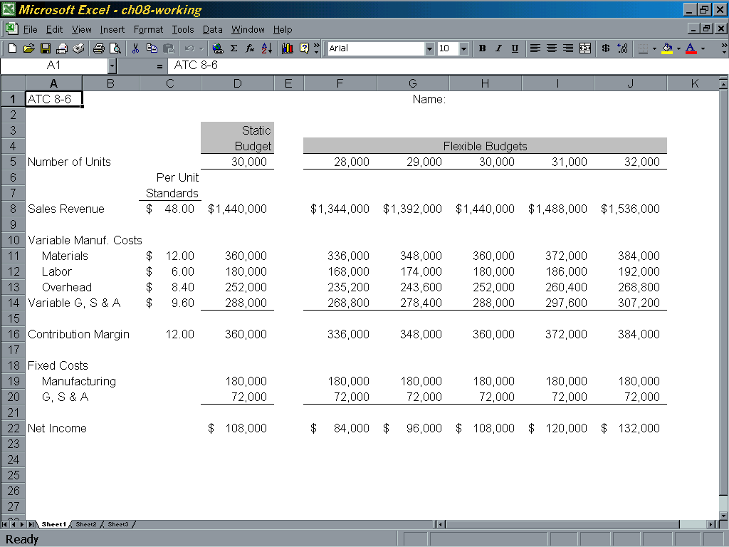

ATC 8-6 (continued)

Screen capture of cell formulas:

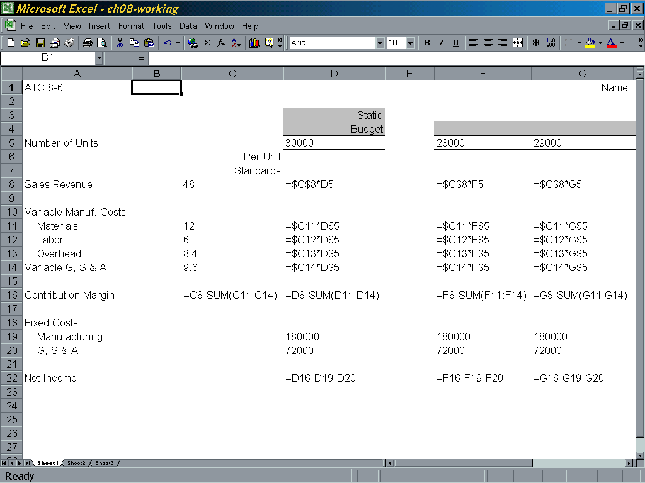

ATC 8-6 (continued)

Screen capture of cell formulas (continued):

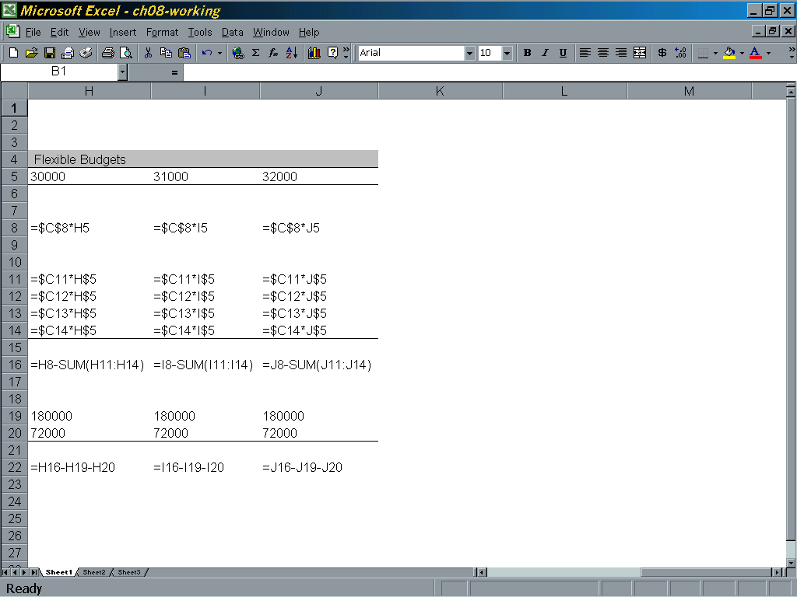

ATC 8-7

Screen capture of cell values:

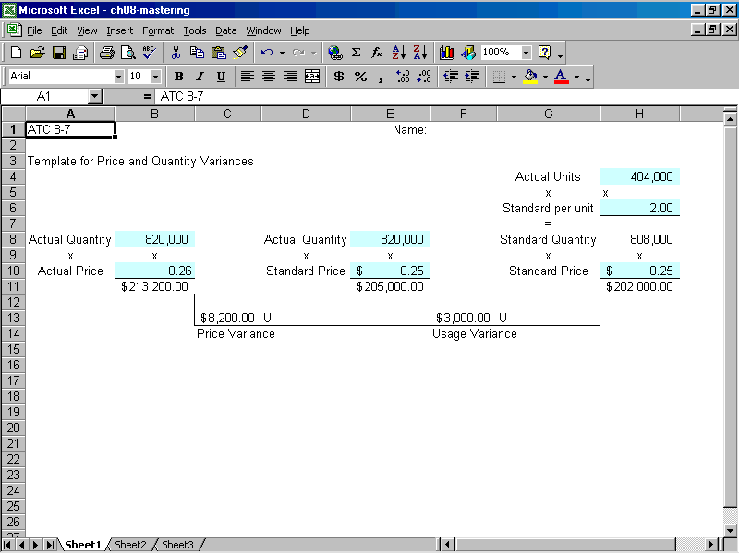

ATC 8-7

Screen capture of cell formulas:

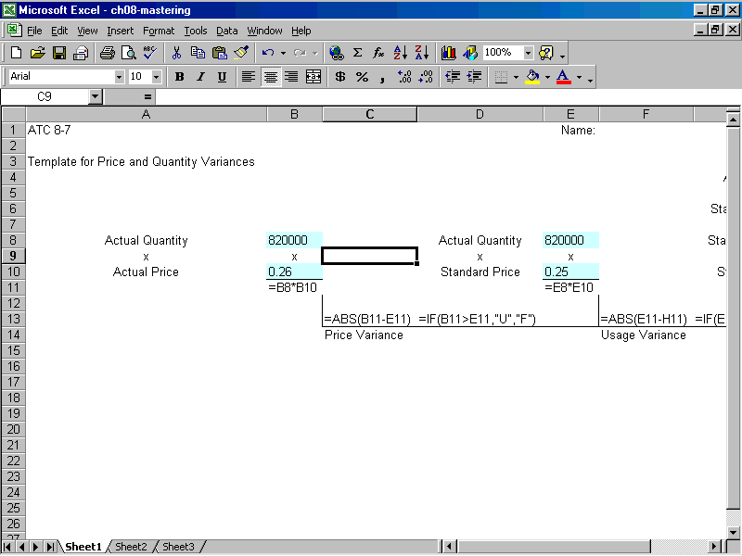

ATC 8-7 (continued)

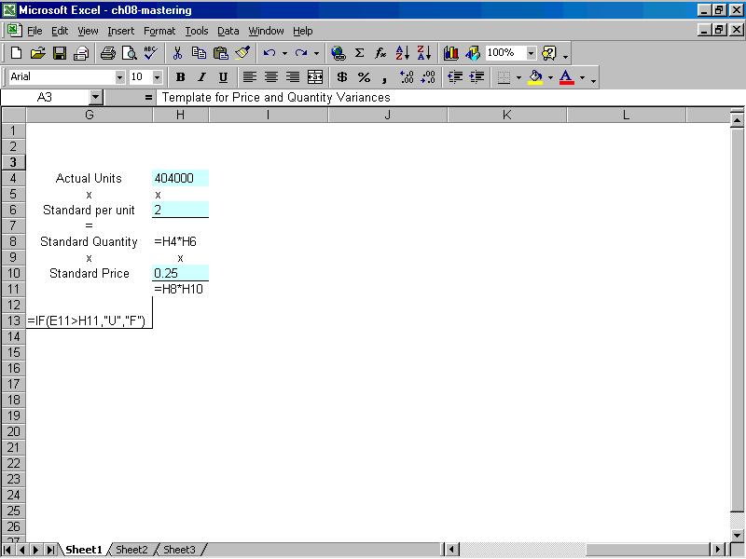

Chapter 8 Comprehensive Problem
Requirement a
 |  |  |  | Static
 |  |  |  | Budget | Flexible Budgets
Number of units |  |  |  | 5,000 | 3,000 |  | 6,000
 |  | Cost per Unit
Sales revenue |  | $120 |  | $600,000 | $360,000 |  | $720,000
Variable manufacturing costs
Materials |  | 40 |  | (200,000) | (120,000) |  | (240,000)
Labor |  | 25 |  | (125,000) | (75,000) |  | (150,000)
Overhead |  | 4 |  | (20,000) | (12,000) |  | (24,000)
Variable G,S,&A |  | 6 |  | (30,000) | (18,000) |  | (36,000)
Contribution margin |  |  |  | 225,000 | 135,000 |  | 270,000
Fixed costs
Manufacturing rent |  |  |  | (50,000) | (50,000) |  | (50,000)
Dep. on manu. equip. |  |  |  | (60,000) | (60,000) |  | (60,000)
G,S,&A Expenses |  |  |  | (71,950) | (71,950) |  | (71,950)
Dep. On admin. equip. |  |  |  | (12,000) | (12,000) |  | (12,000)
Net income |  |  |  | $ 31,050 | $ (58,950) |  | $ 76,050

Requirements b & c
 |  |  |  | Static | Flexible
 |  |  |  | Budget | Budget | Variance
Number of units |  |  |  | 5,000 | 6,000
 |  | Cost per Unit
Sales revenue |  | $120 |  | $ 600,000 | $720,000 | $120,000 | Favorable
Variable manufacturing costs
Materials |  | 40 |  | (200,000) | (240,000) | (40,000) | Unfavorable
Labor |  | 25 |  | (125,000) | (150,000) | (25,000) | Unfavorable
Overhead |  | 4 |  | (20,000) | (24,000) | (4,000) | Unfavorable
Variable G,S,&A |  | 6 |  | (30,000) | (36,000) | (6,000) | Unfavorable
Contribution margin |  |  |  | 225,000 | 270,000 | 45,000 | Favorable
Fixed costs
Manufacturing rent |  |  |  | (50,000) | (50,000) | 0
Dep. on manu. equip. |  |  |  | (60,000) | (60,000) | 0
G,S,&A Expenses |  |  |  | (71,950) | (71,950) | 0
Dep. on admin. equip. |  |  |  | (12,000) | (12,000) | 0
Net income |  |  |  | $ 31,050 | $ 76,050 | $ 45,000 | Favorable

