Answers to Questions

1. People, not budgets, control costs. Ms. Kelly needs to use the budget system to build a responsibility accounting program. The managers must be motivated to control costs. They should be trained to use the budgets as tools in helping them to gain and maintain the desired control.

2. The travel expenses do not appear to be reported in accordance with a responsibility accounting system. Under a responsibility accounting system, the travel costs would be reported directly to the managers who exercise predominant control over the expenditures. Responsibility accounting utilizes individual managers as the reporting focus.

3. Five potential advantages associated with decentralization include:
- it encourages upper-level management to concentrate on strategic decisions;
- it promotes improvements in decision making;
- it motivates managers to improve productivity;
- it trains lower-level managers to accept greater responsibilities; and,
- it improves performance evaluation.

4. A responsibility report is prepared for each individual who controls revenue or expense items. The report includes a list of the items under that person’s control including the budgeted and actual amounts for each item, and the variances from the budgeted costs.

5. Managers seldom have absolute control over revenue and expense items. For example, a production supervisor’s labor costs will be affected by the quality of raw materials as well as his capacity to motivate employees. Since absolute control is not likely to exist in real-world situations, responsibility must be assigned to managers with predominant control. Variances in responsibility reports must be evaluated in light of the imperfections in assigning control. Upper-level managers must exercise good judgment to assure the responsibility data is used in a fair manner.

6. Responsibility reports show variances from standard or expected amounts. Managers can focus attention on the larger variance (exception) items and ignore the items that are reported as expected.

7. A responsibility center is the point in an organization where the control over revenue or expense items is located.

8. The three types of responsibility centers are:
- cost centers,
- profit centers, and
- investment centers.
Cost centers exist where a business segment incurs costs but does not generate revenue. Profit centers consist of segments that control revenue items as well as expenses. Investment centers control investments of capital as well as revenue and expense items.

9. It is possible for a manager with a lower return on investment (ROI) to be outperforming a manager with a higher ROI. Many factors such as work stoppage, valuation bias, and asset age can affect the ROI even though they may be beyond the control of a manager. The proper use of ROI for performance evaluation requires the evaluation of qualitative as well as quantitative data.

10. The factors that affect the computation of return on investment are: (1) Margin; Net Income/Sales and (2) Turnover; Sales/Investment.

11. The return on investment can be increased by:
- increasing sales,
- reducing expenses, and,
- reducing the investment base.

12. A manager is rewarded for an investment that returns an amount in excess of the company’s desired rate of return under the residual income method. Accordingly, the manager will not be motivated to turn down investments that are beneficial to the company as a whole because such investments would reduce his segment’s average return on investment. The residual income approach reduces the conflict between the company’s interest and the manager’s personal interest. Therefore, suboptimization is reduced.

13. The manager with the highest residual income is not always the best performer. Managers with larger investments will naturally have higher residual incomes. Therefore, if access to assets is limited, managers with fewer assets may have lower residual income but may be outperforming other managers with more assets and higher residual income.

14. The revenue of one manager will become an expense of another manager. Since these items affect the measurement of profitability, the managers are in natural competition with each other. If handled properly, this competition may be healthy for the organization as a whole.

15. Three approaches to transfer pricing in descending order of preference include:
- price based on market forces,
- price based on negotiation, and
- price based on cost.

16. If cost is used as the transfer price, standard cost is preferable to actual cost. By using standard costs, selling departments are held responsible for the variances that they generate and some degree of cost control is encouraged.

Exercise 9-1B

Exercise 9-2B

The responsibility report for the director of Asian Operations should include the following items.

Office expenses of the Japanese branch
Asian director’s salary
Revenues of the Taiwanese branch
Office expenses of the Taiwanese branch
Revenues of the Japanese branch

Exercise 9-3B

a.

b. Controllability depends on the structure of a particular organization. A cost that is controllable by a division director in one company may not be controllable by a division director in another company. Moreover, controllable costs overlap between different job positions. Some costs that could be controllable by persons holding the various job positions mentioned in this problem are offered below as examples.
Exercise 9-3B (continued)

Job Title | Controllable Costs
V. P. of R & D | Salaries, wages, equipment, supplies
Lab directors | Salaries, lab supplies, lab equipment
Personnel managers | Salaries, departmental equipment, and supplies
Accounting managers | Salaries, departmental equipment, and supplies
Senior researchers | Wages or salaries of research assistants,  research equipment, supplies
Research assistants | Supplies
Recruiters | Supplies, travel expenses
Bookkeepers | Supplies

Exercise 9-4B
a & b
Kahil Company
Internal Income Statement for 2007
 | Budget | Actual | Variance
Sales | $400,000 | $414,000 | $14,000 | Favorable
Variable Costs:
Product Costs | (120,000) | (122,000) | 2,000 | Unfavorable
Selling Expenses | (39,000) | (42,000) | 3,000 | Unfavorable
Other Expenses | (8,000) | (7,000) | 1,000 | Favorable
Contribution Margin | 233,000 | 243,000 | 10,000 | Favorable
Fixed Costs:
Product Costs | (56,000) | (60,000) | 4,000 | Unfavorable
Selling Expenses | (21,000) | (19,200) | 1,800 | Favorable
Other Expenses | (2,000) | (10,000) | 8,000 | Unfavorable
Operating Income | $154,000 | $153,800 | 200 | Unfavorable
Interest Expense | (1,000) | (1,050) | 50 | Unfavorable
Net income | $153,000 | $152,750 | $250 | Unfavorable

Exercise 9-5B

a. & b.
 | Static Budget | Per Unit Cost
 | 5,000 Doors
Direct materials | $225,000 | $45.00
Direct labor | 110,000 | 22.00
Variable MOH | 60,000 | 12.00

 | Flexible Budget | Actual Results | Variances
 | 5,250 Doors | 5,250 Doors
Direct materials | $236,250 | $231,000 | $ 5,250 F
Direct labor | 115,500 | 126,000 | 10,500 U
Variable MOH | 63,000 | 60,900 | 2,100 F
Total variable costs | 414,750 | 417,900 | 3,150 U
Fixed MOH | 205,000 | 203,000 | 2,000 F
Total manufacturing cost | $619,750 | $620,900 | $1,150 U

Analyzing flexible budget variances suggests Mr. Ireland, the plant manager, did well controlling direct materials, variable manufacturing overhead, and fixed manufacturing overhead costs. His control of direct labor cost is below expectations. His overall performance is marginally below expectations because the total manufacturing cost variance is unfavorable. However, while the difference between the static budget and the actual results is substantial, the difference between the flexible budget and the actual results is immaterial.

c. Because Mr. Ireland isn’t authorized to make pricing and marketing decisions, he has no control over revenue. Based on the concept of controllability, his performance evaluation should only include costs, not sales revenue or net income.

Exercise 9-6B

a. The individual branches of World Travel Company are profit centers because their primary responsibilities are to provide services to customers for revenue and to control their expenses. Profit is the difference between revenues and expenses. Since branch managers make decisions that affect their revenues and expenses, Ms. Juliano should evaluate them using profit center measures such as operating income and return on sales.

b. A balanced scorecard includes both financial and nonfinancial measures. While return on sales is a good measure for the performance evaluation of individual branches, it does not reflect how well the customers feel about the service provided by the travel agents in individual branches and whether the customers will likely return to the same branch for future business. A customer satisfaction survey can shed some light on this particular aspect of branch performance.

Employee turnover measures whether branch staff are happy and willing to continue working for the company. If turnover is high, the branch cannot provide good customer service because employees do not plan to stay with the store for the long run and will not have enough experience with their jobs. If travel agents cannot do their jobs well, customers won’t be happy. The future business of the branch will be negatively affected. Also, high turnover increases the cost of employee training. As an example, World Travel can set up a balanced scorecard for performance evaluation including return on sales, operating income, customer satisfaction, and employee turnover. The approach enables Ms. Juliano to take a broader view of individual stores’ performances

Exercise 9-7B

Operating income ÷ Operating assets = ROI
$60,000 ÷ $480,000= 12.50%

Exercise 9-8B

Operating income ÷ Operating assets = ROI
Operating income = Operating assets x ROI
Operating income = $2,500,000 x 10% = $250,000
Operating income = Sales – Expenses
= $5,000,000 – Expenses = $250,000
Expenses = $5,000,000 – $250,000 = $4,750,000

a. If Calder reduces expenses by $50,000, expenses will become $4,700,000. Operating income will become $300,000 ($5,000,000 – $4,700,000).

ROI = $300,000 ÷ $2,500,000 = 12.0%

b. If Calder cannot change either sales or expenses, net income would remain at $250,000. To achieve the same ROI calculated above (12.0%), Calder must decrease the investment base as follows:

Operating income ÷ Operating assets = ROI
$250,000 ÷ Operating assets = 12.0%
Operating assets = $250,000 ÷ 12.0% = $2,083,333

Calder must decrease the operating assets from $2,500,000 to $2,083,333 to achieve a 12.0% ROI. In other words, Calder must decrease the investment base by $416,667.

Exercise 9-9B

RI = Earned income – (Operating assets x Desired rate of return)
RI = $3,600,000 – ($20,000,000 x 15%) = $600,000

Exercise 9-10B

- Houston Division:
Residual income = $60,000 – ($250,000 x .15) = $22,500

Dallas Division:
Residual income = $40,000 – ($200,000 x .15) = $10,000

b. The Houston Division increased the company's overall profitability more because it produced residual income of $22,500 compared to the Dallas Division’s residual income of $10,000.

Exercise 9-11B

Operating income |  | Operating income/ Operating assets = 12%  Operating income = Operating assets x 12%  Operating income = $600,000 x 12%  Operating income = $72,000
Sales |  | Margin = Operating income/Sales  0.08 = $72,000/Sales  Sales = $72,000/0.08 = $900,000
Turnover |  | Turnover = Sales/ Operating assets  Turnover = $900,000/$600,000  Turnover = 1.50
Residual income |  | $72,000 – (0.11 x $600,000) = $6,000

Exercise 9-12B

Current RI:
$3,000,000 x 16% – $3,000,000 x 10% = $180,000

RI if St. Louis accepts the investment opportunity:
($3,000,000 + $600,000) x 15.5% – ($3,000,000 + $600,000) x 10% = $198,000

Because the revised residual income is greater than current residual income, the St. Louis Division will produce improved results if it accepts the investment opportunity.
Exercise 9-13B

a. ROI

EIC: $58,712,000 ÷ $372,690,000 = 15.75%
Automobile Division: $12,520,000 ÷ $66,488,000 = 18.83%
Additional investment opportunity: $1,160,000 ÷ $7,250,000 = 16%

b. RI

EIC: $58,712,000 – $372,690,000 x 14% = $6,535,400
Automobile Division: $12,520,000 – $66,488,000 x 14% = $3,211,680
Additional investment opportunity: $1,160,000 – $7,250,000 x14% = $145,000

Exercise 9-14B

a. If Sweet Water purchases filters from outside vendors, overall company profit will suffer. Because Aquafresh has excess capacity and no other customers, its opportunity cost is zero and its fixed costs are sunk and irrelevant. Consequently, the only cost relevant to this decision is Aquafresh’s variable cost of $12 per unit, much lower than the $24 market price Sweet Water would have to pay an outside vendor.

b. The president of Boone should endeavor to ensure that Sweet Water continues to use the filters produced by Aquafresh. The best way to achieve this objective without hurting the morale and productivity of division employees is to create an incentive for the division managers that will serve both their division interests and the company’s overall interest. Though the corporate-level facility-sustaining cost allocated to Aquafresh is irrelevant to a short-term transfer-pricing decision, it does have a long-term effect on Aquafresh, because Sweet Water is its only customer. Specifically, if the transfer price is below Aquafresh’s full long-term product cost, Ms. Mead’s career would be adversely affected by consistent division losses, whether they are substantial or small amounts. Her morale could also be adversely affected and she may seek other employment opportunities. The president can eliminate the allocation of corporate-level facility-sustaining costs to divisions because they are not controllable by divisions. Doing so would effectively lower Aquafresh’s cost per unit to $22, which is lower than the market price charged by outside vendors. Mr. Pell should encourage Ms. Mead and Mr. Sanders to negotiate based on this new condition, which is far more likely to result in a compromise in the company’s best interest.

Exercise 9-15B

a. It currently costs the Hart Division $360,000 ($18 x 20,000) to purchase laptop fans from an outside vendor. The Murdock Division could make the fans internally at an avoidable cost of $260,000 ($6 x 20,000 + $140,000). Yesso would save $100,000 ($360,000 − $260,000) if the Hart Division purchased the fans from the Murdock Division instead of from an outside vendor.

At 20,000 fans, the per unit avoidable cost is $13 ($260,000 ÷ 20,000 units) per fan. Any price higher than $13 would increase the profitability of the Murdock Division. The current cost of buying the fans is $18 each. Any price below $18 would increase the profitability of the Hart Division. A transfer price between $13 and $18 would benefit the financial performance of both divisions.

- Increasing the volume would broaden the range over which the transfer price would benefit both divisions because the fixed cost per unit to the Murdock Division decreases when the volume increases. The total avoidable cost of making 35,000 fans is $350,000, as follows:

Variable Cost | + | Fixed Cost | = | Total
$6 x 35,000 | + | $140,000 | = | $350,000

The cost per fan is $10 ($350,000 ÷ 35,000 fans). Any transfer price between $10 and $18 would benefit the financial performance of both divisions.

Problem 9-16B

Controllable Items | Amount
Salaries of Salespeople | $560,000
Travel Expenses | 64,000
Telephone Expenses | 78,000
Total | $702,000

There are other expenses associated with the sales department such as cost of goods sold, depreciation on equipment, sales manager's salary and property taxes. However, the amount of these items results from past decisions or the amounts are set by external sources and are therefore beyond the control of the sales department.

Problem 9-17B

a. Investigate the underlying facts. Variances are usually the beginning, not the end, of performance evaluation. Verify Ms. Grayson's statements regarding the purchase of substandard materials and the hiring of underqualified workers. The main objective of this investigation is to discover the real causes of material variances, both favorable and unfavorable.

b. Ms. Grayson did not deserve the credit she tried to take. The purchasing department's acquisition of substandard materials may have been the result of purchasing materials at less than standard cost. Because Ms. Grayson did not control purchasing decisions, the materials price variance, favorable or not, was not her responsibility. Similarly, the personnel department controlled recruiting decisions and consequently, the production department was not responsible for the labor price variance.

c. Ms. Grayson was not responsible for the unfavorable variances if her allegations were true. If the substandard materials did cause substantial spoilage, the unfavorable materials usage variance was the responsibility of the purchasing department. Because recruitment of underqualified workers and materials spoilage did lengthen work hours, the personnel department and the purchasing department should share the blame for the unfavorable labor usage variance. Finally, the volume variance was the responsibility of the sales department.

d. A balanced scorecard includes both financial and nonfinancial measures. In addition to the financial measures that the company used currently, Friedman Corporation can use some nonfinancial measures to reflect the underlying operating performance better. Some nonfinancial measures include quality measurement as a result of inspecting incoming raw materials and measurements of worker qualifications such as years of experience, education, and training.

Problem 9-18B
a.
Responsibility Report
Coleman Region
For the Month Ended March 31
Controllable costs: | Budget | Actual | Variances
Cahaba branch | $ 528,000 | $ 520,000 | $ 8,000 | Favorable
Garner branch | 500,000 | 503,200 | 3,200 | Unfavorable
Other costs | 280,000 | 292,000 | 12,000 | Unfavorable
Total | $1,308,000 | $1,315,200 | $7,200 | Unfavorable

b.
Responsibility Report
Vice President of Mortgages
For the Month Ended March 31
Controllable costs: | Budget | Actual | Variances
Coleman region | $1,308,000 | $1,315,200 | $ 7,200 | Unfavorable
Helena region | 1,400,000 | 1,452,000 | 52,000 | Unfavorable
Alabaster region | 1,720,000 | 1,688,000 | 32,000 | Favorable
Other costs | 384,000 | 392,000 | 8,000 | Unfavorable
Total | $4,812,000 | $4,847,200 | $35,200 | Unfavorable

c. The $24,000 favorable promotions variance in the responsibility report of the Cahaba branch manager is summarized in the $7,200 unfavorable variance of the Coleman region that appears in the vice-president’s report.

d. The largest variance in the Coleman region general manager’s report is the variance associated with the general manager's other costs. The variance represents 4.3% of the budgeted amount (i.e. $12,000/$280,000). Further, the variance is unfavorable. The general manager should concentrate her effort to see that this variance is brought under control.

Problem 9-19B

a. Seaborn should classify the electronic division as a profit center because the division has control over profit-related decisions such as production, cost control, and revenue generation.

b. If the electronic division is treated as a cost center, the divisional manager would pay special attention to cost control but would ignore the effort to market the division's products. Efforts spent to generate revenues would not be rewarded under that circumstance and, therefore, the divisional manager would choose to concentrate on other efforts such as cost controls that would later give the individual due credit.

If the electronic division is classified as an investment center, the divisional manager would be frustrated and not know what to do except complain. The divisional manager has no control over investment decisions and, therefore, the manager couldn't improve the individual own performance with the individual own effort.

Problem 9-20B

a. Operating income, instead of net income, should be used to determine the ROI for the Issac investment center because operating income is a better measurement of Issac’s operating performance. Net income may include gains, losses, or non-operating expenses that do not reflect Issac’s performance consistently.

b. Operating assets, instead of total assets, should be used to determine the ROI for the Issac investment center because operating assets is a better measurement. Total assets may include assets that are not used in operation, thus, making the denominator of ROI misleading.

c. Operating assets = Total assets – Non-operating assets
Operating assets = $979,000 – $48,000 = $931,000
Operating income ÷ Operating assets = ROI
$106,740 ÷ $931,000 = 11.47%

Problem 9-20B (continued)

d. If ROI is the only performance measure for Issac’s performance, the new investment would hurt Issac’s manager if the new ROI decreases. Issac’s return on the new investment opportunity is 10%, lower than the current ROI, which will drag the original ROI down, thus hurting Issac’s performance measure. Further computation follows.

Income from new investment = $300,000 x 10% = $30,000
New operating income = $30,000 + $106,740 = $136,740
New operating assets = $931,000 + $300,000 = $1,231,000
New ROI = $136,740 ÷ $1,231,000 = 11.11%

e. If Taite’s objective is profit maximization, residual income (RI), rather than ROI can measure operating performance to reflect that objective better. Further computation follows.

Original RI = $106,740 – $931,000 x 8% = $32,260
New RI = $136,740 – $1,231,000 x 8% = $38,260

If Taite uses RI, instead of ROI, for performance evaluation, the manager would receive a better evaluation and reward. Consequently, the manager would be encouraged to pursue the company’s objectives, rather than personal objectives.

Problem 9-21B

a. Margin = Operating income ÷ Sales
= $96,000 ÷ $1,920,000 = 5%

b. Turnover = Sales ÷ Operating assets
= $1,920,000 ÷ $600,000= 3.2

c. ROI = Margin x Turnover
= 5% x 3.2 = 16%

d1. ROI = Margin x Turnover
= ($113,400 ÷ $2,160,000) x ($2,160,000 ÷ $600,000)
= 18.90%

d2. ROI = Margin x Turnover
= ($100,800 ÷ $1,920,000) x ($1,920,000 ÷ $600,000)
= 16.80%

d3. ROI = Margin x Turnover
= ($96,000 ÷ $1,920,000) x ($1,920,000 ÷ $576,000)
= 16.67%

Problem 9-22B

a. Denton Division’s ROI before the new investment opportunity:
$1,750,000 ÷ $12,000,000 = 14.58%

Denton Division’s ROI after the new investment opportunity:
($1,750,000 + $360,000) ÷ ($12,000,000 + $3,000,000) = 14.07%

Because Denton Division’s ROI would decline if Denton decides to take the additional investment, it will not accept the additional funding.

b. Perryman Company’s ROI before the new investment opportunity:
$4,070,000 ÷ $36,000,000 = 11.31%

Perryman Company’s ROI after the new investment opportunity:
($4,070,000 + $360,000) ÷ ($36,000,000 + $3,000,000) = 13.36%

Because Perryman Company’s ROI would rise if Denton decides to take the additional investment, Perryman would benefit from the new investment.

c. Denton’s residual income if investment is accepted:

$360,000 – $3,000,000 x 10% = $60,000

Because the residual income for Denton’s new investment is greater than zero, Denton would accept the new funding when the residual income is used as the sole performance measure.

Problem 9-23B

a. ROI

Americas Division: $6,900,000 ÷ $38,400,000 = 17.97%
Asia Division: $3,208,000 ÷ $19,300,000 = 16.62%
Europe Division: $3,300,000 ÷ $24,300,000 = 13.58%

The Americas Division has the highest ROI.

b. The manager of the Europe Division would be most eager to accept the $600,000 investment funds. Because the ROI of the division’s investment opportunity, 15%, is greater than the division’s current ROI, 13.58%, the investment could raise the division’s ROI. The other two divisions’ current ROIs are higher than those of their individual investment opportunities. In other words, the new investments would decrease their ROIs and make the divisional performances look bad.

c. The manager of the Asia Division would be least likely to accept the $600,000 investment opportunity because expected ROI for the investment opportunity, 12%, is lower than not only the division’s current ROI but also the company’s desired rate of return.

d. The Americas Division offers the best investment opportunity for TTC because the division’s investment opportunity has the highest ROI.

e. The term used to describe the apparent conflict between parts b and d is called suboptimization, which means that some managers may make decisions to benefit their own organizational units at the expense of the organization as a whole.

Problem 9-23B (continued)

f. As long as the ROI of an investment opportunity exceeds the company’s desired rate of return, the investment would increase the division’s residual income. Consequently, if residual income is used as the only performance measure, divisional managers would be motivated to take such an investment opportunity. From the company’s perspective, any new investment opportunity that exceeds the desired rate of return would benefit the company’s overall performance. In other words, using residual income as the performance measure makes divisional managers’ local interest comply with the company’s overall interest.

g. Residual incomes:

Corporate level: $13,408,000 – $82,000,000 x 14% = $1,928,000

Division level

Americas Division: $6,900,000 – $38,400,000 x 14% = $1,524,000
Asia Division: $3,208,000 – $19,300,000 x 14% = $506,000
Europe Division: $3,300,000 – $24,300,000 x 14% = $(102,000)

Investment level

Americas Division: $600,000 (16% – 14%) = $12,000
Asia Division: $600,000 (12% – 14%) = $(12,000)
Europe Division: $600,000 (15% – 14%) = $6,000

Division level after the additional investment

Americas Division: $1,524,000 + $12,000 = $1,536,000
Asia Division: $506,000 + $(12,000) = $494,000
Europe Division: $(102,000) + $6,000 = $(96,000)

h. Both the Americas Division manager and the Europe Division manager should be interested in their individual investment opportunities because they both get positive residual incomes from their investments. However, the Europe Division manager would be more eager to accept the opportunity because of his/her current negative residual income.

Problem 9-24B

a. A preferred transfer price is a competitive market price. In this case, there are two market prices, the $144 that Denton normally pays for modems and ChengKung's normal selling price of $150. However, even the lower price of $144 exceeds ChengKung's variable cost per unit ($70), resulting in a good profit for ChengKung. Since both managers could benefit from the intercompany sale of modems, they should be able to negotiate a transfer price that is largely based on market forces.

b. The intercompany sale would not affect either manager’s investment base. Accordingly, if profitability can be increased the ROIs will increase. If Denton can purchase at a price below $144, its costs will decrease and profits will increase. Since it has adequate excess capacity, if ChengKung can sell at any price above variable cost (i.e., $70), it will realize a contribution margin that will cause profits to increase. Accordingly, a transfer price anywhere between $70 and $144 will cause the ROIs of both managers to increase. However, the revenue of one manager becomes an expense of the other manager. Thus, the two managers are in competition with each other. As a result, the manager of ChengKung will try to set the transfer price as close to $144 as possible and the manager of Denton will try to set the transfer price as close to $70 as possible. The two managers will have to negotiate a fair compromise.

c. Wang would suffer if some of the ChengKung's modems that are currently being sold for $150 each were sold to Denton. Because Denton can buy substitute modems for $144 each, Wang would be better off to have ChengKung modems sold to outsiders and have Denton purchase the modems that it needs from outsiders. Wang benefits from intercompany sales only to the extent that ChengKung's excess capacity can be utilized.

ATC 9-1

The computations below are used to answer requirements a., b., c., and d.

Dollar amounts in millions
 | North |  | Europe, | Latin
2004 FY | America | Africa | etc. | America | Asia
(A) Segment income | $1,629 | $337 | $1,916 | $1,270 | 1,841
(B) Identifiable assets | 4,731 | 789 | 5,373 | 1,405 | 1,722
Return on Investment (A/B) | 34.43% | 42.71% | 35.66% | 90.39% | 106.91%
Residual Income [(B x .2) -A] | $ 682.8 | $ 179.2 | $ 841.4 | $ 989.0 | $1,496.6
2003 FY
(A) Segment income | $1,326 | $ 249 | $1,921 | $ 975 | $1,740
(B) Identifiable assets | 4,953 | 721 | 5,222 | 1,440 | 1,923
Return on Investment (A/B) | 26.77% | 34.54% | 36.79% | 67.71% | 90.48%
Residual Income [(B x .2) -A] | $ 335.4 | $ 104.8 | $ 876.6 | $ 687.0 | $1,355.4

a. The computations of each segment’s ROI are in the table above. The data in the table show that the Asian segment had the best ROI for the 2004 fiscal year, while the Latin America segment’s ROI showed the most improvement from 2003 to 2004.

b. The computations of each segment’s residual income are in the table above. The data in the table show that the Asian segment had the highest residual earnings for both fiscal years. The North American segment increased the most with an increase of $347.4. The Latin American was a close second with an increase of $302.
ATC 9-1 (continued)

c. Even though Africa’s ROI was higher than North America’s in each year, residual income was significantly lower because the North American segment had a lot more identifiable assets on which to earn a profit than did the African segment.

d. Based on the ROI’s alone, the Asian division seems to be the best place to invest. However, non-quantitative factors should also be considered. It is possible that Coke has more growth opportunities in Latin America, due to less government regulation.

ATC 9-2

1. ROI Current Asset Amount $8,640,000 ÷ $72,000,000 = 12%
ROI Revised Assets $9,960,000* ÷ $84,000,000** = 11.86%
*$8,640,000 + (.11 x $12,000,000)
**$72,000,000 + $12,000,000

Since the new investment would decrease Bellco’s ROI, it would have a negative effect on Mr. Sedatt’s performance evaluation. Accordingly, the groups should recommend that Mr. Sedatt not accept the investment opportunity.

2. Residual income, Current Asset Amount
$8,640,000 − ($72,000,000 x .10) = $1,440,000
Residual Income, Revised Assets
$9,960,000* − ($84,000,000** x .10) = $1,560,000
*$8,640,000 + (.11 x $12,000,000)
**$72,000,000 + $12,000,000

Since the new investment would increase Bellco’s residual income, it would have a positive effect on Mr. Sedatt’s performance evaluation. Accordingly, the groups should recommend that Mr. Sedatt accept the investment opportunity.

3. & 4. In-class Requirements.

5. ROI is more likely to produce suboptimization because an opportunity that would benefit the company as a whole would be detrimental to the performance evaluation of an investment center manager.
ATC 9-3

a. Bed Bath & Beyond operates using an organizational style that is more decentralized than centralized.

b. Two quotes from the article support the conclusion that Bed Bath & Beyond is more decentralized than centralized:.

- “[Bed Bath & Beyond] became a big chain, in large part, … [because] it has been vigilant about catering to local taste…”
- “…store managers pick 70% of their own merchandise.”

c. A couple of reasons were given by analysts who think Bed Bath & Beyond may not be able to maintain its historic growth rate into the future.

- They believe the best locations for Bed Bath & Beyond have already been obtained, and that new stores will have to locate in less profitable locations. Organizational structure has little effect on this issue.
- They believe the local character of stores will be harder to maintain as more stores are opened. This could lead to a more centralized organizational structure. Some centralized shipping has already begun at Bed Bath & Beyond.

d. The children of the founders of Bed Bath & Beyond do not play any role at the company, although they did work at the stores when they were younger. The two founders of Bed Bath & Beyond decided early in their partnership that, to avoid conflict, none of their children would ever run the company.

ATC 9-4

a. The company as a whole is losing $12 per engine (i.e., $90 current cost charged by outside supplier minus $78 avoidable cost of production). The total loss in profitability is $480,000 (i.e., $12 x 40,000 units).

b. There is no definitive answer to this question. However, the students’ responses should recognize the motivational importance of maintaining autonomy in a decentralized organization. So long as the negative consequences are not significant, divisional managers are usually permitted to exercise their own judgment. In other words, the long-term benefits derived from autonomous management outweigh the short-term detriments of suboptimization.

ATC 9-5

a. A “big bath” acts to front-load expenses. For example, writing off an asset with a five-year life in the year that it is purchased will overstate year 1 expenses. However, in years 2-5 depreciation expense will be zero and net income will soar. Managers who are evaluated by ROI and residual income may be willing to trade one bad year of net income for four great years.

b. Annual reports are prepared by managerial accountants who, if they are members of the IMA, are bound by the organization’s standards of ethical conduct. The responsibility for annual reports belongs to the company’s management, not to the auditors. Auditors simply provide an opinion about the financial statements which are the management accountant’s work. Further, it should be noted that fraud (deliberate misrepresentation) is governed by law, the violation of which can lead to fines and incarceration.

ATC 9-6

Screen capture of cell values:

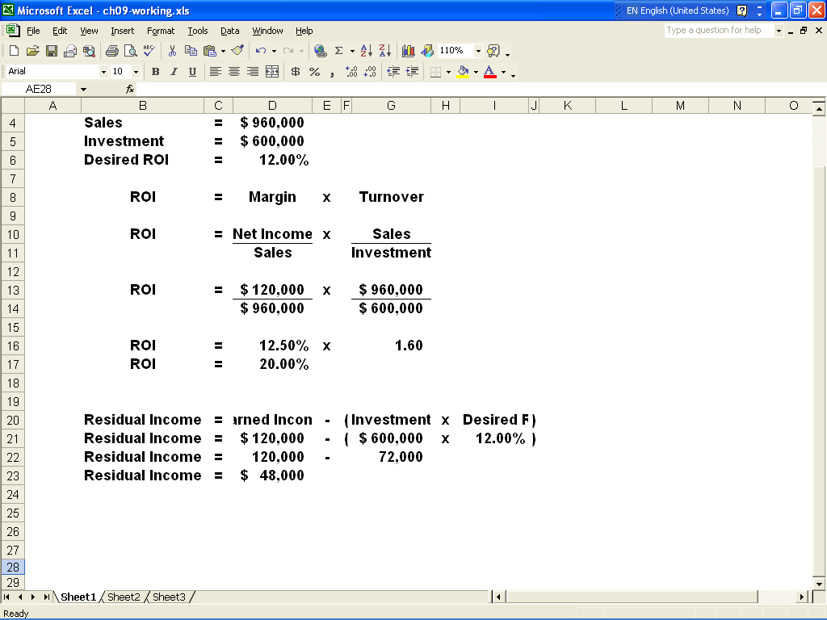

ATC 9-6

Screen capture of cell formulas:

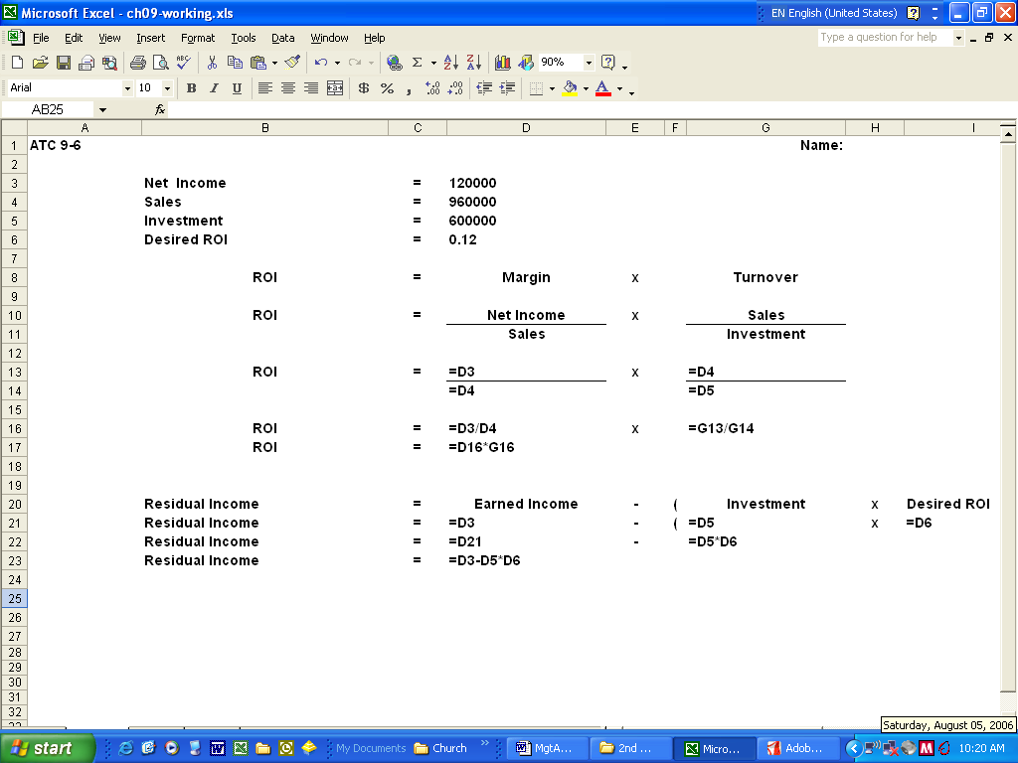

ATC 9-7

Screen capture of cell values:

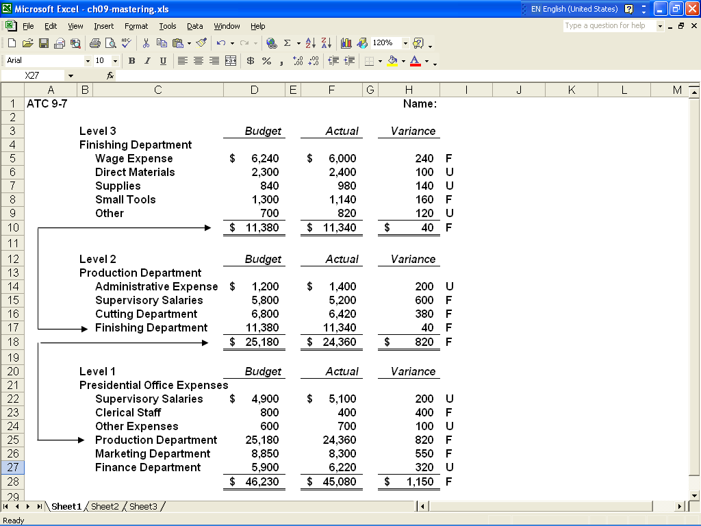

ATC 9-7

Screen capture of cell formulas:

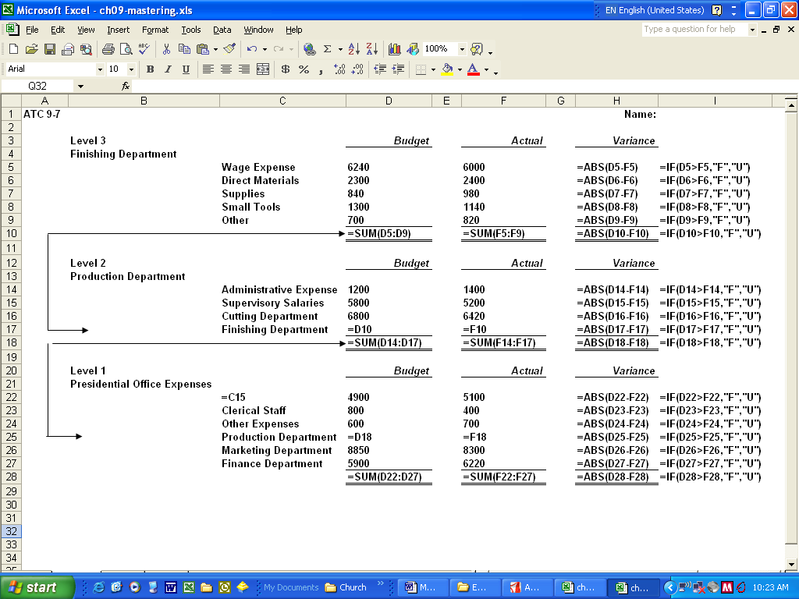

Chapter 9 Comprehensive Problem
Requirement a
ROI = Net income / Investment (Total assets)
ROI = 31,050 / (544,050 +210,000 + 27,000)
ROI = 3.975
Since Gilmore's existing ROI (3.95%) is higher than the expected ROI on
the additional investment (3.5%), the division manager would be motivated
to reject the investment opportunity.
Requirement b
The term used to describe the condition in requirement a is suboptimization, which means that some managers choose to benefit themselves at the expense of the entire organization.
Requirement c
The operating income on the investment opportunity is $3,500 ($100,000 x 3.5%)
Residual income = Operating income − (Operating assets x Desired ROI)
Residual income = $3,500 − ($100,000 x 3%)
Residual income = $3,500 − $3,000
Residual income = $500
Since the investment opportunity would increase MM's residual income, the
division manager would be motivated to accept the investment opportunity.

