Answers to Questions

1. A capital investment is an investment in a long-term operational asset. Stocks and bonds are not operational assets but rather intangible legal agreements of ownership in another company or loans to another company. They are bought and sold in organized free markets, such as the New York Stock Exchange where there is a definable market price based on supply and demand. They are easily bought and sold for the market price. Capital investments are usually tangible assets that are not intended for resale but for use in production or other operations. They represent long-term investments in the company that are not easily sold or exchanged. The return on these investments is normally recovered by the additional revenues, or cost savings, generated by the asset.

2. This concept applies for the following reasons: 1) the smaller present amount can be invested to earn interest that increases its future worth, 2) there is risk associated with the receipt of a future amount so that it takes a greater amount in the future to equal the smaller amount today and 3) inflation depletes the buying power of a future amount so that it takes a greater amount in the future to equal the smaller amount today.

3. Yes, both statements mean that a dollar today has more value because it can be invested to earn interest, it has less risk associated with its receipt, and there is less risk of its decrease in buying power due to inflation. In the first statement, you make a comparison between two dollar amounts, a dollar amount in the present versus a dollar amount in the future. Given the choice between the same dollar amount today or in the future, the dollar amount today would have more value. Therefore, to make these two amounts equal in value the amount in the present would have to be a lesser amount – the present value of a future amount is less.

4. When a company invests in capital assets, it is giving up present dollars in exchange for future dollars. Since present dollars have more value, the company must be compensated for the exchange. This compensation is called the return on investment. It is usually expressed as a percentage. For example, if you invested $5,000 in a new computer and earned $500 of income in the first year of your investment you received a 10% return ($500/$5,000).

5. In order to obtain assets (capital) to make investments, businesses must pay owners dividends and lenders interest. The return paid to investors and creditors is the company’s cost of capital. The company must earn a return on its investments that equals or exceeds its cost of capital in order to stay in business. Accordingly, the cost of capital establishes the minimum acceptable rate of return on investments.

6. To determine the amount to invest today solve the following equation:

Investment x (.10) + Investment = $500,000
Investment x (.10 + 1) = $500,000
Investment = $500,000/1.10 = $454,545.45

$454,545.45 today has the same value as $500,000 a year from today assuming a 10% interest rate. You would be indifferent between the two alternatives.

7. Many times converting future values into their present value equivalents requires a considerable amount of mathematical manipulation, particularly if the future values extend beyond a year. Present value tables consist of conversion factors for different return rates and different time periods that can be used to easily transform future values into present values.

8. An annuity is a series of equal cash flows paid over equal time intervals at a constant rate of return. An example of an annuity receipt would be lottery winnings that were paid in $10,000 installments at the beginning of each year for 10 years.

9. Some programs offer an efficient means of converting future values into present value equivalents. The conversion power of the present value function available with software programs allows you to explore many possible present value scenarios by just changing variables within the functions (changing the present value assumptions to determine “what happens if”). The computer instantaneously does the calculations.

10. The mathematical formula based on the present value of an annuity table factor would be written as:

annual payment x PV of an annuity factor @14% for 5 years = PV
$100,000 x 3.433081 = $343,308.10
The Excel spreadsheet function would be written as:

PV(rate,nper,pmt)

11. The bank’s investment balance is declining each year. A part of the original investment is recovered with each payment made by Ms. Espinosa. Since the interest Ms. Espinosa pays is based on the investment balance, the amount of interest Ms. Espinosa is paying each year is declining. In order to maintain its 8% annual compounded interest, the bank will have to reinvest the entire payment (recovery of investment and return on investment) each year at 8% annual interest in order to earn 8% compounded interest on the original investment.

12. The higher net present value does not necessarily imply the better investment opportunity. Other factors such as the amount of the initial outlay and the availability of capital must also be considered. Additionally, the net present value approach does not address the issues of risk or uncertainty about the estimated future cash flows.

13. Projects that produce zero or positive net present values satisfy the desired rate of return criteria. In other words, the present value of cash inflows will be equal to or greater than the present value of cash outflows.

14. The net present value method does not provide a measure of the rate of return. It simply indicates whether or not a project meets the desired rate of return criterion.

15. The investment with the highest internal rate of return is not always the best investment even when risk is relatively equal. Firms have a limited supply of capital that is normally spread among investment alternatives. The selection of the mix of investments that produces the highest weighted average internal rate of return will maximize profitability. In other words, if there are $100,000 of available funds to invest, two investments that cost $50,000 each and earn 12% each may be better than one investment that costs $80,000 and earns 14% but leaves insufficient funds to invest further.

16. Pursuing the highest rate of return does not guarantee the maximum profit for companies. As long as an investment results in a return greater than the company's cost of capital, the investment will contribute additional profit to the company. If Spark Company insists on selecting only investment opportunities with the highest rate of return, it will miss many other opportunities to increase the company's profit. In other words, the company's profit would not be maximized under the company's current strategy.

17. The desired rate of return represents the level of return that management seeks to attain on all investments. The internal rate of return is the actual return from a particular investment. The internal rate of return must be equal to or greater than the desired rate of return in order to satisfy the rate of return criterion for acceptance.

18. Inflow items include incremental revenue, operating cost savings, salvage values, and working capital releases. Outflow items include the initial investment, increases in operating expenditures, and working capital commitments.

19. The strategy is not sound because it does not take into account the limitations of the payback method. For example, the technique does not take into consideration the total life of the asset. The asset that pays for itself more quickly may also have a much shorter useful life.

20. The payback method can be used when cash flows are unequal. A cumulative technique or an averaging technique can be employed.

21. The primary advantages of the unadjusted rate of return are simplicity and ease of understanding. The primary disadvantage is that the technique fails to take into account the time value of money.

22. Capital investments involve major commitments of resources that are recovered over extended future periods via increases in revenue or decreases in expenses. Once acquired, the assets are not easily sold. Instead, costs are normally recovered from the utilization of the assets. If the projected revenues or cost savings do not materialize, profitability suffers.

23. A postaudit consists of using the same analytical techniques used for evaluating a capital investment proposal in evaluating its success. A postaudit is conducted at the end of a capital investment project and based on actual cash inflows and outflows. The audit provides feedback that enables managers to improve the accuracy of future predictions and thereby maximize the quality of the company’s future capital investments.

Exercise 10-1B

Potential Cash Inflows:
Incremental revenue
Salvage value
Cost savings
Recovery of working capital
Potential Cash Outflows:
Initial cost of investment
Incremental expenses
Cost of overhaul or additional investments
Working capital commitments
The above is a partial list of possible cash flows. There may be others.

Exercise 10-2B

a.
 |  |  |  | Present value
Present value | = | Future value | x | table factor⁽¹⁾
Present value | = | $100,000 | x | .925926
Present value | = | $92,592.60
⁽¹⁾Table 1, n = 1, r = 8%

b.

Investment + (.08 x Investment) = $100,000
Investment = $100,000/1.08
Investment = $92,592.59
Exercise 10-3B

a.
 |  |  |  | Present value
Present value | = | Future value | x | table factor⁽¹⁾
Present value | = | $1,000,000 | x | 0.751315
Present value | = | $ 751,315
⁽¹⁾Table 1, n = 3, r = 10%

b. Elbert’s friend is obviously not much of a friend. He is offering Elbert $500,000 for an asset that is worth $ 751,315. This so-called friend is seeking to profit financially from Elbert’s ignorance about the present value of future cash flows.

Exercise 10-4B

a. |  |  |  | Present value
Present value | = | Future value | x | table factor | = | Present value
Present value | = | $4,000 |  | 0.909091⁽¹⁾ | = | $ 3,636.36
Present value | = | $4,000 |  | 0.826446⁽²⁾ | = | $ 3,305.78
Total present value |  |  |  |  |  | $ 6,942.14
⁽¹⁾Table 1, n = 1, r = 10%
⁽²⁾Table 1, n = 2, r = 10%

b. |  |  |  | Present value
Present value | = | Future value | x | table factor | = | Present value
Present value | = | $4,000 | x | 1.735537⁽¹⁾ | = | $6,942.15
⁽¹⁾Table 2, n = 2, r = 10%

c. The total present values are the same except for a minor rounding error because the present value factor from Table 2 is the sum of the two values from Table 1.

Exercise 10-5B

a.
 |  |  |  | Present value
Present value | = | Future value | x | table factor | = | Present value
Present value | = | $1,600 | x | 2.245890⁽¹⁾ | = | $3,593.42
Present value | = | $1,000 | x | 0.640658⁽²⁾ | = | 640.66
Total present value |  |  |  |  | = | 4,234.08
Cost of popcorn machine |  |  |  |  | = | (5,000.00)
Net present value |  |  |  |  | = | $ (765.92)
⁽¹⁾Table 2, n = 3, r = 16%
⁽²⁾Table 1, n = 3, r = 16%

b. Since the net present value is negative, the investment opportunity is expected to earn a rate of return that is less than the desired rate of return. The analysis suggests that the investment opportunity should be rejected.

Exercise 10-6B

a.
Year | Cash  Inflow | − | Cash  Outflow | = | Net Cash Flow | x | Present Value  Table Factor⁽³⁾ | = | Present Value
2008 | $ 6,800 | − | $3,200 | = | $3,600 | x | 0.892857 | = | $ 3,214.29
2009 | 7,600 | − | 4,240⁽¹⁾ | = | 3,360 | x | 0.797194 | = | 2,678.57
2010 | 8,400 | − | 3,840 | = | 4,560 | x | 0.711780 | = | 3,245.72
2011 | 11,600⁽²⁾ | − | 4,000 | = | 7,600 | x | 0.635518 | = | 4,829.94
 |  |  |  |  |  |  | Present value |  | 13,968.52
 |  |  |  |  |  |  | Cost of van |  | 13,200.00
 |  |  |  |  |  |  | Net present value |  | $ 768.52
⁽¹⁾$3,600 + $640 ⁽²⁾$9,200 + $2,400
⁽³⁾Table 1, n = Periods 1, 2, 3, 4, r = 12%

b. The positive net present value indicates the investment would earn a return above the desired rate of return. Mr. Logan should start the delivery business.

Exercise 10-7B

a.

Alternative 1
Present value – Cash inflows |  | $133,000
Present value – Cash outflows |  | (127,000)
Net present value |  | $ 6,000

Alternative 2
Present value – Cash inflows |  | $230,000
Present value – Cash outflows |  | (223,000)
Net present value |  | $ 7,000

b.

Present value index |  | Present value of cash inflows |  | $133,000
for | = | ———————— | = | ———— | = | 1.05
Alternative 1 |  | Present value of cash outflows |  | $127,000

Present value index |  | Present value of cash inflows |  | $230,000
for | = | ———————— | = | ————– | = | 1.03
Alternative 2 |  | Present value of cash outflows |  | $223,000

c. The higher present value index for Alternative 1 indicates that this investment opportunity will produce a higher internal rate of return than Alternative 2, even though it produces a lower net present value.

Exercise 10-8B

a.

Present value table factor x $600,000 = $1,794,367.20
Present value table factor = $1,794,367.20 ÷ $600,000
Present value table factor = 2.990612

In row 5 of Table 2, the factor 2.990612 appears in the 20% rate of return column. Therefore, the internal rate of return is 20%.

b. Since the internal rate of return (20%) is more than the cost of capital (18%), Lavoy should accept the investment opportunity.

Exercise 10-9B

a. Determine the annuity table values by dividing the cost of the investment by the annuity amount:

First opportunity: $99,674.82 ÷ $14,000 = 7.119630. Based on where this value appears in Table 2, Row 17, this investment is expected to earn a 12% internal rate of return.

Second opportunity: $91,272.96 ÷ $12,000 = 7.60608. Based on where this value appears in Table 2, Row 15, this investment is expected to earn a 10% internal rate of return.

b. Because it has a higher internal rate of return, Ms. Marlin should select the first investment opportunity.

c. Ms. Marlin could also use the net present value method or the present value index to compare the two investment opportunities.

Exercise 10-10B

Revenue | $7,000
Operating expense | (1,200)
Depreciation expense | (4,000) | ($14,000 – $2,000) ÷ 3
Income before taxes | 1,800
Income tax expense | (540) | ($1,800 x .30)
Net income | 1,260
Add back depreciation | 4,000
Net cash flow | $5,260

Exercise 10-11B

A postaudit provides an opportunity to determine whether the results expected from an investment opportunity were actually achieved. The postaudit involves substituting the actual investment results in place of the estimated results into the original evaluation technique. Ms. Todd appears to be unduly conservative. Her policy of intentionally underestimating projected cash flows may have resulted in rejecting attractive investment opportunities that would have contributed to the company’s profitability. The primary objective in projecting cash flows is accuracy, not conservatism.

Exercise 10-12B

a.

Cash cost of investment ÷ Annual cash inflow = Payback period

Alternative 1
$200,000 ÷ $80,000 = 2.5 Years

Alternative 2
$252,000 ÷ $90,000 = 2.8 years

Since the payback period for the first machine is shorter, that is the one Hillman should buy based on the payback approach.

b. The payback method does not consider the life of the investment. In this case, Alternative 1 provides the quickest payback but Alternative 2 continues to provide cash inflows for two years after Alternative 1 has expired. Also, the payback method ignores the time value of money.

Exercise 10-13B
a.

Year | Nature of Cash Flow | Cash Flows
2008 | Revenue | $ 8,000
2009 | Revenue | 6,000
 | Total | $14,000

The payback occurs at the end of 2 years.

b. Compute average cash flow as follows:

[$8,000 + $6,000 + ($5,500 – $2,000) + $3,000 + ($2,000 + $1,600)] ÷ 5 = $4,820 average per year

Payback period = $14,000 ÷ $4,820 = 2.9 years

Exercise 10-14B

a. $3,350 ÷ ($20,000/2) = 33.50%

b. The unadjusted rate of return does not consider the time value of money.

Exercise 10-15B

a. $36,000 ÷ $12,000 = 3 years

b. Depreciation expense = $36,000 ÷ 4 = $9,000 per year

Incremental increase in annual net income
= Revenue − Depreciation expense
= $12,000 − $9,000 = $3,000

Unadjusted rate of return = $3,000 ÷ ($36,000 ÷ 2) = 16.67%

c. No, the company should not purchase the additional boat. The unadjusted rate of return is below the company’s desired rate of return, which is 30%.

Problem 10-16B

a.
Alternative 1
Cash Inflows |  |  | Table Value* |  | Present Value
Year 1 | $ 48,000 | x | 0.892857 | = | $ 42,857.14
Year 2 | 96,000 | x | 0.797194 | = | 76,530.62
Year 3 | 152,000 | x | 0.711780 | = | 108,190.56
Year 4 | 192,000 | x | 0.635518 | = | 122,019.46
Year 5 | 240,000 | x | 0.567427 | = | 136,182.48
Working capital recovery | 120,000 | x | 0.567427 | = | 68,091.24
Salvage value | 160,000 | x | 0.567427 | = | 90,788.32
Cash outflows
Cost of investment |  |  |  |  | (480,000.00)
Working capital increase |  |  |  |  | (120,000.00)
Net present value |  |  |  |  | $ 44,659.82
*Table 1, n= 1 – 5, r=12%

Exercise 10-16B (continued)

Alternative 2
Cash Inflows |  |  | Table Value |  | Present Value
Annual cash inflows | $120,000 | x | 3.604776¹ | = | $432,573.12
Salvage value | 80,000 | x | 0.567427² | = | 45,394.16
Cash outflows
Cost of investment |  |  |  |  | (400,000.00)
Cost of training |  |  |  |  | (40,000.00)
Net present value |  |  |  |  | $ 37,967.28
¹Table 2, n= 5, r=12% ²Table 1, n= 5, r=12%

b.
Alternative 1
Present value of cash inflows |  | $644,659.82
––––––––––––––––––––––––––––––– | = | ––––––––––––– | = | 1.074
Present value of cash outflows |  | $600,000.00

Alternative 2
Present value of cash inflows |  | $477,967.28
–––––––––––––––––––––––––––––––– | = | ––––––––––––– | = | 1.086
Present value of cash outflows |  | $440,000.00

c. Alternative 1 results in a greater net present value, but Alternative 2 will provide the higher rate of return. With Alternative 2 there is only $440,000 invested while there is $600,000 invested with Alternative 1. If additional funds can be invested at the rate of return provided by Alternative 2, then that alternative should be accepted. However, if the additional $160,000 of capital (i.e., $600,000 – $440,000) must sit idle, then Alternative 1 may be the better option. The information provided is insufficient to determine which is the better alternative.

Problem 10-17B

a.
 | Alternative 1 |  | Alternative 2
Cash revenue | $100,000 |  | $170,000
Cash expenses | (56,000) |  | (94,000)
Amortization expense | (20,000)
Depreciation expense |  |  | (36,000)
Income before tax | 24,000 |  | 40,000
Income tax expense @20% | (4,800) |  | (8,000)
Net Income | 19,200 |  | 32,000
Add back amortization | 20,000
Add back depreciation |  |  | 36,000
Cash flow per year | $39,200 |  | $68,000

Alternative 1 |  |  | Alternative 2
Payback |  |  | Payback
$80,000 |  |  | $144,000
–––––––––– | = 2.04 years |  | –––––––––– | = 2.12 years
$39,200 |  |  | $68,000
Unadjusted rate of return |  |  | Unadjusted rate of return
$19,200 |  |  | $32,000
––––––––––– | = 48% |  | –––––––––– | = 44%
$40,000 |  |  | $72,000
b. Because of its shorter payback period and its higher unadjusted rate of return, the first alternative appears to be a better choice. However, neither analytical technique considers the time value of money.

Problem 10-18B

a.

Project 1
Cash Inflows |  |  | Table Value |  | Present Value
Annual cash inflows | $ 28,800 | x | 3.387211 | = | $97,551.68
Cash outflows
Cost of investment |  |  |  |  | (88,000.00)
Net present value |  |  |  |  | $ 9,551.68

Project 2
Cash Inflows |  |  | Table Value |  | Present Value
Annual cash inflows | $14,000 | x | 3.387211 | = | $47,420.95
Cash outflows
Cost of investment |  |  |  |  | (40,000.00)
Net present value |  |  |  |  | $ 7,420.95

Since Project 1 results in a greater net present value than Project 2, Project 1 should be adopted based on the net present value approach.

b.

Project 1:

Present value table factor x $28,800 = $88,000
Present value table factor = $88,000 ÷ $28,800
Present value table factor = 3.055556

Looking at Table 2, at row 4, we find the factor 3.037349 under the rate of return column marked 12%, which is close to, and less than, the factor 3.055556. Accordingly, the approximate internal rate of return of Project 1 is close to, and less than, 12%.

Problem 10-18B (continued)

Project 2:

Present value table factor x $14,000 = $40,000
Present value table factor = $40,000 ÷ $14,000
Present value table factor = 2.857143

Looking at Table 2, at row 4, 2.857143 would be between factor 2.798181 under the rate of return column marked 16% and 2.913712 in the 14% column. Accordingly, the approximate internal rate of return of Project 2 is more than 14% and less than 16%, or about 15%.

Since Project 2 has a greater internal rate of return, it should be adopted according to the internal rate of return approach.

c. Each method has its own strengths and weaknesses. Project 1 generates a greater net present value, resulting from a greater initial investment. If the company has no other investment opportunities, Project 1 is clearly a better choice. However, if Mr. Coshatt can invest in Project 2 for $40,000 and other projects with the remaining $48,000 for a similar rate of return, Project 2 would be preferable to Project 1.
Problem 10-19B
a.

Project A
 | Cash Inflows |  | Table Value* |  | Present Value
Year 1 | $182,400 | x | 0.909091 | = | $165,818.20
Year 2 | 104,000 | x | 0.826446 | = | 85,950.38
Year 3 | 59,200 | x | 0.751315 | = | 44,477.85
Year 4 | 67,200 | x | 0.683013 | = | 45,898.47
Cash outflows
Cost of investment |  |  |  |  | (320,000.00)
Net present value |  |  |  |  | $22,144.90
*Table 1, n = 1 – 4, r=10%

Project B
 | Cash Inflows |  | Table Value |  | Present Value
Year 1 | $ 45,600 | x | 0.909091 | = | $ 41,454.55
Year 2 | 53,600 | x | 0.826446 | = | 44,297.51
Year 3 | 118,400 | x | 0.751315 | = | 88,955.70
Year 4 | 270,400 | x | 0.683013 | = | 184,686.72
Cash outflows
Cost of investment |  |  |  |  | (320,000.00)
Net present value |  |  |  |  | $ 39,394.48

Since Project B generates a greater net present value, it should be adopted based on the net present value approach.

b. Payback Period:

Project A:

The sum of cash inflows for year 1 and year 2 =
$182,400 + $104,000 = $286,400 < $320,000

The sum of cash inflows from year 1 to year 3 =
$182,400 + $104,000 + $59,200= $345,600 > $320,000

The payback period is more than 2 years and less than 3 years.

Problem 10-19B (continued)

Project B:

The sum of cash inflows from year 1 to year 3 =
$45,600 + $53,600 + $118,400 = $217,600< $320,000

The sum of cash inflows from year 1 to year 4 =
$45,600 + $53,600 + $118,400 + $270,400 = $488,000 > $320,000

The payback period is more than 3 years and less than 4 years.

Since Project A has a shorter payback period, it should be adopted based on the payback approach.

c. The net present value represents the net cash profit with the consideration of the time value of money for a particular investment opportunity. The payback period, on the other hand, measures how fast the original investment can be recovered without the consideration of the time value of money. In other words, it is a measurement of the risk of an investment rather than of profitability. Since the two methods measure two different characteristics of investments, neither method is better nor worse than the other one.

If an investor is very concerned about the risk of an investment, he/she should probably use the payback method as the primary decision tool and the net present value method as the secondary tool. Under that circumstance, Project A should be adopted.

If an investor pays the most attention to profitability and is less concerned about the market risk, he/she should use the net present value method as the primary decision tool and the payback method as the secondary tool. Under that circumstance, Project B should be adopted.

Problem 10-20B

a.

Year | 1 | 2 | 3 | 4 | 5
Revenue | $32,000 | $32,000 | $32,000 | $32,000 | $32,000
Depreciation | (12,000) | (12,000) | (12,000) | (12,000) | (12,000)
Income before tax | 20,000 | 20,000 | 20,000 | 20,000 | 20,000
Income tax @ 25% | (5,000) | (5,000) | (5,000) | (5,000) | (5,000)
Net Income | 15,000 | 15,000 | 15,000 | 15,000 | 15,000
Add back depreciation | 12,000 | 12,000 | 12,000 | 12,000 | 12,000
Cash flow | $27,000 | $27,000 | $27,000 | $27,000 | $27,000

Net Present Value |  |  | Table Value |  | Present Value
Present value of cash inflows | $27,000 | x | 3.790787¹ | = | $ 102,351
Present value of salvage value | 20,000 | x | 0.620921² | = | 12,418
Present value of cash outflows |  |  |  |  | (80,000)
Net present value |  |  |  |  | $34,769
¹Table 2, n=5, r=10%
²Table 1, n=5, r=10%

Present value index | $114,769 | / | $80,000 | = | 1.43

b.
Year | 1 | 2 | 3 | 4 | 5
Revenue | $32,000 | $32,000 | $32,000 | $32,000 | $32,000
Depreciation* | (32,000) | (19,200) | (8,800) | (0) | (0)
Income before tax | 0 | 12,800 | 23,200 | 32,000 | 32,000
Income tax @ 25% | (0) | (3,200) | (5,800) | (8,000) | (8,000)
Net income | 0 | 9,600 | 17,400 | 24,000 | 24,000
Add back depreciation | 32,000 | 19,200 | 8,800 | 0 | 0
Cash flow | $32,000 | $28,800 | $26,200 | $24,000 | $24,000
*Double-declining-balance depreciation:
Year 1: $80,000 x 2/5 = $32,000
Year 2: ($80,000 – $32,000) x 2/5 = $19,200
Year 3: ($80,000 – $32,000 – $19,200) x 2/5 = $11,520
However, the salvage value is $20,000.
$80,000 – $32,000 – $19,200 – $20,000 = $8,800
Problem 10-20B (continued)

Net Present Value |  |  | Table Value* |  | Present Value
Present value of cash inflows
Year 1 | $32,000 | x | 0.909091 | = | $29,091
Year 2 | 28,800 | x | 0.826446 | = | 23,802
Year 3 | 26,200 | x | 0.751315 | = | 19,684
Year 4 | 24,000 | x | 0.683013 | = | 16,392
Year 5 | 24,000 | x | 0.620921 | = | 14,902
Present value of salvage value | 20,000 | x | 0.620921 | = | 12,418
Present value of cash outflows |  |  |  |  | (80,000)
Net present value |  |  |  |  | $36,289
*Table 1, n=1-5, r=10%

Present value index | $116,289 | / | $80,000 | = | 1.45

c. The net present value and the present value index are higher under double-declining-balance depreciation because the accelerated depreciation delays the cash payment of taxes.

d.
Payback | $80,000 | / | $27,000 | = | 2.96 years
Unadjusted rate of return | $15,000 | / | $40,000 | = | 38%

Alternative giving consideration to salvage value:

Unadjusted rate of return | $15,000 | / | $30,000 | = | 50%

e.
Average annual cash flow:
(1/5) ($32,000 + $28,800 + $26,200 + $24,000 + $24,000) = $27,000

Average annual income:
(1/5) ($0 + $9,600 + $17,400 + $24,000 + $24,000) = $15,000

Payback | $80,000 | / | $27,000 | = | 2.96 years
Unadjusted rate of return | $15,000 | / | $40,000 | = | 38%

Problem 10-20B (continued)

Alternative giving consideration to salvage value

Unadjusted rate of return | $15,000 | / | $30,000 | = | 50%
f. There is no difference in the payback period or unadjusted rate of return when straight-line versus double-declining-balance depreciation is used because these analytical techniques do not give consideration to the time value of money.

Problem 10-21B

a.

Cash Inflows |  |  | Table Value* |  | Present Value
Year 1 | $65,400 | x | 0.909091 | = | $ 59,454.55
Year 2 | 71,286 | x | 0.826446 | = | 58,914.03
Year 3 | 77,702 | x | 0.751315 | = | 58,378.68
Year 4 | 84,694 | x | 0.683013 | = | 57,847.10
Cash outflows
Cost of investment |  |  |  |  | (250,000.00)
Net present value |  |  |  |  | $ (15,405.64)
*Table 1, n= 1-4, r=10%

Since the net present value is negative, Mr. Cofield should not approve purchasing the trucks.

b. & c.

The cash flow should increase by $18,000 per year (i.e. $60,000 x 30%) due to the tax deduction on depreciation.

The revised cash flow forecast and the net present value computation should be as follows:

Cash Inflows |  |  | Table Value |  | Present Value
Year 1 | $ 83,400 | x | 0.909091 | = | $ 75,818.19
Year 2 | 89,286 | x | 0.826446 | = | 73,790.06
Year 3 | 95,702 | x | 0.751315 | = | 71,902.35
Year 4 | 102,694 | x | 0.683013 | = | 70,141.34
Cash outflows
Cost of investment |  |  |  |  | (250,000.00)
Net present value |  |  |  |  | $ 41,651.94

Since the net present value with the revised cash flow is positive, Mr. Cofield should approve purchasing the trucks.

Problem 10-22B

a. Unadjusted Rate of Return:

Average Increase in Net Income ÷ Average Net Cost of Original investment
$40,000 ÷ $180,000 = 22%

Since the rate of return under this definition is greater than the required minimum rate of 9%, the company should invest in the project.

b. Internal Rate of Return:

Present value table factor x $110,000 = $360,000
Present value table factor = $360,000 ÷ $110,000
Present value table factor = 3.272727

Looking at Table 2, at row 4, we find the factor 3.2727 to be between 3.312127 and 3.239720; therefore the factor reflects a rate that is between 8% and 9% (approximately 8.5%). Since the internal rate of return is less than the minimum requirement of 9%, the company should reject this project.

c. The internal rate of return is the better method for this capital investment decision because the method takes into account the time value of money while the unadjusted rate of return doesn't.

Problem 10-23B

a.

Cash Inflows |  |  | Table Value |  | Present Value
Year 1 | $1,840,000 | x | 0.877193 | = | $1,614,035
Year 2 | 1,920,000 | x | 0.769468 | = | 1,477,379
Year 3 | 2,000,000 | x | 0.674972 | = | 1,349,944
Year 4 | 2,400,000 | x | 0.592080 | = | 1,420,992
Cash outflows
Cost of investment |  |  |  |  | (5,600,000)
Net present value |  |  |  |  | $262,350

b.

Cash Inflows |  |  | Table Value |  | Present Value
Year 1 | $1,600,000 | x | 0.877193 | = | $1,403,509
Year 2 | 1,520,000 | x | 0.769468 | = | 1,169,591
Year 3 | 2,560,000 | x | 0.674972 | = | 1,727,928
Year 4 | 2,800,000 | x | 0.592080 | = | 1,657,824
Cash outflows
Cost of investment |  |  |  |  | (5,600,000)
Net present value |  |  |  |  | $358,852

c. The postaudit reveals that the original cash flow estimate was inaccurate; however, the original investment objective has been achieved. The actual net present value is about 37% greater than the original expectation. The actual cash flow pattern, though, reflected lower cash inflow in the first two years and substantially greater cash inflow in the last two years.

ATC 10-1

a.

Annual savings in heating and
cooling costs ($2,100 ÷ 3) $ 700
x present value factor of a
10 year annuity, at 5% 7.721735
Present value of the annual
energy savings $ 5,405.21

Increase in resale value
of the house ($12,000 x .7) $ 8,400
x present value factor of $1 in
10 years, at 5% 0.613913
Present value of the increase
in resale value 5,156.87

Total present value of benefits 10,562.08

Cost of the new windows, today (12,000.00)
Net present value of the replacement windows ($1,437.92)

The windows cost more than the present value of their future benefits, so this opportunity has a negative net present value.

b. Since the NPV of the windows was negative when computed at 5%, the IRR of the project is obviously something lower. When computed with Excel or a financial calculator, it is revealed to be 3.25%.

c. As shown in requirement a., from a strictly financial point of view, the homeowners should not buy the windows. Of course there are non-quantitative factors in favor of buying the windows that the analysis above did not consider. Perhaps the homeowners believe their neighbors will like them more if they improve the looks of their house. The new windows probably will look better than the old windows. The more homeowners enjoy the appearance of their house, the happier they will be living in it. Also, the new windows may be more secure than the old ones, reducing the chance of a burglary. If the homeowners think these non-financial factors are worth at least $1,437.93 to them, they should go ahead and purchase the windows.

ATC 10-2

Computations rounded to nearest whole dollar:

Harding Properties

a (1) | Cash Inflow | Table Value* | Present Value
Year 1 | $ 360,000 | 0.892857 | $ 321,429
Year 2 | 502,500 | 0.797194 | 400,590
Year 3 | 865,000 | 0.711780 | 615,690
Year 3 | 5,175,000 | 0.711780 | 3,683,462
 | Present value of inflows |  | 5,021,171
 | Present value of outflows |  | (4,500,000)
 | Net present value |  | $ 521,171
*Table 1, n = 1-3, r=12%

Present value index $5,021,171 ÷ $4,500,000 = 1.12

Summit Apartments

a (2) | Cash Inflow | Table Value | Present Value
Year 1 | $ 290,000 | 0.892857 | $ 258,929
Year 2 | 435,000 | 0.797194 | 346,779
Year 3 | 600,000 | 0.711780 | 427,068
Year 3 | 4,050,000 | 0.711780 | 2,882,709
 | Present value of inflows |  | 3,915,485
 | Present value of outflows |  | (3,450,000)
 | Net present value |  | $ 465,485

Present value index $3,915,485 ÷ $3,450,000 = 1.13

b. The class should reach the conclusion that the second alternative has the higher rate of return.

ATC 10-2 (continued)

c. It would certainly affect the decision. If EREIC decides to invest in Summit Apartments, roughly 23 percent ($1,050,000 ÷ $4,500,000) of the invested funds would be earning a low 5 percent return. The remainder of the investment would earn a return of more than 12 percent. The weighted average return would be approximately:

 | .05 | x | .23 | = | 0.0115
 | .13 | x | .77 | = | 0.1001
 | Weighted average |  |  |  | 0.1116 = 11.2% | (rounded)

Since this is below the desired rate of return, the investment opportunity would be rejected. The investment in Harding Properties would be earning greater than 12 percent and would be the more attractive alternative.

d. There is no definitive answer to this question. However, it should be noted that all of the future cash flows represent estimates that are uncertain. The possibility to obtain additional cash flows definitely adds value. As to whether that value is sufficient to change the selection of the alternative chosen in requirement b will depend on management’s tolerance for risk.

ATC 10-3

a. Chapter 9 defines “return on investment” (ROI) as Net Income ÷ Investment. This is essentially the same ratio as the “unadjusted rate of return” explained in this chapter.

b. Suncor Energy, Inc. is an example of a company from the article that appears to be using the payback method. Johanthan Warton, the e-business manager at Suncor, indicates that he decided to invest in a new Internet software package because he “… is confident he will pay for his initial investment within eight months after the software starts running…”

Cutler-Hammer is another company mentioned in the article that calculated a payback period for one of its capital investment projects.

ATC 10-3 (continued)

c. Ferguson Enterprises, a plumbing distributor, is an example of a company from the article that appears to be using the internal rate of return method. Polly Foote, a business analyst at Ferguson, was considering investing in a human resources software package, “so she spent two weeks coming up with her own calculations – yielding a 77% internal rate of return.…”

d. Computer Service Solutions, a Dutch company, is an example of a company from the article that used a postaudit to evaluate a capital budgeting decision it had made. The company purchased SAP software to …”create online links with its suppliers.” Later, an audit of how well the system was working caused the company to realize “… it could use the same software to provide online purchasing for corporations.” This led to a spin-off company.

e. The article notes that a capital project study that Cutler-Hammer undertook before buying a software system from Metreo Inc. took three months to complete and involved 200 staffers. It is worth noting that the size of the capital investment being considered was only $250,000.
ATC 10-4

The student’s response should recognize the fact that planning techniques for capital investment are only as good as the estimated data that are used in the analysis. With respect to discounted cash flow techniques, the discount rate or desired rate of return is usually raised when the data involve a great deal of uncertainty. Even so, investing remains a matter of judgment. Indeed, the level of uncertainty can be so great that projected cash flows cannot be reasonably estimated. For example, while many high technology companies will be dissolved before they are able to bear financial fruit, others will become so prosperous that the returns they provide will be astronomical. While these investment opportunities involve so much uncertainty that they do not lend themselves to sophisticated analytical techniques, they nonetheless attract strong investor interest. Numeric financial data is only one input variable that goes into the decision making process.

In the case of Webb Publishing, the opportunity to purchase a printing company would be more suitable to analysis with the planning techniques of capital investments. This is so because the cash flows are more predictable. However, this does not mean that the printing business is a better investment than the Internet opportunity, only that it is more suitable to measurement techniques. While measurement of the Internet opportunity may be difficult, it certainly has the potential to provide a dramatic return. The best investment alternative in this case depends on management’s philosophy with respect to the tradeoff between risk and reward. The limitations associated with general risk assessment apply to less sophisticated techniques such as payback and unadjusted rate of return as well as the discounted cash flow techniques.

ATC 10-5
a.
Present Value Table Factor (a)3.790787 (Table 2, 10%, 5 Years)
 | Actual |  | Projected |  | Projected
Cash inflows (b) | $91,000 |  | $90,000 |  | $70,000
Present value (a x b) | $344,961.62 |  | $341,170.83 |  | $265,355.09
Cost of investment | (250,000.00) |  | (250,000.00) |  | (250,000.00)
Net present value | $ 94,961.62 |  | $ 91,170.83 |  | $ 15,355.09

ATC 10-5 (continued)

Bonus if $90,000 is used as the projected annual cash inflow:
$94,961.62 − $91,170.83 = $3,790.79 x .10 = $379.08

Bonus if $70,000 is used as the projected annual cash inflow:
$94,961.62 − $15,355.09 = 79,606.53 x .10 = $7,960.65

b. Mr. Holt may not be a member of the Institute of Management Accountants and therefore may not be bound by the organization’s ethical standards though he is clearly unethical. Regardless, his behavior is in violation of many of the standards including: his behavior violates the integrity standards to: (1) avoid actual or apparent conflicts of interest and advise all appropriate parties of any potential conflict, (2) refrain from engaging in any activity that would prejudice their ability to carry out their duties ethically, and (3) refrain from either actively or passively subverting the attainment of the organization’s legitimate and ethical objectives.

c. The bonus plan encourages managers to consistently underestimate cash inflows and to reject investment opportunities for which real cash flows approach the company’s desired rate of return. In essence this acts to raise the effective desired rate of return. In other words there is no bonus for a project that provides a real return that is equal to the desired rate of return. The motive to misrepresent cash flow corrupts the moral integrity of management which is likely to manifest itself in other corrupt practices. The raising of the desired rate of return could lead to a scarcity of investment opportunities.

d. The bonus plan should seek to motivate accuracy in reporting. A motive to underestimate cash flows is just as detrimental as a motive to overestimate. The objective is accuracy. Many potential reward systems are possible. One example would be to provide a bonus to managers who minimize the variance between actual and budgeted net present value.
ATC 10-6

Screen capture of cell values:

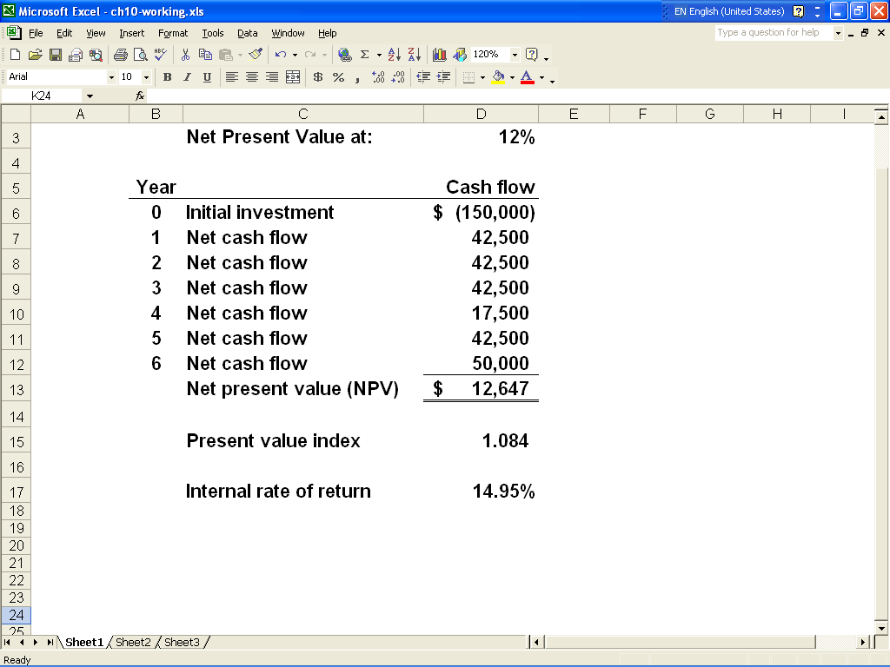

ATC 10-6

Screen capture of cell formulas:

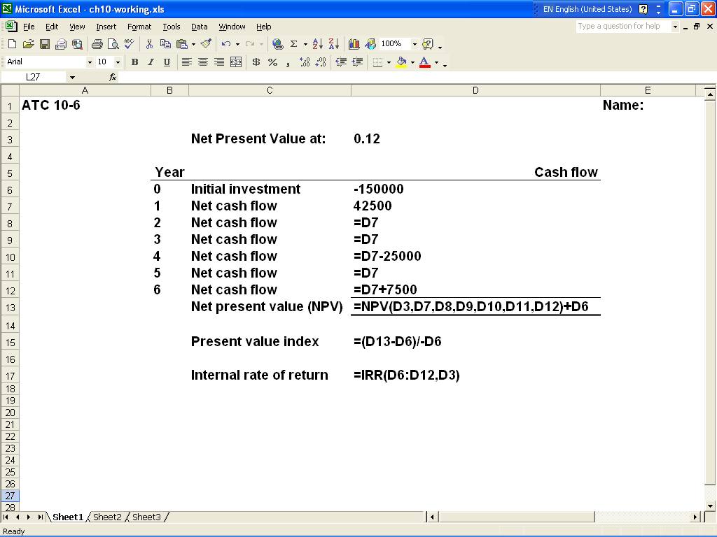
ATC 10-7

Screen capture of cell values:

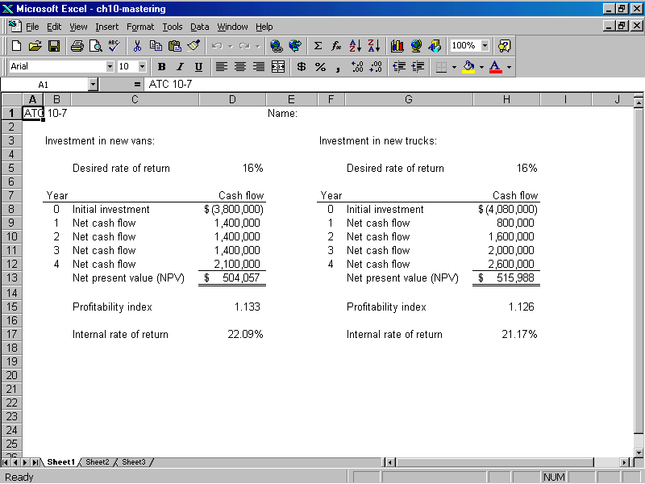

ATC 10-7

Screen capture of cell formulas:

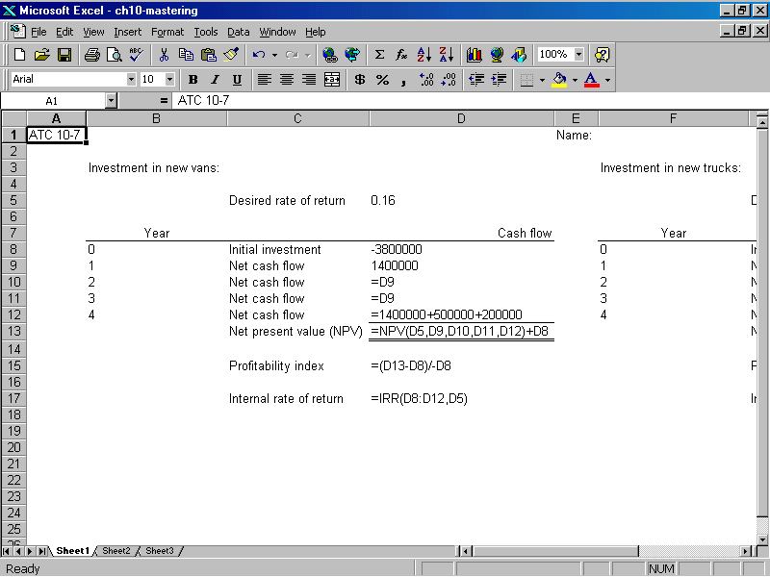
ATC 10-7

Screen capture of cell formulas (continued):

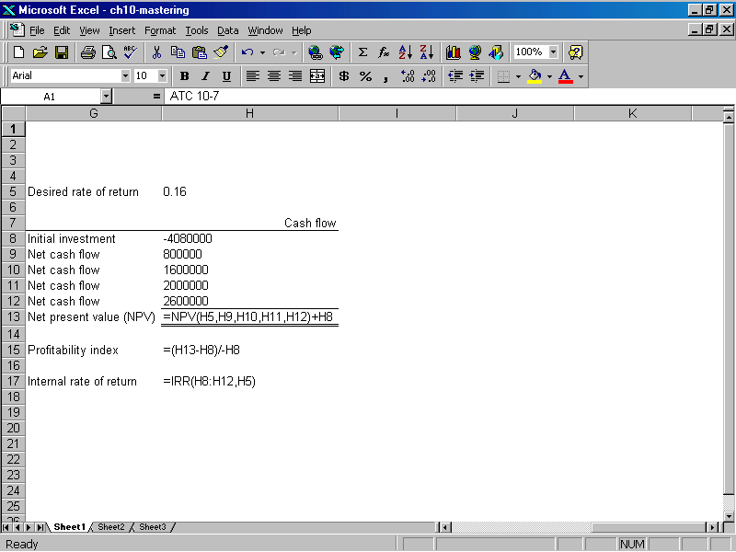

Chapter 10 -- Comprehensive Problem
Requirement a
Opportunity | A |  | B |  |  | C |  | D
Cash inflow | $6,000 |  | $5,000 |  |  | $8,000 |  | $4,800
Times present value factor | 2.798181 |  | 3.274294 |  |  | 2.245890 |  | 3.274294
Present value of cash flows | $ 16,789.09 |  | $16,371.47 |  |  | $17,967.12 |  | $15,716.61
Minus cost of investment | (16,000.00) |  | (15,000.00) |  |  | (18,000.00) |  | (16,000.00)
Net present value | $ 789.09 |  | $1,371.47 |  |  | ($32.88) |  | ($283.39)

Requirement b
Investment Data
Time period | 4
Cash inflow -- incremental revenue | 6,000
Cash outflow -- Cost of investment | (16,000) | (Note: The cash outflow must be
Desired rate of return | 0.16 | entered with a minus sign.)
Results
Internal rate of return | 18.45%
Net present value | $789.09

Summary of Results
Opportunity | A |  | B |  | C | D
Internal rate of return | 18.45% |  | 19.86% |  | 15.89% | 15.24%
Net present value | $789.09 |  | $1,371.47 |  | ($32.88) | ($283.39)

