Answers to Questions

1. Direct materials are those materials that can be directly traced to the finished products. Indirect materials are materials that cannot be easily or cost effectively traced to finished products. Because of the difficulty of tracing indirect costs, they are allocated to products produced in a period.

2. When direct materials are transferred to work in process inventory, costs are being transferred from one asset account to another asset account. Accordingly, total assets, liabilities, equity, cash flows, and net income are unaffected. Net income is affected only when material costs associated with goods sold are transferred from finished goods inventory to cost of goods sold. There would be no financial statement effects from the transfer if the original purchase had been with cash. The cash effects would have taken place at the time of purchase, not when the costs are transferred from one inventory account to another.

3. The costs of raw materials are first accumulated in the raw materials inventory account. As production proceeds, the costs of raw materials used are transferred to a work in process inventory account. The costs of labor are added to the work in process inventory account as they are incurred. Actual overhead costs are accumulated in the manufacturing overhead account as they are incurred; then they are applied to work in process periodically through an allocation process. As goods are completed, their costs are transferred to a finished goods inventory account. When goods are sold, their costs are transferred from the finished goods inventory account to the cost of goods sold account.

4. When goods are sold, their cost ($2,000) is transferred from finished goods inventory, an asset account, to cost of goods sold, an expense account. The revenue earned ($3,000) is recorded as sales revenue, an equity account, and accounts receivable, an asset account. Therefore, this sale on account would increase assets by $1,000 (inventory decreases by $2,000 and accounts receivable increases by $3,000), and increase equity by $1,000 (revenue increases equity by $3,000 and cost of goods sold decreases equity by $2,000). Net income would increase by $1,000 and the cash flow statement would be unaffected since a sale on account does not affect cash.

5. Recording the adjusting entry for accrued wages of production workers increases assets (increases work in process inventory) and increases liabilities (increases salaries payable). Equity is unaffected until the goods associated with these wages are sold. Net income is unaffected and the cash flow statement is unaffected.

6. The cost of utilities on the manufacturing facility is an indirect overhead cost. Since this cost cannot be easily and cost effectively traced to the products in production, it is necessary to accumulate utilities cost in the manufacturing overhead account and allocate it to work in process. Assuming that a proper allocation base is used to make the allocation, the allocated costs should approximate the amount of utilities associated with the goods in production.

7. The labor cost of the production worker’s salary results in the production of inventory that has a future economic benefit to the company. The inventory will produce revenue through sales at some future date. In order to accomplish matching, the cost of the production worker’s salary is capitalized in inventory until the inventory is sold. When the sales revenue is recorded, the salary cost is expensed in the cost of goods sold account. Accordingly, revenue is matched with the expense (production worker’s salary) incurred to produce it. While some portion of the marketing manager’s salary may result in some future economic benefit, the point of its realization is normally considered too obscure to measure. As a result, practical considerations require the accountant to treat the marketing manager’s salary as a selling, general, and administrative cost that is expensed in the period incurred.
8. Mr. Carmon could use direct labor hours or machine hours as an activity base for the predetermined overhead rate.

9. When a predetermined overhead rate is used to allocate costs, more or less overhead may be allocated than the actual amount of overhead costs that are incurred. Overapplied overhead is the term used to describe an allocation that is greater than the actual amount of overhead incurred. Underapplied overhead describes an allocation that is less than the actual amount of overhead incurred.

- Product costs are all the costs incurred to manufacture a product. These costs would include the costs of materials used in the product, such as lumber, metals, and paints; the costs of labor to produce the product, such as production workers’ wages, and supervisors’ salaries; and the costs of production facilities, such as utilities, rent, and insurance. Selling, general, and administrative costs are, as their name implies, costs associated with the administrative operations of the business and the costs associated with marketing and selling the products. Such costs would include the costs of the president’s salary, the salaries of clerical and secretarial staff, the costs of support functions (the accounting department and the human resources department), the costs associated with obtaining customers (advertising and sales salaries), and delivering goods to the customer (packaging costs, and shipping costs).

11. When overhead is overapplied, more overhead costs have been allocated to the products produced in the period than actual overhead costs incurred to produce the products. The objective of closing the manufacturing overhead account when overhead cost is overapplied is to reduce the amount of overhead cost expensed. The entry is a debit to manufacturing overhead and a credit to cost of goods sold. The credit to cost of goods sold reduces the expense associated with goods sold which in turn increases net income.

12. When product cost is determined periodically during the accounting period, many fixed overhead costs may not yet have been incurred. Fixed overhead costs are not related to production. For instance, insurance is a set amount regardless of how many products are produced. If actual costs are used, the products in that period may not include many fixed overhead costs that will be incurred later in the year or include fixed costs that should be assigned to the entire year’s production. Fixed overhead costs are incurred for the production of all products and should be included equally in the cost of all products. To eliminate this problem, overhead is applied to all products produced by using a predetermined overhead rate that assigns an equal amount of all overhead to each product. The applied overhead eliminates distortions in unit costs that would result if actual overhead costs were used.

13. Buresch could use a predetermined overhead rate to allocate overhead costs (heating costs) to its products. The rate is determined by dividing total expected overhead costs (which would include heating cost) by some measure of total expected production. The result could then be multiplied by the actual production to determine the amount of overhead to allocate to the products in work in process inventory. More heating cost would be allocated in months of high production and less in months of low production. This procedure would have the effect of averaging the seasonal fluctuations and would, therefore, result in a more stable unit cost figure.

14. The manufacturing overhead account serves as a temporary account to do the following: (1) accumulate the costs of actual overhead for the period and (2) serve as an account from which overhead costs can be applied (allocated) to work in process. Its ending balance will reflect the amount of over- or under- applied overhead that is closed to cost of goods sold. The closing entry is necessary in order to adjust cost of goods sold to actual cost for financial statement purposes.

15. The Cost of Goods Manufactured and Sold Schedule is prepared to show the computation of the amount of cost of goods manufactured and the amount of cost of goods sold for an accounting period. It would be prepared only by a manufacturing company where product cost accumulation needs further explanation due to the complexity of the number and kinds of costs used in product manufacture.

16. Under variable costing only the variable product costs are capitalized in the inventory accounts. Therefore, the unit cost of products sold consists of only variable manufacturing costs. The absorption method capitalizes both fixed and variable manufacturing cost in inventory. Therefore, under the absorption method, the unit cost of the product will consist of both fixed and variable product costs. In contrast to the traditional income statement, the income statement under variable costing is prepared by subtracting the variable cost of goods sold and the variable selling, general, and administrative costs from revenues to determine the contribution margin. All fixed costs are treated as period costs and expensed in the period incurred by subtracting them from contribution to get net income. The traditional method subtracts cost of goods sold made up of both fixed and variable costs from revenues to determine gross margin followed by subtracting both variable and fixed selling, general, and administrative costs to get net income.

17. Under absorption costing, the amount of reported net income (profitability) is affected by increases in productivity. This method allows the cost per unit to be reduced by increasing production. Total unit cost in absorption costing includes fixed product costs as well as variable product costs. The cost behavior of fixed costs causes the per unit product cost to decrease with increases in units produced. Therefore, with increases in production, cost of goods sold (based on unit cost of products sold) can be reduced to increase reported profit. Under variable costing, the amount of reported net income cannot be affected by increases in productivity. Cost of goods sold includes only variable product costs thereby not including the effects of operating leverage with production increases. Under the variable costing approach, all fixed product costs are expensed in the period incurred.

18. Variable costing would be used in internal reporting circumstances where companies want to stress the importance of profitability without motivating management to overproduce. Under the absorption costing method, increases in production can decrease the amount of cost of goods sold, which increases reported profits (higher production lowers the unit cost of the company’s products as a result of operating leverage, thereby reducing the cost of goods sold expense on the income statement). If a manager’s bonus is based on income, absorption costing creates an incentive to overproduce to increase income. The variable costing method provides no incentive to overproduce because the level of production has no effect on net income.

Exercise 11-1B
a.

Event | Assets |  |  |  |  |  |  |  |  | = | Equity |  |  |  | Rev. | - | Exp. | = | N. Inc. |  | Cash Flow
No. | Cash | + | MOH | + | Raw M. | + | WIP | + | F. Goods | = | Com. Stk. | + | Ret. Ear.
1 | 1,800 | + | N/A | + | N/A | + | N/A | + | N/A | = | 1,800 | + | N/A |  | N/A | - | N/A | = | N/A |  | 1,800 FA
2 | (600) | + | N/A | + | 600 | + | N/A | + | N/A | = | N/A | + | N/A |  | N/A | - | N/A | = | N/A |  | (600) OA
3 | N/A | + | N/A | + | (500) | + | 500 | + | N/A | = | N/A | + | N/A |  | N/A | - | N/A | = | N/A |  | N/A
4 | (700) | + | N/A | + | N/A | + | 700 | + | N/A | = | N/A | + | N/A |  | N/A | - | N/A | = | N/A |  | (700) OA
5 | N/A | + | (325) | + | N/A | + | 325 | + | N/A | = | N/A | + | N/A |  | N/A | - | N/A | = | N/A |  | N/A
6 | N/A | + | N/A | + | N/A | + | (1,100) | + | 1,100 | = | N/A | + | N/A |  | N/A | - | N/A | = | N/A |  | N/A
7 | 1,600 | + | N/A | + | N/A | + | N/A | + | N/A | = | N/A | + | 1,600 |  | 1,600 | - | N/A | = | 1,600 |  | 1,600 OA
8 | N/A | + | N/A | + | N/A | + | N/A | + | (875) | = | N/A | + | (875) |  | N/A | - | 875 | = | (875) |  | N/A
9 | (450) | + | N/A | + | N/A | + | N/A | + | N/A | = | N/A | + | (450) |  | N/A | - | 450 | = | (450) |  | (450) OA
10 | (350) | + | 350 | + | N/A | + | N/A | + | N/A | = | N/A | + | N/A |  | N/A | - | N/A | = | N/A |  | (350) OA
11 | (100) | + | N/A | + | N/A | + | N/A | + | N/A | = | N/A | + | (100) |  | N/A | - | N/A | = | N/A |  | (100) FA
12 | N/A | + | (25) | + | N/A | + | N/A | + | N/A | = | N/A | + | (25) |  | N/A | - | 25 | = | (25) |  | N/A
Total | 1,200 | + | 0 | + | 100 | + | 425 | + | 225 | = | 1,800 | + | 150 |  | 1,600 | - | 1,350 | = | 250 |  | 1,200 NC

Exercise 11-1B (continued)

b.

Spencer Manufacturing
Schedule of Cost of Goods Manufactured and Sold
For the Year Ended December 31, 2007
Beginning raw materials inventory | $ 0
Raw material purchases | 600
Raw materials available for Use | 600
Ending raw materials inventory | (100)
Raw materials used | 500
Direct labor | 700
Manufacturing overhead | 350
Total manufacturing costs | 1,550
Beginning work in process inventory | 0
Total work in process inventory | 1,550
Ending work in process inventory | (425)
Cost of goods manufactured | 1,125
Beginning finished goods inventory | 0
Finished goods available for sale | 1,125
Ending finished goods inventory | (225)
Cost of goods sold | $ 900

Exercise 11-2B

a.
Cash |  |  | Raw Materials |  |  | Work in Process |  |  | Finished Goods |  |  | Common Stock
(1) 1,600 | (2) 480 |  | (2) 480 | (3) 360 |  | (3) 360 | (7) 1,040 |  | (7) 1,040 | (8) 824 |  |  | (1) 1,600
(7) 1,360 | (4) 640 |  | Bal. 120 |  |  | (4) 640 |  |  | Bal. 216
 | (6) 464 |  |  |  |  | (5) 464
 | (9) 320 |  |  |  |  | Bal. 424 |  |  |  |  |  | Retained Earnings
Bal. 1,056 |  |  |  |  |  |  |  |  |  |  |  |  | (cl) 216
Manufacturing Overhead
(6) 464 | (5) 464 |  |  |  |  |  |  |  |  |  |  | Sales Revenue
 |  |  |  |  |  |  |  |  |  |  |  | (cl) 1,360 | (7) 1,360
 |  |  |  |  |  |  |  |  |  |  |  | Cost of Goods Sold
 |  |  |  |  |  |  |  |  |  |  |  | (8) 824 | (cl) 824
 |  |  |  |  |  |  |  |  |  |  |  | Selling & Admin. Exp.
 |  |  |  |  |  |  |  |  |  |  |  | (9) 320 | (cl) 320

Exercise 11-2B (continued)

b.

Micoli Manufacturing Company
Financial Statements for 2007
 | Cost of Goods Manf. and Sold |  |  | Income Statement |  |  | Balance Sheet |  |  | Statement of Cash Flows
 | Beg. Raw Mat. Inv. | $ 0 |  | Sales Revenue | $ 1,360 |  | Assets |  |  | Operating Activities
 | Purchases | 480 |  | Cost of Goods Sold | (824) |  | Cash | $1,056 |  | Inflow from Revenue | $1,360
 | Raw Mat. Avail. | 480 |  | Gross Margin | 536 |  | Raw Mat. Inv. | 120 |  | Outflow for Inventory | (1,584)
 | End. Raw Mat. Inv. | (120) |  | Sell. & Admin. Exp. | (320) |  | WIP Inv. | 424 |  | Outflow for Sell. & Adm. | (320)
 | Raw Mat. Used | 360 |  | Net Income | $ 216 |  | Fin. Goods Inv. | 216 |  | Net Outflow from Oper. | (544)
 | Labor | 640 |  |  |  |  | Total Assets | $1,816 |  | Investing Activities | 0
 | Overhead | 464 |  |  |  |  |  |  |  | Financing Activities
 | Total Manf. Costs | 1,464 |  |  |  |  |  |  |  | Inflow from Stock Issue | 1,600
 | Beg. WIP Inv. | 0 |  |  |  |  | Equity |  |  | Net Change in Cash | 1,056
 | Total WIP Inv. | 1,464 |  |  |  |  | Common Stock | $1,600 |  | Beginning Cash Balance | 0
 | End. WIP Inv. | (424) |  |  |  |  | Retained Earnings | 216 |  | Ending Cash Balance | $1,056
 | Cost of Goods Man. | 1,040 |  |  |  |  | Total Equity | $1,816
 | Beg. Fin. Goods | 0
 | Goods Available | 1,040
 | End. Fin. Goods | (216)
 | Cost of Goods Sold | $ 824

Exercise 11-3B

Event | Balance Sheet |  |  |  |  |  |  |  | Income Statement |  |  |  |  |  | Statement of
No. | Assets | = | Liab. | + | C. Stk | + | Ret. Ear. |  | Rev. | - | Exp. | = | Net Inc. |  | Cash Flows
a. | I D |  | NA |  | NA |  | NA |  | NA |  | NA |  | NA |  | D OA
b. | I |  | NA |  | NA |  | I |  | I |  | NA |  | I |  | I OA
c. | I D |  | NA |  | NA |  | NA |  | NA |  | NA |  | NA |  | NA
d. | D |  | NA |  | NA |  | D |  | NA |  | I |  | D |  | NA
e. | D |  | NA |  | NA |  | D |  | NA |  | I |  | D |  | NA
f. | I D |  | NA |  | NA |  | NA |  | NA |  | NA |  | NA |  | NA
g. | I |  | I |  | NA |  | NA |  | NA |  | NA |  | NA |  | NA
h. | I D |  | NA |  | NA |  | NA |  | NA |  | NA |  | NA |  | I FA

Exercise 11-4B

a.
Raw Materials |  |  | Work in Process |  |  | Finished Goods
Bal. 5,400 | 33,000 |  | Bal. 5,600 | 105,000 |  | Bal. 6,600 | 101,400
34,000 |  |  | M 33,000 |  |  | 105,000
Bal. 6,400 |  |  | DL 38,000 |  |  | Bal. 10,200
 |  |  | OH 37,400
 |  |  | Bal. 9,000

Exercise 11-4B (continued)

b.
Hammer Manufacturing Company
Schedule of Cost of Goods Manufactured and Sold
For the Year Ended December 31, 2007
Beginning raw materials inventory |  | $ 5,400
Purchases |  | 34,000
Raw materials available |  | 39,400
Ending raw materials inventory |  | (6,400)
Raw materials used |  | 33,000
Direct labor |  | 38,000
Manufacturing overhead |  | 37,400
Total manufacturing costs |  | 108,400
Beginning work in process inventory |  | 5,600
Total work in process inventory |  | 114,000
Ending work in process inventory |  | (9,000)
Cost of goods manufactured |  | 105,000
Beginning finished goods inventory |  | 6,600
Goods available for sale |  | 111,600
Ending finished goods inventory |  | (10,200)
Cost of goods sold |  | $101,400

Hammer Manufacturing Company
Income Statement
For the Year Ended December 31, 2007
Sales Revenue |  | $153,800
Cost of Goods Sold |  | (101,400)
Gross Margin |  | 52,400
Selling and Administrative Expenses |  | (36,000)
Net Income |  | $ 16,400

Exercise 11-5B

Koch Corporation
Statement of Cost of Goods Manufactured and Sold
For the Year Ended December 31, 2006
Raw materials:
Beginning inventory | $ 40,000
Plus: Purchases | 280,000
Raw materials available for Use | $320,000
Minus: Ending raw materials inventory | (30,000)
Cost of direct raw materials used |  | $290,000
Direct labor |  | 240,000
Manufacturing overhead |  | 220,000
Total manufacturing costs |  | $750,000
Plus: Beginning work in process inventory |  | 36,000
Total work in process During the Year |  | $786,000
Minus: Ending work in process inventory |  | (41,000)
Cost of goods manufactured |  | $745,000
Plus: Beginning finished goods inventory |  | 53,000
Finished goods available for sale |  | $798,000
Minus: Ending finished goods inventory |  | (42,000)
Cost of goods sold |  | $756,000

Exercise11- 6B

Raw Materials |  |  | Work in Process |  |  | Finished Goods
Bal. 4,000 | ? = 15,400 |  | Bal. 6,200 | ? = 42,600 |  | Bal. 6,800 | ? = 43,600
16,000 |  |  | M 15,400 |  |  | 42,600
Bal. 4,600 |  |  | DL 15,000 |  |  | Bal. 5,800
 |  |  | OH 11,000
 |  |  | Bal. 5,000

a. $4,000 + $16,000 – $4,600 = $15,400

b. $6,200 + $15,400 + $15,000 + $11,000 – $5,000 = $42,600

c.
Sales revenue |  | $76,800
Cost of goods sold |  | (43,600)
Gross margin |  | $33,200

Exercise11- 7B

a.
Depreciation on manufacturing equipment |  | $ 86,000
Cost of manufacturing supplies |  | 15,000
Rent on manufacturing facility |  | 38,000
Manufacturing utilities cost |  | 30,000
Maintenance cost for manufacturing facility |  | 26,000
Total estimated manufacturing overhead costs |  | $195,000

b. Predetermined overhead rate:
Total estimated overhead cost/Allocation base
$195,000/30,000 machine hours = $6.50 per machine hour

c. The term “predetermined” is used because the overhead rate is determined before the actual overhead cost is known.

d. Applied overhead = $6.50 x 29,200 = $189,800.

Exercise 11-8B

a. | Total expected overhead costs
 | –––––––––––––––––––––––––––––– | = | Predetermined overhead rate
 | Total expected units

 |  | $139,400
 | Predetermined overhead rate = | ––––––––––– | = | $4.10 per unit
 |  | 34,000

b. | Applied OH cost | = | Predetermined overhead rate x Weight of base
 |  | = | $4.10 x 34,600 units = $141,860
 | Since Longstreet applied more overhead ($141,860) than it actually incurred ($140,500), overhead cost was overapplied.

c. Since overhead was overapplied, too much cost was ultimately charged to cost of goods sold. The entry to close the manufacturing overhead account corrects this condition by reducing the amount of cost of goods sold.

Exercise 11-9B

a. Compute the predetermined overhead rate as follows:

(X) = predetermined overhead rate
Actual direct labor cost x (X) = Applied overhead
$84,000 (X) = $58,800 ($59,600 actual OH – $800 underapplied)
(X) = $0.70 per direct labor dollar

b. T- accounts:

Manufacturing Overhead Cost of Goods Sold
59,600 | 58,800 |  | Adj. 800
800 | Adj. 800

c. The entry to close the manufacturing overhead account increases cost of goods sold and decreases reported Net Income.

Exercise 11-10B

a. | Total expected overhead costs
 | –––––––––––––––––––––––––––––– | = | Predetermined overhead rate
 | Total expected machine hours

Gray:
 |  | $16,800
 | Predetermined overhead rate = | ––––––––––– | = | $1.40 per machine hour
 |  | 12,000
Greene:
 |  | $34,800
 | Predetermined overhead rate = | ––––––––––– | = | $1.74 per machine hour
 |  | 20,000

b. | Applied OH cost | = | Predetermined overhead rate x Weight of base
 | Gray:
 | Applied OH cost | = | $1.40 x 12,300 hours = $17,220
 | Since Gray applied $17,220 overhead while the actual overhead was $17,000, overhead was overapplied.
 | Greene:
 | Applied OH cost | = | $1.74 x 19,500 hours = $33,930
 | Since Greene applied $33,930 overhead while the actual overhead was $34,500, overhead was underapplied.

c. Since Gray’s overhead was overapplied, too much cost was charged to cost of goods sold. The entry to close the manufacturing overhead account will correct this condition by reducing the amount of cost of goods sold.

Since Greene’s overhead was underapplied, too little cost was charged to cost of goods sold. The entry to close the manufacturing overhead account will correct this condition by increasing the amount of cost of goods sold.

Exercise 11-11B

a. and b.

Cash |  |  |  | Manufacturing Overhead |  |  | WIP Inventory
 | (1) 58,000 |  |  | (1) 58,000 | (4) 88,000 |  | (4) 88,000
 |  |  |  | (2) 27,000
Accumulated Depreciation |  |  |  | (3) 2,300
 |  | (2) 27,000 |  | (cl) 700
Supplies |  |  |  |  |  |  | Cost of Goods Sold
 |  | (3) 2,300 |  |  |  |  |  | (cl) 700

Exercise 11-12B

Raw Materials Inventory WIP Inventory
25,000 | (a) 23,800 |  | (a) 23,800 | 52,000
1,200 |  |  | 15,600
 |  |  | 17,800
 |  |  | (b) 5,200

Finished Goods Inventory Cost of Goods Sold
(c) 52,000 | 47,000 |  | 47,000
5,000 |  |  |  | 800
 |  |  | (d) 46,200

Manufacturing Overhead
17,000 | (e) 17,800
(cl) 800 | 800

Exercise 11-13B

a.
Antitum Company
Income Statement
(Absorption Costing)
Sales Revenue (1) |  |  |  | $186,200
Cost of Goods Sold:
Direct Materials (2) |  | $(30,400)
Direct Labor (3) |  | (38,000)
Manufacturing Overhead (4) |  | (34,200)
 |  |  |  | (102,600)
Gross Margin |  |  |  | 83,600
Selling and Administrative (5) |  |  |  | (51,400)
Net Income |  |  |  | $ 32,200

(1) Sales revenue: $49/unit x 3,800 units = $186,200
(2) Direct materials: $8/unit x 3,800 units = $30,400
(3) Direct labor: $10/unit x 3,800 units = $38,000
(4) Fixed overhead per unit: 24,000/4,000 units = $6
Total MOH [($6/unit + $3/unit) x 3,800 units] = $34,200
(5) Variable S&A: $7/unit x 3,800 units = $26,600
Fixed S&A = $24,800
Total S&A = $26,600 + $24,800 = $51,400
Exercise 11-13B (continued)

b.
Antitum Company
Income Statement
(Variable Costing)
Sales Revenue (1) |  |  |  | $186,200
Cost of Goods Sold:
Direct Materials (2) |  | $(30,400)
Direct Labor (3) |  | (38,000)
Variable Overhead (4) |  | (11,400)
Variable S & A (5) |  | (26,600)
 |  |  |  | (106,400)
Contribution Margin |  |  |  | 79,800
Fixed Overhead |  |  |  | (24,000)
Fixed S&A |  |  |  | (24,800)
Net Income |  |  |  | $31,000

(1) Sales Revenue: $49/unit x 3,800 units = $186,200
(2) Direct Materials: $8/unit x 3,800 units = $30,400
(3) Direct Labor: $10/unit x 3,800 units = $38,000
(4) Variable MOH: $3/unit x 3,800 units = $11,400
(5) Variable S&A: $7/unit x 3,800 units = $26,600

c. Companies are required by generally accepted accounting principles to use absorption costing for external reporting. They may choose to use variable costing for internal reporting because it reduces management motivation to overproduce. When fixed manufacturing costs are recorded as inventory, building inventory keeps some of these costs off the income statement. A manager may be motivated to produce and hold inventory because doing so will improve the amount of reported income. Since variable costing charges all fixed costs directly to the income statement, there is little or no benefit to overproducing inventory.

Exercise 11-14B

a. January:
Variable cost | $4 x 1,200 units = | $4,800
Fixed cost |  | 4,500
Total product cost |  | $9,300
Per unit cost | $9,300/1,200 = | $7.75 per unit

February:
Variable cost | $4 x 2,100 units = | $ 8,400
Fixed cost |  | 4,500
Total product cost |  | $12,900
Per unit cost | $12,900/2,100 = | $6.14 per unit

b. Predetermined OH rate = Total expected cost/Allocation base
Predetermined OH rate = ($4,500 x 12)/12,000 hrs = $4.50 per hour

January:
Variable cost | $4 x 1,200 units = | $4,800
Fixed cost | $4.50 x 800 DL hours = | 3,600
Total cost |  | $8,400
Per unit cost | $8,400/1,200 units = | $7.00 per unit

February:
Variable cost | $4 x 2,100 units = | $ 8,400
Fixed cost | $4.50 x 1,400 DL hours = | 6,300
Total cost |  | $14,700
Per unit cost | $14,700/2,100 = | $7.00 per unit

c. Requirements a and b demonstrate that allocation smoothes the distribution of fixed costs over the total units produced, which is useful when applying a cost-plus pricing strategy. Customers are likely to be confused by and object to prices that fluctuate each month. Tameka would find using allocated fixed costs the better method since it produces uniform costs regardless of production levels.

Problem 11-15B

a. c. and d.

2005

Event | Assets |  |  |  |  |  |  |  |  | = | Equity |  |  |  | Rev. | - | Exp. | = | N. Inc. |  | Cash Flow
No. | Cash | + | MOH | + | Raw M. | + | WIP | + | F. Goods | = | Com. Stk. | + | Ret. Ear.
1 | 2,400 | + | NA | + | NA | + | NA | + | NA | = | 2,400 | + | NA |  | NA | - | NA | = | NA |  | 2,400 FA
2 | (960) | + | NA | + | 960 | + | NA | + | NA | = | NA | + | NA |  | NA | - | NA | = | NA |  | (960) OA
3 | NA | + | NA | + | (720) | + | 720 | + | NA | = | NA | + | NA |  | NA | - | NA | = | NA |  | NA
4 | (600) | + | NA | + | NA | + | 600 | + | NA | = | NA | + | NA |  | NA | - | NA | = | NA |  | (600) OA
5 | NA | + | (600) | + | NA | + | 600 | + | NA | = | NA | + | NA |  | NA | - | NA | = | NA |  | NA
6 | (610) | + | 610 | + | NA | + | NA | + | NA | = | NA | + | NA |  | NA | - | NA | = | NA |  | (610) OA
7 | NA | + | NA | + | NA | + | (1,080) | + | 1,080 | = | NA | + | NA |  | NA | - | NA | = | NA |  | NA
8a | 960 | + | NA | + | NA | + | NA | + | NA | + | NA | + | 960 |  | 960 | - | NA | = | 960 |  | 960 OA
8b | NA | + | NA | + | NA | + | NA | + | (720) | = | NA | + | (720) |  | NA | - | 720 | = | (720) |  | NA
9 | (60) | + | NA | + | NA | + | NA | + | NA | = | NA | + | (60) |  | NA | - | 60 | = | (60) |  | (60) OA
CL | NA | + | (10) | + | NA | + | NA | + | NA | = | NA | + | (10) |  | NA | - | 10 | = | (10) |  | NA
Total | 1,130 | + | 0 | + | 240 | + | 840 | + | 360 | = | 2,400 | + | 170 |  | 960 | - | 790 | = | 170 |  | 1,130

Problem 11-15B (continued)

a. c. and d.

2006

Event | Assets |  |  |  |  |  |  |  |  | = | Equity |  |  |  | Rev. | - | Exp. | = | N. Inc. |  | Cash Flow
No. | Cash | + | MOH | + | Raw M. | + | WIP | + | F. Goods | = | Com. Stk. | + | Ret. Ear.
BB | 1,130 | + | 0 | + | 240 | + | 840 | + | 360 | = | 2,400 | + | 170 |  | NA | - | NA | = | NA |  | NA
1 | 1,200 | + | NA | + | NA | + | NA | + | NA | = | 1,200 | + | NA |  | NA | - | NA | = | NA |  | 1,200 FA
2 | (960) | + | NA | + | 960 | + | NA | + | NA | = | NA | + | NA |  | NA | - | NA | = | NA |  | (960) OA
3 | NA | + | NA | + | (840) | + | 840 | + | NA | = | NA | + | NA |  | NA | - | NA | = | NA |  | NA
4 | (720) | + | NA | + | NA | + | 720 | + | NA | = | NA | + | NA |  | NA | - | NA | = | NA |  | (720) OA
5 | NA | + | (640) | + | NA | + | 640 | + | NA | = | NA | + | NA |  | NA | - | NA | = | NA |  | NA
6 | (630) | + | 630 | + | NA | + | NA | + | NA | = | NA | + | NA |  | NA | - | NA | = | NA |  | (630) OA
7 | NA | + | NA | + | NA | + | (1,800) | + | 1,800 | = | NA | + | NA |  | NA | - | NA | = | NA |  | NA
8a | 1,920 | + | NA | + | NA | + | NA | + | NA | + | NA | + | 1,920 |  | 1,920 | - | NA | = | 1,920 |  | 1,920 OA
8b | NA | + | NA | + | NA | + | NA | + | (1,680) | = | NA | + | (1,680) |  | NA | - | 1,680 | = | (1,680) |  | NA
9 | (120) | + | NA | + | NA | + | NA | + | NA | = | NA | + | (120) |  | NA | - | 120 | = | (120) |  | (120) OA
CL | NA | + | 10 | + | NA | + | NA | + | NA | = | NA | + | 10 |  | NA | - | (10) | = | 10 |  | NA
Total | 1,820 | + | 0 | + | 360 | + | 1,240 | + | 480 | = | 3,600 | + | 300 |  | 1,920 | - | 1,790 | = | 130 |  | 690
 | 1,130 | + | 0 | + | 240 | + | 840 | + | 360 | = | 2,400 | + | 170 |  | NA | - | NA | = | NA |  | NA

Problem 11-15B (continued)

a. c. and d.

2007

Event | Assets |  |  |  |  |  |  |  |  | = | Equity |  |  |  | Rev. | - | Exp. | = | N. Inc. |  | Cash Flow
No. | Cash | + | MOH | + | Raw M. | + | WIP | + | F. Goods | = | Com. Stk. | + | Ret. Ear.
BB | 1,820 | + | 0 | + | 360 | + | 1,240 | + | 480 | = | 3,600 | + | 300 |  | NA | - | NA | = | NA |  | NA
1 | (600) | + | NA | + | 600 | + | NA | + | NA | = | NA | + | NA |  | NA | - | NA | = | NA |  | (600) OA
2 | NA | + | NA | + | (960) | + | 960 | + | NA | = | NA | + | NA |  | NA | - | NA | = | NA |  | NA
3 | (360) | + | NA | + | NA | + | 360 | + | NA | = | NA | + | NA |  | NA | - | NA | = | NA |  | (360) OA
4 | NA | + | (500) | + | NA | + | 500 | + | NA | = | NA | + | NA |  | NA | - | NA | = | NA |  | NA
5 | (520) | + | 520 | + | NA | + | NA | + | NA | = | NA | + | NA |  | NA | - | NA | = | NA |  | (520) OA
6 | NA | + | NA | + | NA | + | (1,980) | + | 1,980 | = | NA | + | NA |  | NA | - | NA | = | NA |  | NA
7 a | 2,640 | + | NA | + | NA | + | NA | + | NA | + | NA | + | 2,640 |  | 2,640 | - | NA | = | 2,640 |  | 2,640 OA
7 b | NA | + | NA | + | NA | + | NA | + | (2,160) | = | NA | + | (2,160) |  | NA | - | 2,160 | = | (2,160) |  | NA
8 | (240) | + | NA | + | NA | + | NA | + | NA | = | NA | + | (240) |  | NA | - | 240 | = | (240) |  | (240) OA
9 | (480) | + | NA | + | NA | + | NA | + | NA | = | NA | + | (480) |  | NA | - | NA | = | NA |  | (480) FA
CL | NA | + | (20) | + | NA | + | NA | + | NA | = | NA | + | (20) |  | NA | - | 20 | = | (20) |  | NA
Total | 2,260 | + | 0 | + | 0 | + | 1,080 | + | 300 | = | 3,600 | + | 40 |  | 2,640 | - | 2,420 | = | 220 |  | 440

Problem 11-15B (continued)

b. and d. Schedule for Years 2005, 2006, and 2007
Liaw Manufacturing Company
Cost of Goods Manufactured and Sold Schedule
 |  | 2005 |  | 2006 |  | 2007
Beginning raw materials inventory |  | $ 0 |  | $ 240 |  | $ 360
Purchases |  | 960 |  | 960 |  | 600
Raw materials available |  | 960 |  | 1,200 |  | 960
Ending raw materials inventory |  | (240) |  | (360) |  | (0)
Raw materials used |  | 720 |  | 840 |  | 960
Labor |  | 600 |  | 720 |  | 360
Manufacturing overhead |  | 610 |  | 630 |  | 520
Total manufacturing costs |  | 1,930 |  | 2,190 |  | 1,840
Beginning work in process inventory |  | 0 |  | 840 |  | 1,240
Total work in process inventory |  | 1,930 |  | 3,030 |  | 3,080
Ending work in process inventory |  | (840) |  | (1,240) |  | (1,080)
Cost of goods manufactured |  | 1,090 |  | 1,790 |  | 2,000
Beginning finished goods inventory |  | 0 |  | 360 |  | 480
Goods available for sale |  | 1,090 |  | 2,150 |  | 2,480
Ending finished goods inventory |  | (360) |  | (480) |  | (300)
Cost of goods sold |  | $ 730 |  | $1,670 |  | $2,180

Problem 11-15B (continued)

b. and d. Financial Statements for Years 2005, 2006, and 2007
Liaw Manufacturing Company
Financial Statements
 |  | 2005 |  | 2006 |  | 2007
Income Statements
Sales Revenue |  | $ 960 |  | $1,920 |  | $2,640
Cost of Goods Sold |  | (730) |  | (1,670) |  | (2,180)
Gross Margin |  | 230 |  | 250 |  | 460
Selling and Administrative Expenses |  | (60) |  | (120) |  | (240)
Net Income |  | $ 170 |  | $ 130 |  | $ 220
Balance Sheets
Assets
Cash |  | $1,130 |  | $1,820 |  | $2,260
Raw Materials Inventory |  | 240 |  | 360 |  | 0
Work in Process Inventory |  | 840 |  | 1,240 |  | 1,080
Finished Goods Inventory |  | 360 |  | 480 |  | 300
Total Assets |  | $2,570 |  | $3,900 |  | $3,640
Equity
Common Stock |  | $2,400 |  | $3,600 |  | $3,600
Retained Earnings |  | 170 |  | 300 |  | 40
Total Equity |  | $2,570 |  | $3,900 |  | $3,640
Statements of Cash Flows
Operating Activities
Inflow from Revenue |  | $ 960 |  | $ 1,920 |  | $2,640
Outflow for Inventory |  | (2,170) |  | (2,310) |  | (1,480)
Outflow for Selling and Admin. Exp. |  | (60) |  | (120) |  | (240)
Net Inflow (Outflow) from Oper. Act. |  | (1,270) |  | (510) |  | 920
Investing Activities |  | 0 |  | 0 |  | 0
Financing Activities |  | 2,400 |  | 1,200 |  | (480)
Net Change in Cash |  | 1,130 |  | 690 |  | 440
Beginning Cash Balance |  | 0 |  | 1,130 |  | 1,820
Ending Cash Balance |  | $1,130 |  | $1,820 |  | $2,260

Problem 11-16B
a.
Cash |  |  | Raw Materials |  |  | Work in Process |  |  | Accounts Payable |  |  | Common Stock
Bal. 2,800 | (2) 3,500 |  | Bal. 200 | (1) 4,000 |  | Bal. 600 | (9) 15,000 |  | (2) 3,500 | (1) 5,100 |  |  | Bal. 4,200
(10) 14,000 | (4) 6,500 |  | (1) 4,600 |  |  | (1) 4,000 |  |  |  | Bal. 1,600
 | (6) 1,400 |  | Bal. 800 |  |  | (3) 7,200
 | (7) 3,000 |  |  |  |  | (5) 5,280
Bal. 2,400 |  |  | Prop., Plant, & Equip |  |  | Bal. 2,080 |  |  | Wages Payable |  |  | Retained Earnings
 |  |  | Bal. 7,000 |  |  |  |  |  | (4) 6,500 | (3) 7,200 |  |  | Bal. 4,800
 |  |  |  |  |  |  |  |  |  | Bal. 700 |  |  | (cl) 2,530
 |  |  |  |  |  |  |  |  |  |  |  |  | Bal. 7,330
 |  |  | Accumulated Dep. |  |  | Finished Goods
 |  |  |  | Bal. 2,000 |  | Bal. 400 | (10) 10,000
 |  |  |  | (8) 2,000 |  | (9) 15,000
 |  |  |  | Bal. 4,000 |  | Bal. 5,400 |  |  |  |  |  | Revenue
 |  |  |  |  |  |  |  |  |  |  |  | (cl) 14,000 | (10) 14,000
Manufacturing Overhead
(7) 3,000  Predetermined OH rate:  $5,500÷1,250=$4.40  Amount applied:  $4.40 x 1,200=$5,280 | (5) 5,280
(8) 2,000 | (12) 70
(11) 350 |  |  |  |  |  |  |  |  |  |  |  | Cost of Goods Sold
Bal. 0 |  |  |  |  |  |  |  |  |  |  |  | (10) 10,000 |  | (cl) 10,070
 |  |  |  |  |  |  |  |  |  |  |  | (12) 70
 |  |  |  |  |  |  |  |  |  |  |  | Selling & Admin. Exp.
Supplies |  |  |  |  |  |  |  |  |  |  |  | (6) 1,400 |  | (cl) 1,400
(1) 500 | (11) 350
Bal. 150

Problem 11-16B

b.
Fernando Manufacturing Company
Financial Statements for 2006
Cost of Goods Manf. and Sold |  |  | Income Statement |  |  | Balance Sheet |  |  | Statement of Cash Flows
Beg. Raw Mat. Inv. | $ 200 |  | Sales Revenue | $14,000 |  | Assets |  |  | Oper. Activities
Purchases | 4,600 |  | Cost of Goods Sold | (10,070) |  | Cash | $ 2,400 |  | Inflow from Rev. | $14,000
Raw Mat. Avail. | 4,800 |  | Gross Margin | 3,930 |  | Prod. Supplies | 150 |  | Outflow for Inventory¹ | (13,000)
End. Raw Mat. Inv. | (800) |  | Sell. & Admin. Exp. | (1,400) |  | Raw Mat. Inv. | 800 |  | Outflow for Sell. & Adm. | (1,400)
Raw Mat. Used | 4,000 |  | Net Income | $2,530 |  | W-I-P Inv. | 2,080 |  | Net Outflow from Oper. | (400)
Labor | 7,200 |  |  |  |  | Fin. Goods Inv. | 5,400 |  | Investing Activities | 0
Overhead (Actual) | 5,350 |  |  |  |  | Pr., Plt. & Equip. | 7,000 |  | Financing Activities | 0
Total Manf. Costs | 16,550 |  |  |  |  | Acc. Dep. | (4,000) |  | Net Change in Cash | (400)
Beg. W-I-P Inv. | 600 |  |  |  |  | Total Assets | $13,830 |  | Beginning Cash Balance | 2,800
Total W-I-P Inv. | 17,150 |  |  |  |  |  |  |  | Ending Cash Balance | $ 2,400
End. W-I-P Inv. | (2,080) |  |  |  |  | Liabilities
Cost of Goods Man. | 15,070 |  |  |  |  | Acct. Payable | $ 1,600
Beg. Fin. Goods | 400 |  |  |  |  | Wages Payable | 700
Goods Available | 15,470 |  |  |  |  | Equity
End. Fin. Goods | (5,400) |  |  |  |  | Common Stock | 4,200
Cost of Goods Sold | $10,070 |  |  |  |  | Retained Earnings | 7,330
 |  |  |  |  |  | Total Equity | $13,830

¹$3,500 + $6,500 + $3,000 = $13,000 (Nos. 2, 4, and 7)
Problem 11-17B

a.

Event | Assets |  |  |  |  |  |  |  |  | = | Equity |  |  |  | Rev. | – | Exp. | = | N. Inc. |  | Cash Flow
No. | Cash | + | MOH | + | Raw M. | + | WIP | + | F. Goods | = | Com. Stk. | + | Ret. Ear.
BB | 2,250 | + | 100 | + | NA | + | 220 | + | 180 | = | 2,000 | + | 750 |  | NA | – | NA | = | NA |  | NA
1 | (750) | + | 750 | + | NA | + | NA | + | NA | = | NA | + | NA |  | NA | – | NA | = | NA |  | (750) OA
2 | NA | + | (500) | + | NA | + | 500 | + | NA | = | NA | + | NA |  | NA | – | NA | = | NA |  | NA
3 | (600) | + | NA | + | NA | + | 600 | + | NA | = | NA | + | NA |  | NA | – | NA | = | NA |  | (600) OA
4 | NA | + | NA | + | (600) | + | 600 | + | NA | = | NA | + | NA |  | NA | – | NA | = | NA |  | NA
5 | (650) | + | NA | + | 650 | + | NA | + | NA | = | NA | + | NA |  | NA | – | NA | = | NA |  | (650) OA
6 | NA | + | NA | + | NA | + | (1,080) | + | 1,080 | = | NA | + | NA |  | NA | – | NA | = | NA |  | NA
7 | (200) | + | NA | + | NA | + | NA | + | NA | + | NA | + | (200) |  | NA | – | 200 | = | (200) |  | (200) OA
8a | 1,500 | + | NA | + | NA | + | NA | + | NA | = | NA | + | 1,500 |  | 1,500 | – | NA | = | 1,500 |  | 1,500 OA
8b | NA | + | NA | + | NA | + | NA | + | (720) | = | NA | + | (720) |  | NA | – | 720 | = | (720) |  | NA
9 | NA | + | NA |  | (50) | + | NA | + | NA | = | NA | + | (50) |  | NA | – | 50 | = | (50) |  | NA
Total | 1,550 | + | 350 | + | 0 | + | 840 | + | 540 | = | 2,000 | + | 1,280 |  | 1,500 | – | 970 | = | 530 |  | (700)

Problem 11-17B (continued)

b.

Mikhail Manufacturing Company
Financial Statements for 2007
Cost of Goods Manf. and Sold |  |  | Income Statement |  |  | Balance Sheet |  |  | Statement of Cash Flows
Beg. Raw Mat. Inv. | $ 100 |  | Sales Revenue | $ 1,500 |  | Assets |  |  | Oper. Activities
Purchases | 750 |  | Cost of Goods Sold | (770) |  | Cash | $ 1,550 |  | Inflow from Rev. | $ 1,500
Raw Mat. Avail. | 850 |  | Gross Margin | 730 |  | Raw Mat. Inv. | 350 |  | Outflow for Inventory¹ | (2,000)
End. Raw Mat. Inv. | (350) |  | Sell. & Admin. Exp. | (200) |  | W-I-P Inv. | 840 |  | Outflow for Sell. & Adm. | (200)
Raw Mat. Used | 500 |  | Net Income | $ 530 |  | Fin. Goods Inv. | 540 |  | Net Inflow from Oper. | (700)
Labor | 600 |  |  |  |  | Total Assets | $3,280 |  | Investing Activities | 0
Overhead | 650 |  |  |  |  |  |  |  | Financing Activities | 0
Total Manf. Costs | 1,750 |  |  |  |  |  |  |  | Net Change in Cash | (700)
Beg. W-I-P Inv. | 220 |  |  |  |  | Equity |  |  | Beg. Cash Balance | 2,250
Total W-I-P Inv. | 1,970 |  |  |  |  | Common Stk. | $2,000 |  | Ending Cash Balance | $1,550
End. W-I-P Inv. | (840) |  |  |  |  | Ret. Earnings | 1,280
Cost of Goods Man. | 1,130 |  |  |  |  | Total Equity | $3,280
Beg. Fin. Goods | 180
Goods Available | 1,310
End. Fin. Goods | (540)
Cost of Goods Sold | $ 770

¹$750 + $600 + $650 = $2,000 (Nos. 1, 3, and 5)

Problem 11-18B
a.
Cash |  |  | Raw Materials |  |  | Work in Process |  |  | Finished Goods |  |  | Common Stock
(1) 25,000 | (2) 4,300 |  | (2) 4,000 | (3) 3,896 |  | (3) 3,896 | (9) 9,321 |  | (9) 9,321 | (10) 7,800 |  |  | (1) 25,000
(10) 9,600 | (4) 4,200 |  | (12) 46,000 | (13) 41,050 |  | (4) 4,200 |  |  | (19) 117,000 | (21) 78,000 |  |  | (11) 200,000
(11) 200,000 | (6) 800 |  | Bal. 5,054 |  |  | (5) 1,225 |  |  | Bal. 40,521 |  |  |  | Bal. 225,000
(21) 96,000 | (7) 700
 | (8) 600 |  |  |  |  | (13) 41,050 | (19) 117,000 |  |  |  |  | Retained Earnings
 | (12) 50,000 |  |  |  |  | (14) 58,800 |  |  |  |  |  |  | (23) 11,575
 | (14) 58,800 |  |  |  |  | (15) 17,150 |  |  |  |  |  |  | Bal. 11,575
 | (16) 8,800 |  |  |  |  | Bal. 0
 | (17) 7,700
 | (18) 6,600
Bal. 188,100 |  |  |  |  |  | January cost per unit:  $9,321/ 956 = $9.75
 |  |  |  |  |  |  |  |  |  |  |  | Revenue
 |  |  |  |  |  |  |  |  |  |  |  | (23) 105,600 | (10) 9,600
Manufacturing Overhead  Predetermined OH rate:  $16,800÷9,600=$1.75 |  |  |  |  |  |  |  |  |  |  |  |  | (21) 96,000
(7) 700 | (5) 1,225
(8) 600 | (15) 17,150
(17) 7,700 |  |  |  |  |  |  |  |  |  |  |  | Cost of Goods Sold
(18) 6,600 |  |  |  |  |  |  |  |  |  |  |  | (10) 7,800 | (22) 1,375
(20) 1,400 |  |  |  |  |  |  |  |  |  |  |  | (21) 78,000 | (23) 84,425
(22) 1,375
Bal. 0
 |  |  |  |  |  |  |  |  |  |  |  | Selling & Admin. Exp.
Production Supplies |  |  |  |  |  |  |  |  |  |  |  | (6) 800 | (23) 9,600
(2) 300 | (20) 1,400 |  |  |  |  |  |  |  |  |  |  | (16) 8,800
(12) 4,000
Bal. 2,900

Problem 11-18B (continued)
b.

Francia Manufacturing Company
Financial Statements for 2006
Cost of Goods Manf. and Sold |  |  | Income Statement |  |  | Balance Sheet |  |  | Statement of Cash Flows
Beg. Raw Mat. Inv. | $ 0 |  | Sales Revenue | $105,600 |  | Assets |  |  | Oper. Activities
Purchases | 50,000 |  | Cost of Goods Sold | (84,425) |  | Cash | $188,100 |  | Inflow from Rev.¹ | $105,600
Raw Mat. Avail. | 50,000 |  | Gross Margin | 21,175 |  | Prod. Supplies | 2,900 |  | Outflow for Inventory² | (132,900)
End. Raw Mat. Inv. | (5,054) |  | Sell. & Admin. Exp. | (9,600) |  | Raw Mat. Inv. | 5,054 |  | Outflow for Sell. & Adm.³ | (9,600)
Raw Mat. Used | 44,946 |  | Net Income | $ 11,575 |  | W-I-P Inv. | 0 |  | Net Outflow from Oper. | (36,900)
Labor | 63,000 |  |  |  |  | Fin. Goods Inv. | 40,521 |  | Investing Activities | 0
Overhead | 17,000 |  |  |  |  | Total Assets | $236,575 |  | Financing Activities⁴ | 225,000
Total Manf. Costs | 124,946 |  |  |  |  |  |  |  | Net Change in Cash | 188,100
Beg. W-I-P Inv. | 0 |  |  |  |  | Equity |  |  | Beginning Cash Balance | 0
Total W-I-P Inv. | 124,946 |  |  |  |  | Common Stock | $225,000 |  | Ending Cash Balance | $188,100
End. W-I-P Inv. | 0 |  |  |  |  | Ret. Ear. | 11,575
Cost of G. Manuf. | 124,946 |  |  |  |  | Total Equity | $236,575
Beg. Fin. Goods | 0
Goods Available | 124,946
End. Fin. Goods | (40,521)
Cost of Goods Sold | $ 84,425

¹$9,600 + $96,000 = $105,600 (Nos. 10 and 21)
²$4,300 + $4,200 +$700 + $600 +$50,000 + $58,800 +$7,700 +$6,600 = $132,900
(Nos. 2, 4, 7, 8, 12, 14, 17, and 18)
³$800 + $8,800 = $9,600 (Nos. 6 and 16)
⁴$25,000 + $200,000 = $225,000 (Nos. 1 and 11)

Problem 11-19B

a. T-accounts for 2006
Cash |  |  | Raw Materials |  |  | Work in Process |  |  | Finished Goods |  |  | Common Stock
(1) 1,000,000 | (2) 600,000 |  | (2) 600,000 | (2) 52,000 |  | (2) 52,000 | (5) 196,000 |  | (5) 196,000 | (8) 1,176,000 |  |  | (1) 1,000,000
(8) 1,536,000 | (3) 24,000 |  |  | (6) 468,000 |  | (3) 24,000 |  |  | (7) 1,764,000 |  |  |  | Bal 1,000,000
 | (6) 216,000 |  | Bal 80,000 |  |  | (4) 120,000 |  |  | Bal 784,000
Cost of End. Inventory:  2006 Layer:  40,000 Units @ $19.60 | (9) 1,220,000 |  |  |  |  |  |  |  |  |  |  | Retained Earnings
 | (10) 300,000 |  |  |  |  | (6) 468,000 | (7) 1,764,000 |  |  |  |  |  | (12) 40,000
Bal 176,000 |  |  |  |  |  | (6) 216,000 |  |  |  |  |  |  | Bal 40,000
 |  |  |  |  |  | (6) 1,080,000
Manufacturing Overhead |  |  |  |  |  | Bal 0
(9) 1,220,000  Cost Per Unit:  (5) $196,000 ÷ 10,000 = $19.60  (7) $1,764,000 ÷ 90,000 = $19.60  Predetermined OH Rate:  $1,300,000÷$260,000  =$5 per direct labor $ | (4) 120,000
 | (6) 1,080,000 |  |  |  |  |  |  |  |  |  |  | Sales Revenue
 | (11) 20,000 |  |  |  |  |  |  |  |  |  |  | (12) 1,536,000 | (8) 1,536,000
Bal 0 |  |  |  |  |  |  |  |  |  |  |  |  | Bal 0
 |  |  |  |  |  |  |  |  |  |  |  | Cost of Goods Sold
 |  |  |  |  |  |  |  |  |  |  |  | (8) 1,176,000 | (12)1,196,000
 |  |  |  |  |  |  |  |  |  |  |  | (11) 20,000
 |  |  |  |  |  |  |  |  |  |  |  | Bal 0
 |  |  |  |  |  |  |  |  |  |  |  | Selling and Admin. Exp.
 |  |  |  |  |  |  |  |  |  |  |  | (10) 300,000 | (12) 300,000
 |  |  |  |  |  |  |  |  |  |  |  | Bal 0

Problem 11-19B (continued)

a. Continued T-accounts for 2007
Cash |  |  | Raw Materials |  |  | Work in Process |  |  | Finished Goods |  |  | Common Stock
Bal 176,000 | (2) 400,000 |  | Bal 80,000 | (2) 41,600 |  | (2) 41,600 | (6) 176,000 |  | Bal 784,000 | (13)1,884,000 |  |  | Bal 1,000,000
(1) 600,000 | (3) 19,200 |  | (2) 400,000 | (7) 31,200 |  | (3) 19,200 |  |  | (6) 176,000 |  |  |  | (1) 600,000
(13)2,520,000 | (4) 14,000 |  |  | (10) 286,000 |  | (4) 115,200 |  |  | (9) 132,000 |  |  |  | Bal 1,600,000
 | (5) 3,000 |  | Bal 121,200 |  |  |  |  |  | (12) 1,210,000 |  |  | Retained Earnings
 | (7) 14,400 |  |  |  |  | (7) 31,200 | (9) 132,000 |  | Bal 418,000 |  |  |  | Bal 40,000
Cost of Layers:  2006 Layer:  40,000 Units @ $19.6=  $784,000  2007 Layer:  50,000 Units @ $22=  $1,100,000 | (8) 3,000 |  |  |  |  | (7) 14,400 |  |  |  |  |  |  | (18) 400,000
 | (10) 132,000 |  |  |  |  | (7) 86,400 |  |  |  |  |  |  | Bal 440,000
 | (11) 30,000
 | (14) 260,000 |  |  |  |  | (10) 286,000 | (12) 1,210,000
 | (16) 922,000 |  |  |  |  | (10) 132,000 |  |  |  |  |  | Sales Revenue
Bal 1,498,400 |  |  |  |  |  | (10) 792,000 |  |  |  |  |  | (18)2,520,000 | (13)2,520,000
 |  |  |  |  |  | Bal 0 |  |  |  |  |  |  | Bal 0
Manufacturing Overhead
Predetermined OH Rate:
Facilities $36,000
Supplies 14,000
Other 910,000
Total $960,000

$960,000÷$160,000
=$6 per direct labor $
(5) 3,000  Cost Per Unit:  (6) $176,000÷ 8,000 = $22  (9) $132,000 ÷ 6,000 = $22  (12) $1,210,000 ÷ 55,000 = $22 | (4) 115,200 |  |  |  |  |  |  |  |  |  |  | Cost of Goods Sold
(8) 3,000 | (7) 86,400 |  |  |  |  |  |  |  |  |  |  | (13) 1,884,000 | (17) 24,000
(11) 30,000 | (10) 792,000 |  |  |  |  |  |  |  |  |  |  |  | (18) 1,860,000
(15) 11,600 |  |  |  |  |  |  |  |  |  |  |  | Bal 0
(16) 922,000
(17) 24,000 |  |  |  |  |  |  |  |  |  |  |  | Selling and Admin. Exp.
Bal 0  Ending Inventory:  19,000 x $22 = $418,000 |  |  |  |  |  |  |  |  |  |  |  | (14) 260,000 | (18) 260,000
 |  |  |  |  |  |  |  |  |  |  |  | Bal 0
Production Supplies
(4) 14,000 | (15) 11,600
Bal 2,400

Problem 11-19B (continued)

b.

Beach Manufacturing Company
Schedule of Cost of Goods Manufactured and Sold
 |  | 2006 |  | 2007
Beginning raw materials inventory |  | $ 0 |  | $ 80,000
Purchases |  | 600,000 |  | 400,000
Raw materials available |  | 600,000 |  | 480,000
Ending raw materials inventory |  | (80,000) |  | (121,200)
Raw materials used |  | 520,000 |  | 358,800
Labor |  | 240,000 |  | 165,600
Manufacturing overhead |  | 1,220,000 |  | 969,600
Total manufacturing costs |  | 1,980,000 |  | 1,494,000
Beginning work in process inventory |  | 0 |  | 0
Total work in process inventory |  | 1,980,000 |  | 1,494,000
Ending work in process inventory |  | 0 |  | 0
Cost of goods manufactured |  | 1,980,000 |  | 1,494,000
Beginning finished goods inventory |  | 0 |  | 784,000
Goods available for sale |  | 1,980,000 |  | 2,278,000
Ending finished goods inventory |  | (784,000) |  | (418,000)
Cost of goods sold |  | $1,196,000 |  | $1,860,000

Problem 11-19B (continued)

b. Continued

Beach Manufacturing Company
Financial Statements
 |  | 2006 |  | 2007
Income Statements
Sales Revenue |  | $1,536,000 |  | $2,520,000
Cost of Goods Sold |  | (1,196,000) |  | (1,860,000)
Gross Margin |  | 340,000 |  | 660,000
Selling and Administrative Expenses |  | (300,000) |  | (260,000)
Net Income |  | $ 40,000 |  | $ 400,000
Balance Sheets
Assets
Cash |  | $ 176,000 |  | $1,498,400
Production Supplies |  | 0 |  | 2,400
Raw materials Inventory |  | 80,000 |  | 121,200
Work in Process Inventory |  | 0 |  | 0
Finished Goods Inventory |  | 784,000 |  | 418,000
Total Assets |  | $1,040,000 |  | $2,040,000
Equity
Common Stock |  | $1,000,000 |  | $1,600,000
Retained Earnings |  | 40,000 |  | 440,000
Total Equity |  | $1,040,000 |  | $2,040,000
Statements of Cash Flows
Operating Activities
Inflow from Revenue |  | $ 1,536,000 |  | $2,520,000
Outflow for Inventory |  | (2,060,000) |  | (1,537,600)
Outflow for Selling and Admin. Exp. |  | (300,000) |  | (260,000)
Net Inflow from Operating Activities |  | (824,000) |  | 722,400
Investing Activities |  | 0 |  | 0
Financing Activities |  | 1,000,000 |  | 600,000
Net Change in Cash |  | 176,000 |  | 1,322,400
Beginning Cash Balance |  | 0 |  | 176,000
Ending Cash Balance |  | $ 176,000 |  | $1,498,400

Problem 11-20B

a., b., and c.

Cost Category: |  | Type | Behavior | Cost at  800 Units | Cost at  2,000 Units
Components |  | Dir. Material | Variable | $28,800 | $ 72,000
Assembly labor |  | Dir. labor | Variable | 20,160 | 50,400
Manufacturing Rent |  | Overhead | Fixed | 9,600 | 9,600
Utilities |  | Overhead | Fixed | 2,880 | 2,880
Sales Salaries |  | Overhead | Fixed | 5,760 | 5,760
Dep. of Equipment |  | Overhead | Fixed | 1,600 | 1,600
Total cost |  |  |  | $68,800 | $142,240

c. Cost per unit: $68,800 ÷ 800 = $86
Cost per unit: $142,240 ÷ 2,000 = $71.12

d. Profitability would range between $8,000 for 800 units sold (i.e., $76,800 – $68,800) and $49,760 for 2,000 units sold (i.e., $192,000 – $142,240). Financially, Stacey would be better off if she can sell 2,000 stereos and worse off if she sells only the 800 of committed sales.

Problem 11-21B

Loring Manufacturing Company
Absorption Costing Income Statement
a.
Sales ($50 x 7,600 Units) | $380,000
Cost of Goods Sold¹ | (334,400)
Gross Margin | $ 45,600
Selling and Administrative Expenses | 0
Net Income | $ 45,600
¹Cost of inventory
Variable cost ($24 x 8,000) = $192,000
Fixed cost 160,000
Total product cost $352,000
Cost per unit = $352,000 ÷ 8,000 Units =$44 per unit
Cost of goods sold = $44 per unit x 7,600 units = $334,400

Loring Manufacturing Company
Variable Costing Income Statement
b.
Sales ($50 x 7,600 Units) | $380,000
Variable Manufacturing Costs ($24 x 7,600) | (182,400)
Contribution Margin | $197,600
Fixed Manufacturing Costs | (160,000)
Net Income | $ 37,600

c. The difference in the amount of reported net income under the two approaches is $8,000 ($45,600 – $37,600). This represents the amount of fixed manufacturing costs that have been capitalized in the inventory account under absorption costing (i.e., $160,000 ÷ 8,000 units = $20 per unit; $20 x 400 units = $8,000). The balance in inventory under absorption costing is $17,600 (i.e., $44 per unit x 400 units). Under variable costing the amount in ending inventory is $9,600 (i.e., $24 per unit x 400 units). Again, the difference between the two inventory balances is $8,000.

Problem 11-22B

a.
Tortorici Company
Financial Statements
Units Produced |  | 1,500 |  | 2,000 |  | 2,500
Income Statements – Absorption Costing
Sales Revenue ($200 x 1,500 Chairs) |  | $300,000 |  | $300,000 |  | $300,000
Cost of Goods Sold |  | (270,000)* |  | (240,000) |  | (222,000)
Gross Margin |  | 30,000 |  | 60,000 |  | 78,000
Selling and Administrative Exp. |  | 0 |  | 0 |  | 0
Net Income |  | $ 30,000 |  | $ 60,000 |  | $ 78,000
*[(28+72) x 1,500 + 120,000] = 270,000
b.

Tortorici Company
Financial Statements
Units Produced |  | 1,500 |  | 2,000 |  | 2,500
Income Statements – Variable Costing
Sales Revenue ($200 x 1,500 Chairs) |  | $300,000 |  | $300,000 |  | $300,000
Variable Cost |  | (150,000) |  | (150,000) |  | (150,000)
Contribution Margin |  | 150,000 |  | 150,000 |  | 150,000
Fixed Cost |  | (120,000) |  | (120,000) |  | (120,000)
Net Income |  | $ 30,000 |  | $ 30,000 |  | $ 30,000

c. Tortorici may prepare income statements under two different formats because GAAP requires the use of absorption costing for financial reporting purposes. The variable format is useful for decision making and may be prepared for internal use. Since net income increases as the level of production increases under absorption costing (i.e., fixed cost per unit decreases) this format may motivate management to overproduce. Variable costing avoids this potential problem. Also, when variable costs act as a proxy for avoidable costs, variable costing may be useful in making special order decisions.

Problem 11-23B

a.

2005

Wheaton Manufacturing

Absorption Costing

Income Statement
For the Year Ended Dec. 31, 2005
Revenues |  |  |  | $280,000
Cost of Goods Sold:
Direct Materials (1) |  | $ (40,000)
Direct Labor (2) |  | (60,000)
Manufacturing OH (3) |  | (111,000)
 |  |  |  | (211,000)
Gross Margin |  |  |  | 69,000
S & A Expenses (4) |  |  |  | (50,000)
Net Income |  |  |  | $ 19,000

(1) DM: $8/unit x 5,000 units = $40,000
(2) DL: $12/unit x 5,000 units = $60,000
(3) MOH:
Fixed: $91,000/5,000 units = $18.20
$18.20/unit x 5,000 units = $91,000
Variable: $4/unit x 5,000 units = $20,000
Total MOH: $91,000 + $20,000 = $111,000

(4) Variable S&A: $4/unit x 5,000 = $20,000
Fixed S&A: $30,000
Total S & A: $20,000 + $30,000 = $50,000

Problem 11-23B (continued)

2006

Wheaton Manufacturing

Absorption Costing

Income Statement
For the Year Ended Dec. 31, 2006
Revenues |  |  |  | $280,000
Cost of Goods Sold:
Direct Materials (1) |  | $(40,000)
Direct Labor (2) |  | (60,000)
Manufacturing OH (3) |  | (85,000)
 |  |  |  | (185,000)
Gross Margin |  |  |  | 95,000
S & A Expenses (4) |  |  |  | (50,000)
Net Income |  |  |  | $ 45,000

(1) DM: $8/unit x 5,000 units = $40,000
(2) DL: $12/unit x 5,000 units = $60,000
(3) MOH:
Fixed: $91,000/7,000 = $13/unit
$13 x 5,000 units = $65,000
Variable: $4/unit x 5,000 = $20,000
Total MOH: $65,000 + $20,000 = $85,000

(4) Variable S&A: $4/unit x 5,000 = $20,000
Fixed S&A: $30,000
Total S&A: $20,000 + $30,000 = $50,000

b. The cost per unit for fixed manufacturing cost is reduced when more units are produced. This means that less fixed cost is expensed in cost of goods sold ($26,000 less). The remaining fixed cost is associated with goods in ending inventory (i.e., 2,000 x $13 = $26,000). It will not be expensed until the 2,000 remaining units are sold.

Problem 11-23B (continued)

c. By increasing production management can reduce cost of goods sold (operating leverage associated with fixed costs causes the cost per unit to decrease with increases in production), thereby increasing reported profits. Since management’s bonus is based on a percentage of profits, increasing reported profits would increase management’s bonus compensation.

d. There are 2,000 units in ending inventory. Their cost is determined as follows:
Dir. materials |  | 2,000 units x $8/unit = | $16,000
Dir. labor |  | 2,000 units x $12/unit = | 24,000
Variable MOH |  | 2,000 units x $4/unit = | 8,000
Fixed MOH |  | 2,000 units x $13/unit= | 26,000
Total costs |  |  | $74,000

Costs associated with carrying inventory include: warehouse space, employee handling, financing, and insurance. Risks and dangers associated with inventory accumulation include obsolete, damaged, stolen, and destroyed inventories.

e. If the company were to use the variable costing approach, all fixed manufacturing cost would be expensed in the period it is incurred. Management would be unable to reduce the fixed manufacturing cost per unit with overproduction. Fixed manufacturing cost could not be hidden in ending inventory in order to increase profits.

Problem 11-23B (continued)

Wheaton Manufacturing

Variable Costing

Income Statement
For the Year ended Dec. 31, 2005
Revenues |  |  |  | $280,000
Cost of Goods Sold:
Direct Materials. (1) |  | $(40,000)
Direct Labor (2) |  | (60,000)
Variable MOH (3) |  | (20,000)
Variable S & A (4) |  | (20,000)
 |  |  |  | (140,000)
Contribution Margin |  |  |  | 140,000
Fixed S & A Expenses |  |  |  | (30,000)
Fixed MOH |  |  |  | (91,000)
Net Income |  |  |  | $ 19,000

(1) DM: $8/unit x 5,000 units = $40,000
(2) DL: $12/unit x 5,000 units = $60,000
(3) Var MOH: $4 unit x 5,000 units = $20,000
(4) Variable S&A:$4/unit x 5,000 units = $20,000

Problem 11-23B (continued)

2006

Wheaton Manufacturing

Variable Costing

Income Statement
For the Year ended Dec. 31, 2006
Revenues |  |  |  | $280,000
Cost of Goods Sold:
Direct Materials. (1) |  | $(40,000)
Direct Labor (2) |  | (60,000)
Variable MOH (3) |  | (20,000)
Variable S & A (4) |  | (20,000)
 |  |  |  | (140,000)
Contribution Margin |  |  |  | 140,000
Fixed S & A Expenses |  |  |  | (30,000)
Fixed MOH |  |  |  | (91,000)
Net Income |  |  |  | $ 19,000

(1) DM: $8/unit x 5,000 units = $40,000
(2) DL: $12/unit x 5,000 units = $60,000
(3) Variable MOH: $4/unit x 5,000 units = $20,000
(4) Variable S&A: $4/unit x 5,000 units = $20,000

ATC 11-1

a. The overapplied overhead would result in a credit balance for the manufacturing overhead account. Assuming that the ending inventory is immaterial, the credit balance would be closed into the Cost of Goods account (i.e., debit the overhead account and credit Cost of Goods Sold) thus reducing the recorded amount of cost of goods sold. The reduction in cost of goods sold would increase the net income. (This phenomenon, however, would not really increase the net income; rather, it is just a manipulation of record-keeping procedure. An additional impact of the manipulation is addressed in part c., below.)

b. Estimated manufacturing overhead cost and cost per sets of chips under different assumptions:

Assuming that 750,000 sets of chips would be produced:
$5,900,000
750,000 = $7.86 per set of chips

Estimated cost per sets of chips = $4.70 + $1.45 + $7.86 = $14.01

Assuming that 850,000 sets of chips would be produced:
$5,900,000
850,000 = $6.94 per set of chips

Estimated cost per set of chips = $4.70 + $1.45 + $6.94
= $13.09

c. Ms. Sellers is overestimating cost, which in turn causes the company to price its goods higher than is necessary, thereby increasing the chances that customers will buy their computer chips from a competitor who charges a lower price.

ATC 11-2

Depree Manufacturing Company
Cost of Goods Manufactured and Sold
For Year Ended 12/31/2006
 | Beginning raw materials inventory | $ 356,900
 | Plus: Purchases | 2,200,000
 | Raw materials available for Use | 2,556,900
 | Less: Ending raw materials inventory | (208,000)
 | Direct raw materials used | 2,348,900
 | Direct labor | 2,780,200
 | Overhead (actual) | 3,300,000
 | Total manufacturing costs | 8,429,100
 | Plus: Beginning work in process inventory | 410,000
 | Total work in process inventory | 8,839,100
 | Less: Ending work in process inventory | (450,000)
 | Cost of goods manufactured | 8,389,100
 | Plus: Beginning finished goods inventory | 390,000
 | Cost of goods available for sale | 8,779,100
 | Less: Ending finished goods inventory | (360,000)
 | Cost of goods sold | $8,419,100

ATC 11-3

a. EA Sports seems to be providing services, software development and internet gaming, and it also seems to be providing products, games on CDs, DVDs, and cartridges, that are sold in retail outlets.

b. There would be no inventory for internet games, since these are programs that are stored on network servers, but the CDs, etc. are items that would be stored in inventory.

Note 9 of the 2004 annual report shows the following inventories:
As of March 31,
2004 2003
Raw materials and work in process $ 2,263 $ 2,762
Finished goods 52,880 36,917

The information about EA Sports’ inventories confirms that it is, at least in part, a manufacturing company.

c. There are probably several cost drivers that EA Sports could use, but one is the number of hours spent developing each game.

ATC 11-4

Each student’s answer will vary slightly. However, the response should recognize that raw materials, work in process, and finished goods are inventory accounts. Costs may flow through these accounts on FIFO, LIFO, or WA basis. Manufacturing companies differ from retail companies in that they have three inventory accounts instead of one. However, the number of inventory accounts does not affect the type of inventory cost flow (i.e., FIFO, LIFO, and WA) method that can be used.

ATC 11-5

a. If earnings fall to $0.18 per share, and the p/e ratio falls to 40, the stock would sell for $7.20 per share. Accordingly, options to buy the stock at $12 per share would be worthless.

b. If 800,000 drives are made and sold the total amount of fixed overhead cost (i.e., $28,800,000) will be included in the amount of cost of goods sold on the income statement. If 1,200,000 drives are made and only 800,000 are sold, 400,000 drives will remain in inventory. Overhead fixed cost per unit would be $24 (i.e., $28,800,000 ÷ 1,200,000 units). Accordingly, $9,600,000 (i.e., $24 x 400,000) of the fixed overhead cost would be accumulated in an inventory account thereby increasing reported net earnings by an equal amount.

c. Mr. Dennis has a strong motive to see that actual earnings meet or exceed the forecast. If he can hide the declining sales growth until after he exercises his stock options, he stands to make a fortune. Accordingly, his order to increase production appears to be motivated by self-interest rather than the interest of his company. If his so-called belief about the recovery of foreign economies fails to materialize, he will still be rich. Only the stockholders will suffer when the real condition of the company becomes apparent in next year’s reported earnings.

ATC 11-5 (continued)

d. Mr. Dennis’ behavior is unethical. He may not be a member of the Institute of Management Accountants and therefore may not be bound by the organization’s ethical standards. However, if he is bound by those ethical standards, his behavior is in violation of many of the standards including: The confidentiality standard to refrain from using or appearing to use confidential information acquired in the course of his work for unethical or illegal advantage either personally or through third parties. His behavior also violates the integrity standards to: (1) avoid actual or apparent conflicts of interest and advise all appropriate parties of any potential conflict, (2) refrain from engaging in any activity that would prejudice his ability to carry out his duties ethically, (3) refrain from either actively or passively subverting the attainment of the organization’s legitimate and ethical objectives, (4) communicate unfavorable as well as favorable information and professional judgments or opinions, and (5) recognize and communicate professional limitations or other constraints that would preclude responsible judgment or successful performance of an activity.

e. Several features that motivate illegal or unethical behavior are presented in the case. These include opportunity. Mr. Dennis is in a position to influence the level of production. Another feature is the capacity for rationalization. Mr. Dennis started the company and apparently feels that he is entitled to the rewards that would result from exercising the stock options when the market price of the stock is high.

ATC 11-6

Screen capture of cell values:

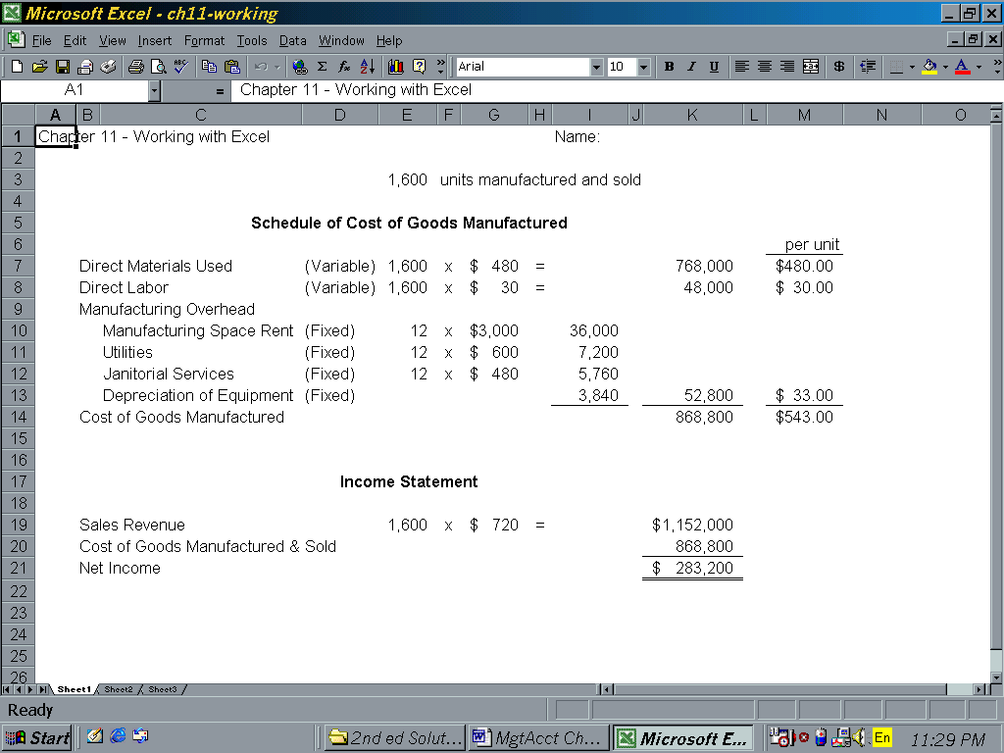

ATC 11-6

Screen capture of cell formulas:

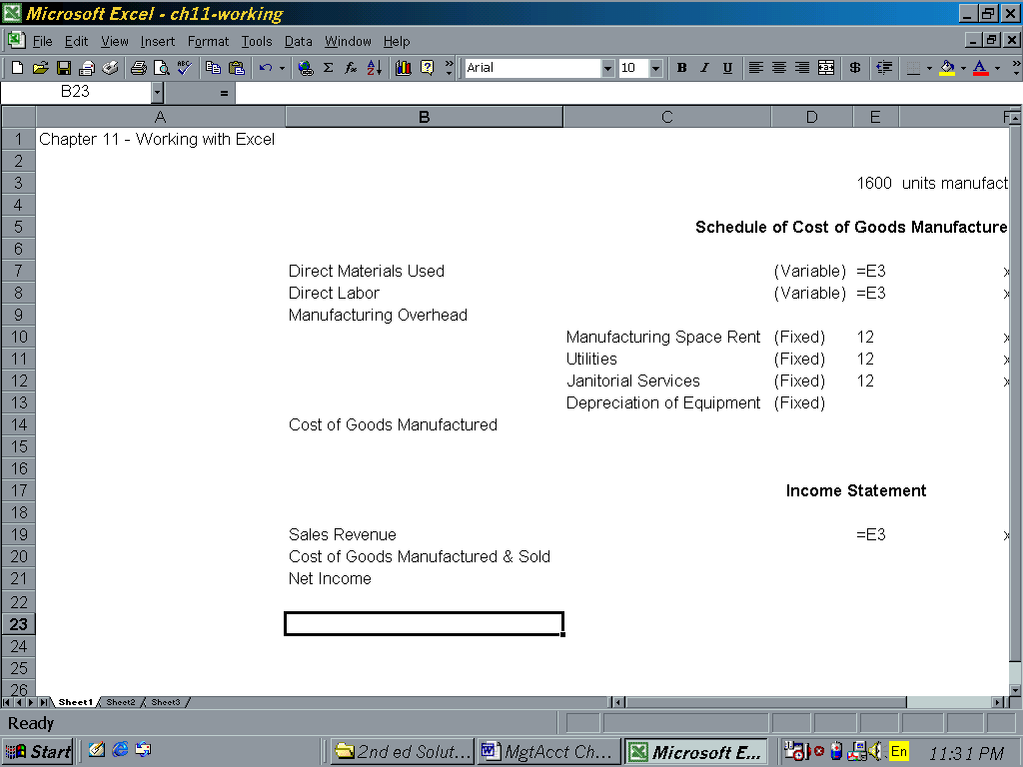

ATC 11-6

Screen capture of cell formulas (continued):

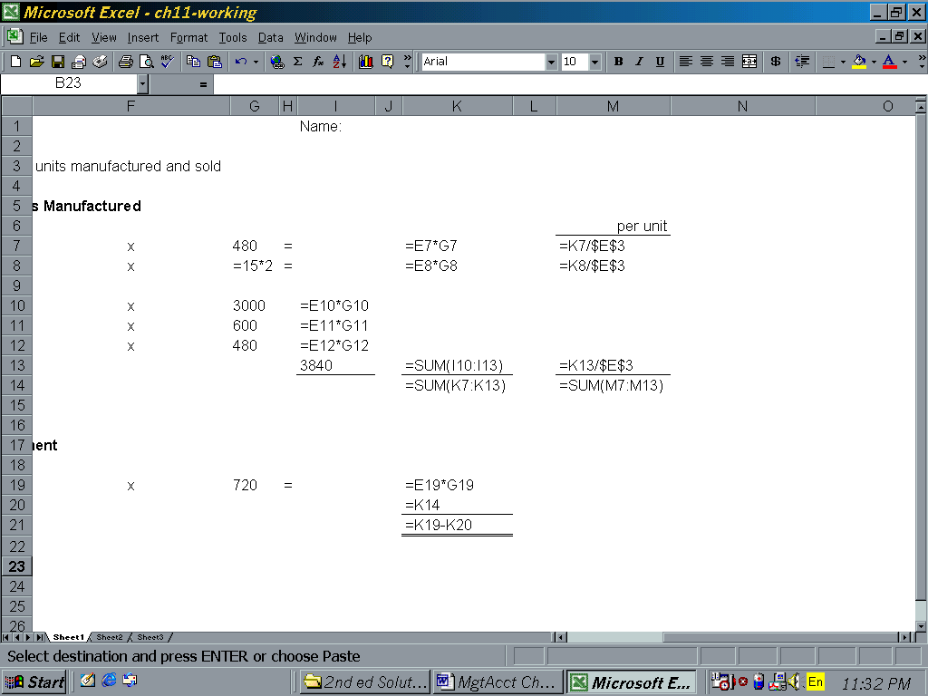

ATC 11-7

Screen capture of cell values:
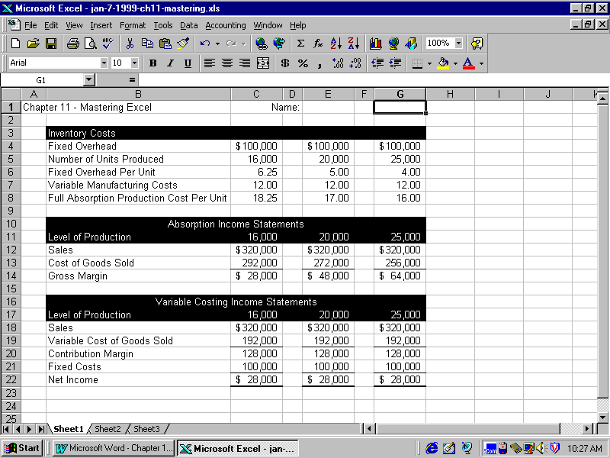

ATC 11-7

Screen capture of cell formulas:
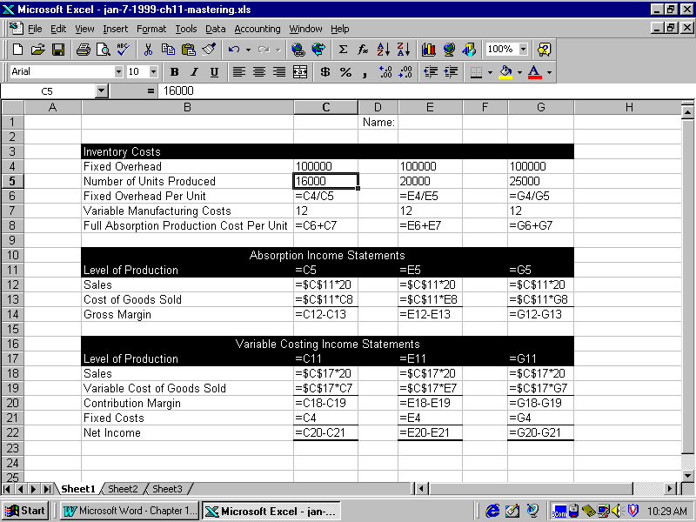

Chapter 11 Comprehensive Problem

Requirement a
 |  |  |  |  | Assets |  |  |  |  | = | Equity |  |  |  |  |  | Income Statement |  |  |  |  |  |  | Cash
 |  |  |  |  |  |  |  |  |  |  |  |  |  |  | Rev. | - | Exp | = | Net Inc. |  |  |  |  | Flow
Event |  |  |  |  | Raw |  | Work in |  | Finished |  | Common |  | Retained
Number | Cash | + | MOH | + | Materials | + | Process | + | Inventory | = | Stock | + | Earnings
Beg. Bal. | 200,000 | + | 0 | + | 4,000 | + | 6,000 | + | 7,000 | = | 129,000 | + | 88,000 |  |  | - |  | = |  |  |  |  |  | 200,000 |  | Bal.
1 | (60,000) | + |  | + | 60,000 | + |  | + |  | = |  | + |  |  |  | - |  | = |  |  |  |  |  | (60,000) |  | OA
2 |  | + |  | + | (50,000) | + | 50,000 | + |  | = |  | + |  |  |  | - |  | =
3 | (80,000) | + |  | + |  | + | 80,000 | + |  | = |  | + |  |  |  | - |  | = |  |  |  |  |  | (80,000) |  | OA
4 |  | + | (53,000) | + |  | + | 53,000 | + |  | = |  | + |  |  |  | - |  | =
5 |  | + |  | + |  | + | (163,000) | + | 163,000 | = |  | + |  |  |  | - |  | =
6a | 182,000 | + |  | + |  | + |  | + |  | = |  | + | 182,000 |  | 182,000 | - |  | = | 182,000 |  |  |  |  | 182,000 |  | OA
6b |  | + |  | + |  | + |  | + | (143,000) | = |  | + | (143,000) |  |  | - | 143,000 | = | (143,000)
7 | (20,000) | + |  | + |  | + |  | + |  | = |  | + | (20,000) |  |  | - | 20,000 | = | (20,000) |  |  |  |  | (20,000) |  | OA
8 | (55,000) | + | 55,000 | + |  | + |  | + |  | = |  | + |  |  |  | - |  | = |  |  |  |  |  | (55,000) |  | OA
9 |  | + | (2,000) | + |  | + |  | + |  | = |  | + | (2,000) |  |  | - | 2,000 | = | (2,000)
10 | (5,000) | + |  | + |  | + |  | + |  | = |  | + | (5,000) |  |  | - |  | = |  |  |  |  |  | (5,000) |  | FA
Total | 162,000 | + | 0 | + | 14,000 | + | 26,000 | + | 27,000 | = | 129,000 | + | 100,000 |  | 182,000 | - | 165,000 | = | 17,000 |  |  |  |  | 162,000 |  | Bal.

Chapter 11 Comprehensive Problem (continued)
Requirement b
Statement of Cost of Goods Manufactured and Sold
Beginning raw materials inventory |  |  | $4,000
Plus: Purchases |  |  | 60,000
Raw materials available for Use |  |  | 64,000
Less: Ending raw materials inventory |  |  | (14,000)
Direct raw materials used |  |  | 50,000
Direct labor |  |  | 80,000
Overhead (actual) |  |  | 55,000
Total manufacturing costs |  |  | 185,000
Plus: Beginning work in process inventory |  |  | 6,000
Total work in process inventory |  |  | 191,000
Less: Ending work in process inventory |  |  | (26,000)
Cost of goods manufactured |  |  | 165,000
Plus: Beginning finished goods inventory |  |  | 7,000
Cost of goods available for sale |  |  | 172,000
Less: Ending finished goods inventory |  |  | (27,000)
Cost of goods sold |  |  | $145,000
Requirement c
Anywhere, Inc.
Income Statement
For Year Ended December 31, 20X2
Sales Revenue | $182,000
Cost of Goods Sold | (145,000)
Gross Margin | 37,000
Selling and Administrative Expenses | (20,000)
Net Income | $ 17,000

Chapter 11 Comprehensive Problem (Continued)

Anywhere, Inc.
Balance Sheet
December 31, 20X2
Assets:
Cash |  |  | $162,000
Raw Materials Inventory |  |  | 14,000
Work-in-Process Inventory |  |  | 26,000
Finished Goods Inventory |  |  | 27,000
Total Assets |  |  | $229,000
Stockholders’ Equity
Common Stock |  |  | $129,000
Retained Earnings |  |  | 100,000
Total Stockholders’ Equity |  |  | $229,000

Anywhere, Inc.
Statement of Cash Flows
For Year Ended December 31, 20X2
Cash Flows from Operations:
Inflow from Customers | $182,000
Outflow for Production of Inventory* | (195,000)
Outflow for Selling and Administrative Exp. | (20,000)
Net Inflow from Operating Activities | (33,000)
Cash Flow from Investing Activities | -0-
Cash Flow from Financing Activities | (5,000)
Net Change in Cash | (38,000)
Plus: Beginning Cash Balance | 200,000
Ending Cash Balance | $162,000
*$60,000 + $80,000+ $55,000 = $195,000

