Answers to Questions

1. Ratios and trends are useful tools for analyzing financial statements because they give the analyst a basis for comparing companies of different sizes and characteristics. Absolute numbers themselves often have little meaning. However, if they are used to generate percentages and examine trends, the resulting information can improve decision-making results.

2. “Liquidity” is the short-term ability to convert assets to cash or some form useful for executing transactions (particularly paying off debts). “Solvency” is the long-run ability to pay debts and continue the operations of the business.

3. Horizontal analysis is a tool for comparing the behavior of items over several periods by analyzing the percentage of change. Vertical analysis is the study of items on the statements in terms of their percentages of other items, usually sales or total assets.

4. This ratio provides information about how rapidly a company is selling its inventory.

Inventory turnover is generally calculated as:

Costs of Goods Sold
-----------------------------------
Average Inventory

5. The current ratio presents the number of dollars of current assets to each dollar of current liabilities. The quick ratio, by omitting the less liquid current assets of prepaid items and inventories, measures immediate debt-paying ability. Both the current and quick ratios are used to measure short-term debt-paying ability.

6. Absolute amounts are often insufficient because companies are of different sizes, thus have different levels of materiality. One amount may be considered small to one company and large to another, thus it is almost impossible to analyze the meaning of that amount without further information.

7. ROI is a measure of income as a percentage of the total capital employed by the company. ROE analyzes income as a percentage of capital that is not provided by creditors.

8. a) Debt/Equity Ratio: Total Liabilities
---------------------------------------------
Total Stockholders’ Equity

- Debt to Total Assets: Total Liabilities
-----------------------------
Total Assets

9. Because earnings per share is a combination of “net income” and “average shares outstanding,” problems in either part affect the outcome. Net income contains many estimates and different methods of calculating expenses and revenues. The number of average shares outstanding varies depending on the number of treasury shares held, stock options outstanding, and other factors. Assumptions regarding rights of bond holders and preferred shareholders add to the problem of analyzing the meaning of EPS figures.

10. ROI: Net Income
--------------------- Total Assets

This is the simplest manner of calculating ROI, but many companies and analysts modify either or both parts of the calculation. The formula above measures net income in terms of total assets employed. By modifying the fraction to, for example, net operating income to operating assets, the analyst arrives at a more precise measure of return on normal operations.

11. Information overload refers to a situation where users of information are overwhelmed with facts to the point that the desired information is obscured.

12. Price-Earnings Ratio = Market Price per Share
---------------------------------------
Earnings per Share

The PE ratio is a measure of the market price of a share of stock expressed as a multiple of the earnings per share. If a share of stock has a PE ratio of ten, then the stock is selling for ten times the earnings per share. The dividend yield is a measure of the amount of dividends received per dollar of the market price of a share of stock. The PE ratio is more theoretical because purchasers of stock do not normally receive all of a company’s earnings directly. In contrast the dividend yield actually refers to real cash benefits received by stockholders.

13. Some environmental factors that should be considered are (1) the size of the company; (2) the type of industry; (3) the state of the economy; (4) the state of the industry; and (5) the political atmosphere.

14. Accounting principles are the major determinants of the methods used to account for assets, liabilities, expenses, and revenues. In analyzing financial statements, the user should be careful to consider what methods are being used. Also, accounting principles require assets to be recorded at historical cost, which can be very different from the actual value of assets.

Exercise 13-1B

Cost of goods sold ÷ Average inventory

= $2,400,000 ÷ [($340,000 + $620,000)/2] = 5 times

Exercise 13-2B

Income before interest and taxes:
$520,000 + $100,000 + $280,000 = $900,000

Income before interest and taxes ÷ Interest expense:
$900,000 ÷ $100,000 = 9 times

Exercise 13-3B

When Barnette Corporation purchased $500 of merchandise on account, both the current asset inventory and the current liability accounts payable increased by $500. Assuming that the company’s current ratio is greater than 1:1 before this transaction, he purchase caused the current ratio to decline.

The following example illustrates the relationship. Assume that, before the purchase, Barnette’s current assets and current liabilities were $3,500 and $1,750 respectively, producing a current ratio of 2 ($3,500 ÷ $1,750). After the purchase, current assets and current liabilities would increase to $4,000 and $2,250 respectively, decreasing the current ratio to 1.78 ($4,000 ÷ $2,250).

Exercise 13-4B

a. Working capital before the securities purchase:

Current assets – Current liabilities

= $50,000 – $20,000 = $30,000

Current assets after the securities purchase:
= $50,000 + $10,000 – $10,000 = $50,000

Working capital after the securities purchase:

Current assets – Current liabilities
= $50,000 – $20,000 = $30,000

The transaction did not affect working capital because Fordham merely exchanged one current asset for another.

b. Current ratio before the securities purchase:

Current assets ÷ Current liabilities
= $50,000 ÷ $20,000 = 2.5

Current ratio after the securities purchase:

Current assets ÷ Current liabilities
= $50,000 ÷ $20,000 = 2.5

(Note: the solution above assumes Fordham classifies the marketable securities as current assets.)
Exercise 13-5B

a. Working capital before the equipment purchase:
$50,000 – $20,000 = $30,000

Working capital after the equipment purchase:
$40,000 – $20,000 = $20,000

b. Current ratio before the equipment purchase:
$50,000 ÷ $20,000 = 2.5
Current ratio after the equipment purchase:
$40,000 ÷ $20,000 = 2.0

Exercise 13-6B

a.
Gamlin Corporation
Income Statements
 | 2006 |  | 2005 |  | % Change
Sales | $440,000 |  | $400,000 |  | +10.0
Cost of Goods Sold | 264,000 |  | 254,000 |  | +3.9
Gross Margin | 176,000 |  | 146,000 |  | +20.5
Operating Expenses | 75,000 |  | 65,000 |  | +15.4
Income before Taxes | 101,000 |  | 81,000 |  | +24.7
Income Taxes | 45,000 |  | 31,600 |  | +42.4
Net Income | $ 56,000 |  | $ 49,400 |  | +13.4

b. Though Gamlin's sales increased by 10.0 % from 2005 to 2006, its cost of goods sold increased only 3.9% resulting in a 20.5% increase in gross margin. Gamlin probably achieved a lower percentage increase in cost of goods sold by improving its manufacturing efficiency. The company did not manage operating expenses as well in 2006 resulting in an increase of 15.4%, far greater than the increase in sales. Income before taxes showed a significant increase of 24.7%. However, the higher level of income probably moved the company to a higher tax bracket, resulting in a disproportionate increase in income taxes. Because of higher operating expenses and income taxes, the increase in net income is only 13.4%.
Exercise 13-7B

Sanspree Company
Vertical Analysis of Income Statements
 | 2006 | % of Sales | 2007 | % of  Sales
Sales | $500,000 | 100.0% | $640,000 | 100.0%
Cost of Goods Sold | 320,000 | 64.0 | 408,000 | 63.8
Gross Margin | 180,000 | 36.0 | 232,000 | 36.3
Operating Expenses | 95,000 | 19.0 | 115,000 | 18.0
Income before Taxes | 85,000 | 17.0 | 117,000 | 18.3
Income Taxes | 27,000 | 5.4 | 31,000 | 4.8
Net Income | $ 58,000 | 11.6 | $ 86,000 | 13.5*
*The figure does not correspond to the above computation because of rounding errors.

Exercise 13-8B

a. Working capital = Current assets – Current liabilities
= $20,000 – $15,000 = $5,000

b. Current ratio = Current assets ÷ Current liabilities
= $20,000 ÷ $15,000 = 1.33:1

c. Debt to assets ratio
= Total liabilities ÷ Total assets = $60,000 ÷ $160,000 = 38%

d. Debt to equity ratio
= Total liabilities ÷ Common stock and retained earnings
= $60,000 ÷ $100,000 = 0.6:1

Exercise 13-9B

a. Earnings per share:
(Net income – Preferred dividends) ÷ Avg. O/S common shares
= ($960,000 – $160,000*) ÷ 200,000 = $4.00

*$100 x 20,000 x 8% = $160,000

b. Book value per share of common stock:
(Total equities – Total liabilities – Preferred rights*) ÷ Avg. O/S common shares
= ($3,500,000 – $640,000 – $2,000,000*) ÷ 200,000
= $4.30

*$100 x 20,000 = $2,000,000

c. Price-earnings ratio:
Common stock price ÷ Earnings per share
= $40.00 ÷ $4.00 = 10.0 times earnings

d. Dividend yield:
Common dividend ÷ Common stock price = $3.60 ÷ $40 = 9.0%

Exercise 13-10B

I 7. J
- G 8. A
- E 9. B
- H 10. K
- L 11. C
- D 12. F

Exercise 13-11B

a. Horizontal Analysis

McLure Company
Horizontal Analysis of Income Statements
 | 2006 |  | 2005 |  | % Change  over 2005
Sales | $240,000 |  | $216,000 |  | +11.1
Cost of Goods Sold | 126,000 |  | 114,000 |  | +10.5
Selling Expenses | 15,000 |  | 12,000 |  | +25.0
Administrative Expenses | 27,000 |  | 25,000 |  | + 8.0
Interest Expense | 4,000 |  | 5,000 |  | – 20.0
Total Expenses | 172,000 |  | 156,000 |  | +10.3
Income before Taxes | 68,000 |  | 60,000 |  | +13.3
Income Taxes Expense | 14,000 |  | 12,000 |  | +16.7
Net Income | $ 54,000 |  | $ 48,000 |  | +12.5

b. Vertical Analysis

McLure Company
Vertical Analysis of Income Statements
 | 2006 | % of  Sales | 2005 | % of  Sales
Sales | $240,000 | 100.0 | $216,000 | 100.0
Cost of Goods Sold | 126,000 | 52.5 | 114,000 | 52.8
Selling Expenses | 15,000 | 6.3 | 12,000 | 5.6
Administrative Expenses | 27,000 | 11.3 | 25,000 | 11.6
Interest Expense | 4,000 | 1.7 | 5,000 | 2.3
Total Expenses | 172,000 | 71.7* | 156,000 | 72.2*
Income before Taxes | 68,000 | 28.3 | 60,000 | 27.8
Income Taxes Expense | 14,000 | 5.8 | 12,000 | 5.6
Net Income | $ 54,000 | 22.5 | $48,000 | 22.2
*The figure does not correspond to the above computation because of rounding errors.
Exercise 13-12B

a. Current ratio: $226,000 ÷ $46,000 = 4.91:1
b. Earnings per share: $48,000 ÷ 1,500 = $32 per share
c. Quick (acid-test) ratio: $113,800 ÷ $46,000 = 2.47:1
d. Return on investment: $48,000 ÷ $352,000 = 13.64%
e. Return on equity: $48,000 ÷ $202,000 = 23.8%
f. Debt to equity ratio: $150,000 ÷ $202,000 = 74%

Exercise 13-13B

 | Quick Ratio | Working  Capital | Stockholders'  Equity | Debt to  Equity Ratio | Retained  Earnings
a. | NC | NC | NC | NC | NC
b. | – | – | NC | + | NC
c. | NC | NC | NC | + | NC
d. | + | + | +* | – | +
e. | + | NC | NC | – | NC
f. | + | + | + | – | NC
g. | + | + | + | –* | +
h. | – | NC | NC | + | NC
i. | – | – | – | + | –

+ = Increase – = Decrease NC = No Change

* The income on the sale increases retained earnings, thus stockholders’ equity.

Exercise 13-14B

a. Net credit sales ÷ Average net receivables =
$4,000,000 ÷ $590,000 = 6.78 Times

b. Cost of goods sold ÷ Average inventories =
$2,800,000 ÷ $410,000 = 6.83 Times

c. Net income ÷ Total sales =
($3,600,000 – $2,640,000) ÷ $3,600,000 = 26.67%

Exercise 13-15B

a. Current liabilities = $26,000 + $14,000 = $40,000
Quick ratio = Quick assets/Current liabilities
Quick assets = Quick ratio x Current liabilities
Quick assets = 1.3 x $40,000 = $52,000

Cash + Accounts receivable = Quick assets
Accounts receivable = Quick assets – Cash
= $52,000 – $15,000 = $37,000

b. Working capital = Current assets – Current liabilities
$42,000 = Current assets – $40,000
Current assets = $82,000
= Cash + Accounts receivable + Inventory
=$15,000 + $37,000 + Inventory
Inventory = $82,000 – ($15,000 + $37,000)
= $30,000

Inventory turnover = Cost of goods sold/Ending inventory
12 = Cost of goods sold/$30,000
Cost of goods sold = $30,000 x 12 = $360,000

Sales – Cost of goods sold = Gross margin
Sales – $360,000 = $126,000
Sales = $486,000

Total assets = $15,000 + $37,000 + $30,000 + $278,000
= $360,000

Turnover of assets = Sales/Total assets
= $486,000/$360,000 = 1.35

Exercise 13-15B (continued)

c. Total liabilities to stockholders' equity = 0.8
Let stockholders' equity be Q
Total liabilities = 0.8Q
Total liabilities + Stockholders' equity = Total assets
0.8Q + Q = $360,000
1.8Q = $360,000
Q = $200,000

Total liabilities = 0.8 x $200,000 = $160,000
= $26,000 + $14,000 + Long-term debt
Long-term debt = $120,000

d. Stockholders' equity = Common stock + Retained earnings
$200,000 = $160,000 + Retained earnings
Retained earnings = $40,000

Problem 13-16B

Ackerson Corporation
Income Statements
For the Years Ended December 31,
 | 2006 | 2005
Sales | $800,000 | $400,000
Cost of Goods Sold | 456,000 | 216,000
Gross Margin | 344,000 | 184,000
Selling and Administrative Expenses | 144,000 | 80,000
Interest Expense | 22,400 | 16,000
Total Expenses | 166,400 | 96,000
Income before Taxes | 177,600 | 88,000
Income Taxes | 80,000 | 32,000
Net Income | $97,600 | $ 56,000

Problem 13-17B

a. Times interest earned

2006: $400,000 ÷ $45,000 = 8.89 times

2005: $325,000 ÷ $30,000 = 10.83 times

b. 2006: Earnings per share = $175,000 ÷ 16,000 = $10.94

2005: Earnings per share = $120,000 ÷ 15,000 = $8.00

c. Price-earnings ratio

2006: $75 ÷ $10.94 = 6.86 times

2005: $60 ÷ $8.00 = 7.50 times

d. 2006: Average equity = ($900,000 + $750,000) ÷ 2 = $825,000

Return on average equity = $175,000 ÷ $825,000=21.2%

2005: Average equity = ($750,000 + $600,000) ÷ 2 = $675,000

Return on average equity = $120,000 ÷ $675,000 = 17.8%

e. Net margin:

2006: $175,000 ÷ $1,800,000 = 9.72%

2005: $120,000 ÷ $1,250,000 = 9.60%

Problem 13-18B

 | Current Ratio | Working Capital
a. | + | +
b. | + | NA
c. | + | +
d. | NA | NA
e. | NA | NA
f. | – | NA
g. | NA | NA
h. | – | –
i. | – | –
j. | + | +
k. | – | NA
l. | NA | NA

Problem 13-19B

a. Earnings per share:

$210,000 – $79,800*
––––––––––––––––– = $3.26 per share
40,000**

* Preferred dividends in arrears | $39,900
Preferred dividends – Current year | 39,900
Total preferred dividends | $79,800

** 40,500 – 500 (treasury) = 40,000

Price-earnings ratio: $38 ÷ $3.26 = 11.7
Return on equity: $210,000 ÷ $2,103,000 = 10.0%

b. From this information alone, it wouldn't be wise to invest in Wethon. However, these three ratios do provide some basis of comparison with other companies in the same industry. Wethon's earnings per share and return on equity ratios are higher than the industry averages. The market has taken into account Wethon's superior earnings power with a higher price-earnings ratio. Other factors such as industry prospects and the economy in general would need to be examined.

Problem 13-20B

- A. $96,000 F. $ 28,500
- B. $210,000 G. $216,000
- C. $315,000 H. $129,000
- D. $480,000 I. $264,000
- E. $30,000 J. $480,000

Current ratio = 1.75 Current liabilities = $120,000
Current assets = 1.75 x $120,000 = $210,000 (B).

$37,500 + (A) + $63,000 + $13,500 = $210,000
(A) = $96,000

(C) – $45,000 = $270,000
(C) = $315,000

(D) = (J) = $210,000 + $270,000 = $480,000

Current liabilities = $120,000 = $63,000 + (E) + $27,000
(E) = $30,000

Debt to assets ratio = 45%
Total liabilities (G) = $480,000 x 45% = $216,000
Stockholders' equity (I) = $480,000 – $216,000 = $264,000

$120,000 + L-T liabilities = $216,000
L-T liabilities = $96,000
$67,500 + (F) = $96,000; (F) = $28,500

$135,000 + (H) = $264,000; (H) = $129,000

Problem 13-21B

a. Current assets – Current liabilities
= $461,000 – $166,000= $295,000

b. Current assets ÷ Current liabilities
= $461,000 ÷ $166,000=2.78:1

c. (Current assets – Inventories – Prepaid expenses) ÷ Current liabilities
= $254,000 ÷ $166,000 = 1.53:1

Problem 13-21B (continued)

d. Net sales ÷ Average accounts receivable
= $240,000 ÷ $110,000=2.18 times

e. 365 ÷ Turnover (d) = 365 ÷ 2.18 = 167 days

f. Cost of goods sold ÷ Average inventory
= $143,000 ÷ $186,000= 0.77 times

g. 365 ÷ Turnover (f) = 365 ÷ 0.77 = 474 days

h. Total liabilities ÷ Total assets
= $302,000 ÷ $922,000 = 33%

i. Total liabilities ÷ Stockholders’ equity
= $302,000 ÷ $620,000 = 48.7%

j. Income before taxes plus interest ÷ Interest
= ($43,000 + $8,000 + $7,000) ÷ $7,000 = 8.29 times

k. Plant assets ÷ Long-term liabilities = $260,000 ÷ $136,000
= 1.9: 1

l. Net income ÷ Net sales = $43,000 ÷ $240,000 = 17.92%

m. Net sales ÷ Avg. total assets = $240,000 ÷ $896,500 = .27

n. Net income ÷ Avg. total assets = $43,000 ÷ $896,500 = 4.8%, or
Net margin x Turnover of assets = .179 x .268 = 4.8%

o. Net income ÷ Average stockholders’ equity
= $43,000 ÷ $603,500 = 7.1%

p. (Net income – Preferred dividends) ÷Avg. common shares outstanding:
($43,000 – $4,000) ÷ 12,000 = $3.25 per share

q. (Stockholders’ equity – Preferred rights) ÷ Avg. common shares outstanding:
($619,000 – $100,000 – $36,000) ÷ 12,000 = $40.25 per share

r. Market price ÷ Earnings per share: $13.26 ÷ $3.25 = 4.1

s. Common dividend ÷ Market price: $0.50 ÷ $13.26 = 3.8%

Problem 13-22B

a. Current assets ÷ Current liabilities
= $107,000,000 ÷ $28,000,000 = 3.82:1

b. Quick assets ÷ Current liabilities = $55,000,000 ÷ $28,000,000
= 1.96:1

c. Accounts receivables turnover = Net sales ÷ Average net receivables
= $180,000,000 ÷ $45,500,000 = 3.96 times

Days in receivables = 365 ÷ Turnover = 365 ÷ 3.96 = 92

d. Cost of goods sold ÷ Average inventory
= $147,000,000 ÷ $55,000,000 = 2.67 times

e. (Stockholders’ equity – Preferred rights) ÷ Avg. common shares outstanding
= ($102,000,000 – $20,000,000) ÷ 5,000,000
= $16.40 per share

f. (Net income – Preferred dividends) ÷ Avg. common shares out.
= ($6,000,000 – $1,000,000) ÷ 5,000,000 = $1.00 per share

g. Market price ÷ Earnings per share = $16.00 ÷ $1.00 = 16

h. Total liabilities ÷ Total assets
=$113,000,000 ÷ $215,000,000 = 53%

i. Net income ÷ Average total assets
= $6,000,000 ÷ $220,500,000 = 2.72%

j. Net income ÷ Average total stockholders' equity
= $6,000,000 ÷ $101,000,000 = 5.9%

Problem 13-23B

Hooper Company
Horizontal Analysis
(In thousands)
 | 2006 | 2005 | % Change
Assets
Cash | $ 3,000 | $ 2,000 | + 50.0%
Marketable Securities | 5,000 | 4,000 | + 25.0
Accounts Receivable (net) | 47,000 | 44,000 | + 6.8
Inventories | 50,000 | 60,000 | – 16.7
Prepaid Expenses | 2,000 | 1,000 | +100.0
Total Current Assets | 107,000 | 111,000 | – 3.6
Property, Plant, & Equipment | 100,000 | 105,000 | – 4.8
Investments | 1,000 | 1,000 | 0.0
Long-Term Receivables | 3,000 | 2,000 | +50.0
Goodwill and Patents | 2,000 | 4,000 | – 50.0
Other Assets | 2,000 | 3,000 | – 33.3
Total Assets | $215,000 | $226,000 | – 4.9
Liabilities
Notes Payable | $ 3,000 | $ 5,000 | – 40.0
Accounts Payable | 12,000 | 16,000 | – 25.0
Accrued Expenses | 9,000 | 11,000 | – 18.2
Income Taxes Payable | 1,000 | 1,000 | 0.0
Payments Due within One Year | 3,000 | 2,000 | + 50.0
Total Current Liabilities | 28,000 | 35,000 | – 20.0
Long-Term Debt | 50,000 | 60,000 | – 16.7
Deferred Income Taxes | 30,000 | 27,000 | + 11.1
Other Liabilities | 5,000 | 4,000 | + 25.0
Total Liabilities | 113,000 | 126,000 | – 10.3
Stockholders' Equity
Preferred Stock | 20,000 | 20,000 | 0.0
Common Stock | 5,000 | 5,000 | 0.0
Additional Paid-in Capital - Common | 35,000 | 35,000 | 0.0
Retained Earnings | 42,000 | 40,000 | + 5.0
Total Stockholders' Equity | 102,000 | 100,000 | + 2.0
Total Liabilities & Stockholders’ Equity | $215,000 | $226,000 | – 4.9

Problem 13-23B (continued)

Hooper Company
Horizontal Analysis
(In thousands)
 | 2006 | 2005 | % Change
Net Sales | $180,000 | $150,000 | + 20.0%
Expenses
Cost of Goods Sold | 147,000 | 120,000 | + 22.5
Selling, Gen., and Admin. Expenses | 20,000 | 18,000 | + 11.1
Other | 2,000 | 2,000 | 0.0
Total Expenses | 169,000 | 140,000 | + 20.7
Income before Income Taxes | 11,000 | 10,000 | + 10.0
Income Taxes | 5,000 | 4,000 | + 25.0
Net Income | $ 6,000 | $ 6,000 | 0.0

Problem 13-24B

Hooper Company
Vertical Analysis
(In thousands)
 | 2006 |  | 2005
 | Amount | % of Total | Amount | % of Total
Net Sales | $180,000 | 100.0% | $150,000 | 100.0%
Expenses
Cost of Goods Sold | 147,000 | 81.7 | 120,000 | 80.0
Selling, Gen., and Admin. Expenses | 20,000 | 11.1 | 18,000 | 12.0
Other | 2,000 | 1.1 | 2,000 | 1.3
Total Expenses | 169,000 | 93.9 | 140,000 | 93.3
Income before Income Taxes | 11,000 | 6.1 | 10,000 | 6.7
Income Taxes | 5,000 | 2.8 | 4,000 | 2.7
Net Income | $ 6,000 | 3.3 | $ 6,000 | 4.0

Problem 13-24B (continued)
Hooper Company
Vertical Analysis
(In thousands)
 | 2006 |  | 2005
Assets | Amount | % of  Total | Amount | % of  Total
Cash | $ 3,000 | 1.4% | $ 2,000 | 0.9%
Marketable Securities | 5,000 | 2.3 | 4,000 | 1.8
Accounts Receivable (net) | 47,000 | 21.9 | 44,000 | 19.5
Inventories | 50,000 | 23.3 | 60,000 | 26.5
Prepaid Expenses | 2,000 | 0.9 | 1,000 | 0.4
Total Current Assets | 107,000 | 49.8 | 111,000 | 49.1
Property, Plant, & Equipment | 100,000 | 46.5 | 105,000 | 46.5
Investments | 1,000 | 0.5 | 1,000 | 0.4
Long-Term Receivables | 3,000 | 1.4 | 2,000 | 0.9
Goodwill and Patents | 2,000 | 0.9 | 4,000 | 1.8
Other Assets | 2,000 | 0.9 | 3,000 | 1.3
Total Assets | $215,000 | 100.0 | $226,000 | 100.0
Liabilities
Notes Payable | $ 3,000 | 1.4 | $ 5,000 | 2.2
Accounts Payable | 12,000 | 5.6 | 16,000 | 7.1
Accrued Expenses | 9,000 | 4.2 | 11,000 | 4.9
Income Taxes Payable | 1,000 | 0.5 | 1,000 | 0.4
Payments Due within One Year | 3,000 | 1.4 | 2,000 | 0.9
Total Current Liabilities | 28,000 | 13.0* | 35,000 | 15.5
Long-Term Debt | 50,000 | 23.3 | 60,000 | 26.5
Deferred Income Taxes | 30,000 | 14.0 | 27,000 | 11.9
Other Liabilities | 5,000 | 2.3 | 4,000 | 1.8
Total Liabilities | 113,000 | 52.6 | 126,000 | 55.8*
Stockholders' Equity
Preferred Stock | 20,000 | 9.3 | 20,000 | 8.8
Common Stock | 5,000 | 2.3 | 5,000 | 2.2
Additional Paid-in Capital - Common | 35,000 | 16.3 | 35,000 | 15.5
Retained Earnings | 42,000 | 19.5 | 40,000 | 17.7
Total Stockholders' Equity | 102,000 | 47.4 | 100,000 | 44.2
Total Liabilities & Stockholders’ Equity | $215,000 | 100.0 | $226,000 | 100.0
*The figure does not correspond to the above computation because of rounding errors.

ATC 13-1

a. Compute the following ratios for 2005 for the companies’ fiscal years:

1. Current ratio
Best Buy: $6,903 ÷ $4,959 = 1.39 to 1
Circuit City: $2,686 ÷ $1,264 = 2.13 to 1

- Average days to sell inventory (Use average inventory.)

1st, compute average inventory:
Best Buy: ($2,851 + $2,607) ÷ 2 = $2,729.0
Circuit City: ($1,460 + $1,517) ÷ 2 = $1,488.5

2nd, compute inventory turnover:
Best Buy: $20,938÷ $2,729.0 = 7.67 times
Circuit City: $7,904 ÷ $1,488.5 = 5.31 times

3rd, compute the average days to sell inventory:
Best Buy: 365 ÷ 7.67 = 48 days
Circuit City: 365 ÷ 5.31 = 69 days

- Debt to assets ratio
Best Buy: $5,845 ÷ $10,294 = 57%
Circuit City: $1,702 ÷ $ 3,789 = 45%

- Return on investment (Use average assets and use “earnings from continuing operations” rather than “net earnings.”)

1st, compute average assets: (Also used for ratios 6 and 8)
Best Buy: ($10,294 + $8,652) ÷ 2 = $9,473
Circuit City: ($ 3,789 + $3,731) ÷ 2 = $3,760

2nd, compute the ROI:
Best Buy: $934 ÷ $9,473 = 9.86%
Circuit City: $ 60 ÷ $3,760 = 1.60%

ATC 13-1 (continued)

5. Gross margin percentage
Best Buy: $6,495 ÷ $27,433 = 23.7%
Circuit City: $2,569 ÷ $10,473= 24.5%

6. Asset turnover (Use average assets.)
Best Buy: $27,433 ÷ $9,473= 2.90 times
Circuit City: $10,473 ÷ $3,760= 2.79 times

7. Return on sales (Use “earnings from continuing operations” rather than “net earnings.”)
Best Buy: $934 ÷ $27,433 = 3.4%
Circuit City: $ 60 ÷ $10,473 = 0.6%

8. Plant assets to long term debt ratio
Best Buy: $2,464 ÷ $886= 2.8 to 1
Circuit City: $ 739 ÷ $438 = 1.7 to 1

b. The ratios above that are most relevant to determining profitability are:

Return on investment (Best Buy’s is better.)
Return on sales (Best Buy’s is better.)

c. The ratios above that are most relevant to determining financial risk are:

Current ratio (Circuit City’s is better.)
Debt to assets ratio (Circuit City’s is better.)
Plant assets to long term debt (Best Buy’s is better.)
ATC 13-1 (continued)

d. The ratio above that are most relevant to determining which company is charging the most for its goods is the gross margin percentage. Both companies have similar gross margin percentages, but Circuit City’s is a bit higher, indicating it is charging more for its goods in relation to what it pays for the items it sells. Of course this assumes they use the same methods for computing cost of goods sold.

e. The ratios above that are most relevant to determining how efficiently assets are being used are:

Average days to sell inventory (Best Buy’s is better.)
Asset turnover (Best Buy’s is better.)

ATC 13-2

a.

(Dollar amounts are in millions.)
A B C D
Sales $20,561 $18,110 $2,627.3 $1,017.6
Cost of Goods Sold 6,254 13,374 1,885.2 453.4
Gross Margin $14,307 $ 4,736 $ 742.1 $ 564.2

Company
RATIO: | A | B | C | D
 | 69.6% = | 26.2% = | 28.2% = | 55.4% =
Gross margin | $14,307 | $4,736 | $742.1 | $564.2
 | $20,561 | $18,110 | $2,627.3 | $1,017.6
 | 15.9% = | 9.2% = | 5.5% = | 7.2% =
Net margin | $3,261 | $1,665 | $144.6 | $72.8
 | $20,561 | $18,110 | $2,627.3 | $1,017.6
 | 9.0% = | 8.0% = | 15.8% = | 8.8% =
Return-on-assets | $3,261  $36,301 | $1,665  $20,756 | $144.6  $914.8 | $72.8  $827.1

ATC 13-2 (continued)

The four companies relate to the financial information as follows:

BellSouth is company “D”
Caterpillar is company “B”
Dollar General is company “C”
Tiffany is company “A”

b. BellSouth is company D because it provides telephone services for customers and doesn’t have inventory. Dollar General is company C because the discount store sells merchandise in cash and does not have accounts receivable. Companies A and B both have inventory and accounts receivable. On the other hand, their gross margin rates are significantly different even though their net margins and returns on assets are not far apart. Because Tiffany operates high-end jewelry stores and has a high gross margin, it should be company A. Because Caterpillar manufactures heavy-duty machinery in a competitive market, its gross margin should be lower than a jewelry company. Hence, Caterpillar is company B.
ATC 13-3

a. The article presents information in absolute dollar values, percentages, and graphical formats. Examples of each type of presentation can be seen in the text box shown on the bottom half of page 55.

b. Most of the discussion centers on horizontal analysis. Financial information frequently refers to growth rates measured across different time periods. Horizontal analysis is particularly useful to external users (e.g., earnings growth rate). Vertical analysis provides insights that are particularly useful to the management of a business (e.g., inventory turnover, days to collect receivables, etc.). Since Business Week is a public rather than an insider magazine, its focus on horizontal analysis is appropriate.

c. Sales and operating profits are presented both in absolute and percentage values. An interested party may desire to know the size of a company as well as its growth rate. Size data are expressed in absolute terms while growth data are presented in terms of percentages.

ATC 13-4

a. Assessing risk involves more that computing a company’s debt-to-assets ratio. Some industries are inherently riskier than others. The construction industry is very sensitive to changes in the economy, and is a relatively unregulated industry. Banks, while sensitive to changing interest rates, are generally viewed as more stable than home construction. Perhaps the biggest difference between banks and construction companies is the very high level of regulation and oversight to which banks are subjected. When a bank gets into financial trouble, government agencies probably will intervene to prevent this failure. Such is not the case for construction companies.

b. Wachovia is more highly leveraged than Pulte. In general, banks are among the most highly leveraged of all companies. Wachovia is using this additional leverage to multiply its return-on-equity compared to its return on assets.

Though not covered in the text, to avoid undue confusion, instructors may wish to show students the following mathematical relationship between the two companies’ debt-to assets, return-on-assets, and return-on-equity ratios.

Except for rounding and assorted “weird stuff” that sometimes occur, the following relationship holds:

Return-on-assets
(1.0 − Debt-to-assets) = Return-on-equity

Wachovia: 1.2%
(1.0 − .903) = 12.4% (rounding accounts for the 12.4% vs. 14.0%)

Pulte: 9.5%
(1.0 − .565) = 21.8%

ATC 13-5

a. Writing off the trucks would make the asset base smaller and thereby cause the return-on-assets ratio to be higher.

b. Writing off the trucks would make the base year amounts smaller and thereby cause the growth in assets and income to be higher.

c. Ms. Talbot may not be a member of the Institute of Management Accountants and therefore may not be bound by the organization’s ethical standards. However, her action is unethical whether or not she is a member of the Institute. If she is bound by those ethical standards, her behavior is in violation of the integrity standards to: (1) avoid actual or apparent conflicts of interest and advise all appropriate parties of any potential conflict, (2) refrain from engaging in any activity that would prejudice their ability to carry out their duties ethically, (3) refrain from either actively or passively subverting the attainment of the organization’s legitimate and ethical objectives, and (4) communicate unfavorable as well as favorable information and professional judgments or opinions.

ATC 13-6
Screen capture of cell values

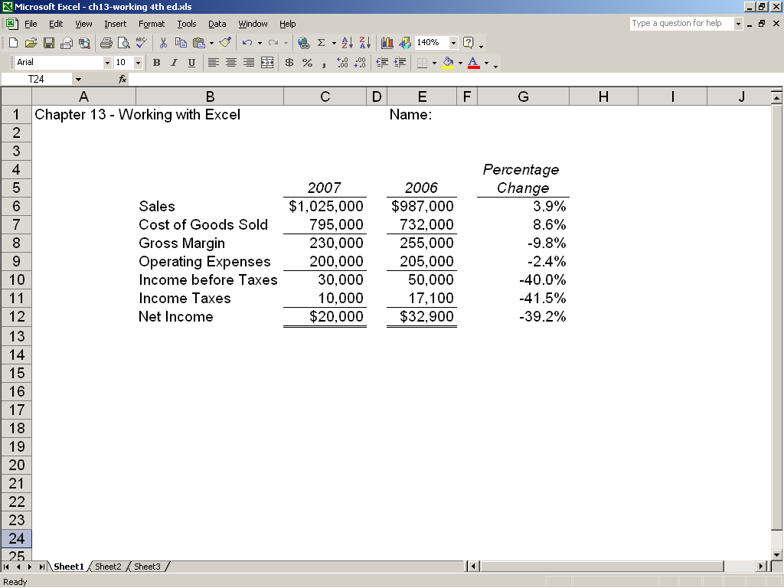

ATC 13-6
Screen capture of cell formulas

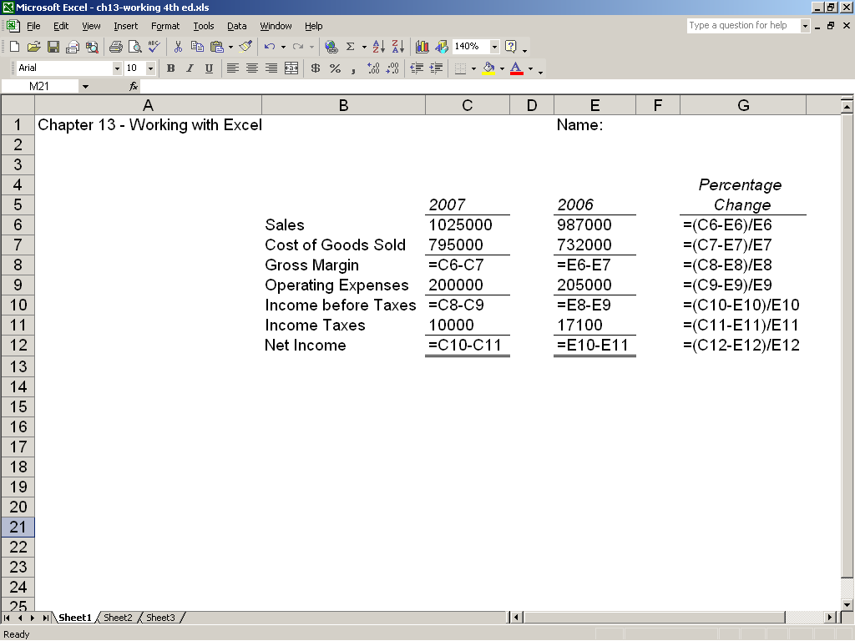

ATC 13-7
Screen capture of cell values

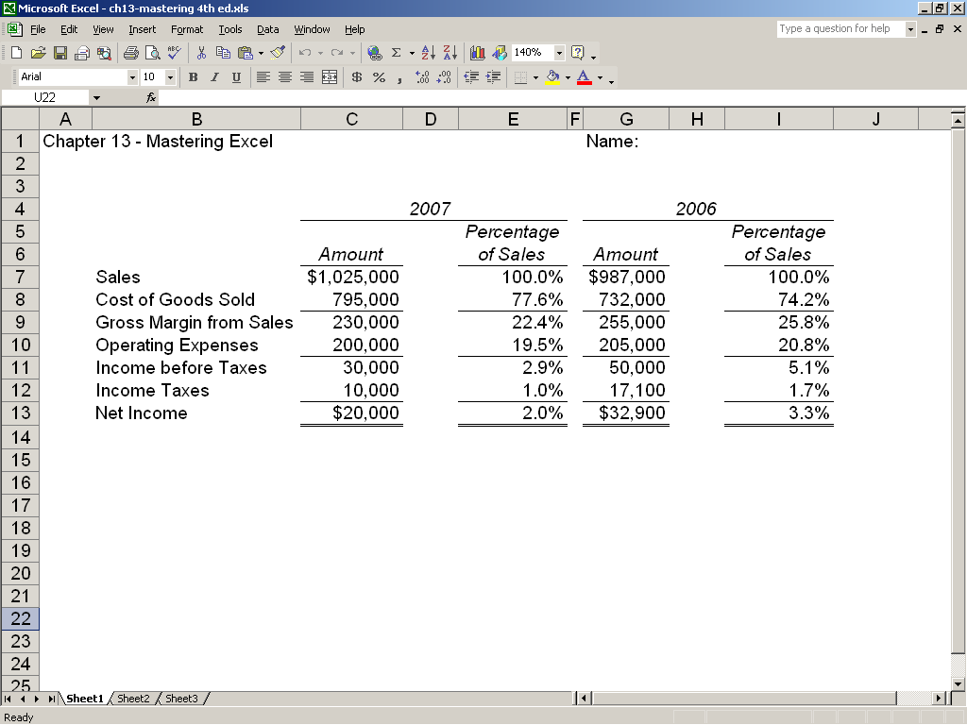

ATC 13-7
Screen capture of cell formulas

