ANSWERS TO QUESTIONS

1. The statement of cash flows explains how a company obtained and used cash during some period of time. Understanding the cash flows of a business is important in assessing the company’s ability to pay its bills and fund operations in the future.

2. The three categories of cash inflows and outflows are operating activities, investing activities, and financing activities.

Operating activities include cash inflows and outflows that are generated by operating the business. Example: Cash received from the sale of goods; cash paid for salaries.

Investing activities include cash inflows and outflows that are generated by the purchase and sale of long-term operational assets, investments in other companies, and lending activities. Example: Cash received from the sale of equipment previously used by the business; cash paid for the purchase of new equipment.

Financing activities include cash inflows and outflows associated with a company's own equity transactions and borrowing activities. Example: Cash received from the sale of stock; cash paid for the repayment of a loan.

3. Noncash investing and financing activities are transactions that do not require the receipt or payment of cash. For example, a company may purchase an operating asset with a small down payment and finance the balance. If only cash transactions are included, then significant transactions would be omitted from the statement of cash flows. These transactions are shown in a separate schedule included in the statement of cash flows.

4. Since the ending balance of accounts receivable exceeded the beginning balance by $2,000, more sales were made than collected. The amount of cash collected would equal $108,000, the amount of sales of $110,000 less the increase in the accounts receivable balance of $2,000.

5. Since the ending balance of utilities payable exceeded the beginning balance by $1,900, more utility cost was used than paid for. The amount of cash paid was $85,100, the amount of utility expense of $87,000 less the increase in utilities payable of $1,900.

6. Since the ending balance of unearned revenue was greater than the beginning balance by $1,400, more cash was received in advance than was earned. The amount of cash received was $17,000, the $15,600 revenue earned plus the $1,400 increase in unearned revenue.

7. a. Payment of accounts payable - operating activity.
b. Payment of interest on bonds - operating activity.
c. Sale of common stock - financing activity.
d. Sale of preferred stock at a premium - financing activity.
e. Payment of dividend on the stock - financing activity.

c, d, and e are financing activities.

8. Depreciation expense is an allocation of the cost of an asset over its estimated useful life; thus, the allocation does not affect cash flows. Cash flows are affected at the purchase or sale of the asset.

9. Cost of Land $4,200
Gain on Sale 500
Sales Price $4,700

10. Cost of Office Equipment $7,500
Accumulated Depreciation (7,200)
Book Value 300
Loss on Sale (100)
Selling Price $ 200

11. a. operating activities
b. investing activities, or operating activities if trading securities
c. investing activities
d. operating activities
e. financing activities
f. operating activities
g. financing activities
h. financing activities
i. investing activities
j. operating activities

12. When the direct method of preparing the statement of cash flows is used, each transaction that affects cash is analyzed. One method of doing this is called the T-account approach. When this approach is used, each balance sheet account is analyzed. This is the method recommended by the FASB. When the indirect method is used, net income as reported on the income statement is the starting point. Adjustments are made to net income to convert the accrual net income amount to a cash net income amount. Cash flows from investing and financing activities are determined in the same manner as under the direct method, by analyzing each of the balance sheet accounts except for the current assets and current liabilities.

13. The direct method is more logical because it analyzes each of the changes to the cash account.

14. The primary advantage of using the indirect method is the fact that it requires less time to start with the net income amount and simply make conversion adjustments from the accrual basis to the cash basis of accounting.

15. The primary advantage of using the direct method is that it is more logical and presents the actual amount of cash inflows and outflows from each operating activity. The indirect method only shows net income and the related increases and decreases in the current asset and liability accounts.

16. a. Cash outflow of $46,000 as an investing activity.
b. Cash inflow of $8,700 as an investing activity.

17. Yes, it is possible for a company to have negative operating cash flow and net income in the same period. As is illustrated in Exhibit 14-9 for Toll Brothers, a company may use operating and borrowed cash to support sales growth by purchasing inventory, property, plant, and equipment. Thus cash may be going out currently to help generate future cash inflows.

18. NOTE: FASB’s reasons for precluding disclosure of cash flow per share are not discussed in the text.

SFAS #95, Paragraph 33 states:
Neither cash flow nor any component of it is an alternative to net income as an indicator of an enterprise’s performance, as reporting per share amounts might imply.

Students may logically reach this conclusion based on their knowledge of the income statement and cash flows statement.

Exercise 14-1B

a. | Operating Activity
b. | Operating Activity
c. | Financing Activity
d. | Financing Activity
e. | Investing Activity
f. | Operating Activity
g. | Financing Activity
h. | Financing Activity
i. | Investing Activity
j. | Operating Activity

Exercise 14-2B

Conditions in Requirements c, e, and f produce cash inflow from operating activities. Further explanations on those that don’t produce cash inflow from operating activities follow.
a. Cash outflow – operating
b. Cash outflow – investing
d. Cash outflow – financing

Exercise 14-3B

a.
Accounts Receivable |  |  | Interest Receivable
2002 |  |  | 2002
1/1 40,000 |  |  | 1/1 5,000
Sales 275,000 | Cash 269,000 |  | Int. Earned 25,000 | Cash 27,000
12/31 46,000 |  |  | 12/31 3,000

Inflow from Operations
From Sales | $269,000
Interest | 27,000
Total | $296,000

b.
Accounts Payable |  |  | Salaries Payable
 | 2002 |  |  | 2002
 | 1/1 30,000 |  |  | 1/1 12,000
Cash 193,000 | Op. Exp. 196,000 |  | Sal. Paid 76,500 | Acc. Sal. 75,000
 | 12/31 33,000 |  |  | 12/31 10,500

Outflow from Operations
Payment of Oper. Exp. | $193,000
Payment of Salaries | 76,500
Total | $269,500

Exercise 14-4B

Unearned Revenue |  |  | Prepaid Rent
 | Bal. 18,000 |  | Bal. 2,000
Recog. 41,000 | Cash 31,000 |  | Cash 6,900 | Exp. 8,000
 | Bal. 8,000 |  | Bal. 900

Inflow from revenue: $31,000

Outflow for rent: $6,900

Exercise 14-5B

Land |  |  | Marketable Securities
Cost of Land Sold | $50,000 |  | Cost of Securities Sold | $30,000
Plus: Gain | 9,000 |  | Less: Loss | (1,200)
Cash Inflow | $59,000 |  | Cash Inflow | 28,800

Cash Flows from Investing Activities:
Cash Inflow from Sale of Land | $ 59,000
Cash Inflow from Sale of Marketable Securities | 28,800
Cash Outflow to Purchase Land | (100,000)
Cash Outflow to Purchase Marketable Securities | (40,000)
Net Cash Outflow from Investing Activities | $(52,200)

Exercise 14-6B

Cash Flows from Financing Activities:
Cash Inflow from Stock Issue | $80,000
Cash Outflow for Repayment of Mortgage | (62,000)
Net Cash Inflow from Financing Activities | $18,000

Exercise 14-7B

$134,000 cash paid for purchases, calculated as follows:

If $120,000 of inventory was sold, then $144,000 of inventory was purchased.

Inventory
Bal. 41,000
Pur. 144,000 | Sold 120,000
Bal. 65,000

Assuming purchases are on account, the Accounts Payable account would appear as shown below. If $144,000 of inventory was purchased on account, then $134,000 was paid for inventory in order to have an ending balance of $52,000.

Accounts Payable
 | Bal. 42,000
Paid 134,000 | Pur. 144,000
 | Bal. 52,000

Exercise 14-8B

Net Cash Flow from Operating Activities:
Net Income | $45,000
Add: Decrease in Prepaid Rent | 800
Decrease in Interest Receivable | 400
Increase in Accounts Payable | 500
Increase in Unearned Revenue | 1,000
Deduct: Increase in Accounts Receivable | (5,000)
Decrease in Salaries Payable | (400)
Net Cash Inflow from Operating Activities | $42,300

Exercise 14-9B

Assets |  |  | Liabilities
Cash |  |  | Accounts Payable
Bal. 42,000 | 2. 12,600 |  |  | Bal. 120,000
1. 210,200 | 3. 130,000 |  | 3. 130,000 | Exp. 135,000
 | 4. 20,800
Bal. 88,800 |  |  |  | Bal. 125,000
Accounts Receivable |  |  | Utilities Payable
Bal. 158,000 |  |  |  | Bal. 12,000
Rev. 212,000 | 1. 210,200 |  |  | Exp. 17,200
 |  |  | 4. 20,800
Bal. 159,800 |  |  |  | Bal. 8,400
Prepaid Rent
Bal. 3,000
2. 12,600
 | Exp. 10,000
Bal. 5,600

a. Direct Method (see T-accounts above):
Cash Flow from Operating Activities:
Cash Inflow from Customers | (1) $210,200
Cash Outflow for Rent | (2) (12,600)
Cash Outflow for Operating Expenses | (3) (130,000)
Cash Outflow for Utilities | (4) (20,800)
Net Cash Inflow from Operating Activities | $ 46,800

b. Indirect Method:
Cash Flow from Operating Activities:
Net Income: | $49,800
Add: Increase in Accounts Payable | 5,000
Deduct: Increase in Accounts Receivable | (1,800)
Increase in Prepaid Rent | (2,600)
Decrease in Utilities Payable | (3,600)
Net Cash Inflow from Operating Activities | $46,800
Exercise 14-10B

Note: The T-accounts are provided for the use of the instructor.
T-Accounts - Selected Information:

Cash |  |  | Notes Payable, Bank |  |  | No-Par Common Stock
2. 2,000 | 1. 9,800 |  |  | 3. 20,000 |  |  | 5. 26,500
3. 20,000 | 4. 50,000
 |  |  | Notes Payable, Land |  |  | Retained Earnings
Office Equipment |  |  |  | 4. 75,000 |  |  | 2. 1,000
1. 9,800 | 2. 12,000
Accumulated Depr.
2. 11,000
Land
4. 125,000
Automobile
5. 26,500

a.
Johnston Company
Statement of Cash Flows
For the Year Ended December 31, 2003
Cash Flows from Investing Activities:
Inflow from Sale of Office Equipment |  | $ 2,000
Outflow to Purchase Office Equipment |  | (9,800)
Outflow to Purchase Land |  | (50,000)
Net Cash Flow from Investing Activities |  |  | $(57,800)
Cash Flows from Financing Activities:
Inflow from Loan |  | 20,000
Net Cash Flow from Financing Activities |  |  | 20,000
Net Decrease in Cash |  |  | (37,800)
Schedule of Noncash Investing and Financing Activities:
Issued Common Stock for Automobile |  |  | $ 26,500
Purchased Land with Note |  |  | $ 75,000

Exercise 14-10B (continued)

b. Including the noncash investing and financing activities section provides a more complete picture of the business activities. It provides information about the acquisition or disposition of assets, liabilities, and equity items that is not otherwise available from the statement of cash flows. It provides information about activities that do not directly affect cash.

If this section is omitted, the reader may not have an accurate picture of certain investing and financing activities. Even though the end results of all transactions are reflected in the balance sheet amounts, offsetting transactions may confuse the picture. For instance, if a company acquired an asset by borrowing funds and paid off another loan by giving an asset other than cash, the reader would not be able to detect any significant transaction from looking at the balance sheet. The noncash investing and financing activities section of the statement of cash flows plainly discloses any such transactions.

Problem 14-11B

No. | Type of Activity
a. | Operating Activity
b. | Noncash
c. | Noncash
d. | Financing Activity
e. | Noncash
f. | Noncash Financing and Investing
g. | Investing Activity
h. | Financing Activity
i. | Financing Activity
j. | Operating Activity
k. | Noncash
l. | Operating Activity
m. | Noncash
n. | Financing Activity
o. | Investing Activity
p. | Operating Activity
q. | Investing and the loss is noncash item
r. | Noncash
s. | Operating Activity

Problem 14-12B

 | Transactions |  | Effect on Cash Flow
1. | Cash Received from Sales:
 | Sales of $548,000 + Decrease in Accts. Rec. of $38,000 | = | $ 586,000
2. | Salaries Paid:
 | Salaries Exp. $232,000 + Decrease in Sal. Pay. $8,000 | = | (240,000)
3. | Other Operating Expenses Paid:
 | Other Operating Exp. $236,000 + Decrease in Operating Expense Payable $6,000 | = | (242,000)
4. | Non-Cash Item |  | -0-
5. | Purchased Equipment | = | (12,000)
6. | Repayment of Debt | = | (8,000)
7. | Interest Paid:
 | Interest Exp. $4,600 + Decrease in Int. Pay. $900 | = | (5,500)
8. | Inventory Paid:
 | Merchandise Sold $83,600 + Increase in Inv. $7,400 =  Merchandise Pur. $91,000  $91,000 + Decrease in Accts. Payable $1,600 | = | (92,600)
9. | Collected Note | = | 40,000
10. | Issued Common Stock | = | 40,000
11. | Sold Land | = | 6,000
12. | Taxes Paid:
 | Taxes Exp. $6,600 + Decrease in Taxes Pay. $200 | = | (6,800)
13. | Purchased Investments | = | (50,000)
 | Sold Investments | = | 22,000
 | Change in Cash | = | $ 37,100
Problem 14-12B (continued)

Greenstein Company
Statement of Cash Flows
For the Period Ended December 31, 2003
Cash Flows from Operating Activities:
Cash Receipts from:
Sales | $586,000
Total Cash Inflows |  | $586,000
Cash Payments for:
Inventory Purchased | (92,600)
Salaries | (240,000)
Other Operating Expenses | (242,000)
Interest | (5,500)
Taxes | (6,800)
Total Cash Outflows |  | (586,900)
Net Cash Flow from Operating Activities |  | (900)
Cash Flows from Investing Activities:
Inflow from Sale of Land | 6,000
Inflow from Sale of Investments | 22,000
Inflow from Note Receivable | 40,000
Outflow to Purchase Equipment | (12,000)
Outflow to Purchase Investments | (50,000)
Net Cash Flow from Investing Activities |  | 6,000
Cash Flows from Financing Activities:
Inflow from Stock Issue | 40,000
Outflow to Repay Debt | (8,000)
Net Cash Flow from Financing Activities |  | 32,000
Net Increase in Cash |  | 37,100
Plus: Beginning Cash Balance |  | 86,000
Ending Cash Balance |  | $123,100
Problem 14-13B

a.
Computation of Cash Flows from Operating Activities
Sales $248,000 − $3,200 | $244,800
Inventory Purchase $186,000 − $800 | (185,200)
Insurance Paid $8,000 − $400 | (7,600)
Salaries Expense $42,600 + $600 | (43,200)
Other Operating Expense | (27,400)
Net Cash Flow from Operating Activities | $(18,600)

b.
Gables Auto Supplies
Statement of Cash Flows
For the Period Ended December 31, 2003
Cash Flows from Operating Activities:
Cash Receipts from:
Sales | $244,800
Total Cash Inflows |  | $244,800
Cash Payments for:
Inventory Purchased | (185,200)
Insurance | (7,600)
Salaries | (43,200)
Other Operating Expense | (27,400)
Total Cash Outflows |  | (263,400)
Net Cash Flow from Operating Activities |  | $ (18,600)

Problem 14-14B

a.
Computation of Cash Flows from Investing Activities
Sold Marketable Securities ($66,000 − $51,200) | $ 14,800
Sold Trucks | 11,000
Sold Land | 10,000
Purchased Trucks | (40,000)
Net Cash Flow from Investing Activities | $ (4,200)

b.
Tony’s Flea Markets, Inc.
Statement of Cash Flows
For the Period Ended December 31, 2001
Cash Flows from Investing Activities:
Inflow from Sale of Marketable Securities | $14,800
Inflow from Sale of Trucks | 11,000
Inflow from Sale of Land | 10,000
Outflow to Purchase Trucks | (40,000)
Net Cash Flow from Investing Activities |  | $(4,200)

Problem 14-15B

a.
Computation of Cash Flows from Financing Activities
Issued Stock ($70,000 + $32,000) | $102,000
Borrowed Funds | 40,000
Repaid Debt ($170,000 + $40,000 − $180,000) | (30,000)
Paid Dividends | (28,000)
Net Cash Flow from Financing Activities | $84,000

b.
Engineered Components
Statement of Cash Flows
For the Year Ended December 31, 2002
Cash Flows from Financing Activities:
Inflow from the Issue of Capital Stock | $102,000
Inflow from New Debt | 40,000
Outflow for the Payment of Dividends | (28,000)
Outflow for the Repayment of Debt | (30,000)
Net Cash Flow from Financing Activities |  | $84,000

Problem 14-16B

Transactions Legend:
a1. Revenue on Account, $17,480.
a2. Collection of Accounts Receivable, $17,080 ($17,480 − $400).
b1. Cost of Goods Sold, $6,200.
b2. Inventory Purchased, $5,600 ($6,200 − $600).
b3. Payment on Account, $4,400 ($5,600 − $1,200).
c1. Depreciation Expense, $1,750 (noncash).
d1. Sale of Equipment, $6,800.
d2. Purchase of Equipment, $5,000.
e1. Sale of Land, $1,400.
e2. Exchange of Common Stock for Land, $7,000.
f1. Repaid Long-Term Debt, $800.
g1. Paid Dividends, $900.

Problem 14-16B (continued)
Healthy Products Co.
T-Accounts
Assets |  | = | Liabilities |  | + | Equity
Cash |  |  | Accounts Payable |  |  | Common Stock
Bal. 1,940 |  |  |  | Bal. 2,400 |  |  | Bal. 10,000
a2. 17,080 | b3. 4,400 |  | b3. 4,400 | b2. 5,600 |  |  | e2. 7,000
d1. 6,800 | d2. 5,000 |  |  | Bal. 3,600 |  |  | Bal. 17,000
e1. 1,400 | f1. 800
 | g1. 900 |  | Long-Term Debt |  |  | Retained Earnings
Bal. 16,120 |  |  |  | Bal. 4,000 |  |  | Bal. 2,290
 |  |  | f1. 800 |  |  | b1. 6,200 | a1. 17,480
Accounts Receivable |  |  |  | Bal. 3,200 |  | c1. 1,750 | d1. 1,800
Bal. 2,000 |  |  |  |  |  | e1. 600
a1. 17,480 | a2. 17,080 |  |  |  |  | g1. 900
Bal. 2,400 |  |  |  |  |  |  | Bal. 12,120
Inventory
Bal. 2,600
b2. 5,600 | b1. 6,200
Bal. 2,000
Land
Bal. 8,000
e2. 7,000 | e1. 2,000
Bal. 13,000
Equipment
Bal. 17,100
d2. 5,000 | d1. 8,400
Bal. 13,700
Accumulated Depreciation
 | Bal. 12,950
d1. 3,400 | c1. 1,750
 | Bal. 11,300
Problem 14-16B (continued)

Healthy Products Co.
Statement of Cash Flows
For the Year Ended December 31, 2003
Cash Flows from Operating Activities:
Cash Receipts from:
Sales | $17,080
Total Cash Inflows |  | $17,080
Cash Payments for:
Inventory Purchased | (4,400)
Total Cash Outflows |  | (4,400)
Net Cash Flow from Operating Activities: |  | 12,680
Cash Flows from Investing Activities:
Inflow from Sale of Land | 1,400
Inflow from Sale of Equipment | 6,800
Outflow to Purchase Equipment | (5,000)
Net Cash Flow from Investing Activities |  | 3,200
Cash Flows from Financing Activities:
Outflow for Dividends | (900)
Outflow to Repay Debt | (800)
Net Cash Flow from Financing Activities |  | (1,700)
Net Increase in Cash |  | $14,180
Plus: Beginning Cash Balance |  | 1,940
Ending Cash Balance |  | $16,120
Schedule of Noncash Investing and Financing Activities:
Issue of Common Stock for Land |  | $7,000
Problem 14-17B

Transactions Legend:

a1. Revenue, $300,000.
a2. Collection of Accounts Receivable: $300,000 + $4,000= $304,000
b1. Cost of Goods Sold, $144,000.
b2. Inventory Purchased: $144,000 + $8,000 = $152,000
b3. Inventory Paid: $152,000 + $2,400 = $154,400
c1. Salaries Expense, $88,000.
c2. Salaries Paid: $88,000 − $5,000 = $83,000
d1. Depreciation Expense: $9,800 (noncash).
e1. Utilities Expense: $6,400.
e2. Utilities Paid: $6,400 + $600 = $7,000
f1. Interest Expense, $2,400.
f2. Interest Paid: $2,400 + $1,000 = $3,400
g1. Sold Equipment, $15,200
Cost of Equipment, $72,000
Accumulated Depreciation, $56,000.
h1. Collected Notes Receivable, $16,000.
i1. Purchased Land, $16,000.
j1. Paid Notes Payable, $24,000.
k1. Issued Stock, $40,000.
l1. Distribution of dividends, $7,200.
Problem 14-17B (continued)
Norton Materials, Inc. T-Accounts
Assets |  | = | Liabilities |  | + | Equity
Cash |  |  | Accounts Payable |  |  | Common Stock
Bal. 14,100 |  |  |  | Bal. 26,400 |  |  | Bal. 110,000
a2. 304,000 | b3. 154,400 |  | b3. 154,400 | b2. 152,000 |  |  | k1. 40,000
g1. 15,200 | c2. 83,000 |  |  | Bal. 24,000 |  |  | Bal. 150,000
h1. 16,000 | e2. 7,000
k1. 40,000 | f2. 3,400 |  | Utilities Payable |  |  | Retained Earnings
 | i1. 16,000 |  |  | Bal. 1,400 |  |  | Bal. 67,300
 | j1. 24,000 |  | e2. 7,000 | e1. 6,400 |  | b1. 144,000 | a1. 300,000
 | l1. 7,200 |  |  | Bal. 800 |  | c1. 88,000
Bal. 94,300 |  |  |  |  |  | d1. 9,800
 |  |  | Salaries Payable |  |  | e1. 6,400
Accounts Receivable |  |  |  | Bal. 10,000 |  | f1. 2,400
Bal. 40,000 |  |  | c2. 83,000 | c1. 88,000 |  | g1. 800
a1. 300,000 | a2. 304,000 |  |  | Bal. 15,000 |  | l1. 7,200
Bal. 36,000 |  |  |  |  |  |  | Bal. 108,700
 |  |  | Interest Payable
Inventory |  |  |  | Bal. 1,000
Bal. 64,000 |  |  | f2. 3,400 | f1. 2,400
b2. 152,000 | b1. 144,000 |  |  | Bal. -0-
Bal. 72,000
 |  |  | Notes Payable
Notes Receivable |  |  |  | Bal. 24,000
Bal. 16,000 |  |  | j1. 24,000
 | h1. 16,000 |  |  | Bal. -0-
Bal. -0-
Land
Bal. 30,000
i1. 16,000
Bal. 46,000
Equipment
Bal. 170,000
 | g1. 72,000
Bal. 98,000
Accumulated Depreciation
 | Bal. 94,000
g1. 56,000 | d1. 9,800
 | Bal. 47,800
Problem 14-17B (continued)

Norton Materials, Inc.
Statement of Cash Flows
For the Period Ended December 31, 2001
Cash Flows from Operating Activities:
Cash Receipts from:
Sales | $304,000
Total Cash Inflows |  | $304,000
Cash Payments for:
Inventory Purchased | (154,400)
Salaries | (83,000)
Utilities | (7,000)
Interest | (3,400)
Total Cash Outflows |  | (247,800)
Net Cash Flow from Operating Activities |  | 56,200
Cash Flows from Investing Activities:
Inflow from Sale of Equipment | 15,200
Inflow from Note Collection | 16,000
Outflow to Purchase Land | (16,000)
Net Cash Flow from Investing Activities |  | 15,200
Cash Flows from Financing Activities:
Inflow from Stock Issue | 40,000
Outflow for Repayment of Debt | (24,000)
Outflow for Dividends | (7,200)
Net Cash Flow from Financing Activities |  | 8,800
Net Increase in Cash |  | 80,200
Plus: Beginning Cash Balance |  | 14,100
Ending Cash Balance |  | $ 94,300

Problem 14-18B

Lind Beauty Products, Inc.
Statement of Cash Flows
For the Period Ended December 31, 2003
Cash Flows from Operating Activities:
Net Income | $26,400
Plus: Decreases in Current Assets and
Increases in Current Liabilities:
Decrease in Inventory | 10,800
Decrease in Prepaid Rent | 1,440
Increase in Salaries Payable | 1,600

Less: Increases in Current Assets and
Decreases in Current Liabilities:
Increase in Accounts Receivable | (2,940)
Decrease in Accounts Payable | (2,800)
Plus: Noncash Charges
Depreciation Expense | 11,400
Net Cash Flow from Operating Activities |  | $45,900
Cash Flows from Investing Activities:
Inflow from Sale of Equipment | 10,000
Outflow to Purchase Equipment | (62,000)
Outflow to Purchase Land | (66,000)
Net Cash Flow from Investing Activities |  | (118,000)
Cash Flows from Financing Activities:
Inflow from Stock Issue | 30,000
Net Cash Flow from Financing Activities |  | 30,000
Net Decrease in Cash |  | (42,100)
Plus: Beginning Cash Balance |  | 48,400
Ending Cash Balance |  | $ 6,300

ATC 14-1

a. Revenues, in millions, were $10,940, $10,648, and $14,383 for 2001, 2002, and 2003, respectively. It appears that the contracts related to the operations in Iraq increased Halliburton’s revenues by approximately $3.5 billion, or 35%.

b. Net earnings (loss), in millions, were $809, ($998), and ($820) for 2001, 2002, and 2003, respectively. It should be noted that income from continuing operations was a positive $339 in 2003 versus a negative ($346) in 2002, but this still is not an impressive improvement considering the increase in revenues.

c. Cash flows from operating activities, in millions, were ($775) in 2003.

d. Halliburton’s cash balance increased by $43 million from 2002 to 2003.

e. As noted in item c., in 2003 cash flows from operating activities were negative, so were cash flows from investing activities, ($196) million. The increase in the cash balance was due primarily to “Proceeds from long-term borrowings” of $2,192 million, found in the cash flows from financing activities section. Overall, financing activities resulted in a net cash flow of $1,636 million.

f. Halliburton’s increase in cash was the result of borrowing money. Considering that cash flows from operating activities, as well as net earnings, were negative, the company’s cash increase does not seem to be the result of positive events.

g. Cash flows from investing activities in 2003, when the new government contracts were awarded to Halliburton, of ($196) million were lower than they had been in 2002 and 2001, ($473) million and ($858) million respectively. Therefore, it does not appear the company’s acceptance of the government contracts in 2003 required it to make significant new cash investments.

ATC 14-2

Thinking About the Numbers -- Following the Cash

a. During 1998, Panera received about $13 million cash from the sale of assets. (See the Investing Activities section of its statement of cash flows.) Hence, the sale of the frozen dough facility was a cash transaction.

Panera spent about $22 million to acquire new property and equipment and about $84 million to repay long-term debt. The proceeds from the sale of the frozen dough facility was just one of several sources of cash Panera acquired during 1998. The other sources of cash included $20 million from operations and $75 million from the issuance of additional long-term debt.

b. During 1999, Panera received about $72 million cash from the sale of assets. (See the Investing Activities section of its statement of cash flows.) Hence, the sale of the ABP Division was a cash transaction.

Panera spent about $15 million to acquire new property and equipment and about $106 million to repay long-term debt. The proceeds from the sale of the ABP Division was just one of several sources of cash Panera acquired during 1999. The other sources of cash included about $7 million from operations and about $42 million from the issuance of additional long-term debt.

c. Panera spent approximately $22 million, $15 million, and $20 million in 1998, 1999, and 2000, respectively, to expand its operations. (See the Investing Activities section of its statement of cash flows.) In 1998, The company’s sources of cash to fund the expansion were mainly operations and the sale of the frozen dough facility. In 1999, its main source of cash was the sale of the ABP Division. In 2000, Panera’s main source of cash was from its operations.

ATC 14-3

 | Transactions |  | Effect on Cash Flow
 | Cash Received from Sales:
 | Sales of $1,050,000 − Increase in Accts. Rec. of $18,200 | = | $1,031,800
 | Merchandise Sold $766,500 + Increase in Inv. $14,600= Merchandise Purchases $781,100  $781,100 + Decrease in Accts. Payable $29,800 | = | (810,900)
 | Other Operating Expenses Paid: $202,400 − Depr. $90,000 | = | (112,400)
 | Interest Paid | = | (16,000)
1. | Sold Land | = | 44,000
2. | Sold Equipment | = | 18,000
3. | Purchased Equipment | = | (190,000)
4. | Sold Marketable Securities | = | 70,000
5. | Purchased Marketable Securities | = | (104,000)
6. | Paid Loan | = | (20,000)
7. | Paid off Bond Issue | = | (100,000)
 | Issue New Bonds | = | 200,000
8. | Sold Treasury Stock | = | 10,000
9. | Issued Common Stock | = | 40,000
10. | Issued Preferred Stock | = | 17,600
11. | Paid Dividends | = | (38,500)
 | Change in Cash ($160,200 − $120,600) | = | $ 39,600
ATC 14-3 (continued)

Blythe Industries, Inc.
Statement of Cash Flows
For the Year Ended December 31, 2005
Cash Flows from Operating Activities:
Cash Receipts from:
Sales | $1,031,800
Total Cash Inflows |  | $1,031,800
Cash Payments for:
Inventory Purchased | (810,900)
Operating Expenses | (112,400)
Interest | (16,000)
Total Cash Outflows |  | (939,300)
Net Cash Flow from Operating Activities |  | 92,500
Cash Flows from Investing Activities:
Inflow from Sale of Land | 44,000
Inflow from Sale of Equipment | 18,000
Inflow from Sale of Marketable Securities | 70,000
Outflow to Purchase Marketable Securities | (104,000)
Outflow to Purchase Equipment | (190,000)
Net Cash Flow from Investing Activities |  | (162,000)
Cash Flows from Financing Activities:
Inflow from Common Stock Issue | 40,000
Inflow from Preferred Stock Issue | 17,600
Inflow from Sale of Treasury Stock | 10,000
Inflow from the Issuance of Bonds | 200,000
Outflow for Payment of Loan | (20,000)
Outflow for Payment of Bonds | (100,000)
Outflow for Payment of Dividends | (38,500)
Net Cash Flow from Financing Activities |  | 109,100
Net Increase in Cash |  | 39,600
Plus: Beginning Cash Balance |  | 120,600
Ending Cash Balance |  | $ 160,200

ATC 14-3 (continued)

Class Discussion:
a. Cost per share of the treasury stock was $100 ($10,000 ÷ 100 shares).

- Issue price of the preferred stock was $88.

$10,000 ÷ $50 par = 200 shares
$17,600 ÷ 200 shares = $88 per share

c. Book value of equipment sold was $10,000 ($30,000 − $20,000).

ATC 14-4

This is a writing assignment that will help the students to understand the FASB position on the use of the direct method for the Statement of Cash Flows.

ATC 14-5

Some of the points the student should note are:

Inventory has more than doubled and must be paid for. However, it is difficult to tell whether sales have increased proportionately to the increase in inventory. If sales have not increased enough, the company may be carrying too much inventory.

Accounts receivable has more than doubled. If the increase is proportionate to an increase in sales, then this may not be the main problem.

The other item worth noting is the fact that the company has purchased almost $400,000 worth of equipment. This may or may not have been a necessary purchase. More information is needed to make this determination.

If the expansion of inventory and equipment is necessary because of permanent growth, then the company may need to seek long-term financing through a bond or stock issue.

ATC 14-6

a. Statement of Cash Flows:
Operating Activities:

Inflow from Rent Revenue ($580,000 − $4,000) $576,000
Outflow for Interest ($184,000 − $6,000) (178,000)

Outflow for Operating Expenses
($88,000 + $2,000) (90,000)
Outflow for Management Fees (56,000)

Net Inflow from Operating Activities $252,000

Investing Activities: Outflow to Purchase Computer (24,000)

Financing Activities: Outflow for Loan Payment (150,000) Outflow for Distribution (20,000) Net Outflow from Financing Activities (170,000)
Net Change in Cash $ 58,000

b. Clearly, the apartment complex was generating a positive cash flow. If Ms. Crocket kept the apartments, she would have more, not less, money to spend. Also, Ms. Crocket should consider quitting her own job thereby having time to manage the apartments. Notice that the fees paid to manage the apartments were $18,000 greater than Ms. Crocket’s salary (i.e., $58,000 − $40,000).

c. Mr. Crocket had an opportunity to commit a fraud based on Mrs. Crocket’s seeming ignorance in accounting. The greed to gain more assets out of the divorce settlement could be a pressure for him also. Finally, he might rationalize that he alone made the investment decisions and, naturally, was entitled to grab the money.

ATC14-6 (continued)

d. A major reason that the accountant, who prepared the income statement, did not violate any provision of the Sarbanes-Oxley Act is that Crocket Apartments appeared to be not a public company and, consequently, was not under the jurisdiction of the federal law. Secondly, the income statement complied with GAAP. However, the income statement was only partial truth to the financial conditions of the business. Very often, partial truth is a lie. As long as the accountant was not aware that Mr. Crocket would present this incomplete truth to commit a fraud, the accountant did not commit any crime. The existence of intent or not is an important factor in determining a fraud.

ATC 14-7 Screen capture of cell values 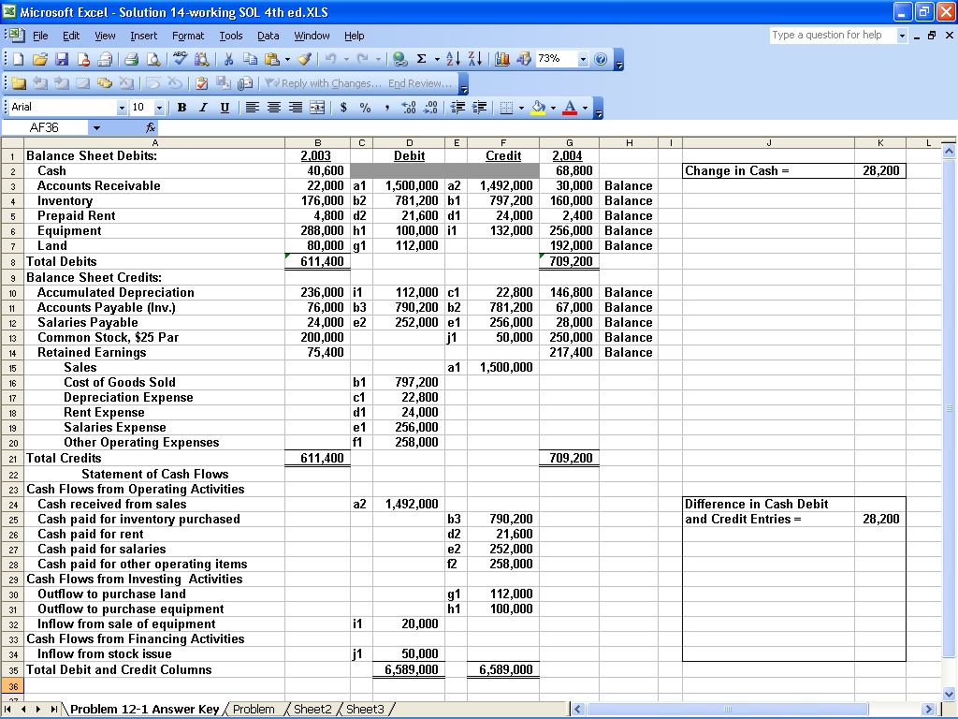
ATC 14-7 Screen capture of cell formulas

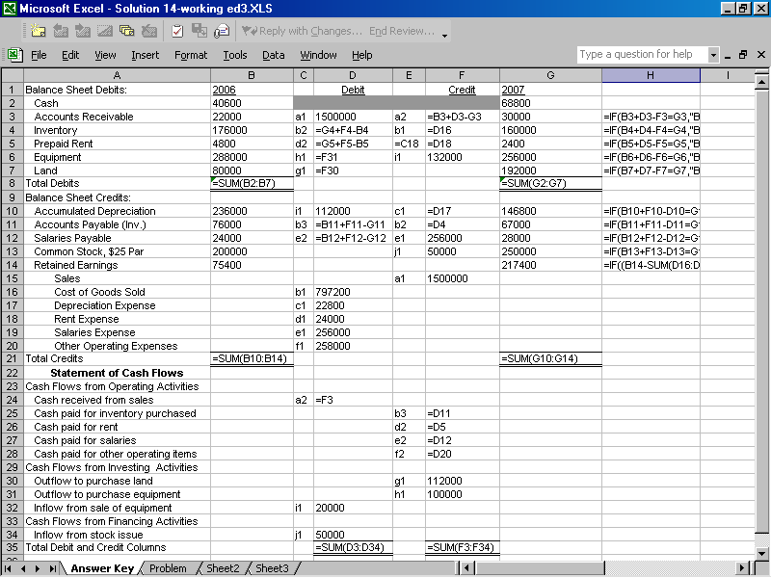
ATC 14-8 Screen capture of cell values

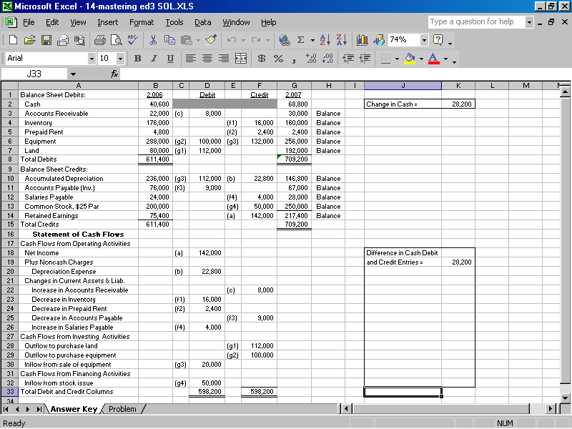
ATC 14-8 Screen capture of cell formulas

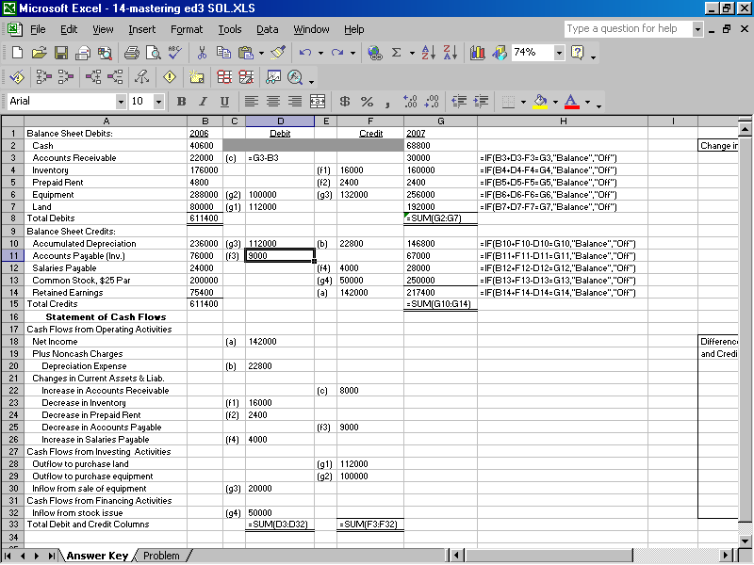
ATC 14-8 Screen capture of cell formulas (continued)

